ECA1415-EMBEDDED SYTEMS
Exp No: 14
EMBEDDED C PROGRAM TO DISPLAY “HELLO WORLD” MESSAGE
AIM:
To write an Embedded C program to display “HELLO WORLD” message using Keil software.
OUTPUT:
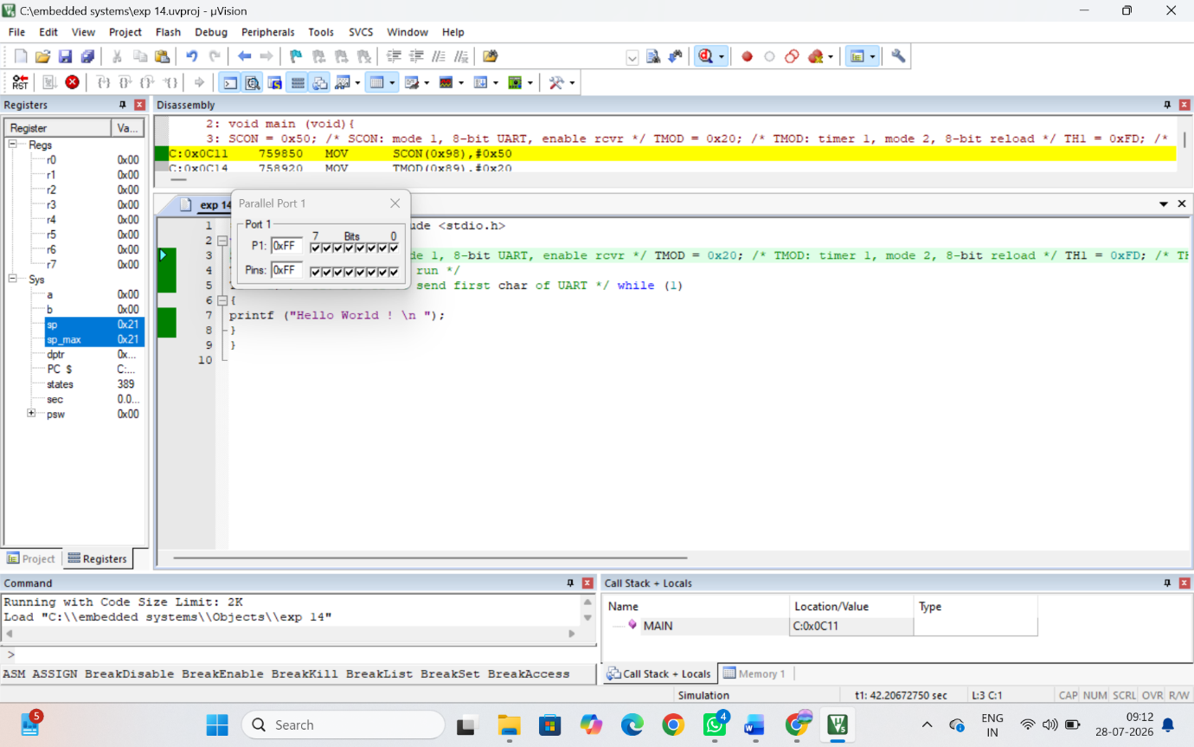
RESULT:
Thus the program has been successfully verified and executed.

