ECA1415-EMBEDDED SYTEMS

Exp No: 17
UART INTERFACING USING INTERRUPT IN KEIL
AIM:
To receive serial data using interrupt.

OUTPUT:
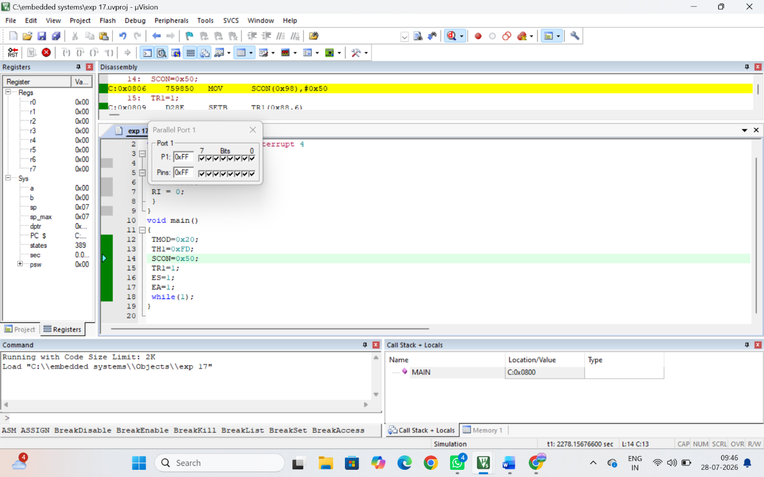

RESULT:
Thus the serial data was received using Interrupt and the received data was verified.

