ECA1415-EMBEDDED SYTEMS
Exp No: 12
EMBEDDED C PROGRAM TO MULTIPLY TWO 16-BIT BINARY NUMBERS
AIM:
To write an Embedded C program to multiply two 16-bit numbers using Keil software
OUTPUT:
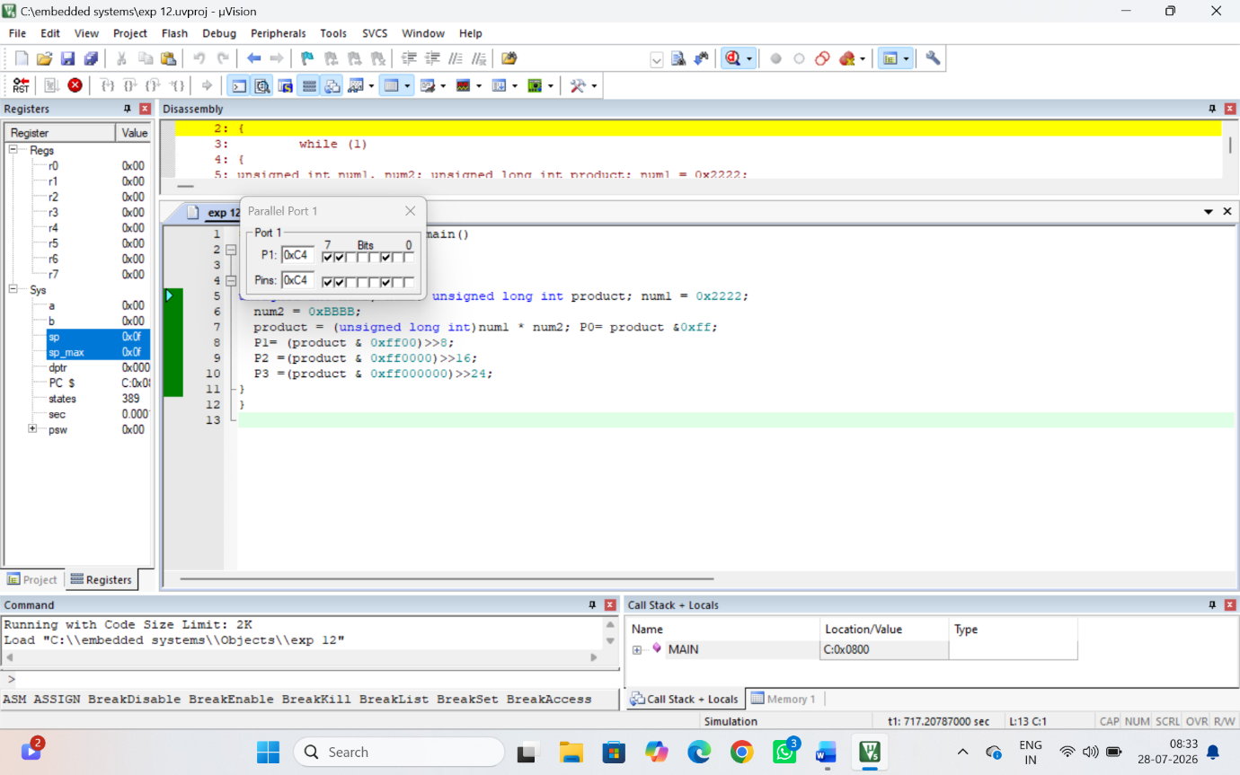

RESULT:
Thus the program has been successfully verified and executed.

