Lab 14: Mini Project Wireframe & Feature Implementation (Project Kickoff)

Objectives:
Start project development: design wireframes, set up project repo, implement core features.

Tools/Tech:
• Figma/pen-and-paper for wireframes
• VS Code, GitHub
• Bootstrap/Vanilla JS

Tasks/Steps:
1. Form project groups (or work individually) and choose a mini-app (blog, event manager, mini e-commerce).
2. Design UI wireframes and list core features (MVP).
3. Set up project repo and scaffold pages (index, about, feature pages).
4. Implement basic navigation and layout for the app.

Deliverables:
• Project repository with wireframes and README.
• Initial codebase with basic navigation and placeholder pages.

Code Example for Mini Project Setup:
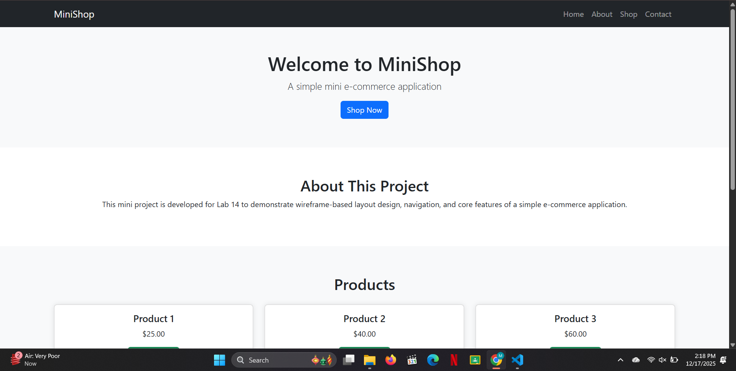
<!DOCTYPE html>
<html lang="en">
<head>
<meta charset="UTF-8">
<meta name="viewport" content="width=device-width, initial-scale=1.0">
<meta name="description" content="Mini e-commerce site showcasing products.">
<title>Mini E-Commerce Site</title>
<link rel="stylesheet" href="styles.css">
</head>
<body>
<!-- Navigation -->
<nav>
<ul>
<li><a href="index.html">Home</a></li>
<li><a href="about.html">About</a></li>
<li><a href="shop.html">Shop</a></li>
<li><a href="contact.html">Contact</a></li>
</ul>
</nav>
<!-- Main Content -->
<section id="home">
<h1>Welcome to Our E-Commerce Store</h1>
<p>Browse our latest collection of products!</p>
</section>
<!-- Footer -->
<footer>
<p>&copy; 2025 Mini E-Commerce App</p>
</footer>
<script src="script.js"></script>
</body>
</html>

