***Problem-Solution fit***

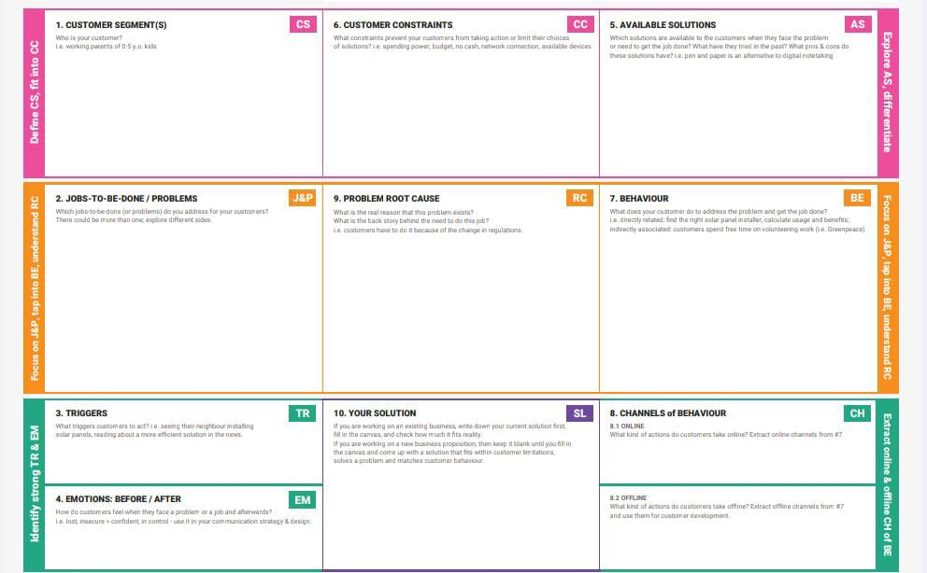

***Project Design Phase***

***Problem – Solution Fit Template***

|  |  |
| --- | --- |
| **Date** | 15 February 2025 |
| **Team ID** | LTVIP2025TMID19444 |
| **Project Name** | Workforce administration management |
| **Maximum Marks** | 4 marks |

**Problem – Solution Fit Template**

The Problem-Solution Fit simply means that you have found a problem with your customer

**Purpose**

Solve complex problems in a way that fits the state of your customers.

Succeed faster and increase your solution adoption by tapping into existing mediums and

channels of behavior.

**Template**



***Project Design Phase***

***Proposed Solution Template***

|  |  |
| --- | --- |
| **Date** | 15 February 2025 |
| **Team ID** | LTVIP2025TMID19444 |
| **Project Name** | Workforce administration management |
| **Maximum Marks** | 4 marks |

***Proposed Solution Template:***

|  |  |  |
| --- | --- | --- |
| ***S.NO.*** | ***Parameter*** | ***Description*** |
| ***1.*** | Problem Statement(Problem to be solved) | .Describe the impact or consequences of not solving the problem. |
| ***2.*** | Idea /Solution description | Number of downloads and active users |
| ***3.*** | Novelty/Uniqueness | Clearly articulate what sets the proposed solution apart from existing solutions***.*** |
| ***4.*** | Social Impact/Customer satisfaction | Describe the positive social impacts of the proposed solution.  " |
| ***5.*** | Business Model(Revenue Model) | Describe the revenue model and pricing strategy***.*** |
| ***6.*** | Scalability of the solution | Describe the scalability goals and objectives. |

***Project Design Phase***

***Solution Architecture***

|  |  |
| --- | --- |
| **Date** | **15 February 2025** |
| **Team ID** | LTVIP2025TMID19444 |
| **Project Name** | Workforce administration management |
| **Maximum Marks** | 4 Marks |

**Solution Architecture:** Solution architecture is a complex process with many sub-processes-that bridges the gap between business problems and technology solutions

**Example - Solution Architecture Diagram:**

