***Requirement Analysis***

**Customer Journey Map**

**Steps:**

A customer journey map is visual representation of the customer's experience across all touchpoints and interactions with a company.

**Iterations:**

Iterations refer to the repetitive process of refining and improving product, service,or process through multiple cycles of design, testing and feedback.

**Goals and Motivations:**

Goals and motivations are the essential concepts in understanding human behaviour and decision-making.

**Positive moments:**

Positive moments refer to experiences or interactions that leave a lasting, positive impression on customers, employees, or users.

**Negative moments:**

Negative moments refer to experiences or iterations that leave a lasting, negative impression on customers, employees,or users.

**Area of opportunity:**

An area of opportunity refers to a situation or circumstance where there is potential for growth, improvement, or innovation. It is an area where efforts can be focused to achieve positive change, increase efficiency, or enhance overall performance.

**Project Design Phase-II**

**Data Flow Diagram & User Stories**

|  |  |
| --- | --- |
| **Date** | 31 January 2025 |
| **Team Id** | LTVIP2025TMID19444 |
| **Project Name** | Workforce administration management |
| **Maximum Marks** | 4 Marks |

**Data flow Diagram:**

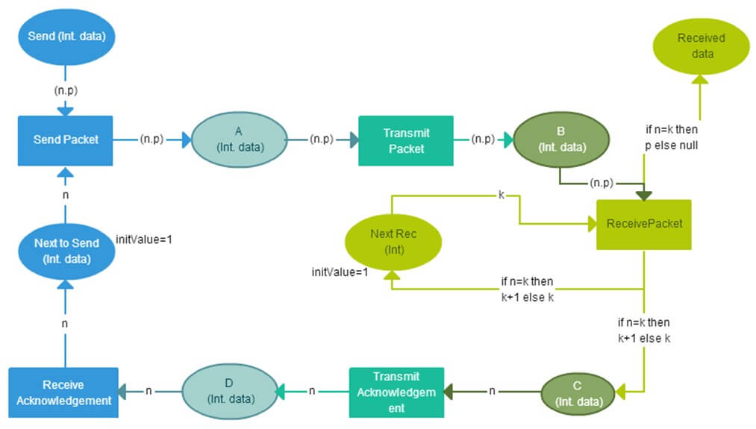

**User Stories:**

| **User Type** | **Functional Requirement (Epic)** | **User Story Number** | **User Story / Task** | **Acceptance criteria** | **Priority** | **Release** |
| --- | --- | --- | --- | --- | --- | --- |
| Customer (Mobile user) | Registration | USN-1 | As a user, I can register for the application by entering my email, password, and confirming my password. | I can access my account / dashboard | High | Sprint-1 |
|  |  | USN-2 | As a user, I will receive confirmation email once I have registered for the application | I can receive confirmation email & click confirm | High | Sprint-1 |
|  |  | USN-3 | As a user, I can register for the application through Facebook | I can register & access the dashboard with Facebook Login | Low | Sprint-2 |
|  |  | USN-4 | As a user, I can register for the application through Gmail |  | Medium | Sprint-1 |

**Project Design Phase-II**

**Solution Requirements (Functional & Non-functional)**

|  |  |
| --- | --- |
| **Date** | 31 January 2025 |
| **Team Id** | LTVIP2025TMID19444 |
| **Project Name** | Workforce administration management |
| **Maximum Marks** | 4 Marks |

**Functional Requirements:**

|  |  |  |
| --- | --- | --- |
| **FR No.** | **Functional Requirement (Epic)** | **Sub Requirement (Story / Sub-Task)** |
| FR-1 | User Registration | Registration through Form  Registration through Gmail  Registration through LinkedIN |
| FR-2 | User Confirmation | Confirmation via Email  Confirmation via OTP |

**Non-Functional Requirements:**

|  |  |  |
| --- | --- | --- |
| **FR No.** | **Non-Functional Requirement** | **Description** |
| NFR-1 | **Usability** | Usability in workforce administration solutions refers to the ease with which users can interact with the system to perform their job tasks efficiently and effectively. |
| NFR-2 | **Security** | Security refers to the practices, measures, and technologies used to protect digital information, systems, and networks from unauthorized access, use, disclosure, disruption, modification, or destruction. |
| NFR-3 | **Reliability** | Reliability refers to the ability of a system, product, or service to consistently perform its intended function without failing or producing errors. |
| NFR-4 | **Performance** | Performance refers to the measurement of how well a system, product, or service achieves its intended goals and objectives. |
| NFR-5 | **Availability** | Availability refers to the degree to which a system, product, or service is accessible and usable when needed. |
| NFR-6 | **Scalability** | Scalability refers to the ability of a system, product, or service to handle increased load, demand, or growth without compromising performance, efficiency, or quality. |

**Project Design Phase-II**

**Technology Stack (Architecture & Stack)**

|  |  |
| --- | --- |
| **Date** | 31 January 2025 |
| **Team Id** | LTVIP2025TMID19444 |
| **Project Name** | Workforce administration management |
| **Maximum Marks** | 4 Marks |

**Technical Architecture:**

The Deliverable shall include the architectural diagram as below and the information as per the table1 & table 2

**Example: Order processing during pandemics for offline mode**

|  |  |  |  |
| --- | --- | --- | --- |
| **S.No** | **Component** | **Description** | **Technology** |
|  | User Interface | How user interacts with application e.g.  Web UI, Mobile App, Chatbot etc. | HTML, CSS, JavaScript / Angular Js / React Js etc. |
|  | Application Logic-1 | Logic for a process in the application | Java / Python |
|  | Application Logic-2 | Logic for a process in the application | IBM Watson STT service |
|  | Application Logic-3 | Logic for a process in the application | IBM Watson Assistant |
|  | Database | Data Type, Configurations etc. | MySQL, NoSQL, etc. |
|  | Cloud Database | Database Service on Cloud | IBM DB2, IBM Cloudant etc. |
|  | File Storage | File storage requirements | IBM Block Storage or Other Storage Service or Local Filesystem |
|  | External API-1 | Purpose of External API used in the application | IBM Weather API, etc. |
|  | External API-2 | Purpose of External API used in the application | Aadhar API, etc. |
|  | Machine Learning Model | Purpose of Machine Learning Model | Object Recognition Model, etc. |
|  | Infrastructure (Server / Cloud) | Application Deployment on Local System / Cloud  Local Server Configuration:  Cloud Server Configuration : | Local, Cloud Foundry, Kubernetes, etc. |

**Table-2: Application Characteristics:**

| **S.No** | **Characteristics** | **Description** | **Technology** |
| --- | --- | --- | --- |
|  | Open-Source Frameworks | List the open-source frameworks used | Technology of Opensource framework |
|  | Security Implementations | List all the security / access controls implemented, use of firewalls etc. | e.g. SHA-256, Encryptions, IAM Controls, OWASP etc. |
|  | Scalable Architecture | Justify the scalability of architecture (3 – tier, Micro-services) | Technology used |
|  | Availability | Justify the availability of application (e.g. use of load balancers, distributed servers etc.) | Technology used |
|  | Performance | Design consideration for the performance of the application (number of requests per sec, use of Cache, use of CDN’s) etc. | Technology used |

**Conclusion:-**

In my point of view,the implementation of Salesforce is a complex process that requires careful planning, execution, and testing. Throughout this project, we have outlined the key steps involved in implementing Salesforce, including requirements gathering, solution design, testing and validation, and deployment. We have also identified key scenarios addressed by Salesforce in the implementation process, including sales, marketing, service, commerce, analytics, and integration scenarios.

By following the steps outlined in this project and addressing the key

scenarios, organizations can ensure a successful Salesforce implementation that meets their business needs and drives user adoption.

**Thank you Smartbridge**

**M S V MANIKANTA**

**TEAM LEADER**