**Ideation Phase**

**Brainstorm & Idea Prioritization**

#### Project Overview : Introduction to Salesforce: Overview of Salesforce and its key components -Understanding Salesforce editions and clouds- Exploring the Salesforce platform and its core services.

|  |  |
| --- | --- |
| Date | 31 January 2025 |
| Team ID | LTVIP2025TMID19444 |
| Project Name | Workforce administration management |
| Maximum Marks | 4 marks |

**Step-1: Team Gathering, Collaboration and Select the Problem Statement**

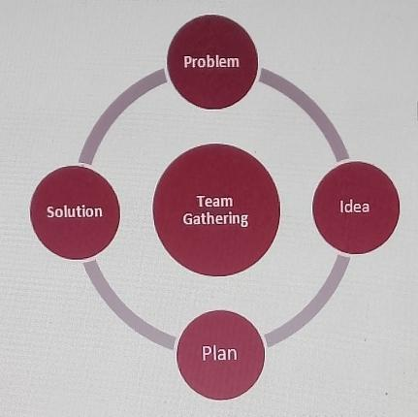

**Step-2: Brainstorm, Idea Listing and Grouping**

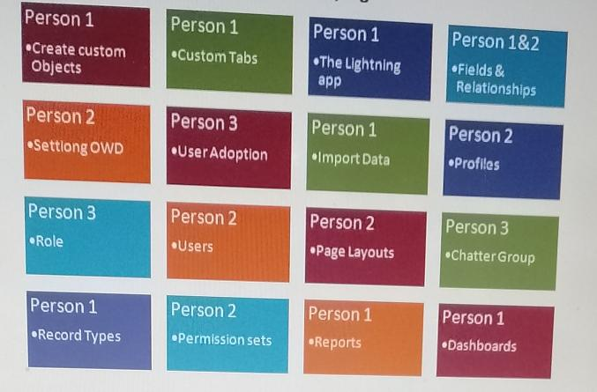

**Step-3: Idea Prioritization**

Prioritization Matrix

- Evaluate ideas based on two criteria (e.g., impact and feasibility)

- Plot ideas on a matrix with the two criteria as axes

**Ideation Phase**

**Define the Problem Statements**

|  |  |
| --- | --- |
| Date | 31 January 2025 |
| Team ID | LTVIP2025TMID19444 |
| Project Name | Workforce administration management |
| Maximum Marks | 4 marks |

**Customer Problem Statement Template:**

Success Metrics: Determine how success will be measured.

Example: "Reduced time spent on meal planning and preparation, increased consumption of healthy meals, and improved family satisfaction with meal options"

***Ideation Phase***

***Empathize & Discover***

|  |  |
| --- | --- |
| **Date** | 31 January 2025 |
| **Team ID** | **LTVIP2025TMID19444** |
| **Project Name** | **Workforce administration**  **management** |
| **Maximum Marks** | 4 marks |

**Empathy Map Canvas:**

**Example:** 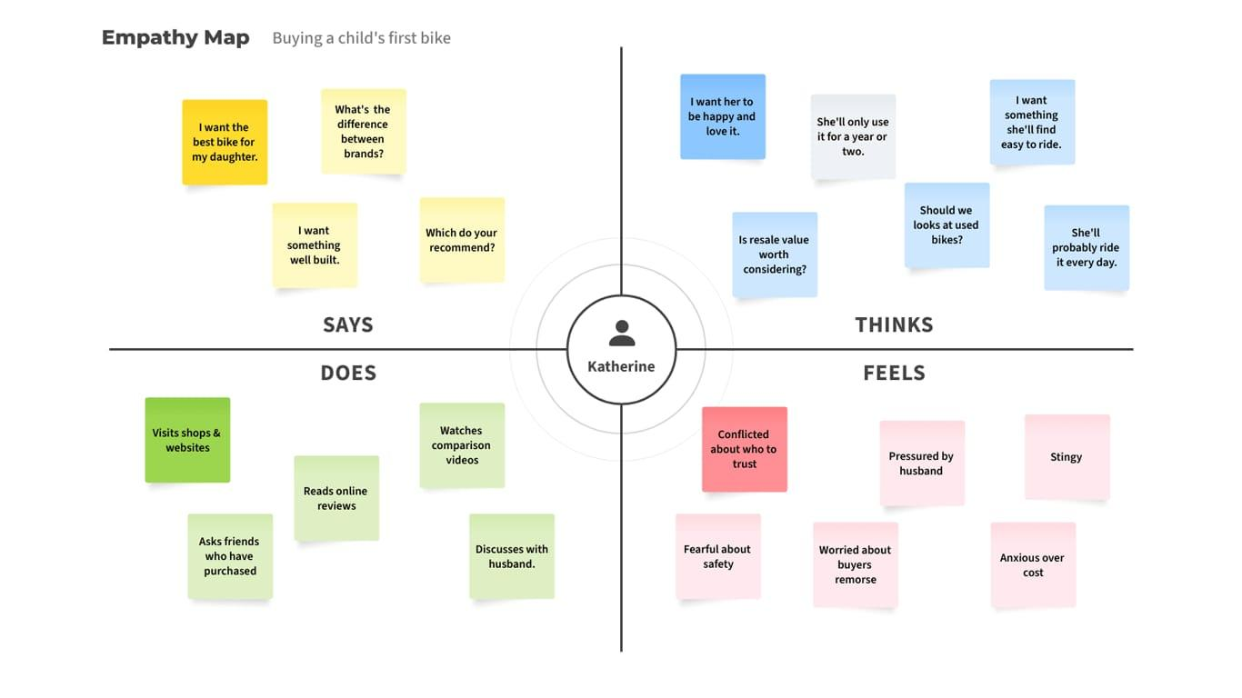

***Empathy Map***

***Example:*** ***Food Ordering & Delivery Application***

