---------------------------------------------- REACT --------------------------------------------

prerequisites:
1)node and npm installation
2)vs code extenstions - [react code snippets, prettier]
refer screenshots for reference

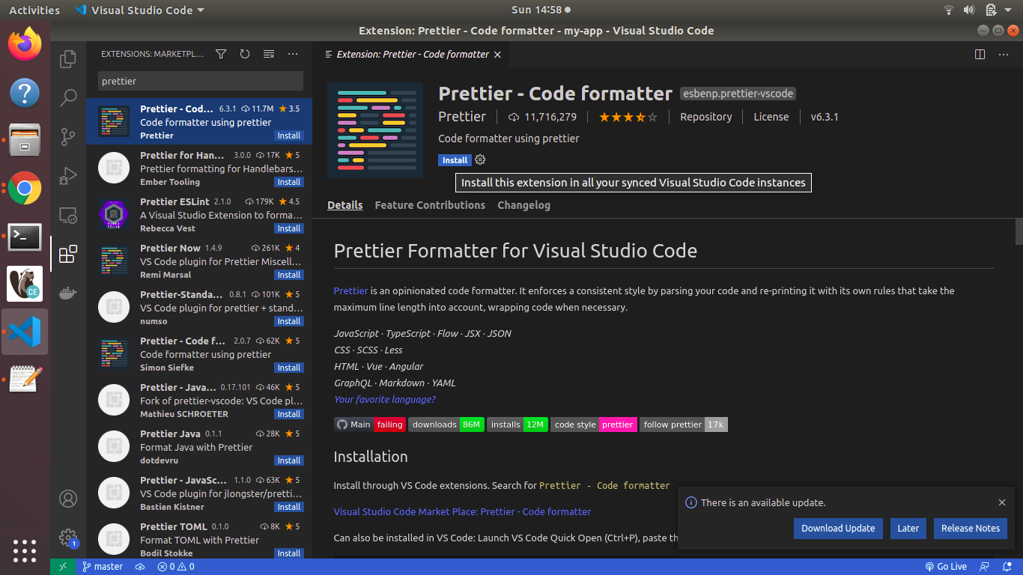

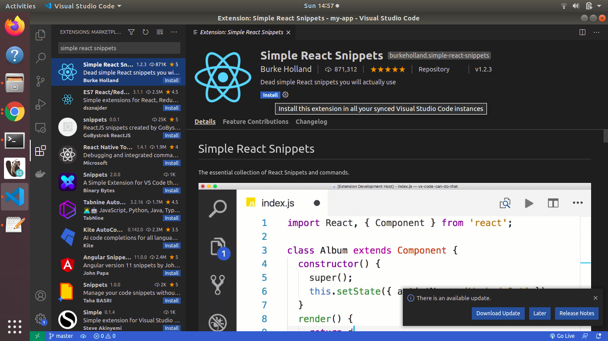

process to create react app:

sudo npm i -g create-react-app
sudo create-react-app my-app

Now React app folder will be created like below image
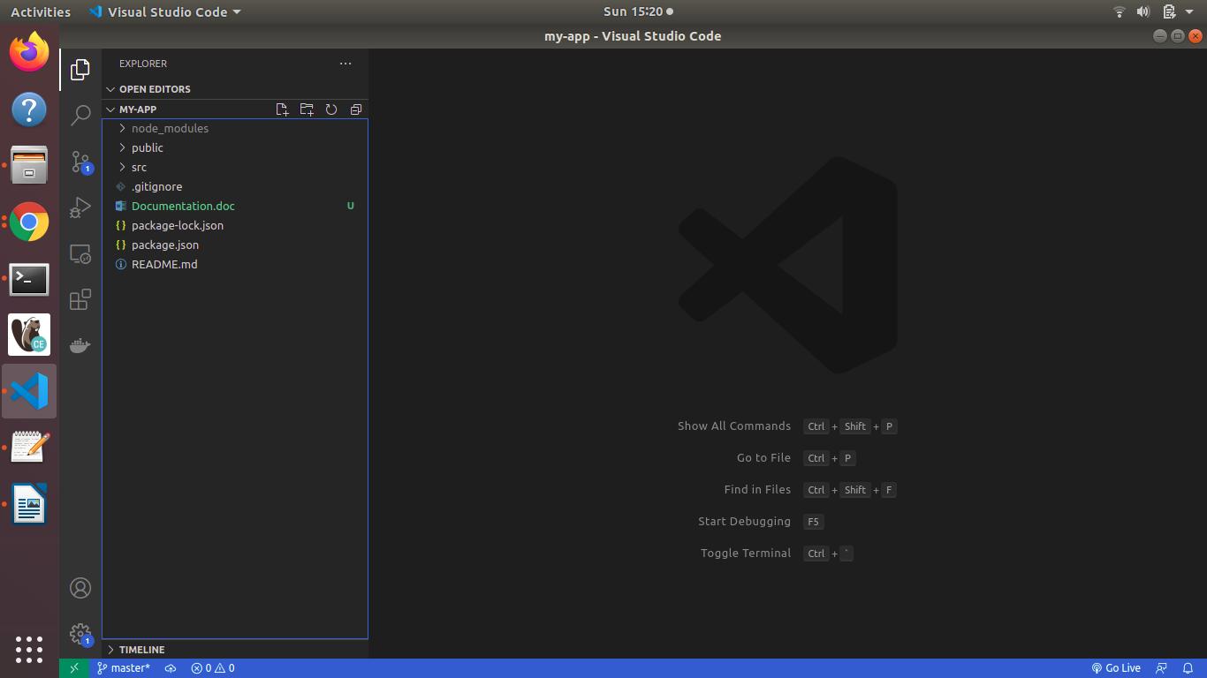

To Run the React App:
- Navigate to your app folder in my case its “ my-app “ folder
- run “npm start”
- This command will open the http://localhost:3000 (react development server) in your default browser with below react page.

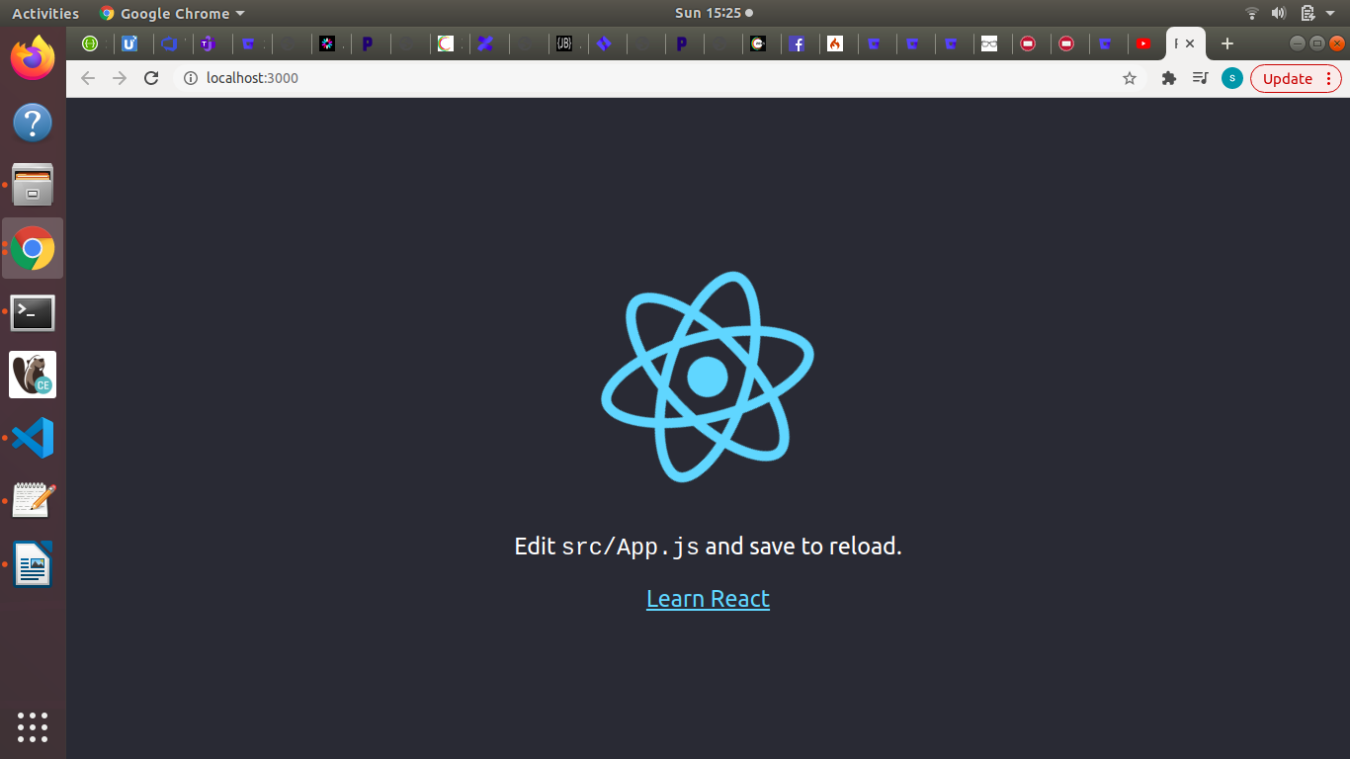
Note: Babel is a compiler to convert JSX syntax to react js (javascript) syntax which is understood by browsers.

npm install bootstrap@4.1.1
Components:Components are classes or functions that will render the (JSX code) which will be compiled by Bable compiler to normal react js (javascript) which is understood by the browser.

Eg:

in JSX, const element = <h1>Hello world</h1> is equal to

in React, like in image below....
