Aim: Write a program to demonstrate different number datatypes in python.
IDE:
Data types in Python refer to classifying or categorizing data objects based on their characteristics and behavior. They determine the type of values variables can hold and specify the operations that can be performed on those values. For instance, Python has several built-in data types, including numeric types (int, float, complex), string (str), Boolean (bool), and collection types (list, tuple, dict, set). Moreover, each data type has its own set of properties, methods, and behaviors that allow programmers to manipulate and process data effectively in their programs.
Built-in Data Types in Python
Built-in data types in Python are fundamental data structures provided by the Python programming language. Pre-defined and available for use without requiring any additional libraries or modules. Python offers several built-in data types, including:
Numeric Data Types: Numeric data types in Python are used to represent numerical values. Python provides three primary numeric datatypes in python:
- Integer (int): Integers are whole numbers without any decimal points. They can be positive or negative.
- Floating-Point (float): Floating-point numbers represent decimal values. They can be positive or negative and may contain a decimal point.
- Complex (complex): People use complex numbers to represent numbers with a real and imaginary part. You write them in the form of a + bj, where a is the real part and b is the imaginary part.
String Data Type(str): Represents a sequence of characters enclosed in single quotes (‘ ‘) or double quotes (” “), such as “Hello, World!”, ‘Python’.
Boolean Data Type(bool): Represents either True or False, used for logical operations and conditions.
Collection Data Types:
- list: Represents an ordered and mutable collection of items, enclosed in square brackets [].
- tuple: Represents an ordered and immutable collection of items, enclosed in parentheses ().
- dict: Represents a collection of key-value pairs enclosed in curly braces {} with unique keys.
- set: Represents an unordered and mutable collection of unique elements, enclosed in curly braces {} or using the set() function.

Results:
Attach the screenshot of each task along with the output

Numeric Data Types

Python Code:

num1 = 10
print(num1)
print(“Datatype of num1 is”, type(num1))

num2 = 2.5
print(num2)
print(“Datatype of num1 is”, type(num2))

num3 = 2+6j
print(num3)
print(“Datatype of num1 is”, type(num3))

Example 1

x = 5
y = -6

# Performing arithmetic operations
sum_result = x + y
difference_result = x - y
multiplication_result = x * y
division_result = x / y
# Printing the results
print("Sum:", sum_result)
print("Difference:", difference_result)
print("Multiplication:", multiplication_result)
print("Division:", division_result)

Code:
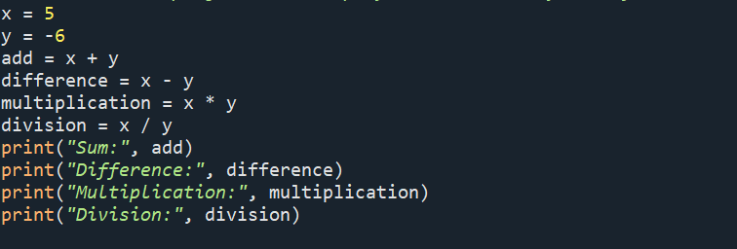

Output:
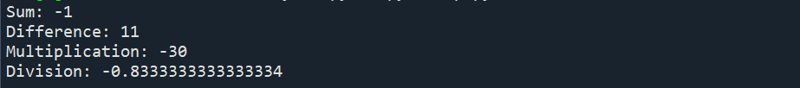

Example 2:
a = 10
b = 20
# Comparing the values
greater_than = a > b
less_than_or_equal = a <= b
equal_to = a == b
not_equal_to = a != b
# Printing the results
print("Greater than:", greater_than)
print("Less than or equal to:", less_than_or_equal)
print("Equal to:", equal_to)
print("Not equal to:", not_equal_to)

Code:
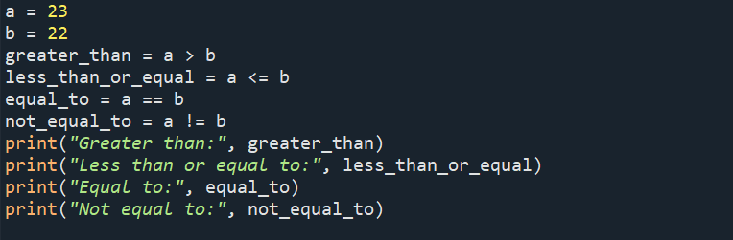
Output
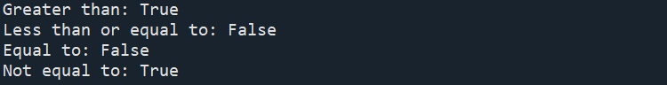

Example 3
x = 3.14
y = 2.5
# Performing arithmetic operations
sum_result = x + y
difference_result = x - y
multiplication_result = x * y
division_result = x / y
# Printing the results
print("Sum:", sum_result)
print("Difference:", difference_result)
print("Multiplication:", multiplication_result)
print("Division:", division_result)

Code:
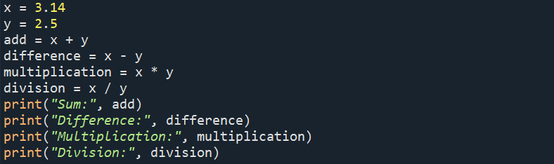
Output
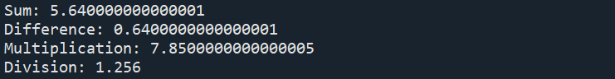
Example 4

a = 1.2
b = 2.7
# Comparing the values
greater_than = a > b
less_than_or_equal = a <= b
equal_to = a == b
not_equal_to = a != b
# Printing the results
print("Greater than:", greater_than)
print("Less than or equal to:", less_than_or_equal)
print("Equal to:", equal_to)
print("Not equal to:", not_equal_to)

Code:
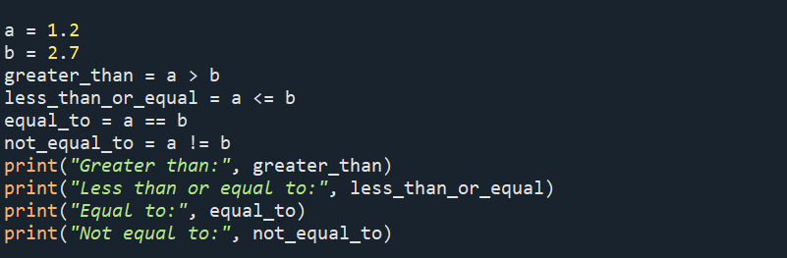

Output
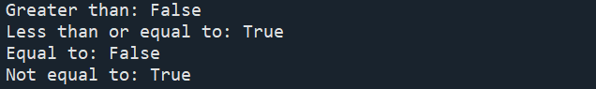

Example 5

x = 2 + 3j
y = -1 + 2j
# Performing arithmetic operations
sum_result = x + y
difference_result = x - y
multiplication_result = x * y
division_result = x / y
# Printing the results
print("Sum:", sum_result)
print("Difference:", difference_result)
print("Multiplication:", multiplication_result)
print("Division:", division_result)

Code:
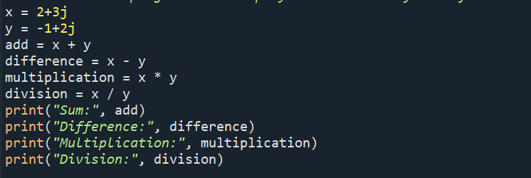
Output:
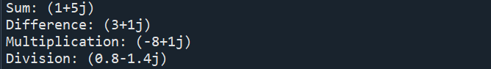
Example 6

a = 1 + 2j
b = 3 + 4j
# Comparing the values
equal_to = a == b
not_equal_to = a != b
# Printing the results
print("Equal to:", equal_to)
print("Not equal to:", not_equal_to)

Code:
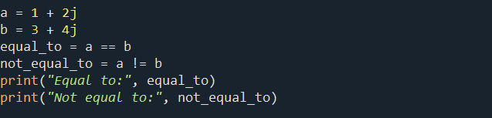
Output:

Example 7

st1 = “ICT Department 3EK1”
print(st1)
print(st1[0])
print(st1[0:4])

Code
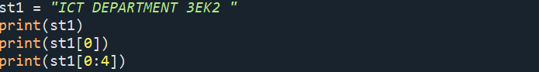
Output
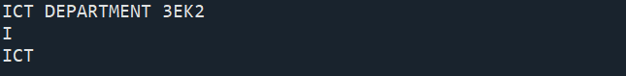

Example 8
st1 = “ICT”
st2 = “Department”
st3 = “3EK1”
print(st1+st2+st3)

Code:
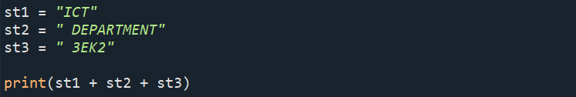
Output:

Repetitions: Python allows us to repeat a given string with the help of ‘ * ‘ operator.

print(4*st1)
Code:
Output:
Membership: The Membership operator helps to check whether a given character is present in the string or not with the help of two operators in and not in. In and not in operator returns the Boolean value True or False.

st1 = “ICT Department 3EK1”
print(“p” in st1)

Output

Print(“f” not in st1)

Output
Collection Data Types

Collection data types in Python are used to store and organize multiple values into a single entity. Python provides several built-in collection data types, including lists, tuples, dictionaries, and sets.

list1=[123,567,89]
print(list1)

list2=[“hello”,”how”,”are”]
print(list2)

list3= [“hey”,1223,”hello”]
print(list3)

Code:
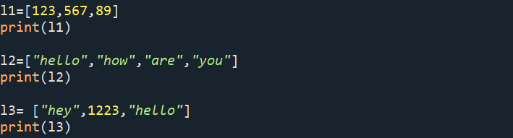

Output
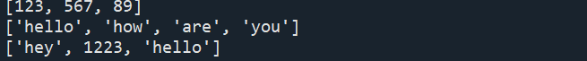

list1=["apple","mango",123,345]
list2 = ["grapes"]
print(list1+ list2)

Code
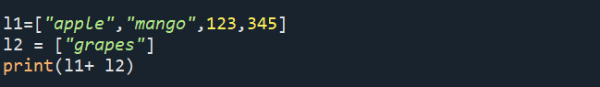
Output

dict1={“comp”: “computer” , “sci” : “science”}
print(dict[“comp”])
dict2={“123”:”computer”,456 : “maths”}
print(dict2[“123”])
print(dict1[“comp”]+ dict2[“123”])

Check
print(dict1+ dict2)
print(dict1[“computer”]+ dict2[“computer”])

Output
my_set = {1, 2, 3, 4, 5}
print(my_set)

set1 = {1, 2, 3, 4, 5}
set2 = {4, 5, 6, 7, 8}
check
print(set1 + set2)

Output
my_tuple = (1, 2, 3, 4, 5)
t1 = (2,3,4)
t2 = (5,6,7)
print(t1+t2)
Code:
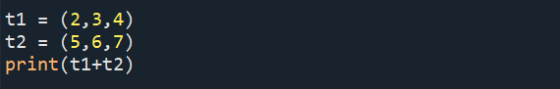
Output:

Post Lab Exercise:
- Write a program that displays “Welcome to Python” five times.
- Write a program that displays the following table:
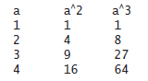
- Write a program that displays the result of
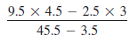
GITHUB:- https://github.com/saimanognanettem2007/Python.git

