Aim: Write a program to create, concatenate and print a string and accessing substring from a given
string.
IDE:
Slicing and indexing are two fundamental concepts in Python. They help us access specific elements in a sequence, such as a string or (list and tuple).
Indexing in Python
Indexing is the process of accessing an element in a sequence using its position in the sequence (its index). In Python, indexing starts from 0, which means the first element in a sequence is at position 0, the second element is at position 1, and so on. To access an element in a sequence, you can use square brackets [] with the index of the element you want to access.
Let's consider the following example:
# create a string using double quotes
string1 = "ICT Department"
print(string1)
# create a string using single quotes
string1 = ' ICT Department '
print(string1)
Code
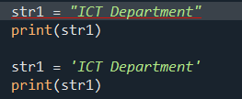

Output
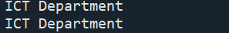

Access String Characters in Python
string2 = '3EK1'
# access 1st index element
print(string2 [1])
Code:
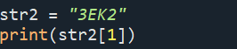
Output:

Negative Indexing:
Python allows negative indexing for its strings. For example,
string3 = 'ICT Department'
# access 4th last element
print(string3 [-4])
Code:
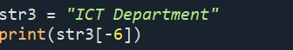
Output:

Slicing in Python
Slicing is the process of accessing a sub-sequence of a sequence by specifying a starting and ending index. In Python, you perform slicing using the colon: operator. The syntax for slicing is as follows:
Example:
sequence[start_index:end_index]
where start_index is the index of the first element in the sub-sequence and end_index is the index of the last element in the sub-sequence (excluding the element at the end_index). To slice a sequence, you can use square brackets [] with the start and end indices separated by a colon.
For example,
string4 = 'ICT Department'
# access character from 1st index to 3rd index
print(string4[1:4])
Code:
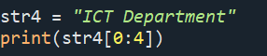
Output:

You can also omit either the start_index or the end_index in a slice to get all the elements from the beginning or end of the sequence. For example:
print(string4[:2])
print(string4[2:])
code:
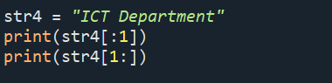
output:
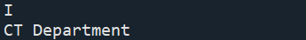

In the first line of the above code, we have used slicing to get all the elements from the beginning of string4 up to (but not including) the element at index 2. In the second line, we have used slicing to get all the elements from index 2 to the end of string4.

Python Strings are Immutable

In Python, strings are immutable. That means the characters of a string cannot be changed. For example,
message = 'ICT Department'
message[0] = 'H'
print(message)
Code:

Output:

However, we can assign the variable name to a new string. For example,
message = 'ICT'
# assign new string to message variable
message = 'ICT Department'
print(message)
code:
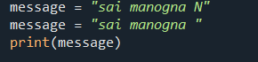
Output:

Python Multiline String
We can also create a multiline string in Python. For this, we use triple double quotes """ or triple single quotes '''. For example,
# multiline string
message = """
ICT
Department
3EK1
"""
print(message)
code:
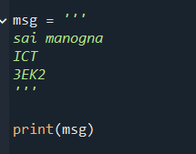
Output:
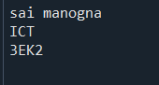

Python String Operations

Many operations can be performed with strings, which makes it one of the most used data types in Python.

1. Compare Two Strings
For example,
str1 = "ICT"
str2 = "Department"
str3 = "3EK1"
# compare str1 and str2
print(str1 == str2)
# compare str1 and str3
print(str1 == str3)

code:
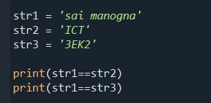
Output:
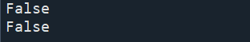

2. Join Two or More Strings
In Python, we can join (concatenate) two or more strings using the + operator.
greet = "ICT"
name = "Department"
# using + operator
result = greet + name
print(result)
code:
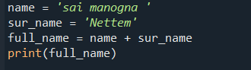
Output:
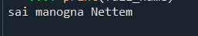

Python String Length
In Python, we use the len() method to find the length of a string. For example,
greet = 'ICT'
# count length of greet string
print(len(greet))
code:
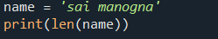
Output:
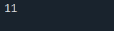

String Membership Test
We can test if a substring exists within a string or not, using the keyword in.
print('a' in 'program')
print('at' not in 'battle')
code:
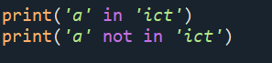
Output:
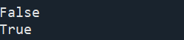
Methods of Python String
Python String upper()
The upper() method converts all lowercase characters in a string into uppercase characters and returns it.
message = 'python is fun'
# convert message to uppercase
print(message.upper())

code:
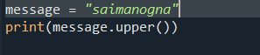
Output:
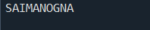

Python String lower()
The lower() method converts all uppercase characters in a string into lowercase characters and returns it.
message = 'PYTHON IS FUN'
# convert message to lowercase
print(message.lower())
code:
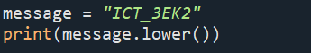
Output:

Python String replace()
The replace() method replaces each matching occurrence of a substring with another string.
text = 'CE Department'
replaced_text = text.replace('CE', 'ICT')
print(replaced_text)
code:
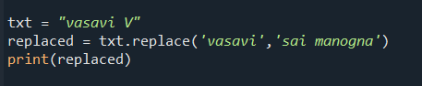
Output:
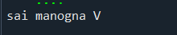

Python String find()
The find() method returns the index of first occurrence of the substring (if found). If not found, it returns -1.
message = 'Python is a fun programming language'
# check the index of 'fun'
print(message.find('fun'))
code:
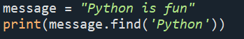
Output:
Python String rstrip()
The rstrip() method returns a copy of the string with trailing characters removed (based on the string argument passed).
title = 'Python Programming '
result = title.rstrip()
print(result)
code:
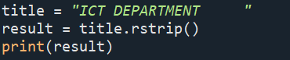
Output:

Python String split()
The split() method breaks down a string into a list of substrings using a chosen separator.
text = 'Python is fun'
# split the text from space
print(text.split())
code:
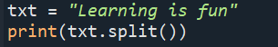
output:

Python String startswith()
The startswith() method returns True if a string starts with the specified prefix(string). If not, it returns False.
message = 'Python is fun'
# check if the message starts with Python
print(message.startswith('Python'))
code:
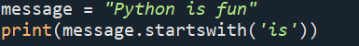
Output:
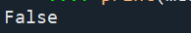

Python String isnumeric()
The isnumeric() method checks if all the characters in the string are numeric.
pin = "523"
# checks if every character of pin is numeric
print(pin.isnumeric())
code:
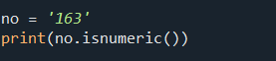
Output:

Python String index()
The index() method returns the index of a substring inside the string (if found). If the substring is not found, it raises an exception.
text = 'Python is fun'
# find the index of is
result = text.index('is')
print(result)
code:
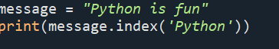
Output:

Python String Formatting (f-Strings)
Python f-Strings makes it easy to print values and variables. For example,
name = 'Cathy'
country = 'UK'
print(f'{name} is from {country}')
code:
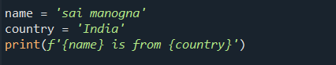
Output:
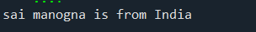

Python Raw String
Python strings become raw strings when they are prefixed with r or R, such as r'...' and R'...'. Raw strings treat backslashes () as literal characters. Raw strings are useful for strings with a lot of backslashes, like regular expressions or directory paths.
str = "This is a \n normal string example"
print(str)
raw_str = r"This is a \n raw string example"
print(raw_str)
code:
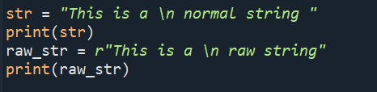
Output
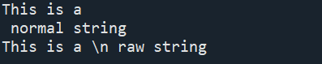
Post Lab Exercise:
- Write a Python program to reverse a string.
- Write a Python program to check if a string is a palindrome.
- Write a Python program to check if a string contains only digits.
- Write a Python program to find the longest word in a sentence.
- Write a Python program to find the length of the last word in a sentence.

GITHUB LINK:- https://github.com/saimanognanettem2007/Python.git

