Aim: Write a program to demonstrate working with tuples in python.
IDE:
Python Tuple
A tuple is a collection similar to a Python list. The primary difference is that we cannot modify a tuple once it is created.
A tuple represents a sequence of any objects separated by commas and enclosed in parentheses. A tuple is an immutable object, which means it cannot be changed, and we use it to represent fixed collections of items.

Create a Python Tuple
numbers = (1, 2, -5)
print(numbers)
Output:

Let's take a look at some examples of Python tuples:

() — an empty tuple
(1.0, 9.9, 10) — a tuple containing three numeric objects
('Casey', 'Darin', 'Bella', 'Mehdi') — a tuple containing four string objects
('10', 101, True) — a tuple containing a string, an integer, and a Boolean object
Also, other objects like lists and tuples can comprise a tuple, like this:
a_tuple = (0, [1, 2, 3], (4, 5, 6), 7.0)
print(a_tuple)
code
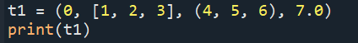
Output
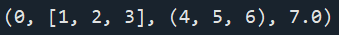

Access Tuple Items
Each item in a tuple is associated with a number, known as a index.
languages = ('Python', 'Swift', 'C++')
languages = ('Python', 'Swift', 'C++')
# access the first item
print(languages[0]) # Python
code:
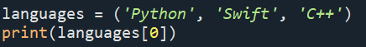
Output:

Python Tuple Length
cars = ('BMW', 'Tesla', 'Ford', 'Toyota')
print('Total Items:', len(cars))
code
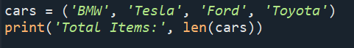
output

Task
a = tuple(range(5))
output

b = tuple(range(5,10))
print(b)
Output:

c = tuple(range(0,10,2))
print(c)
output:

d = tuple(range(10,0,-2))
print(d)
output:

code:
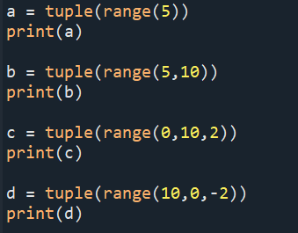
Output:
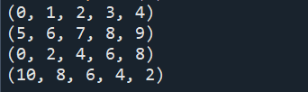

Task:
d = (3,[5,6,7],(4,5,6),[5,6,7,(6,7,8)],9,10)
Extract 6
Code:
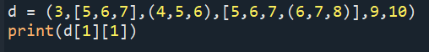
Output:

Important Functions of the Python Tuple
t1 = (2,3,4,5)
print(sum(t1))
code
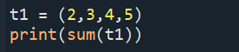
output

t3 = (3,4,4,2,2,3,6,7,4,4)
print(t3.count(4))
code
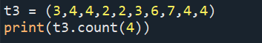
output
4. Python index() Method
t3 = (3,4,4,2,2,3,6,7,4,4)
print(t3.index(2))
print(t3.index(4,3,9))
code:
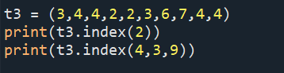
Output:

5. Python min() Method

t3 = (3,4,4,2,2,3,6,7,4,4)
print(min(t3))
code
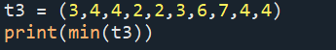
Output

6. Python max() Method
Calculates the maximum of all the elements of the tuple.
numbers = (7, 2, 8, 5, 9)
print(max(numbers))
code
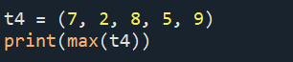
output

# removing duplicates from a tuple using dictionaries
a = (5,6,7,5,5,9,7)
b = ("a","b","v","b")
my_tu_1 = tuple(dict.fromkeys(a))
print(my_tu_1)
my_tu_2 = tuple(dict.fromkeys(b))
print(my_tu_2)
code:
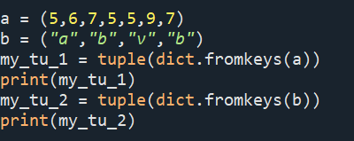
Output:
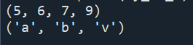

Combining tuples
first_names = ('Simon', 'Sarah', 'Mehdi', 'Fatime')
last_names = ('Sinek', 'Smith', 'Lotfinejad', 'Lopes')
ages = (49, 55, 39, 33)
zipped = tuple(zip(first_names, last_names,ages))
print(zipped)
code
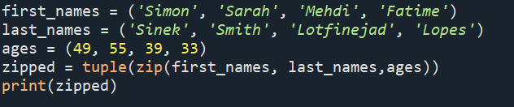
Output

Flatten a tuple of tuples
b = ((1,2),(3,4),(5,6))
my = tuple(item for l in b for item in l)
print(my)
code:
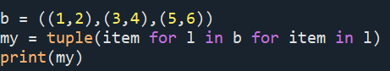
Output:
Post Lab Exercise:
- Write a Python program to Count the occurrences of an element in a tuple.
- Write a Python program to Check if an element exists in a tuple.
- Write a Python program to Convert a tuple to a string.
- Write a Python program to Find the maximum and minimum elements in a tuple.
- Write a Python program to convert a tuple of strings to a single string.
- Write a Python program to sort a tuple of integers.
- Write a python program to find the first and last elements of a tuple.
GITHUB LINK:- https://github.com/saimanognanettem2007/Python.git

