Global Economic Growth & Income Inequality Analysis Dashboard

Power BI Project Documentation

Milestone 2

Author: SHIVANI BHATT
1. Introduction
The purpose of this project is to analyze global economic growth and income inequality using nine socio‑economic indicators across multiple countries and years.
The dashboard transforms raw economic data into meaningful analytical insights using Power BI.
Key questions addressed:
• How is global economic growth changing over time?
• Is income inequality increasing or decreasing?
• How does GDP growth relate to income distribution?
• Which countries show high income concentration among the richest population groups?

2. Data Source
Dataset file: Mastersheet‑1.xlsx
Indicators used:
Gini_Index
Median_Income
GDP_per capita_Constant_LCU
GDP_per_capita_Current_LCU
GDP_per_capita_Current_US$
Income_share_held_by_Top_10%
Income_share_held_by_Top_20%
Income_share_held_by_Bottom_10%
Income_share_held_by_Bottom_20%
Additional fields:
Country
Year

3. Data Loading Process
Steps performed in Power BI:
1. Open Power BI Desktop
2. Click Get Data → Excel
3. Select Mastersheet‑1.xlsx
4. Click Transform Data to open Power Query Editor

4. Data Transformation
There are three transformation to be performed.
- The GDP indicators contained values with five decimal places.
To improve readability and visualization clarity, the values were rounded to two decimal places.
1.1 Columns rounded:
• GDP_Per_Capita_Constant_LCU
• GDP_Per_Capita_Current_LCU
• GDP_Per_Capita_Current_US$
Steps:
Select the three GDP columns
Go to Transform tab
Click Round
Set decimal places to 2 (Like., 7601.23541 to 7601.25)
Enter

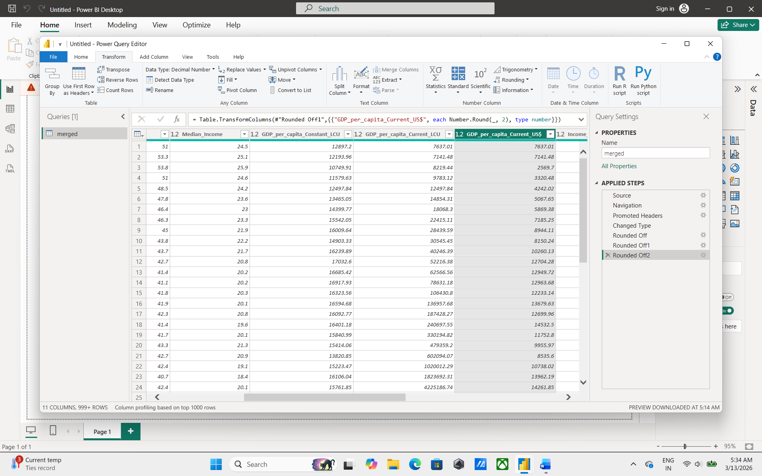

2. Rename the GDP indicators with $ symbol
To improve readability and visualization clarity, the values were renamed with $ symbol.
2.1 Rename $
• GDP_Per_Capita_Constant_LCU
• GDP_Per_Capita_Current_LCU
2.2 Steps:
Select the two GDP columns
Go to Transform tab
Click Rename
Set $ symbol beside LCU ( Like., LCU$)
Enter
Click Close & Apply
The Dollar symbol ($) is added to clearly represent that the columns contains financial values related to GDP.

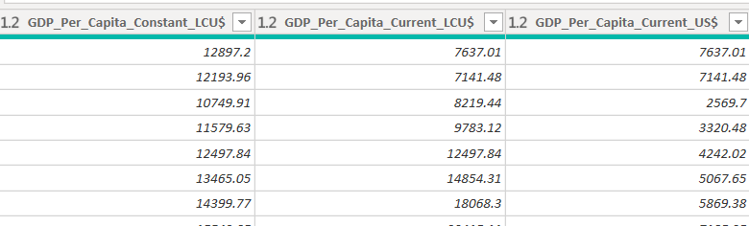

3. Rename the indicators with capital letter
To improve readability and visualization clarity, the values were renamed with capital letter wherever needed.
3.1 Rename
• GDP_per_capita_Constant_LCU
• GDP_per_capita_Current_LCU
3.2 Steps:
Select the columns were rename requires
Go to Transform tab
Click Rename
Do the changes like:
- GDP_Per Capita_Constant_LCU
- GDP_Per_Capita_Current_LCU
- GDP_Per_Capita_Current_US$
- Income_Share_Held_by_Top_10%
- Income_Share_Held_by_Top_20%
- Income_Share_Held_by_Bottom_10%
- Income_Share_Held_by_Bottom_20%
Enter
Click Close & Apply

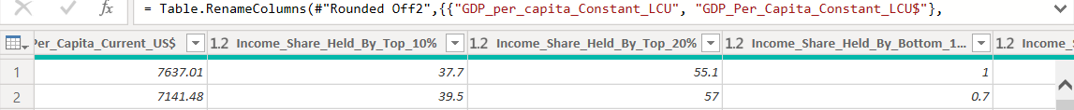

5. Calculated Columns
Calculated columns are created to categorize data and generate new analytical fields that help in better visualization and filtering in the dashboard.
Inequality Level
Inequality Level = IF([gini_index] < 30,"Low",
IF([gini_index] < 45,"Moderate","High"))
Purpose: Categorizes countries into Low, Moderate, and High inequality groups using the Gini Index. This helps compare inequality levels and is used in charts and slicers.

Income Gap 10
Income Gap 10 = [income_share_held_by_top_10%]-[income_share_held_by_bottom_10%]
Purpose: Measures the difference between income share of the richest 10% and poorest 10%. It highlights economic inequality within a country.

Income Gap 20
Income Gap 20 =
[income_share_held_by_top_20%] -[income_share_held_by_bottom_20%]
Purpose: Shows the income difference between the richest 20% and poorest 20%, helping analyze broader inequality patterns.

GDP Category
GDP Category =
IF([GDP_Per_Capita_Current_US$] >= 20000,"High GDP",
IF([GDP_Per_Capita_Current_US$] >= 8000,"Middle GDP","Low GDP"))
Purpose: Classifies countries into Low GDP, Middle GDP, and High GDP groups based on GDP per capita. This grouping is used for donut charts and filtering analysis.

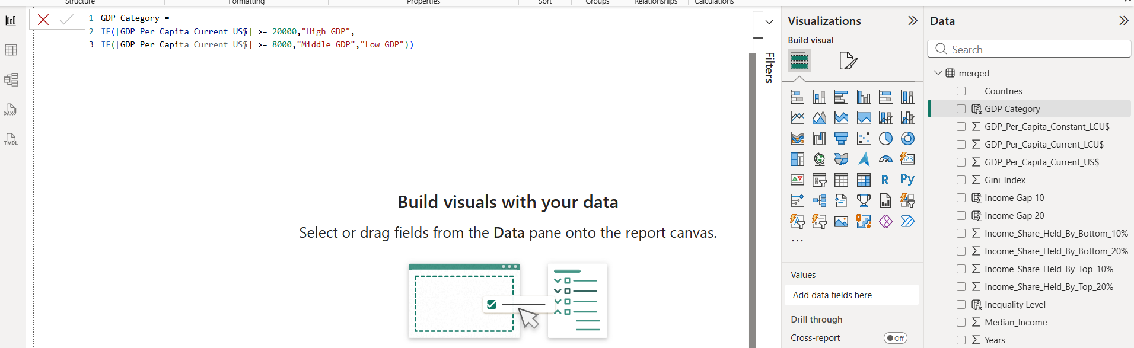

6. Calculated Measures
Avg GDP USD
Avg GDP USD = AVERAGE('Merged'[GDP_Per_Capita_Current_US$])
Purpose: Calculates the average GDP per capita across all countries. Used as a KPI card to represent global economic level.

GDP Growth %
GDP Growth % = VAR CurrentYear = MAX('Merged'[Years])
VAR CurrentGDP =
CALCULATE([Avg GDP USD],'Merged'[Years] = CurrentYear)
VAR PreviousGDP =
CALCULATE([Avg GDP USD],'Merged'[Years] = CurrentYear - 1)
RETURN DIVIDE(CurrentGDP - PreviousGDP,PreviousGDP)
Purpose: Measures the year‑to‑year GDP growth rate, allowing analysis of economic performance over time.

Avg Gini
Avg Gini = AVERAGE('Merged'[gini_index])
Purpose: Shows the average inequality level across all countries.

Avg Median Income
Avg Median Income = AVERAGE('Merged'[median_income])
Purpose: Represents the average income level across countries.

Income Distribution Shift
Income Distribution Shift = AVERAGE('Merged'[income_share_held_by_top_10%]) -
AVERAGE('Merged'[income_share_held_by_bottom_10%])
Purpose: Measures the difference between income held by the richest 10% and poorest 10% to understand inequality movement.
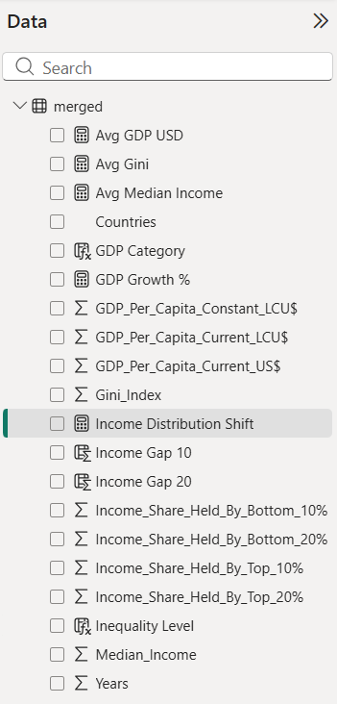

7. Dashboard Design
1. Title
Title: Interactive Analytics Dashboard For Global Income Distribution
2. Global Overview Section (KPIs)
Chart Type: Card

KPI 1 – Average GDP USD
Field: Avg GDP USD

KPI 2 – GDP Growth Rate
Field: GDP Growth %

KPI 3 – Average Gini Index
Field: Avg Gini

KPI 4 – Average Median Income
Field: Avg Median Income
Purpose: KPIs provide quick summary of the global economic condition.
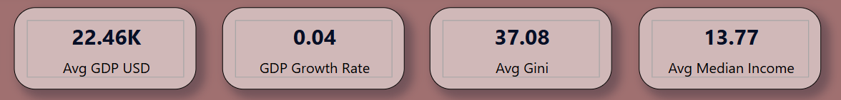
2. Regional Distribution Section
Donut Charts
1. Donut Chart
Chart 1 – GDP Category Distribution
Legend: GDP Category
Values: Country (Count)
Purpose: Shows how many countries fall under High, Middle and Low GDP categories.

2. Donut Chart
Chart 2 – Inequality Level Distribution
Legend: Inequality Level
Values: Country (Count)
Purpose: Shows the distribution of countries by inequality level.
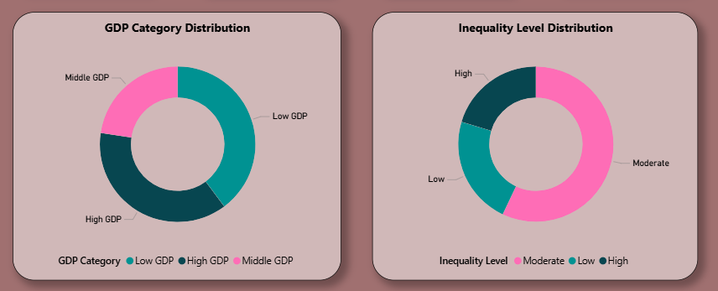
Tree map
Chart Name: Income Concentration by Country
Group: Country
Values: Income_Share_Held_By_Top_10%
Purpose: Shows which countries have the highest income concentration among the richest population.
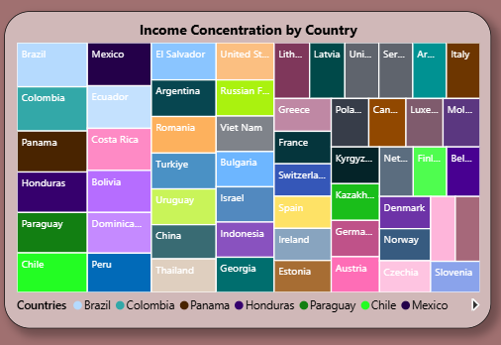
Clustered Bar Chart (Country Comparison)
Chart Name: Country Economic Comparison
Fields
X-axis: Avg GDP USD
Purpose: This chart compares economic performance across countries and helps identify countries with higher GDP per capita.
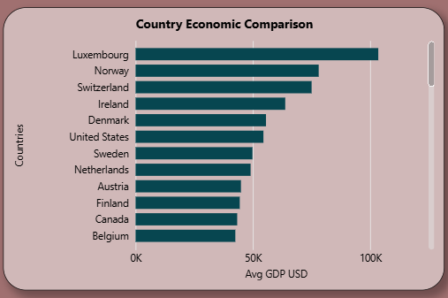
4. Trend Analysis Section
Line Charts
1. Line Charts
Chart 1 – GDP Growth Trend
Axis: Year
Values: Avg GDP USD
Purpose: Shows how GDP changes over time.

2. Line Chart
Chart 2 – Inequality Trend
Axis: Year
Values: Avg Gini
Purpose: Shows whether inequality is increasing or decreasing.
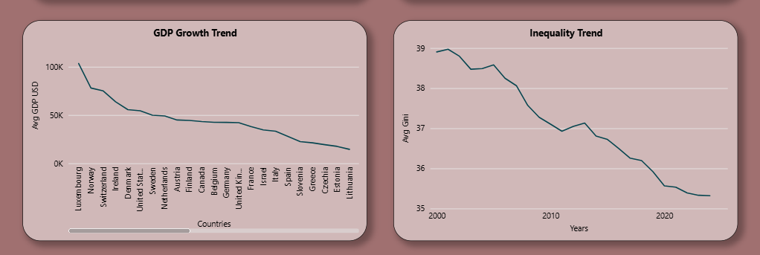
Area Chart
Area Chart – Income Gap Trend
X Axis: Year
Y Axis: Income Gap 20
Purpose: Shows growth of income inequality over time.
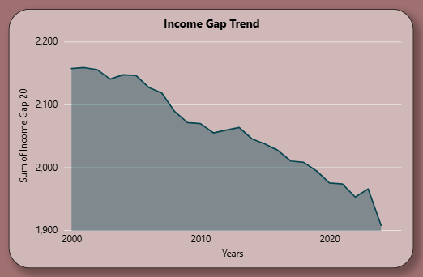
5. Comparative Analysis Section
Gauge Chart
Gauge Chart: GDP Performance Indicator
Value → GDP_Per_Capita_Current_LCU$
Minimum → 0
Maximum → 0
Target Value: GDP_Per_Capita_Current_US$
Purpose: The gauge chart visually represents overall economic performance compared to a maximum benchmark.
It allows viewers to quickly assess whether the average GDP level is low, moderate, or high.
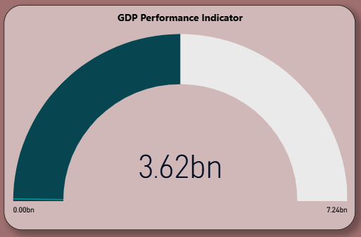

6. Slicers (Dashboard Filters)
Add slicers for interactive filtering.
Slicer 1: Year
Slicer 2: Countries
Slicer 3: GDP Category
Slicer 4: Inequality Level
Purpose: These slicers allow users to filter the dashboard dynamically and analyze specific countries or years.
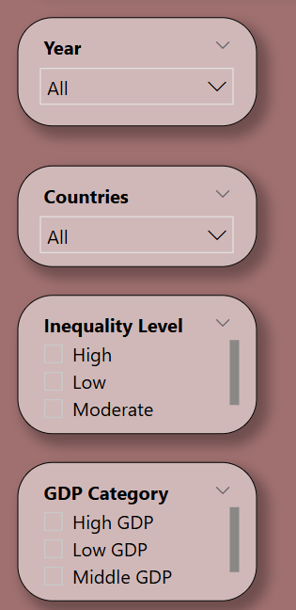
8. Dashboard Styling
1. Canvas Zoom: 100%
2. Canvas Size: Custom
3. Canvas Height: 1890
4. Canvas Width: 1300
5. Background: Hex (#A07070), Red (160), Green (112), Blue (112)
6. Visual background: Hex (#FFFFFF), Red (255), Green (255), Blue (255)
7. Design features:
• Rounded corners
• Shadow effects
• Consistent spacing
• Clear section titles

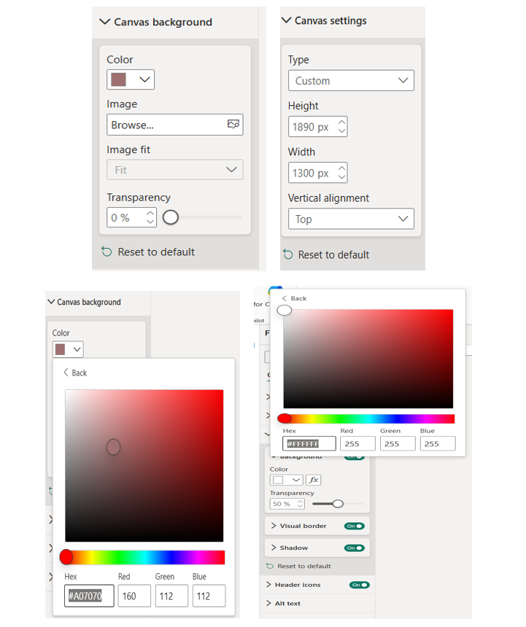
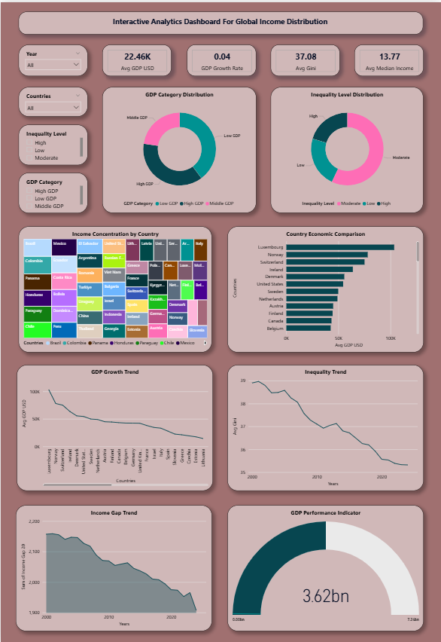
9. Key Considerations During Dashboard Development
- Ensure data cleaning and formatting before creating visuals.
- Round numerical values to improve readability of economic indicators.
- Maintain consistent column naming for easier data modeling.
- Verify DAX formulas when creating calculated columns and measures.
- Choose appropriate chart types to represent economic insights clearly.
- Organize visuals into logical sections for better dashboard structure.
- Use slicers and filters to enable interactive analysis.
- Maintain consistent color themes and formatting across the dashboard.
- Ensure visuals display accurate and meaningful insights from the dataset.

9. Conclusion
The dashboard integrates multiple economic indicators to analyze global economic growth and inequality.
Using calculated columns, DAX measures, and interactive visualizations, users can explore relationships between economic development and income distribution.
The project demonstrates effective use of Power BI for data transformation, modeling, and visualization.

------- Milestone_2_Dashboard_Document_Report_Successfully_Completed -------

