Infosys Springboard
Project Title: Interactive Analytics Dashboard for Global Income Distribution

SHIVANI BHATT
Datasets
Dataset 1: World Bank – World Development Indicators (WDI)
Source
https://databank.worldbank.org/source/world-development-indicators
Global income inequality
Global income inequality refers to the extreme, uneven distribution of income (earnings, capital, and transfers) among the world's population, where a small percentage of individuals or nations hold a disproportionate share of global wealth. It measures disparities in economic, social, and political opportunities across the globe, often using the Gini coefficient to track gaps between the rich and poor.

Data Collection
INDICATOR DESCRIPTION DOCUMENT
Data Source: World Bank Group – World Development Indicators (WDI))
Structure of the Excel File
Countries Covered: 55
• Country Name
• Country Code
• Series Name: Gini Index, Income Share Indicator, Median Income, GDP_Per_Capita
• Series Code
• Annual values from 2000 to 2024
Time Period: 2000–2024 (25 Years)

Indicators
1. Gini Index
The Gini Index measures income inequality within a country on a scale from 0 to 100. A value of 0 represents perfect equality, while 100 represents complete inequality
Source: World Bank – World Development Indicators (WDI)

2. Income Share by Decile
These indicators measure how national income is distributed among different income groups.
This indicator represents the percentage of total national income earned by the richest 10% of the population. A higher percentage indicates stronger income concentration at the top.
This indicator represents the percentage of total national income earned by the richest 20% of the population. A higher percentage indicates stronger income concentration at the top.
This indicator shows the share of total income earned by the poorest 10% of the population. Lower values indicate higher levels of inequality and income vulnerability.
- Income Share Held by Highest 10%
- Income Share Held by Lowest 10%
- Income Share Held by Lowest 20%
- Income Share Held by Highest 20%
Source: World Bank – World Development Indicators (WDI)

4. Median Income
Median income represents the middle income value where half of the population earns below and half earns above this level
• Proportion of People Living Below 50% of Median Income (%)
This indicator measures the percentage of the population earning less than half of the median income. It is widely used as a measure of relative poverty and social inequality.
Source: World Bank – World Development Indicators (WDI)
4. GDP Per Capita
GDP per capita represents the average economic output per person. The constant LCU version reflects real growth (inflation-adjusted), current LCU reflects nominal value, and current US$ allows international comparison
• GDP per Capita (Current LCU)
• GDP per Capita (Constant LCU)
• GDP per Capita (Current US$)
Source: World Bank – World Development Indicators (WDI)
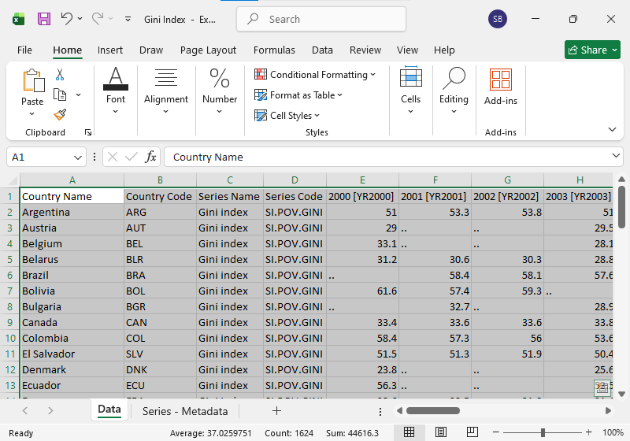

Cleaning
1. Formatting Standardization
Country Name → Countries
'Country Name' was renamed to 'Countries' to simplify naming conventions.
Series Name → Indicators
'Series Name' was renamed to 'Indicators' to clearly represent that the column
Country Code → Removed
Series Code → Removed

Time Period Formatting Standardization
The original World Bank download format displayed years as:
2000 [YR2000], 2001 [YR2001], ..., 2024 [YR2024].
These were reformatted to a simplified and standardized format:
2000, 2001, 2002, ..., 2024. Additionally, the time coverage was standardized and represented as: 2000–2024 (25 Years).
Files Affected by These Changes
All files affected. But it was necessary to make changes to simplify datasets and improve a complete structure like format.
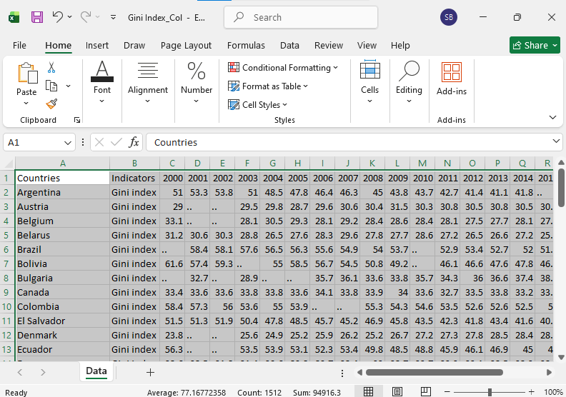

2. Missing Value Handling
Missing values were identified year-wise for each country. Where appropriate, controlled forward filling was applied to maintain continuity in the dataset.
Dataset Renaming and Indicator Separation
To improve structural clarity and simplify transformation, datasets were renamed and separated into individual indicator-based Excel files.

Income Share Indicators were separated into four distinct files:
• top_income10%
• top_income20%
• bottom_income10%
• bottom_income20%
GDP Per Capita indicators were separated into three distinct files:
• GDP_Cur_LCU
• GDP_Con_LCU
• GDP_Cur_US$
The Gini Index and Median Income datasets were also structured into separate clean row-based files.
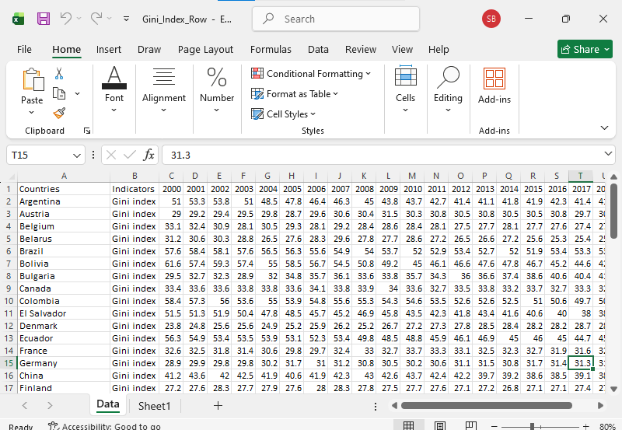

3.Wide to Long Format Transformation Documentation
Transformed all different excel file from wide format into long format with the help of Pivot Table
Structural Change: Wide to Long
Original Wide Format Structure:
Countries | Indicators | 2000 | 2001 | ... | 2024
Transformed Long Format Structure:
Countries | Indicators | Year | Value
Each row in the long format represents one country–year–indicator observation.
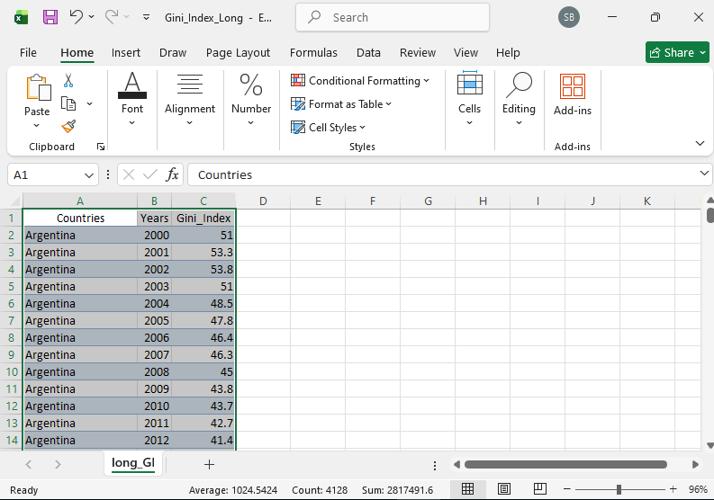

4. Merging of Mastersheet.xlsx
Now merge all the 9 different excel file in 1 excel file and name as mastersheet.xlsx
5. Structure of Final_Merged_File.xlsx
The final merged file contains the following columns:
Countries | Year | Indicators | Value
Each row represents one observation for a specific country, year, and economic or inequality indicator.
The dataset includes:
• 55 Countries
• 25 Years (2000–2024)
• 9 Indicators
• Fully standardized numeric values

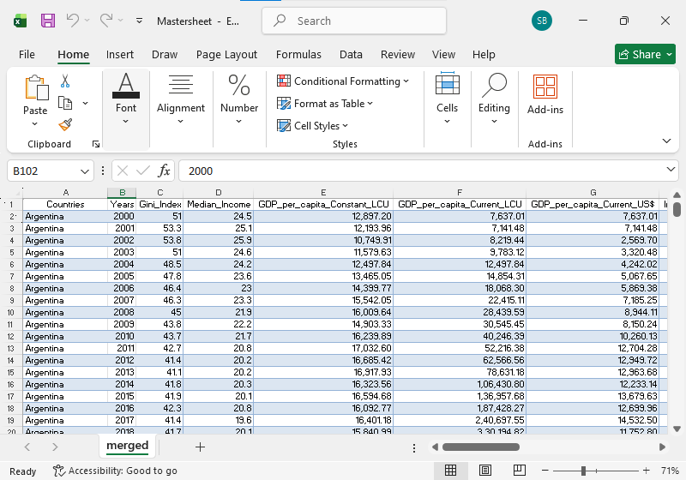

7. Conclusion
The Mastersheet.xlsx marks the completion of the data preparation stage in Milestone 1. By integrating all nine indicator-specific datasets into one structured master dataset, the project achieved full data consistency, validation, and readiness for advanced analytics and interactive dashboard development.

