ITAI-4370: AI for 5G/6G Communications & O-RAN
Course Portfolio — Final Exam Submission
Saima Sano
Professor: Dr. Tawanda Chiyangwa
Summer 2026

Introduction
This portfolio documents my work across all twelve modules of ITAI-4370: AI for 5G/6G Communications & O-RAN. For each module, I summarize the activities I completed (assignments, labs, and hands-on exercises), reflect on what I learned from the experience, and present supporting evidence such as code output, graphs, and tables. Sources for lecture material and any external images are cited at the end of each module section.

Module 1: Telecommunications Fundamentals

Activities
I completed Assignment 1, which covered the definition and scope of telecommunications systems, the transmitter–channel–receiver model, analog vs. digital communication, and how different network topologies (star, mesh, ring, bus) affect performance, reliability, and scalability. I also completed Lab 1, a two-part exercise: Part 1 mapped a TV remote control system onto the transmitter/channel/receiver model, and Part 2 used a Python simulation in Google Colab to model BPSK (Binary Phase-Shift Keying) modulation, transmission through a noisy channel, and demodulation.

Results / What I Learned
Working through Assignment 1 helped me connect abstract telecom concepts to everyday analogies — for example, comparing network topologies to how traffic flows through a city, or comparing a 5G core network to a smart TV replacing a stack of separate cable boxes. The topology comparison (star, mesh, ring, bus) was especially useful for understanding the tradeoffs between performance, reliability, and scalability in real network design.
The Lab 1 simulation was my first hands-on look at how a physical signal actually gets encoded, transmitted, and recovered. Seeing the baseband bits, carrier wave, modulated (BPSK) signal, and the noisy received signal plotted together made it clear that even though the transmitted signal looks completely buried in noise after demodulation, the original bit pattern can still be recovered — which is the whole point of digital communication's noise resilience. I also connected this back to the simple TV remote example from Part 1, since both describe the same source → channel → receiver flow, just at different levels of abstraction.

Evidence
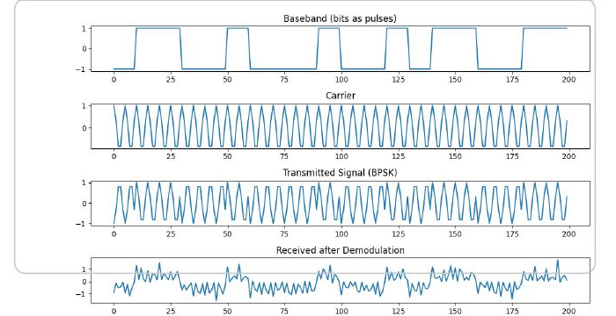
Figure 1.1 — BPSK signal chain: baseband bits, carrier wave, modulated transmission, and the recovered signal after noise and demodulation (Lab 1, Part 2).
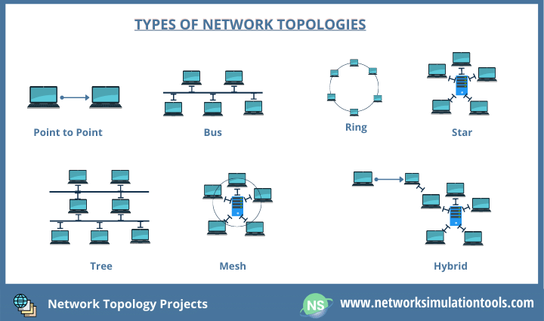
Figure 1.2 — Network topology types referenced in Assignment 1, Question 5 (see source below).

Sources
Chiyangwa, T. (2026). Module 1: Telecom Fundamentals [Lecture slides]. ITAI-4370, Summer 2026.
Network topology diagram: Network Simulation Tools. Network Topology Projects. https://networksimulationtools.com/network-topology-projects/

Module 2: Network Architecture & Wireless Basics

Activities
Assignment 2 asked me to explain the difference between the 4G Evolved Packet Core (EPC) and the 5G Core (5GC), the purpose of network slicing, how Multi-access Edge Computing (MEC) reduces latency, the role of AI in dynamic resource allocation, and the function of the Network Repository Function (NRF) in a 5G Service-Based Architecture. For Lab 2, I wrote a Python script in Colab that calculates and plots Free-Space Path Loss (FSPL) over distance for a 2.4 GHz signal, using the standard FSPL formula.

Results / What I Learned
This module reframed the jump from 4G to 5G as a shift from fixed, dedicated hardware to flexible, software-defined "mini-apps" — similar to replacing a stack of set-top boxes with apps built into a smart TV. Network slicing made much more sense once I pictured it as dedicated lanes on a road (ambulances, delivery trucks, regular traffic) rather than one shared, congested lane for every kind of data. I also came to see MEC as functionally equivalent to opening a local branch of a restaurant instead of shipping every order across the country — the closer the compute resource sits to the user, the less round-trip delay there is.
The FSPL lab gave me a concrete, quantitative view of something the lecture discussed conceptually: signal strength doesn't just fade — it fades logarithmically with distance, which is why the loss curve is steep at short range and flattens out at longer distances. That shape directly explains why cell tower placement and spacing matters so much in real network planning.

Evidence
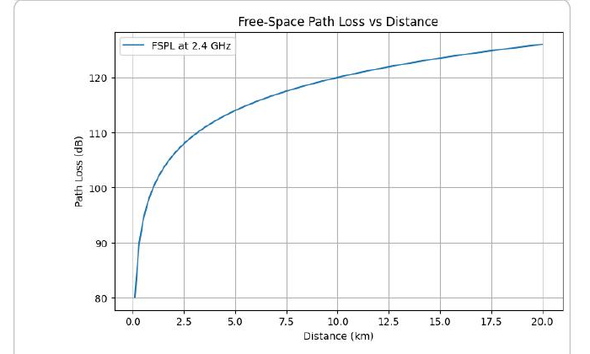
Figure 2.1 — Free-Space Path Loss vs. distance at 2.4 GHz, generated in Lab 2. Path loss increases sharply at short range and levels off at longer distances, consistent with the logarithmic FSPL formula.

Sources
Chiyangwa, T. (2026). Module 2: Network Architecture & Wireless Basics [Lecture slides]. ITAI-4370, Summer 2026.

Module 3: AI and Machine Learning Fundamentals for Telecommunications

Activities
Assignment 3 covered how AI/ML improves radio resource management and reliability in Open RAN, how Self-Organizing Networks (SON) achieve self-optimization and self-healing, why normalizing user demand matters in resource allocation simulations, the differences between traditional RAN and Open RAN, and the distinct roles of the Near-RT RIC and Non-RT RIC. For Lab 3, I built a Random Forest regression model in Python to predict synthetic telecom network traffic (Gbps) from time-based features (hour, day of week, lag values, rolling averages), and evaluated it using MSE and R². I also worked through three additional applied exercises: 3.1 (network traffic prediction with Random Forest), 3.2 (network anomaly detection comparing Isolation Forest and DBSCAN), and 3.3 (customer segmentation using K-Means clustering with silhouette score selection and PCA visualization).

Results / What I Learned
The normalization question in Assignment 3 was a good concrete example of a concept that's easy to state abstractly but easy to misunderstand in practice: without scaling user demand into a common range, a scheduler could end up starving low-demand users while over-serving high-demand ones. I used the analogy of a teacher dividing colored pencils fairly among students based on proportional need rather than who asks the loudest, which mapped directly onto how a RIC scheduler allocates physical resource blocks (PRBs) across connected devices.
Comparing traditional RAN to Open RAN also clarified why vendor interoperability matters: traditional RAN behaves like a closed gaming console ecosystem, while Open RAN's standardized interfaces (O1, E2, A1) act like a common language that lets equipment from different vendors work together, similar to how PC components from different manufacturers can be mixed and matched.
The Lab 3 traffic-prediction model showed me firsthand how a Random Forest can pick up daily and weekly traffic cycles (business-hours boosts, weekday vs. weekend patterns) directly from lag and rolling-average features, without being told the underlying schedule explicitly. Extending that into anomaly detection (Exercise 3.2) and customer segmentation (Exercise 3.3) showed how the same core ML toolkit — supervised learning, unsupervised clustering, and outlier detection — applies to very different telecom operations problems: forecasting, security, and marketing/customer strategy.

Evidence
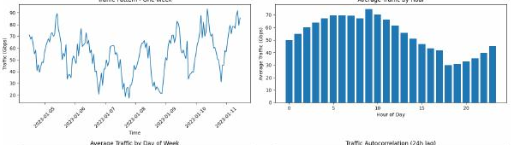
Figure 3.1 — Simulated hourly telecom traffic over one week (Lab 3), showing the daily/weekly cyclical pattern the Random Forest model learned to predict.
Lab 3.3 (Customer Segmentation) used silhouette scores to select the optimal number of K-Means clusters, then visualized customer segments (heavy data users, talkers, texters, low-usage) in 2D using PCA — connecting unsupervised clustering to a practical customer-strategy use case.

Sources
Chiyangwa, T. (2026). Module 3: AI and Machine Learning Fundamentals for Telecommunications [Lecture slides]. ITAI-4370, Summer 2026.

Module 4: 5G Network Architecture and AI Integration

Activities
For this module I completed the Hands-On Lab on 5G architecture modeling in Python. The exercise modeled three network slice types — URLLC (ultra-reliable low-latency), eMBB (enhanced mobile broadband), and mMTC (massive machine-type communications) — each with different simulated bandwidth demand and connection counts, then applied a simple AI-inspired proportional allocation algorithm (weighted by slice priority) to distribute a fixed pool of network resources across the three slices, and visualized the resulting allocation.

Results / What I Learned
This exercise made network slicing tangible in a way the lecture's real-world examples (hospitals, stadiums, self-driving cars) didn't fully capture on their own. Seeing the weighted-priority allocation algorithm in code — where URLLC's weight of 3 meant it received a proportionally larger share of the fixed 500-unit resource pool even with fewer total connections than mMTC — showed exactly how a network can guarantee low latency for critical traffic without simply giving every slice an equal share. It reinforced that "AI-driven resource allocation" in 5G isn't magic — at its core, it's a demand-weighted optimization problem, and the intelligence comes from how well the weights and priorities reflect real QoS requirements.

Sources
Chiyangwa, T. (2026). Module 4: 5G Network Architecture and AI Integration [Lecture slides]. ITAI-4370, Summer 2026.

Module 5: Open RAN (O-RAN) and AI-Driven Networks

Activities
For Lab 5, I built and compared four versions of a neural network classifier for an IoT sensor-state classification task: a full-precision baseline ("cloud") model, a pruned model with fewer/smaller layers, an INT8-quantized model (converted via TensorFlow Lite), and a distilled "student" model trained from the baseline "teacher's" soft predictions. I measured and compared each version's accuracy, inference time, model size, and parameter count, then used the results to make edge-deployment recommendations for three device classes: microcontrollers, edge gateways, and edge servers.

Results / What I Learned
The lecture's discussion of Open RAN's Near-RT RIC and the general push toward "intelligence at the edge" became much more concrete once I saw the actual accuracy/size/speed tradeoffs in the lab. The quantized model kept 93.4% accuracy (vs. 94.4% baseline) while shrinking from about 51 KB to about 22 KB, and the distilled model shrank all the way to about 4.9 KB with a somewhat larger accuracy drop (to 90.2%). That gave me a real feel for why compression technique choice depends on the deployment target: a battery-powered microcontroller needs the smallest possible footprint and can tolerate the quantized model's slight accuracy cost, while an edge server has enough headroom to just run the full baseline model.
This connected directly to the RAN Intelligent Controller (RIC) concepts from the lecture — Near-RT RIC applications need to run inference in near-real time on constrained hardware, so the same compression tradeoffs studied in this lab (pruning, quantization, distillation) are exactly the kind of engineering decisions that would go into deploying an AI-based xApp at the RAN edge.

Evidence
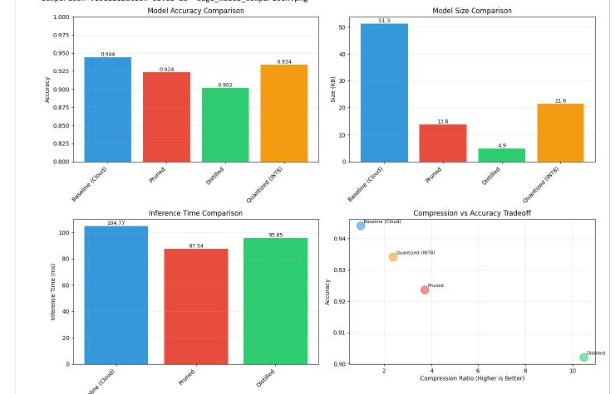
Figure 5.1 — Accuracy, model size, inference time, and compression-vs-accuracy tradeoff across the baseline, pruned, distilled, and quantized (INT8) models (Lab 5).

Sources
Chiyangwa, T. (2026). Module 5: Open RAN (ORAN) and AI-Driven Networks [Lecture slides]. ITAI-4370, Summer 2026.

Module 6: AI for Network Optimization and Management

Activities
For this module I completed Lab 4 (relocated here from its original folder location, since its content — time-series network traffic forecasting — matches this module's focus on AI-driven network optimization). In this lab, I generated a full year of synthetic hourly network traffic data with daily, weekly, and seasonal patterns plus random congestion spikes, then built and compared three forecasting approaches: an ARIMA(2,1,2) statistical model, a Linear Regression model with engineered time-based and lag features, and a two-layer LSTM neural network trained on 24-hour lookback windows.

Results / What I Learned
Comparing all three models side by side was the most valuable part of this lab. The ARIMA model essentially converged toward the series mean on the test set (RMSE ≈ 51.0) and visibly failed to track the daily oscillation once the forecast horizon got long, which matches the closed-loop "Analyze → Decide → Act" framing from the lecture — a model that can't track short-term traffic swings isn't useful for real-time network operations. The engineered-feature Linear Regression model, by contrast, had access to lag and rolling-average features that essentially handed it the recent trend directly, which is why it fit the test set almost perfectly. The LSTM model, trained purely on the raw sequence with no manual feature engineering, still reached R² ≈ 0.893 (RMSE ≈ 15.4) by learning the daily/weekly cycle from the 24-hour lookback window on its own.
This gave me a much clearer sense of the real tradeoff behind "AI for network optimization": simpler statistical models are fast and interpretable but can miss short-term dynamics, hand-engineered features can produce very strong fits but require domain knowledge to design, and sequence models like LSTM can learn temporal patterns automatically at the cost of more training time and less interpretability. In a closed-loop network-operations system, the choice of forecasting model directly affects how well the "Decide" and "Act" stages can respond to real traffic conditions.

Evidence
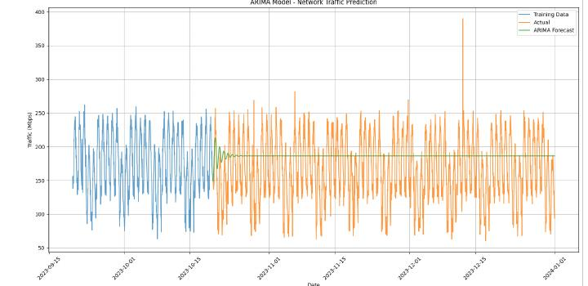
Figure 6.1 — ARIMA(2,1,2) forecast vs. actual traffic. The forecast flattens toward the mean and fails to track the daily oscillation over a long horizon (RMSE ≈ 51.0).
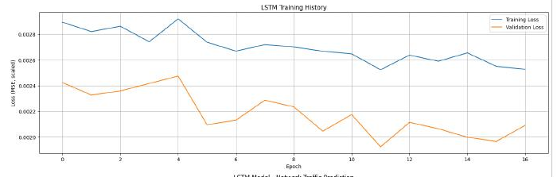
Figure 6.2 — LSTM training vs. validation loss over 16 epochs (early stopping), which achieved R² ≈ 0.893 on the held-out test set.
Model comparison summary:
Model | RMSE | R² | Notes
ARIMA(2,1,2) | 51.03 | — | Converges toward the mean; misses daily cycle at longer horizons
Linear Regression (engineered features) | ~0.0 | 1.0000 | Lag/rolling features made the target near-trivial to fit
LSTM (24h lookback) | 15.35 | 0.8931 | Learned daily/weekly cycle directly from raw sequence

Sources
Chiyangwa, T. (2026). Module 6: AI for Network Optimization and Management [Lecture slides]. ITAI-4370, Summer 2026.

Module 7: IoT and Edge Computing with AI

Activities
No separate lab or written assignment was assigned for this module. I reviewed the lecture material, which covered massive IoT vs. critical IoT, IoT device management, edge AI architectures, real-time decision making, and edge–cloud collaboration.

Results / What I Learned
This module extended the edge-computing and model-compression ideas from Module 5 into the broader IoT context, distinguishing between massive IoT (many low-power, low-data devices) and critical IoT (fewer devices with strict latency/reliability requirements). The edge–cloud collaboration model reinforced why not every inference needs to happen at the edge — the right split depends on latency needs, device constraints, and how time-sensitive the decision is.

Sources
Chiyangwa, T. (2026). Module 7: IoT and Edge Computing with AI [Lecture slides]. ITAI-4370, Summer 2026.

Module 8: Cybersecurity and AI in Telecommunications

Activities
No separate lab or written assignment was assigned for this module. I reviewed the lecture material, which covered traditional network threats, 5G/6G architecture security challenges, and emerging 6G security issues.

Results / What I Learned
This module highlighted that expanding network intelligence and openness (as in Open RAN) also expands the attack surface — more open interfaces and more AI-driven decision points mean more potential points of failure or exploitation. It reframed AI's role in telecom security as double-sided: AI can detect anomalies and threats faster than manual monitoring, but AI-driven network functions themselves need to be secured against manipulation.

Sources
Chiyangwa, T. (2026). Module 8: Cybersecurity and AI in Telecommunications [Lecture slides]. ITAI-4370, Summer 2026.

Module 9: Sustainable AI and Green Communications

Activities
No separate lab or written assignment was assigned for this module. I reviewed the lecture material, which covered energy efficiency metrics, sustainable network design, renewable energy integration, and the circular economy in telecom.

Results / What I Learned
This module connected directly back to the resource-allocation and model-compression labs earlier in the course — a smaller, more efficient model (like the pruned/quantized models from Lab 5) isn't just useful for constrained edge devices, it's also more energy-efficient at scale. It reframed "AI for network optimization" as having a sustainability dimension, not just a performance one.

Sources
Chiyangwa, T. (2026). Module 9: Sustainable AI and Green Communications [Lecture slides]. ITAI-4370, Summer 2026.

Module 10: Advanced AI Applications in Next-Generation Networks

Activities
No separate lab or written assignment was assigned for this module. I reviewed the lecture material, which covered digital twins for network infrastructure, AI-enhanced network slicing, cognitive radio/spectrum management, and the intersection of AI with blockchain and quantum computing.

Results / What I Learned
The digital twin concept stood out as a natural extension of the forecasting work from Module 6 — instead of just predicting a single traffic metric, a digital twin simulates the whole network's behavior so operators can test "what-if" changes before deploying them live. This module also showed how the network-slicing concepts from Module 4 evolve further once AI is used to adjust slice parameters dynamically rather than allocating them once and leaving them fixed.

Sources
Chiyangwa, T. (2026). Module 10: Advanced AI Applications in Next-Generation Networks [Lecture slides]. ITAI-4370, Summer 2026.

Module 11: 6G Vision and AI-Native Networks

Activities
No separate lab or written assignment was assigned for this module. I reviewed the lecture material, which covered 6G requirements and KPIs, AI-native network architecture, terahertz communications, and massive connectivity with satellite integration.

Results / What I Learned
This module was useful for seeing where the RAN Intelligent Controller and Open RAN concepts from Module 5 are headed: rather than AI being bolted onto an existing network architecture, 6G is being designed with AI as a core, built-in network function from the start. The terahertz spectrum and massive connectivity discussion also showed how much further the FSPL and resource-allocation tradeoffs from Modules 2 and 4 will need to scale.

Sources
Chiyangwa, T. (2026). Module 11: 6G Vision and AI-Native Networks [Lecture slides]. ITAI-4370, Summer 2026.

Module 12: Ethical AI and Future Trends

Activities
This module's lecture covered the foundations of ethical AI, including why AI ethics matters in telecommunications, common ethical challenges, sources of bias in AI systems, and privacy concerns raised by AI-driven networks.
Note: Assignment 4 is associated with this module but has not yet been completed. This section will be updated with a summary of that assignment once it is finished.

Results / What I Learned
This module tied together a thread that ran through the whole course: every AI system studied earlier — resource allocation (Module 4), edge model compression (Module 5), traffic forecasting (Module 6), and network security (Module 8) — involves tradeoffs and judgment calls that have ethical weight. A biased or opaque anomaly-detection model (Module 3) could unfairly flag certain users' traffic as suspicious; a resource-allocation scheme (Modules 2 and 4) that isn't carefully designed could systematically under-serve certain customer segments. This module reinforced that ethical review isn't a separate final step — it needs to be part of how each of these systems is designed from the start.

Sources
Chiyangwa, T. (2026). Module 13: Ethical AI and Future Trends [Lecture slides]. ITAI-4370, Summer 2026.

