Saima Sano
ITAI-4370 AI for 5/6G Comm & ORAN
Professor: Dr. Tawanda Chiyangwa
Summer 2026

Question 1
What is the definition of a telecommunications system, and what is its primary scope in modern communication?
A telecommunications system refers to any type of system that enables individuals to transmit information such as written messages, audio, or visual information through technological devices.
Primary Scope: The primary scope of this system today entails connecting the entire world with several types of communication. For instance, it is used in text messaging, talking on the phone, video gaming, and even surfing on the internet.

Question 2
Explain the basic components of a communication system and describe the role of each: transmitter, channel, and receiver.
A communication system is like a person sending a letter via mail. There are three components that make the process possible:
- Transmitter (The Sender): A transmitter refers to the part of the process where the sender converts the message into a form of signal for transmission.
- Channel (The Pathway): These refer to the pathways along which the messages travel from one point to another. They include both wired paths like fiber-optic cables and wireless paths like Wi-Fi.
- Receiver (The Receiver): This component receives the transmitted signal and converts it back to an understandable message to the recipient.

Question 3
Differentiate between analog and digital communication systems. What are the key performance metrics used to evaluate them (e.g., bandwidth, noise, latency)?
Analogue: Transfers information by use of a wave form which is continuous in nature (like the hands on a traditional clock or a vinyl record). It is prone to picking up static and noise along the way.
Digital: Codes the information using bits (which can only be 1 or 0). This makes transmission clear, with little chance of distortion.
Key Metrics to Measure Them:
- Bandwidth: The amount of information that can flow through the pathway simultaneously (like the number of lanes on a highway).
- Noise: Disturbance in transmission, usually in the form of static (like the whispers from your classmates while trying to pay attention in class).
- Latency: Delay in communication from when information is sent until it is received (like when there is a noticeable lag during an international video chat).

Question 4
Describe the main types of communication (voice, data, video, multimedia) and explain how network topology and system architecture influence their transmission.
Different forms of data require different types of care:
- Voice and Video: Needs to be transmitted promptly without any delays to minimize lag experienced during voice calls.
- Data (texts and files): Can take a little extra time, provided it is transmitted accurately.
- Multimedia: A blend of all above forms at once (like YouTube video with accompanying text messages).

Question 5
How do different network topologies (such as star, mesh, ring, and bus) impact the performance, reliability, and scalability of a communication system?
Topology | How it looks | Performance | Reliability | Scalability (Growing)
Star | All devices connect to one central hub. | Fast, because everything goes straight to the center. | Okay. If one computer breaks, the rest work. If the center breaks, everything goes down. | Very easy to plug in a new device.
Mesh | Every single device is connected to every other device. | Super-fast with multiple pathways. | Excellent. If one path breaks, the data just takes a different street. | Hard and expensive to add new devices because of all the extra wires.
Ring | Devices are connected in a circle; data goes around in one direction. | Slower, because data must pass through neighbors to get to the destination. | Bad. If one computer breaks, the whole circle stops working. | Medium difficulty to grow.
Bus | Devices line up along a single main wire. | Slows down heavily if too many devices are talking at once. | Bad. If the main wire breaks, the whole network splits and fails. | It is easy to connect a new device along the line but degrades performance.
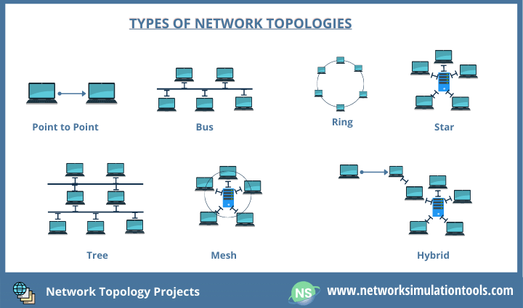

Work Cited:
The image is from https://networksimulationtools.com/network-topology-projects/.

