Experiment 9
Title
Student Processing System using Zoho Creator (SaaS)
Aim
To create a simple cloud-based Student Processing System using Zoho Creator, a SaaS platform, for collecting, processing, monitoring and reporting student information.
Dashboard:
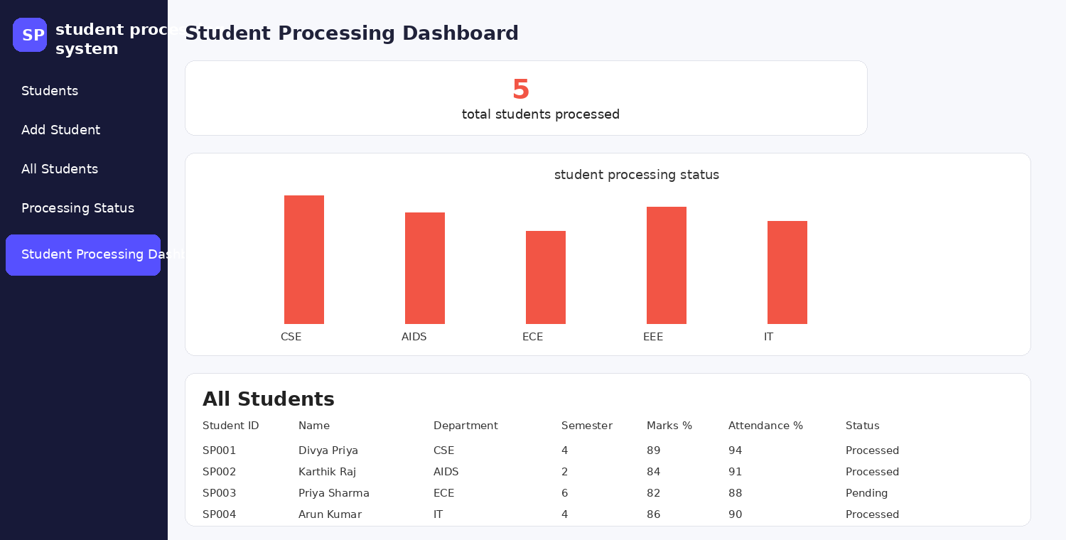
Report:
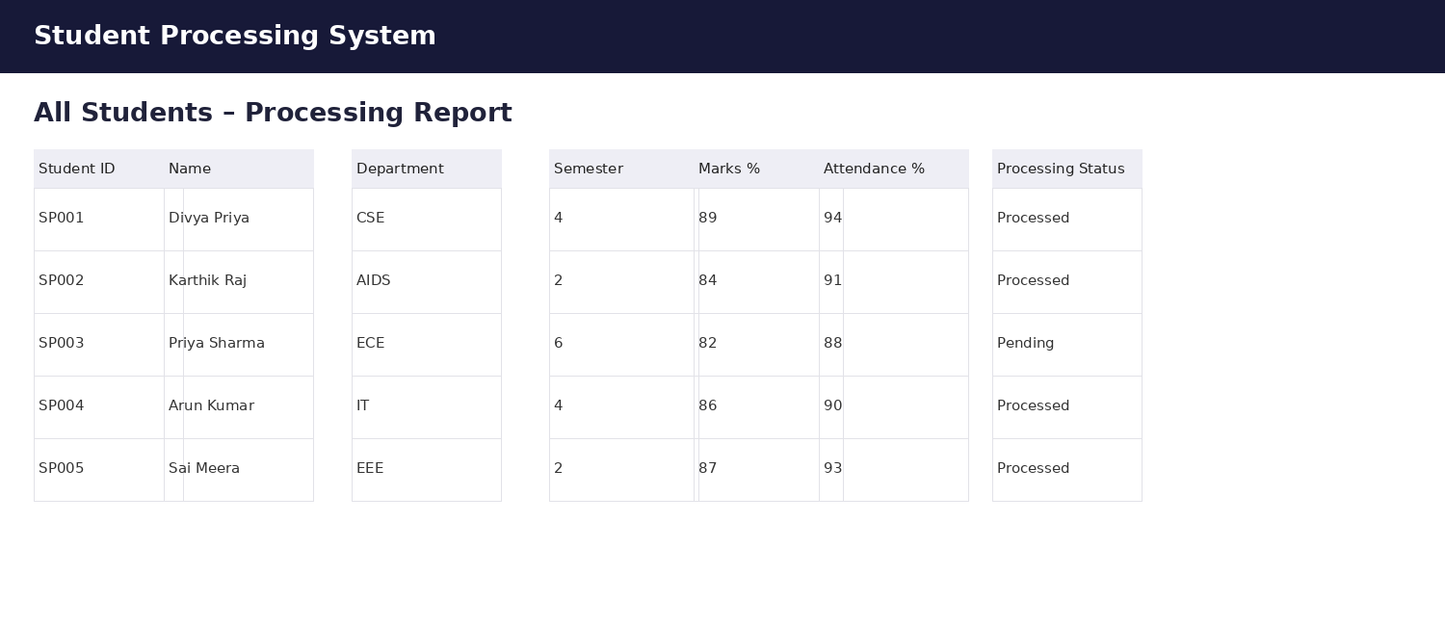
Form:


