Domain-Driven Screen & Systems Architecture
Architecture Playbook for React Native
Author: Saim · Internal Engineering Document
CORE ARCHITECTURAL LAYERS
providers/ | Root context wrappers, Redux provider & native hardware bootstrap
navigation/ | Declarative routing stacks, auth-conditional switches & type contracts
screens/ | Domain-driven screen journeys, sub-pages & encapsulated domain components
store/ | RTK Query server caching, mutex token refresh, MMKV & Keychain
shared/ | Universal atoms, molecules, layout wrappers & responsive scaling utils

PART I: Current Boilerplate Setup & State Engineering
1. Unified Dependency Installation & Purpose
When establishing the foundation of this enterprise boilerplate, every single dependency was deliberately chosen to eliminate concrete mobile failure modes rather than relying on bloated, redundant, or unmaintained packages. We avoid piecemeal installations; the entire runtime and tooling engine is initialized via a single unified command set.
Single Installation Command:
# Production Runtime Dependencies
npm install @reduxjs/toolkit react-redux redux-persist react-native-mmkv react-native-keychain @react-navigation/native @react-navigation/native-stack @react-navigation/bottom-tabs react-native-screens react-native-safe-area-context react-native-gesture-handler react-native-config@1.7.2 react-native-size-matters@0.4.2 react-native-vector-icons@10.3.0 react-native-reanimated react-native-keyboard-controller react-native-bootsplash zod i18next react-i18next
# Development & Compiler Tooling
npm install -D babel-plugin-module-resolver @types/react-native-vector-icons@6.4.18
Below is the architectural breakdown mapping each installed package to the exact mobile failure mode it eliminates:
CATEGORY & LIBRARIES | ARCHITECTURAL RATIONALE & FAILURE MODE ELIMINATED
State Management & Server Cache  @reduxjs/toolkit, react-redux, redux-persist | Eliminates manual fetch waterfalls, race conditions, and unorganized component state. RTK Query provides normalized declarative caching and deduplication, while Redux Persist rehydrates critical client state across cold app restarts.
High-Performance & Secure Storage  react-native-mmkv, react-native-keychain | Replaces legacy AsyncStorage (which blocks the asynchronous bridge with slow JSON serialization) with C++ memory-mapped MMKV (up to 30x faster synchronous I/O). react-native-keychain isolates authentication tokens inside Apple Secure Enclave & Android Keystore hardware vaults.
Native View Navigation & Gestures  @react-navigation/*, react-native-screens, react-native-safe-area-context, react-native-gesture-handler | Delegates view hierarchy transitions directly to native OS controllers (UINavigationController, FragmentTransaction). react-native-screens unloads dormant views to prevent Out-Of-Memory crashes, and safe-area-context calculates hardware cutouts and insets accurately.
Responsive Geometry & Vector Icons  react-native-size-matters, react-native-vector-icons | Solves viewport distortion across small phones and tablets using moderate mathematical scaling (ms, scale, vs with factor 0.3). Bundles scalable TrueType vector glyphs directly without heavy raster bitmaps or pixelation.
UI Polish & Native Elevation  react-native-reanimated, react-native-keyboard-controller, react-native-bootsplash | Executes 60/120 FPS animations on dedicated UI worklet threads. keyboard-controller synchronizes viewport frames smoothly with software keyboards to eliminate layout clipping, and bootsplash locks the native splash window to avoid blank white launch flashes.
Validation, Flavors & Internationalization  zod, react-native-config, i18next, react-i18next | Zod guarantees runtime contract validation with inferred compile-time TypeScript types. react-native-config binds native Gradle/Xcode environment flavors into runtime JS constants, and i18next manages scalable multi-language localization namespaces.

2. The 5 Folders in src/ (What Lives in Each)
The application source directory (src/) is structured into exactly five purposeful folders. Every piece of code in the project lives in one of these five locations based on its architectural responsibility. Below is the structural overview followed by a deep tour of what lives in each folder.
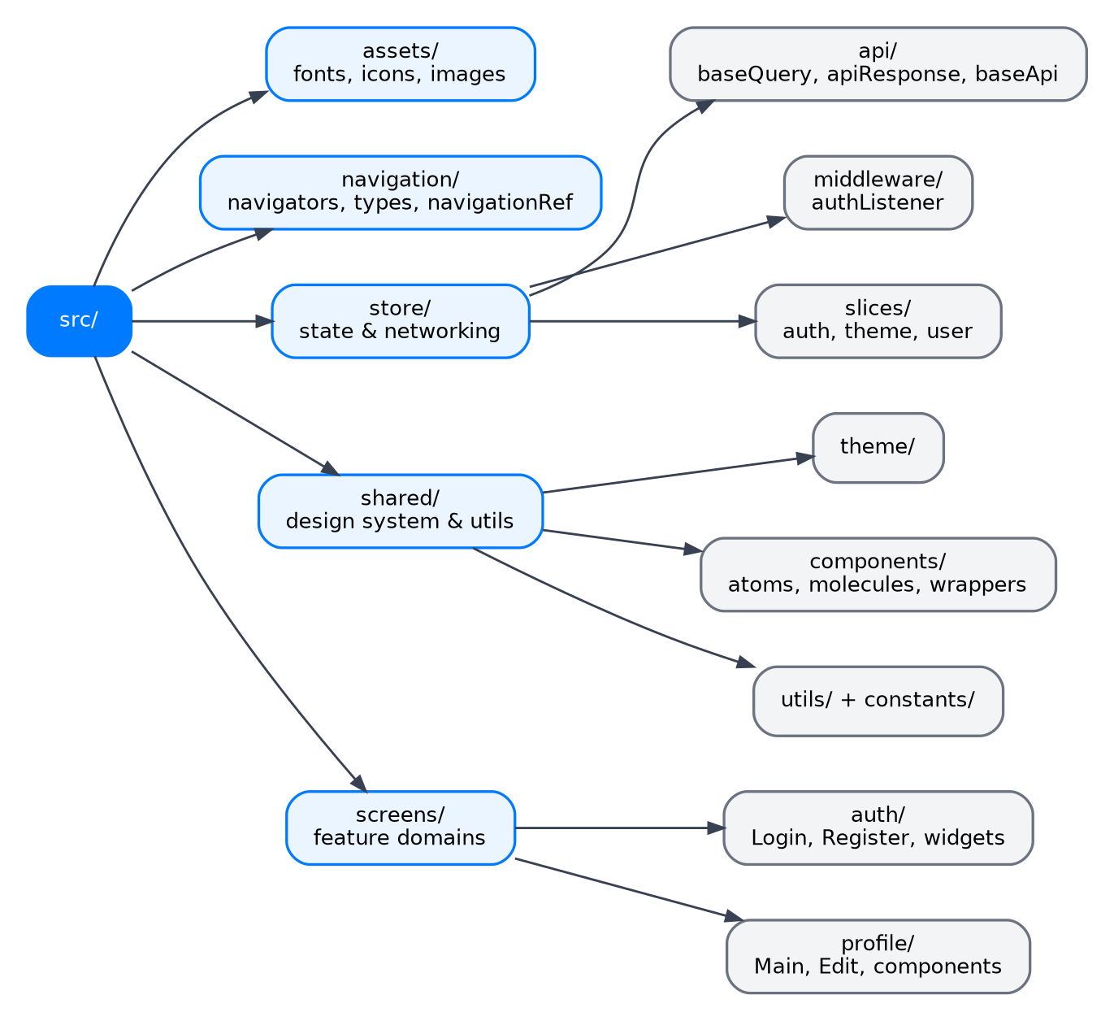
Figure 1.1 — Structural Map of the src/ directory and Layer Boundaries
1. src/providers/ & App.tsx — App Root Configuration & Context Wiring
• Composition Root: App.tsx contains exactly 13 lines of code. It owns zero UI screens and zero business logic. Its sole purpose is mounting <AppProviders> and rendering <RootNavigator />.
• AppProviders.tsx: The single wrapper tree managing Redux <Provider>, <PersistGate> (for rehydrating state), <ThemeProvider>, <SafeAreaProvider>, <GestureHandlerRootView>, and <KeyboardProvider>.
• bootstrapAuth.ts: Executes during native splash screen display to inspect hardware Keychain for active authentication tokens before the navigation tree mounts.
2. src/navigation/ — Declarative Routing & Flow Control
• root/ (RootNavigator.tsx): The conditional auth-switch root. Automatically mounts AuthNavigator when isAuthenticated is false, or MainNavigator (App Tabs) when true.
• auth/ (AuthNavigator.tsx): Pre-authentication native stack managing onboarding and credentials entry (LoginScreen, SignupScreen).
• main/ (MainNavigator.tsx): Post-authentication bottom tab bar and nested domain feature stacks (Home, Profile, Settings).
• navigationService.ts: Centralized imperative navigation service ref. Enables middleware and background services to dispatch route changes without coupling React hooks or components.
• types.ts: Single source of truth for all navigation contracts. Declares RootStackParamList, AuthStackParamList, and TabParamList to guarantee compile-time type safety across route params.
3. src/store/ — State Machine, Caching & Hardware Vault
• storage/ (mmkv.ts & keychain.ts): Partitioned storage engines: mmkv.ts provides high-speed synchronous key-value storage for Redux Persist (theme, UI flags). keychain.ts wraps Apple Secure Enclave & Android Keystore to isolate JWT tokens.
• api/ (baseApi.ts & baseQuery.ts): RTK Query networking hub. baseQuery.ts dynamically attaches Bearer tokens from Keychain, guards against token refresh race conditions via a concurrency mutex lock, and normalizes server responses.
• slices/: Synchronous client-side Redux slices (authSlice.ts, themeSlice.ts) managing UI state and authentication flags.
• middlewares/ (authListener.ts): Centralized event listener middleware. Intercepts logoutUser and sessionExpired actions to wipe hardware tokens and reset navigation cleanly without UI component involvement.
4. src/shared/ — Universal Design System & Infrastructure
src/shared/ is the single home for generic, domain-agnostic primitives. Nothing inside shared knows about any specific feature domain (it does not know what a "User Profile", "Feed", or "Order" is). Below is the exact breakdown of every subfolder inside shared:
SHARED SUBFOLDER | EXACT PURPOSE & ARCHITECTURAL ROLE
components/layouts/ | Non-negotiable screen containers. Includes ScreenWrapper.tsx (safe-area insets, status-bar theme) and KeyboardScreenWrapper.tsx (software keyboard handling via react-native-keyboard-controller). Raw <View> is prohibited as a screen root.
components/atoms/ | Fundamental, indestructible UI primitives with zero domain logic: AppButton.tsx, AppInput.tsx (with leading/trailing icons and password visibility toggling), Icon.tsx (vector font glyphs), and Typography.tsx.
components/molecules/ | Composite UI controls combining multiple atoms that remain strictly domain-agnostic: HeaderBar.tsx, SearchBar.tsx, and PopupCard.tsx.
components/widgets/ | Self-contained, interactive sub-flows reusable across multiple screens (e.g. OtpVerificationWidget.tsx) taking decoupled callback props (onSuccess, onCancel).
theme/ | Design system tokens and responsive geometry: colors.ts (semantic palette), typography.ts, spacing.ts, and scaling.ts (moderate scale ms, vs, scale with factor 0.3).
constants/ | Application-wide immutable dictionaries: routes.ts (AUTH_ROUTES, MAIN_ROUTES), api.ts, storageKeys.ts, translationKeys.ts, and validationLimits.ts.
hooks/ | Cross-cutting universal hooks used throughout the application: useTheme.ts (dynamic theme switching) and useToast.ts (triggering global feedback messages).
lib/ | Infrastructure utility libraries: errors/ for standardizing API error normalization and forms/ for form helper utilities.
translations/ & config/ | translations/ manages the i18next engine and language JSON dictionaries. config/ (env.ts) validates runtime environment variables loaded from react-native-config.
utils/ | Low-level device utilities: mmkv/ for fast local storage operations and secureStorage/ for hardware-encrypted token operations.
5. src/screens/ — Domain-Driven Presentation Layer & "Thin Screen" Principle
Screens in this codebase are organized by business domain rather than technical type (e.g. auth/, profile/, home/, settings/, common/). Inside each domain, we enforce a strict 3-tier encapsulation pattern that keeps the main screen component completely thin, readable, and free of sprawling state logic.
• <domain>/components/: Domain-Shared Components: Components used by two or more screens within this domain (e.g. AuthHeader.tsx and AuthFooterLink.tsx in auth/components/ are shared by both Login and Signup; ProfileAvatar.tsx in profile/components/ is shared by both Main and Edit). This prevents creating duplicate copies without polluting the global shared/ folder.
• <domain>/<screen>/components/: Page-Only Components: Presentation components used exclusively by one screen live directly inside that screen’s local components/ folder (e.g. ProfileFeedList.tsx inside profile/main/components/). If only one screen cares about it, it never leaks into the domain root.
• <domain>/<screen>/hooks/: Page-Level Hooks (The Thin Screen Secret): Every screen extracts its form state, validation, RTK Query mutation triggers, and submission lifecycle into a dedicated custom hook (e.g. useLogin.ts, useProfile.ts).
• <domain>/<screen>/<ScreenName>.tsx: The Thin Screen File: A pure composition shell. It calls the page hook to get reactive state, wraps the view in a layout container, and maps state to UI components. It contains zero raw API calls, zero manual validation parsing, and zero complex business logic.
Code in Action: How useLogin() Makes LoginScreen.tsx Thin
Notice how LoginScreen.tsx in our codebase reads like a pure layout blueprint because all state orchestration is extracted into useLogin.ts:
// src/screens/auth/login/LoginScreen.tsx (Thin Presentation Component)
export const LoginScreen: React.FC = () => {
const { t } = useTranslation();
const { email, setEmail, password, setPassword, errors, isSubmitting, handleLogin } = useLogin();
return (
<KeyboardScreenWrapper contentContainerStyle={styles.container}>
<AuthHeader title={t(TRANSLATION_KEYS.COMMON_WELCOME)} subtitle={t(TRANSLATION_KEYS.AUTH_LOGIN_SUBTITLE)} />
<View style={styles.form}>
<AppInput label={t(TRANSLATION_KEYS.AUTH_EMAIL)} value={email} onChangeText={setEmail} errorMessage={errors.email} />
<AppInput label={t(TRANSLATION_KEYS.AUTH_PASSWORD)} value={password} onChangeText={setPassword} isPassword errorMessage={errors.password} />
<AppButton title={t(TRANSLATION_KEYS.AUTH_LOGIN)} onPress={handleLogin} isLoading={isSubmitting} />
</View>
<AuthFooterLink text={t(TRANSLATION_KEYS.AUTH_NO_ACCOUNT)} linkText={t(TRANSLATION_KEYS.AUTH_SIGNUP)} />
</KeyboardScreenWrapper>
);
};
All the state orchestration — local form states, error mappings, Zod validation, RTK Query mutation dispatches, and navigation triggers — lives inside useLogin.ts:
// src/screens/auth/login/hooks/useLogin.ts (State & Mutation Orchestrator)
export const useLogin = () => {
const [email, setEmail] = useState("");
const [password, setPassword] = useState("");
const [errors, setErrors] = useState<{ email?: string; password?: string }>({});
const [loginMutation, { isLoading: isSubmitting }] = useLoginMutation();
const handleLogin = async () => {
const validation = validateLoginForm({ email, password });
if (!validation.isValid) {
setErrors(validation.errors);
return;
}
try {
await loginMutation({ email, password }).unwrap();
// authListener middleware handles token vaulting and navigation swap automatically!
} catch (err: any) {
// 2-Tier error system: field errors bind to setErrors; global errors route to toast
}
};
return { email, setEmail, password, setPassword, errors, isSubmitting, handleLogin };
};

3. Outer Configuration: @/* Aliasing & Multi-Flavor Builds
Before any TypeScript code compiles or native Android/iOS binary builds, two critical outer configuration systems govern the codebase: the Root Path Aliasing resolver and the Multi-Flavor native build pipelines.
3.1 Root Path Aliasing (@/* Mapping)
To prevent brittle directory traversals (e.g. ../../../../shared/components/atoms/AppInput) that break whenever files are reorganized, our codebase configures a single, clean root alias mapping @/* directly to ./src/*.
This mapping is synchronized across both the Babel runtime compiler (babel.config.js) and the TypeScript language server (tsconfig.json):
// babel.config.js
plugins: [
[
"module-resolver",
{
root: ["./src"],
alias: {
"@": "./src",
},
},
],
"react-native-reanimated/plugin", // Always keep last
];
// tsconfig.json
"compilerOptions": {
"baseUrl": ".",
"paths": {
"@/*": ["src/*"]
}
}
With this foundation, every import across the codebase remains clean, readable, and refactor-proof:
• shared Primitives: import { AppInput, AppButton } from '@/shared/components';
• Navigation Types: import { RootStackParamList } from '@/navigation/types';
• Redux Store Hooks: import { useAppDispatch, useAppSelector } from '@/store/hooks';
• Theme & Scaling: import { ms, scale, colors } from '@/shared/theme';
3.2 Native Build Flavors & Resource Collision Safety
To enable developers, QA engineers, and client stakeholders to install development, staging, and production builds side-by-side on the same physical device without collision, we use native product flavors.
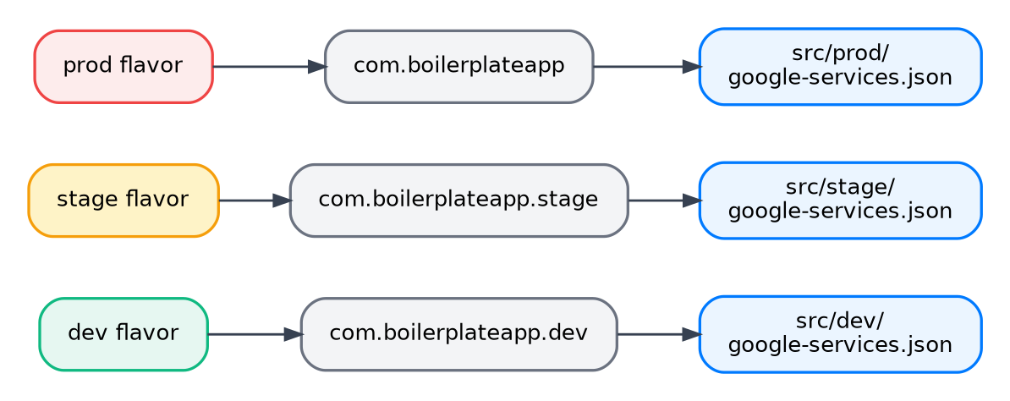
Figure 12.1 — Multi-Flavor Architecture: Partitioning dev, stage, and prod across distinct App IDs and Firebase configs
FLAVOR | APPLICATION ID | APP DISPLAY NAME | TARGET BACKEND
dev | com.boilerplateapp.dev | Boilerplate Dev | Local / Sandbox API
stage | com.boilerplateapp.stage | Boilerplate Staging | QA / UAT Staging API
prod | com.boilerplateapp | Boilerplate App | Live Production API
These flavors are declared inside android/app/build.gradle using flavorDimensions:
// android/app/build.gradle
flavorDimensions "default"
productFlavors {
dev {
dimension "default"
applicationIdSuffix ".dev"
resValue "string", "app_name", "Boilerplate Dev"
}
stage {
dimension "default"
applicationIdSuffix ".stage"
resValue "string", "app_name", "Boilerplate Staging"
}
prod {
dimension "default"
resValue "string", "app_name", "Boilerplate App"
}
}
The Critical strings.xml Gotcha (Resource Collision Prevention)
A frequent failure mode in React Native Android builds is the duplicate resource crash: Execution failed for task ':app:mergeDebugResources' - duplicate value for resource 'string/app_name'.
Why it happens: If android/app/src/main/res/values/strings.xml contains <string name="app_name">BoilerplateApp</string>, and build.gradle also generates app_name via resValue, the Gradle resource merger detects two competing values for the same resource key and fails the build.
The fix applied: We deliberately removed app_name from strings.xml. Gradle is given sole authority to inject the app title dynamically per flavor (Boilerplate Dev, Boilerplate Staging, or Boilerplate App) during compilation.
Flavor Execution Scripts (package.json)
Developers never have to memorize complex Gradle flags. Execution is standardized via npm scripts:
// Run Debug Builds per Flavor
npm run android:dev # react-native run-android --mode=devDebug --appIdSuffix=dev
npm run android:stage # react-native run-android --mode=stageDebug --appIdSuffix=stage
npm run android:prod # react-native run-android --mode=prodDebug
// Generate Standalone Release APKs
npm run build:android:dev # cd android && gradlew assembleDevRelease
npm run build:android:stage # cd android && gradlew assembleStageRelease
npm run build:android:prod # cd android && gradlew assembleProdRelease
// Generate Production Google Play App Bundle (AAB)
npm run bundle:android:prod # cd android && gradlew bundleProdRelease
3.3 Secret Safety & The .gitignore Contract
A foundational security rule of this enterprise boilerplate is that zero production secrets, API credentials, or signing certificates are ever committed to Git. The .gitignore enforces three strict contracts:
• Environment Secrets (.env*): All .env, .env.development, .env.staging, and .env.production files containing live API URLs, OAuth client secrets, or private keys are ignored. Only .env.example is committed as a public schema reference.
• Signing Keystores (*.keystore, *.jks): Production release keystores and passwords are strictly ignored. Only the standard public debug.keystore is whitelisted (!debug.keystore) so contributors can run local debug builds out of the box.
• Firebase Configurations (google-services.json): All real google-services.json (Android) and GoogleService-Info.plist (iOS) files in flavor directories (dev/, stage/, prod/) are ignored to prevent credential leakage. Only .example template schemas are committed.

4. State Architecture: Taking Logic Away from Components
A hallmark of junior codebases is that UI screens become "junk drawers" of logic — managing loading spinners, catching HTTP exceptions, reading hardware storage, clearing tokens, and triggering imperative screen redirects. In this enterprise boilerplate, we enforce an architectural separation: components are purely presentational; all state orchestration and side-effects are extracted away.
4.1 The Core Philosophy: Pure Presentation vs. Side-Effect Separation
The rule for all engineers and trainees is simple: Screens should only read reactive data (via selectors or query hooks) and dispatch user intent (calling a trigger or action). Screens must NEVER:
• Manage Token Lifecycles: Screens never inspect, store, or wipe JWT tokens.
• Direct Storage I/O: Screens never call MMKV or Keychain directly.
• Hardcoded Navigation Side-Effects: Screens never orchestrate logout redirects or session expiry resets.
When logic is stripped from components, screens become durable layout blueprints that are easy to unit-test, quick to refactor, and immune to memory leaks.
4.2 Eliminating Manual State Clutter via RTK Query & extraReducers
In traditional Redux, developers write dozens of manual dispatches per screen: dispatch(fetchStart()), dispatch(fetchSuccess(data)), dispatch(fetchError(err)), accompanied by useState(false) for loading indicators. This creates huge code bloat.
How our boilerplate solves this: RTK Query endpoints completely eliminate manual dispatches from UI screens. Calling const { data, isLoading, isError } = useGetProfileQuery() automatically tracks request lifecycle, caching, deduplication, and polling in the background without a single manual dispatch call.
When global slices need to react to asynchronous operations, we use extraReducers with builder.addMatcher(). For example, when an authentication mutation succeeds or fails, authSlice automatically updates its state by listening to the mutation lifecycle without the UI screen having to dispatch secondary actions.
4.3 Centralized Middleware for Side-Effects (The Event-Driven Model)
Side-effects must not live in UI callbacks. Instead, our Redux store integrates custom listener middleware (createListenerMiddleware) that acts as the central event bus of the application.
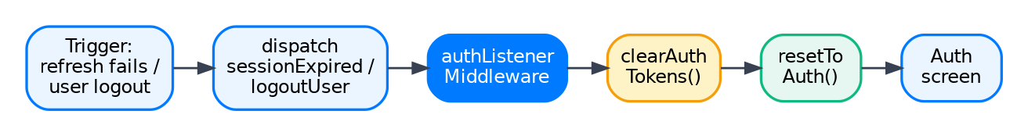
Figure 9.1 — Side-Effect Pipeline: Isolating token cleanup, storage purges, and navigation resets inside Middleware
The canonical example is the Logout & Session Expiry flow. Notice how clean the UI remains:
1. User Taps Logout in UI — The SettingsScreen simply calls dispatch(logoutUser()). That is the only line of code in the component.
2. authListener Middleware Intercepts Action — The middleware catches the logoutUser (or sessionExpired) action automatically in the background.
3. Hardware Vault Purge — The middleware calls Keychain to wipe access and refresh tokens from the Apple Secure Enclave / Android Keystore.
4. Cache & Storage Reset — The middleware clears local user records from MMKV and resets the RTK Query cache.
5. Decoupled Navigation Reset — The middleware invokes navigationService.resetToAuth(), cleanly swapping the root stack back to the Login screen.
How this future-proofs the codebase: When product requirements change (e.g., adding Mixpanel/Firebase logout event tracking, cancelling active WebSocket subscriptions, or resetting push notification badges), trainees never touch any screen components. They simply add a new listener step inside authListener.ts, and every logout event across the app instantly inherits the behavior.
4.4 Talking to Secure Storage (Invisible Token Injection)
How do authenticated network requests get their Bearer token if screens never touch them?
Our networking layer encapsulates token retrieval inside baseQuery.ts via prepareHeaders. Whenever any RTK Query endpoint executes, baseQuery dynamically queries the hardware Keychain for the active accessToken, attaches the Authorization: Bearer <token> header, and dispatches the HTTP request. Authentication is completely invisible to feature domains and UI screens.
4.5 Mutex Concurrency Protection (Silent Token Refresh)
A notorious race condition in mobile apps occurs upon app resume: when an access token expires while the app was backgrounded, multiple mounting components simultaneously dispatch API queries (e.g. getProfile, getFeed, getNotifications).
The Failure Mode: All three queries fail with 401 Unauthorized at the exact same millisecond. Without synchronization, three parallel refresh requests fire to /auth/refresh. The first succeeds and rotates the refresh token. The second and third fail because the old refresh token is now revoked — causing the server to reject the session and inadvertently log the user out!
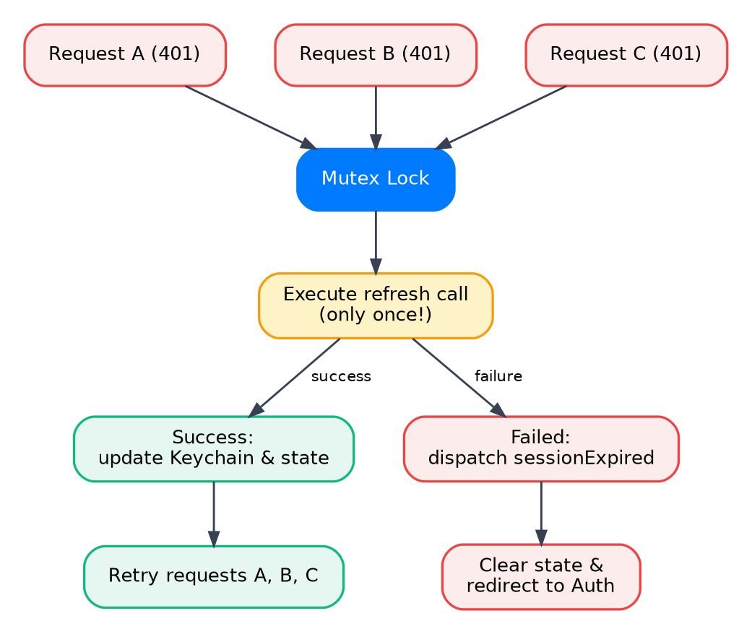
Figure 8.2 — Mutex Concurrency Lock: Guarding silent token refresh against parallel 401 race conditions
The Mutex Solution: baseQueryWithReauth uses an async-mutex concurrency lock. When the first 401 occurs, it acquires the lock and initiates a single token refresh call. The other two requests pause and wait for the lock to release. Once the refresh completes and new tokens are vaulted into Keychain, the waiting requests replay automatically with the fresh token. The user experiences zero interruption and zero session drops.

PART II: Screen & Domain Architecture Playbook
5. Domain Screen Grouping: The profile Domain Case Study
A frequent architectural trap in React Native apps is the "flat screen dump" where fifty screens sit in a single folder. Our architecture groups screens strictly by business domain (e.g. auth/, profile/, home/, settings/). Below is the canonical profile domain architecture:
src/screens/profile/
├── index.ts ← Domain exports (clean public API)
├── types.ts ← Domain route params & profile models
├── components/ ← DOMAIN-SHARED components (used by both Main & Edit!)
│ ├── ProfileAvatar.tsx ← Displays and edits avatar image
│ └── ProfileStats.tsx ← Follower/following statistics block
├── main/ ← Main Profile Screen (overview)
│ ├── index.tsx ← Thin composition screen
│ ├── components/ ← Page-only components (ProfileFeedList.tsx)
│ └── hooks/ ← useProfile.ts (queries profile data & handles refresh)
└── edit/ ← Edit Profile Screen (mutation form)
├── index.tsx ← Thin composition screen
├── components/ ← Page-only components (BioInputField.tsx)
└── hooks/ ← useEditProfile.ts (form state, validation, update mutation)
The Anti-Crowding Rule
To prevent the domain root from becoming cluttered with twenty random files, we enforce strict scoping:
• Page-Only UI: If a component is used ONLY by the main screen (e.g. ProfileFeedList), it MUST live inside profile/main/components/. It never leaks to profile/components/.
• Domain-Shared UI: If a component is shared between Main and Edit (e.g. ProfileAvatar), it lives in profile/components/. Both screens import it locally without polluting global src/shared/.
6. The Layout Wrapper Contract
In our architecture, using a raw un-wrapped <View> as a screen root is strictly prohibited. Every screen in the app must be enclosed in one of two standardized layout containers:
• ScreenWrapper (shared/components/layouts/ScreenWrapper.tsx): Extracts hardware insets via react-native-safe-area-context, guaranteeing that screen content never clips beneath iPhone dynamic islands, camera notches, or Android navigation bars. It automatically syncs the native status bar theme with the active background.
• KeyboardScreenWrapper (shared/components/layouts/KeyboardScreenWrapper.tsx): Wraps interactive form screens with react-native-keyboard-controller. It smoothly elevates inputs in lockstep with the software keyboard’s physical frame, eliminating jumpy screen shifts and avoiding hidden input fields.
7. Reusable Multi-Screen Widgets (The OTP Pattern)
When an interactive sub-flow exists across 2 or 3 completely different domains (e.g. OTP verification needed during Login, User Registration, and Account Phone Number updates), how do we build it?
• The Bad Anti-Pattern: Copy-pasting three different OTP screens across auth/ and profile/, or forcing a rigid screen navigate("OtpScreen") with messy conditional callback routes that are impossible to test.
• The Canonical Widget Pattern: Extract it as a decoupled, self-contained Widget (src/shared/components/widgets/OtpVerificationWidget.tsx).
The widget encapsulates code entry boxes, countdown timer, and resend triggers. It is completely decoupled from navigation and communicates via callbacks:
export interface OtpWidgetProps {
phoneNumber: string;
onSuccess: (verificationToken: string) => void;
onCancel?: () => void;
}
Because it is decoupled, it can be rendered as a full standalone screen (screens/common/OtpScreen.tsx), embedded inside a modal, or rendered inside a bottom sheet in EditProfile without changing a single line of OTP logic!
8. Common / Standalone Screens (src/screens/common/)
Where do screens live that do not belong to a specific feature domain? They live in src/screens/common/.
• OtpScreen.tsx: Full-screen wrapper that hosts OtpVerificationWidget for dedicated push navigation.
• NetworkErrorScreen.tsx: Offline fallback screen displayed when connectivity is lost.
• WebViewScreen.tsx: Universal in-app browser displaying Terms of Service and Privacy Policies.
• PermissionGateScreen.tsx: Hardware permission explanation screen (Camera, Push Notifications).
9. Promoting Code to Shared (The Rule of Promotion)
Code does not start in src/shared/. Code starts as local and is promoted only when real duplication demands it.
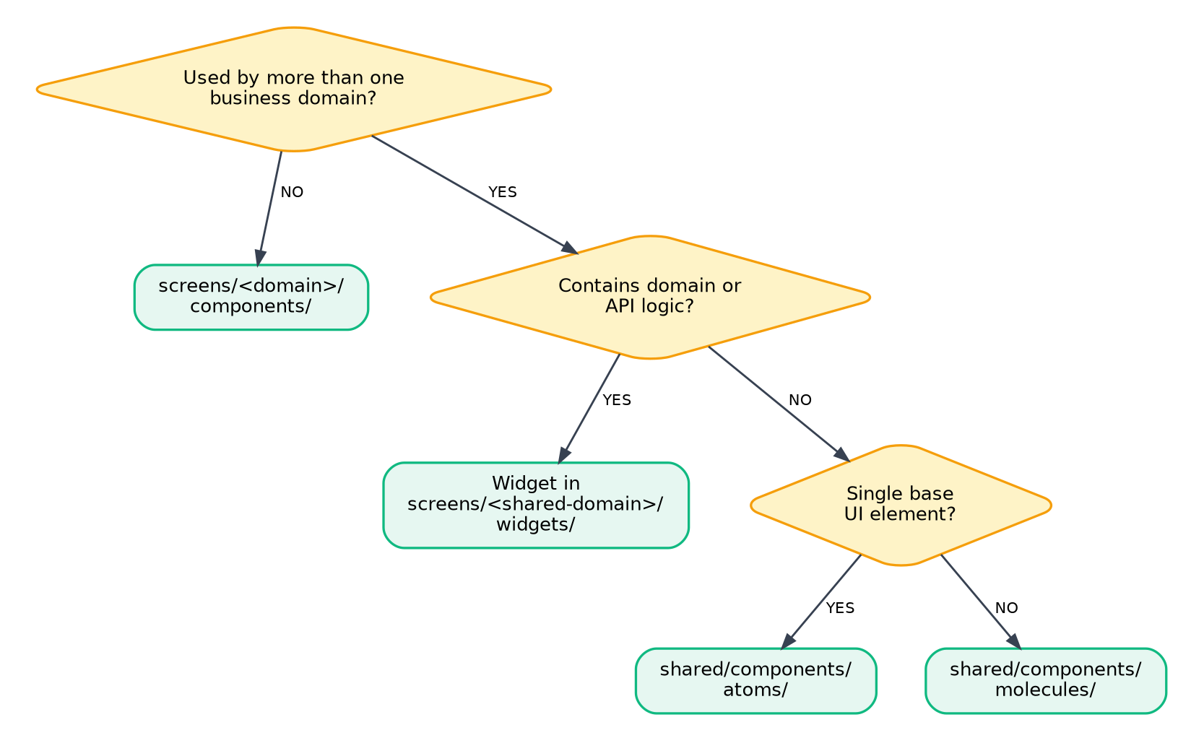
Figure 10.1 — Component Decision Tree: When code lives in a Page, Domain, Widget, or Shared Primitive
The Rule of Two
Step 1: Used in 1 Screen — Keep it strictly inside that screen’s local folder (<screen>/components/ or <screen>/hooks/).
Step 2: Used in 2 Screens within the Same Domain — Promote it to the domain level (screens/<domain>/components/ or <domain>/hooks/).
Step 3: Needed by a Completely Different Domain — Promote it to global src/shared/ (shared/components/, shared/hooks/, or shared/widgets/).
10. Step-by-Step Trainee Guide: Building a New Domain & Screen
When adding a brand-new feature domain to this codebase (e.g. a wallet domain with WalletHomeScreen and TransferFundsScreen), trainees must follow this exact 6-step blueprint:
Step 1: Scaffold Domain Hierarchy — Create src/screens/wallet/ containing main/, transfer/, components/, types.ts, and index.ts.
Step 2: Define Route Param Contracts — In src/navigation/types.ts, declare WalletStackParamList with strong TypeScript types for WalletHome and TransferFunds.
Step 3: Declare RTK Query Endpoints & Schemas — In src/store/api/walletApi.ts, declare endpoints with Zod request/response validation schemas and tag invalidations.
Step 4: Create Page Hook for Business Logic — In screens/wallet/transfer/hooks/useTransfer.ts, manage form state, validate transfer amounts, and trigger the mutation.
Step 5: Assemble Thin Screen with Layout Wrappers — In TransferFundsScreen.tsx, wrap the layout in KeyboardScreenWrapper, consume atomic AppInput and AppButton, and embed OtpVerificationWidget to confirm transfers.
Step 6: Register Domain in App Navigation — Mount WalletNavigator into the authenticated main bottom tab bar inside src/navigation/main/MainNavigator.tsx.
11. Do’s and Don’ts of the Codebase
Before submitting any Pull Request, every engineer must verify that their implementation complies with the canonical practices below:
DO (CANONICAL PRACTICE) | DON'T (STRICT ANTI-PATTERN)
✓ Wrap every screen root in ScreenWrapper or KeyboardScreenWrapper to guarantee safe-area insets and status-bar colors. | ✕ Never use raw un-wrapped <View> as a screen root — it clips beneath notches and breaks on software keyboards.
✓ Import constants for all routes, storage keys, translation keys, and icons (e.g. AUTH_ROUTES.LOGIN, STORAGE_KEYS.USER_TOKEN, APP_ICONS.USER). | ✕ Never use raw magic strings ('Login', 'user_token') or perform string comparisons against arbitrary string literals.
✓ Use @/* path aliases for all module imports (e.g. @/shared/components, @/store/hooks) to keep imports refactor-proof. | ✕ Never use deep relative directory traversals (../../../../shared) that break when files are reorganized.
✓ Always scale dimensions using responsive utility functions: ms(16) for typography/radii, scale(16) for horizontal padding, vs(20) for vertical gaps. | ✕ Never hardcode raw pixel numbers (fontSize: 16, width: 320) which distort layouts on iPhone SE vs. large tablets.
✓ Keep page-only components inside the screen’s local components/ folder to prevent domain folder crowding. | ✕ Don’t dump domain-specific UI cards (e.g. ProfileHeader, OrderCard) into global src/shared/components/.
✓ Extract interactive multi-place flows (like OTP verification) as self-contained Widgets taking callback props (onSuccess, onCancel). | ✕ Never copy-paste flow screens across domains or hardcode rigid navigation redirects with complex return params.
✓ Extract form states, validation, and RTK Query mutations into dedicated page hooks (<screen>/hooks/useLogin.ts) to keep screens thin. | ✕ Never write sprawling 600-line screen files stuffed with useState, inline validation, and raw API promise handlers.
✓ Centralize side-effects (logout, session expiry) inside listener middlewares that interact with Keychain and navigationService. | ✕ Never import Keychain or storage clearing logic directly inside UI screen components or button callbacks.

