|  |
| --- |
| BAHRIA UNIVERSITY (KARACHI CAMPUS)    Open Ended Lab II – SPRING SEMESTER – 2022  Software Application for Mobile Devices    Class: BSE-6A Morning    Lab Instructor: Engr. Muhammad Rehan Baig M. Saim Hassan | 02-131192-015 |

Scenario

OMarket is a Things Sharing/Rental Market place MVP soon to be launched for pitch.

needs a Mobile application. You as an Application Developer responsible for the requirements given below.

*Product Types that can be listed on this market are (Books, Clothes, Music, Valuables... etc.)*

Requirements of App

* Authentication Area
  + User can Authenticate from this page and this authentication information will be used over the application and on executing processes.

* Dashboard.
  + Add Product Option – on click the prompt will be shown that captures the details of the product on the same page.
  + List of the products that are listed in the application for sharing and Rental purposes. - On Click on any product from the list the Activity will open that contains the details of the product and a Checkout button when this button clicked the Checkout Activity will be shown with the order details.
  + For Category music user can play music in the app background before buying without hanging the rest of the application.

* Order Management.
  + It show both Orders (Orders Done by you) and (Order Received By you for your products) in the separate lists.
  + In this Activity Real time order status will be shown after 10 seconds the order status must be updated based on Approval from the Seller. This process must be running in the background so no any process dead.

* Checkout.
  + When Buyer checkout the Seller in the market place will be notified with the OFFER Message sent from Buyer and App Notification for Approval.
  + Until the Offer not approved the Order Status will be displayed as PENDING

Every point is important. Read the given scenario carefully to perform this OpenEnded Lab Late Submissions not allowed.

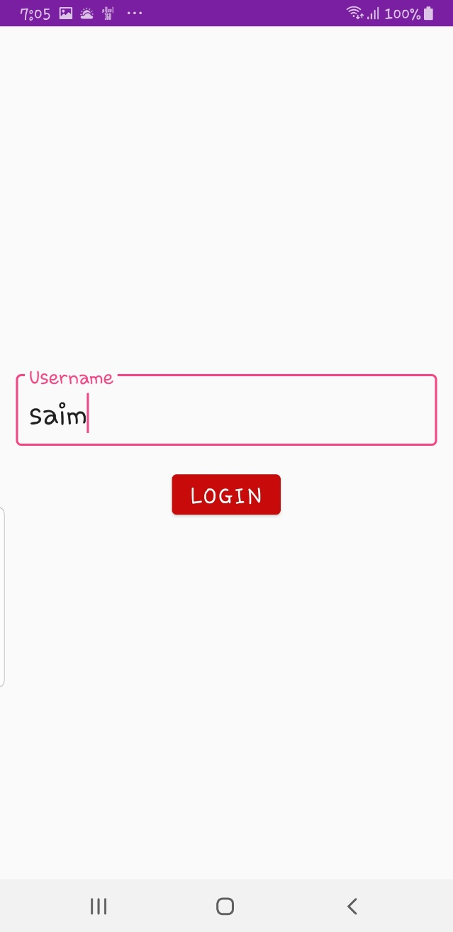 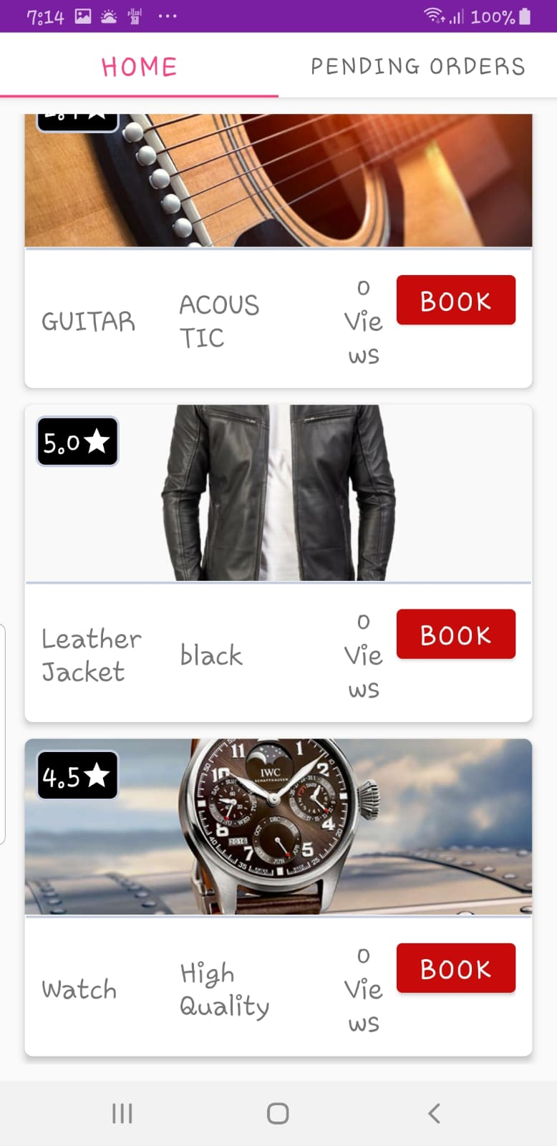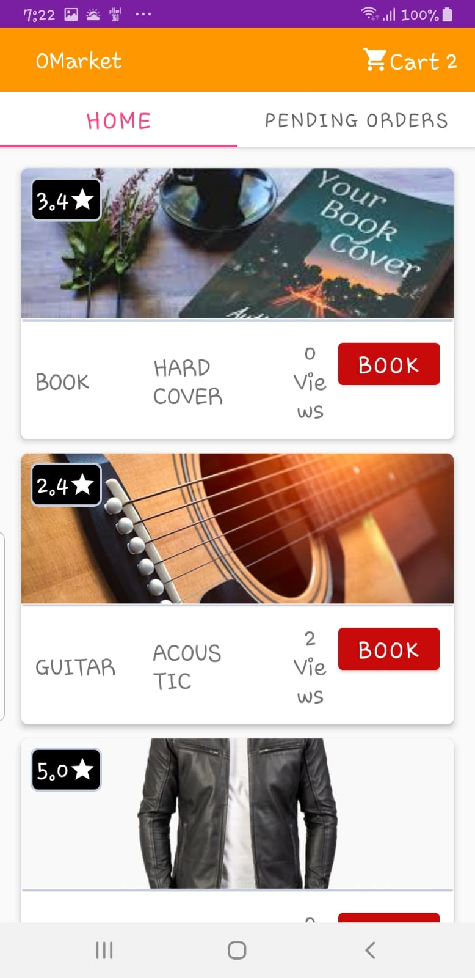 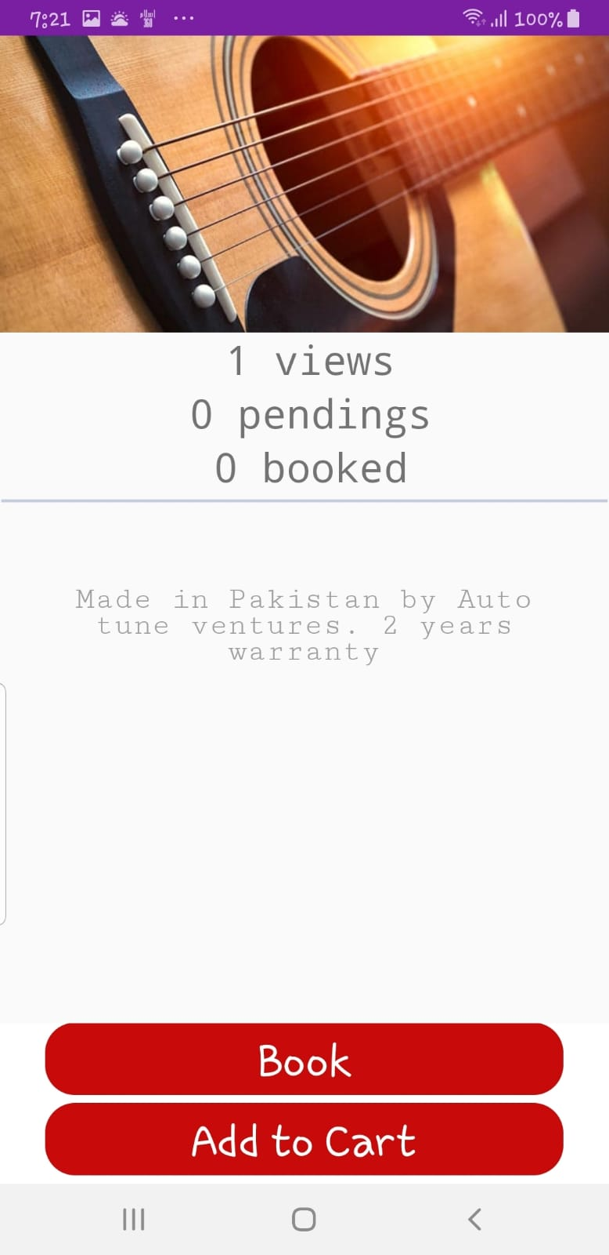

XML FILES:

*<?*xml version="1.0" encoding="utf-8"*?>*<androidx.coordinatorlayout.widget.CoordinatorLayout xmlns:android="http://schemas.android.com/apk/res/android"  
 xmlns:app="http://schemas.android.com/apk/res-auto"  
 xmlns:tools="http://schemas.android.com/tools"  
 android:id="@+id/activity_hotel_info"  
 android:layout_width="match_parent"  
 android:layout_height="match_parent"  
 tools:context=".Activities.HotelInfo">  
  
  
 <com.google.android.material.appbar.AppBarLayout  
 android:layout_width="match_parent"  
 android:layout_height="200dp"  
 android:id="@+id/appbar"  
 android:theme="@style/ThemeOverlay.MaterialComponents.Dark.ActionBar">  
  
 <com.google.android.material.appbar.CollapsingToolbarLayout  
 android:id="@+id/hotelTitle"  
 android:layout_width="match_parent"  
 android:layout_height="match_parent"  
 app:contentScrim="@color/colorPrimary"  
 app:expandedTitleTextAppearance="@style/CollapsingToolbarLayoutExpandedTextStyle"  
 app:layout_scrollFlags="exitUntilCollapsed|scroll">  
  
 <ImageView  
 android:id="@+id/hotelImage"  
 android:layout_width="match_parent"  
 android:layout_height="match_parent"  
 android:scaleType="centerCrop" />  
  
 <androidx.appcompat.widget.Toolbar  
 android:layout_width="match_parent"  
 android:id="@+id/toolbarInfo"  
  
 app:popupTheme="@style/ThemeOverlay.MaterialComponents.Dark.ActionBar"  
 android:layout_height="?actionBarSize"  
 app:titleTextColor="@android:color/black"  
 app:layout_collapseMode="pin" />  
  
  
 </com.google.android.material.appbar.CollapsingToolbarLayout>  
  
  
 </com.google.android.material.appbar.AppBarLayout>  
  
 <androidx.core.widget.NestedScrollView  
 android:layout_width="match_parent"  
 android:layout_height="wrap_content"  
 app:layout_behavior="com.google.android.material.appbar.AppBarLayout$ScrollingViewBehavior">  
 <LinearLayout  
 android:layout_width="match_parent"  
 android:layout_height="match_parent"  
 android:orientation="vertical">  
 <LinearLayout  
 android:layout_width="match_parent"  
 android:gravity="center"  
 android:layout_height="wrap_content"  
 android:orientation="vertical">  
  
 <TextView  
 android:layout_width="wrap_content"  
 android:layout_height="match_parent"  
 android:fontFamily="monospace"  
 android:id="@+id/views"  
 android:gravity="center"  
 android:text="views"  
 android:layout_marginLeft="4dp"  
 android:textSize="18sp"  
 />  
  
 <TextView  
 android:id="@+id/draftText"  
 android:layout_width="wrap_content"  
 android:layout_height="match_parent"  
 android:layout_marginLeft="4dp"  
 android:fontFamily="monospace"  
 android:gravity="center"  
 android:text="pending requests"  
 android:textSize="18sp" />  
  
 <TextView  
 android:layout_width="wrap_content"  
 android:layout_height="match_parent"  
 android:fontFamily="monospace"  
 android:gravity="center"  
 android:text="completed"  
 android:id="@+id/completedText"  
 android:layout_marginLeft="4dp"  
 android:textSize="18sp"  
 />  
  
  
 </LinearLayout>  
 <LinearLayout  
 android:layout_width="match_parent"  
 android:layout_height="10dp"  
 android:background="@drawable/horizontal_line"/>  
 <TextView  
 android:layout_width="match_parent"  
 android:layout_height="wrap_content"  
 android:layout_below="@id/appbar"  
 android:padding="15dp"  
 android:id="@+id/hotelDesc"  
 android:gravity="center|clip_horizontal"  
 android:text="hhjhj"  
 android:fontFamily="serif-monospace"  
 android:textSize="15dp"/>  
 </LinearLayout>  
 </androidx.core.widget.NestedScrollView>  
  
 <LinearLayout  
 android:layout_width="match_parent"  
 android:layout_height="wrap_content"  
 android:layout_gravity="bottom"  
 android:background="@android:color/white"  
 android:orientation="vertical">  
  
 <com.google.android.material.button.MaterialButton  
 android:id="@+id/confirmBooking"  
 style="?android:attr/buttonBarButtonStyle"  
 android:layout_width="350dp"  
 android:layout_height="60dp"  
 android:layout_gravity="center"  
 android:layout_marginTop="-6dp"  
 android:gravity="center"  
 android:text="Book"  
 android:textAllCaps="false"  
 android:textSize="20sp"  
 app:backgroundTint="#C80A0A"  
 app:cornerRadius="20dp" />  
  
 <com.google.android.material.button.MaterialButton  
 android:id="@+id/draftBooking"  
 style="?android:attr/buttonBarButtonStyle"  
 android:layout_width="350dp"  
 android:layout_height="60dp"  
 android:layout_gravity="center"  
 android:layout_marginTop="-6dp"  
 android:gravity="center"  
 android:text="Add to Cart"  
 android:textAllCaps="false"  
 android:textSize="20sp"  
 app:backgroundTint="#C80A0A"  
 app:cornerRadius="20dp" />  
 </LinearLayout>  
  
  
  
</androidx.coordinatorlayout.widget.CoordinatorLayout>

*<?***xml version="1.0" encoding="utf-8"***?>*<**LinearLayout xmlns:android="http://schemas.android.com/apk/res/android"  
 xmlns:app="http://schemas.android.com/apk/res-auto"  
 xmlns:tools="http://schemas.android.com/tools"  
 android:layout_width="match_parent"  
 android:layout_height="match_parent"  
 android:gravity="center"  
 android:orientation="vertical"  
 android:padding="14dp"  
 tools:context=".Activities.LoginActivity"**>  
  
 <**com.google.android.material.textfield.TextInputLayout  
 android:id="@+id/username"  
 style="@style/Widget.MaterialComponents.TextInputLayout.OutlinedBox"  
 android:layout_width="match_parent"  
  
 android:layout_height="wrap_content"**>  
  
 <**com.google.android.material.textfield.TextInputEditText  
 android:layout_width="match_parent"  
 android:digits="ABCDEFGHIJKLMNOPQRSTUVWXYZabcdefghijklmnopqrstuvwxyz1234567890"  
 android:inputType="textFilter"  
 android:text="user"  
 android:layout_height="wrap_content"  
 android:hint="Username"** />  
  
 </**com.google.android.material.textfield.TextInputLayout**>  
  
 <**GridLayout  
 android:layout_width="match_parent"  
 android:layout_height="wrap_content"  
 android:layout_gravity="center"  
 android:clipToPadding="false"  
 android:padding="16dp"**>  
  
 <**com.google.android.material.button.MaterialButton  
 android:id="@+id/loginBtn"  
 android:layout_width="wrap_content"  
 android:layout_height="wrap_content"  
 android:layout_gravity="center"  
 android:text="Login"  
 app:backgroundTint="#C80A0A"** />  
  
 </**GridLayout**>  
  
  
  
</**LinearLayout**>

*<?***xml version="1.0" encoding="utf-8"***?>*<**RelativeLayout xmlns:android="http://schemas.android.com/apk/res/android"  
 xmlns:tools="http://schemas.android.com/tools"  
 android:layout_width="match_parent"  
 android:padding="12dp"  
 android:layout_height="match_parent"  
 tools:context=".Fragments.HomeFrag"**>  
  
 <**androidx.recyclerview.widget.RecyclerView  
  
 android:layout_width="match_parent"  
 android:layout_height="wrap_content"  
 android:id="@+id/hotelList"** />  
  
</**RelativeLayout**>

*<?***xml version="1.0" encoding="utf-8"***?>*<**RelativeLayout xmlns:android="http://schemas.android.com/apk/res/android"  
 xmlns:app="http://schemas.android.com/apk/res-auto"  
 xmlns:tools="http://schemas.android.com/tools"  
 android:id="@+id/fragment_hotel"  
 android:layout_width="match_parent"  
 android:layout_height="match_parent"  
 tools:context=".Activities.HotelInfo"**>  
  
  
 <**com.google.android.material.appbar.AppBarLayout  
 android:layout_width="match_parent"  
 android:layout_height="wrap_content"  
 android:theme="@style/ThemeOverlay.MaterialComponents.Dark.ActionBar"**>  
  
 <**com.google.android.material.appbar.CollapsingToolbarLayout  
 android:id="@+id/hotelTitle"  
 android:layout_width="match_parent"  
 android:layout_height="200dp"  
 app:layout_scrollFlags="enterAlways|scroll"  
 app:title="ProductName"**>  
  
 <**ImageView  
 android:id="@+id/hotelImage"  
 android:layout_width="match_parent"  
 android:layout_height="match_parent"  
 android:scaleType="centerCrop"** />  
  
 <**androidx.appcompat.widget.Toolbar  
 android:layout_width="match_parent"  
 android:layout_height="?actionBarSize"  
 app:layout_collapseMode="parallax"** />  
  
  
 </**com.google.android.material.appbar.CollapsingToolbarLayout**>  
  
  
 </**com.google.android.material.appbar.AppBarLayout**>  
  
 <**com.google.android.material.button.MaterialButton  
 android:id="@+id/confirmBooking"  
 style="?android:attr/buttonBarButtonStyle"  
 android:layout_width="match_parent"  
 android:layout_height="60dp"  
 android:layout_alignParentBottom="true"  
 android:layout_marginTop="-6dp"  
 android:layout_marginBottom="-6dp"  
 android:gravity="center"  
 android:text="Book"  
 android:textAllCaps="false"  
  
 android:textSize="20sp"  
 app:backgroundTint="#C80A0A"  
 app:cornerRadius="0dp"** />  
  
</**RelativeLayout**>

*<?***xml version="1.0" encoding="utf-8"***?>*<**RelativeLayout xmlns:android="http://schemas.android.com/apk/res/android"  
 android:layout_width="match_parent"  
 android:padding="12dp"  
 android:id="@+id/recoFrag"  
 android:layout_height="match_parent"**>  
  
 <**androidx.recyclerview.widget.RecyclerView  
 android:tag="reco"  
 android:layout_width="match_parent"  
 android:layout_height="wrap_content"  
 android:id="@+id/hotelList"** />  
  
 <**TextView  
 android:id="@+id/emptyRecommendationPlaceHolder"  
 android:layout_width="match_parent"  
 android:layout_height="wrap_content"  
 android:layout_centerInParent="true"  
 android:fontFamily="monospace"  
 android:gravity="center"  
 android:text="No requests in pending."  
 android:textSize="23sp"  
 android:visibility="invisible"** />  
  
</**RelativeLayout**>

*<?***xml version="1.0" encoding="utf-8"***?>*<**androidx.cardview.widget.CardView xmlns:android="http://schemas.android.com/apk/res/android"  
 xmlns:app="http://schemas.android.com/apk/res-auto"  
 android:id="@+id/hotelCard"  
 android:layout_width="match_parent"  
 android:layout_height="wrap_content"  
 android:animateLayoutChanges="true"  
 android:clickable="true"  
 android:clipToPadding="false"  
 android:foreground="?android:attr/selectableItemBackground"  
 app:cardCornerRadius="6dp"  
 android:layout_margin="6dp"  
 app:cardElevation="4dp"**>  
  
  
 <**LinearLayout  
 android:layout_width="match_parent"  
 android:layout_height="wrap_content"  
 android:orientation="vertical"**>  
  
  
  
 <**RelativeLayout  
 android:layout_width="match_parent"  
 android:layout_height="wrap_content"**>  
  
 <**ImageView  
 android:id="@+id/hotelImage"  
 android:layout_width="match_parent"  
 android:scaleType="centerCrop"  
 android:layout_height="130dp"** />  
  
 <**LinearLayout  
 android:layout_width="match_parent"  
 android:layout_height="3dp"  
 android:layout_below="@id/hotelImage"  
 android:background="@drawable/horizontal_line"** />  
  
 <**TextView  
 android:layout_width="wrap_content"  
 android:layout_height="wrap_content"  
 android:layout_margin="8dp"  
 android:id="@+id/ratings"  
 android:background="@drawable/rounded_linear_layout"  
  
 android:drawableRight="@drawable/ic_24px_star"  
 android:drawableTint="@android:color/white"  
 android:gravity="center"  
 android:padding="5dp"  
 android:text="4.5"  
 android:textColor="@android:color/white"  
 android:textSize="14sp"**/>  
  
 </**RelativeLayout**>  
  
 <**RelativeLayout  
 android:layout_width="match_parent"  
 android:layout_height="match_parent"  
 android:orientation="horizontal"  
 android:padding="12dp"**>  
  
 <**TextView  
 android:layout_width="39dp"  
 android:layout_height="wrap_content"  
 android:id="@+id/hotelCardViews"  
 android:layout_centerVertical="true"  
 android:layout_marginRight="5dp"  
 android:layout_toLeftOf="@id/hotelBookButton"  
 android:gravity="center"  
 android:text="0\nviews"** />  
  
 <**TextView  
 android:id="@+id/hotelName"  
 android:layout_width="100dp"  
 android:layout_height="wrap_content"  
 android:layout_centerVertical="true"  
 android:orientation="horizontal"** />  
 <**TextView  
 android:layout_width="70dp"  
 android:layout_height="wrap_content"  
 android:layout_marginLeft="2dp"  
 android:id="@+id/tagsList"  
 android:layout_centerVertical="true"  
 android:layout_toRightOf="@id/hotelName"**/>  
  
  
 <**com.google.android.material.button.MaterialButton  
 android:id="@+id/hotelBookButton"  
 android:layout_width="wrap_content"  
 android:layout_height="wrap_content"  
 android:layout_alignParentRight="true"  
 android:text="Book"  
 android:textColorHighlight="#F44336"  
 android:textColorLink="#C11A0E"  
 app:backgroundTint="#C80A0A"** />  
  
 </**RelativeLayout**>  
  
 </**LinearLayout**>  
  
</**androidx.cardview.widget.CardView**>

JAVA CODE:

ACTIVITIES:

**package** com.turquoise.hotelbookrecomendation.Activities;  
  
**import** android.content.Context;  
**import** android.content.SharedPreferences;  
**import** android.net.Uri;  
**import** android.os.Bundle;  
**import** android.util.Log;  
**import** android.view.View;  
**import** android.widget.Button;  
**import** android.widget.ImageView;  
**import** android.widget.TextView;  
  
**import** androidx.appcompat.app.AppCompatActivity;  
**import** androidx.appcompat.widget.Toolbar;  
  
**import** com.google.gson.Gson;  
**import** com.squareup.picasso.Picasso;  
**import** com.turquoise.hotelbookrecomendation.Adapters.RecommendationAdapter;  
**import** com.turquoise.hotelbookrecomendation.Fragments.Recommendation;  
**import** com.turquoise.hotelbookrecomendation.R;  
**import** com.turquoise.hotelbookrecomendation.model.Booking;  
**import** com.turquoise.hotelbookrecomendation.model.Hotel;  
**import** com.turquoise.hotelbookrecomendation.model.HotelResult;  
**import** com.turquoise.hotelbookrecomendation.model.UserHotel;  
  
**import** java.util.HashSet;  
**import** java.util.List;  
**import** java.util.Set;  
  
**public class** HotelInfo **extends** AppCompatActivity {  
  
 **private** Toolbar **toolbar**;  
 **private** ImageView **hotelImage**;  
 **private** TextView **hotelDesc**, **views**, **drafts**, **completed**;  
 **private** Button **book**, **draftBook**;  
 **private** RecommendationAdapter.HotelViewHolder **hotelViewHolder**;  
 Hotel **hotel**;  
 **int pos**;  
 HotelResult **hotelResult**;  
  
 @Override  
 **protected void** onCreate(Bundle savedInstanceState) {  
 **super**.onCreate(savedInstanceState);  
 setContentView(R.layout.activity_hotel_info);  
  
 toolbar = findViewById(R.id.toolbarInfo);  
 hotelImage = findViewById(R.id.hotelImage);  
 hotelDesc = findViewById(R.id.hotelDesc);  
 book = findViewById(R.id.confirmBooking);  
 draftBook = findViewById(R.id.draftBooking);  
 views = findViewById(R.id.views);  
 drafts = findViewById(R.id.draftText);  
 completed = findViewById(R.id.completedText);  
  
  
 }  
  
 @Override  
 **protected void** onResume() {  
 **super**.onResume();  
  
 hotel = (Hotel) getIntent().getExtras().getSerializable(**"data"**);  
  
  
 hotelResult = **new** Gson().fromJson(getHotels(), HotelResult.**class**);  
 pos = getIntent().getExtras().getInt(**"pos"**);  
  
 toolbar.setTitle(hotel.getName());  
  
 setSupportActionBar(toolbar);  
 Picasso  
 .with(HotelInfo.**this**)  
 .load(Uri.parse(hotel.getImageUrl()))  
 .into(hotelImage);  
 hotelDesc.setText(hotel.getDescription());  
  
 views.setText(hotelResult.getHotels().get(pos).getVisits() + **" views"**);  
 drafts.setText(hotelResult.getHotels().get(pos).getDraftBookings() + **" pendings"**);  
 completed.setText(hotelResult.getHotels().get(pos).getCompletedBookings() + **" booked"**);  
  
  
 book.setOnClickListener(**new** View.OnClickListener() {  
 @Override  
 **public void** onClick(View v) {  
  
 setBooking(**true**);  
 finish();  
  
 }  
 });  
 draftBook.setOnClickListener(**new** View.OnClickListener() {  
 @Override  
 **public void** onClick(View v) {  
  
 setBooking(**false**);  
 MainActivity.updatec(1);  
 Log.d(**"ononon"**, **"onClick: "**);  
 finish();  
  
 }  
 });  
 }  
  
 **public** String getHotels() {  
 SharedPreferences sp = getSharedPreferences(**"hotel"**, Context.MODE_PRIVATE);  
 Gson gson = **new** Gson();  
 **if** (sp.contains(**"data"**)) {  
 **return** sp.getString(**"data"**, **null**);  
 } **else** {  
 **return null**;  
 }  
  
 }  
  
 **private void** setBooking(Boolean complete) {  
  
  
 UserHotel hotel1 = **new** UserHotel();  
 hotel1.setName(hotel.getName());  
 hotel1.setCompleted(complete);  
 hotel1.setTags(hotel.getTags());  
  
 Booking booking = **new** Booking();  
  
 List<UserHotel> userHotels = MainActivity.bookings.getUserHotels();  
 userHotels.add(hotel1);  
  
 MainActivity.bookings.setUserHotels(userHotels);  
  
 Set<String> s = **new** HashSet<>();  
 **for** (UserHotel userHotel : MainActivity.bookings.getUserHotels()) {  
 **if** (userHotel.getCompleted()) {  
 **for** (String ss : userHotel.getTags().split(**"\n"**)) {  
 ss = ss.replace(**"null"**, **""**);  
 s.add(ss);  
 }  
  
 }  
 }  
 String sa = **""**;  
  
 **for** (String sss : s) {  
 sa += sss;  
 Recommendation.tagSet.add(sss);  
 }  
  
 **if** (complete) {  
 **int** c = Integer.valueOf(hotelResult.getHotels().get(pos).getCompletedBookings());  
 hotelResult.getHotels().get(pos).setCompletedBookings(String.valueOf(c + 1));  
 storeUpdates(hotelResult);  
 } **else** {  
 **int** c = Integer.valueOf(hotelResult.getHotels().get(pos).getDraftBookings());  
 hotelResult.getHotels().get(pos).setDraftBookings(String.valueOf(c + 1));  
 storeUpdates(hotelResult);  
 }  
  
 }  
  
 **public void** storeUpdates(HotelResult hotelResult) {  
 SharedPreferences.Editor spe = getSharedPreferences(**"Product"**, Context.MODE_PRIVATE).edit();  
 String save = **new** Gson().toJson(hotelResult);  
 spe.putString(**"data"**, save);  
 spe.apply();

}  
}

**package** com.turquoise.hotelbookrecomendation.Activities;  
  
**import** android.content.SharedPreferences;  
**import** android.os.Bundle;  
**import** android.view.View;  
**import** android.widget.Button;  
  
**import** androidx.annotation.NonNull;  
**import** androidx.appcompat.app.AppCompatActivity;  
  
**import** com.google.android.material.textfield.TextInputLayout;  
**import** com.turquoise.hotelbookrecomendation.R;  
  
**import static** com.turquoise.hotelbookrecomendation.Utils.Utilities.newActivity;  
  
**public class** LoginActivity **extends** AppCompatActivity **implements** View.OnClickListener {  
  
 **private** Button **login**;  
 **private** TextInputLayout **username**;  
  
  
 @Override  
 **protected void** onCreate(Bundle savedInstanceState) {  
 **super**.onCreate(savedInstanceState);  
 setContentView(R.layout.activity_login);  
  
  
 **username** = findViewById(R.id.username);  
 **login** = findViewById(R.id.loginBtn);  
 **login**.setOnClickListener(**this**);  
  
  
 }  
  
  
 @Override  
 **public void** onClick(View v) {  
 **if** (v.getId() == R.id.loginBtn) {  
 **if** (getUsername().equals(**""**)) {  
 setError(**username**, **"Enter valid username with length greater than 5 char"**);  
 } **else** {  
  
 SharedPreferences sharedPreferences = getSharedPreferences(getUsername(), MODE_PRIVATE);  
 SharedPreferences.Editor editor = getSharedPreferences(getUsername(), MODE_PRIVATE).edit();  
  
 **if** (sharedPreferences.getString(**"active"**, **"in"**).equals(**"in"**)) {  
  
 SharedPreferences.Editor edit = getSharedPreferences(**"cur"**, MODE_PRIVATE).edit();  
 edit.putString(**"Saim"**, getUsername());  
  
 }  
  
  
 newActivity(LoginActivity.**this**, MainActivity.**class**);  
 }  
 }  
  
 }  
  
 **private void** setError(@NonNull TextInputLayout username, String s) {  
 username.setError(s);  
 }  
  
 **private** String getUsername() {  
  
 **return username**.getEditText().getText().toString();  
  
 }  
}

**package** com.turquoise.hotelbookrecomendation.Activities;  
  
**import** android.os.Bundle;  
**import** android.widget.TextView;  
  
**import** androidx.appcompat.app.AppCompatActivity;  
**import** androidx.appcompat.widget.Toolbar;  
**import** androidx.fragment.app.Fragment;  
**import** androidx.fragment.app.FragmentManager;  
**import** androidx.fragment.app.FragmentPagerAdapter;  
**import** androidx.viewpager.widget.ViewPager;  
  
**import** com.google.android.material.tabs.TabLayout;  
**import** com.turquoise.hotelbookrecomendation.Fragments.HomeFrag;  
**import** com.turquoise.hotelbookrecomendation.Fragments.Recommendation;  
**import** com.turquoise.hotelbookrecomendation.R;  
**import** com.turquoise.hotelbookrecomendation.model.Booking;  
  
**import** java.io.Serializable;  
**import** java.util.ArrayList;  
**import** java.util.List;  
  
**public class** MainActivity **extends** AppCompatActivity **implements** Serializable {  
  
 **private static** Toolbar *toolbar*;  
 **private** TabLayout **tabLayout**;  
 **private** ViewPager **viewPager**;  
 **public static** Booking *bookings*=**new** Booking();  
  
  
 @Override  
 **protected void** onCreate(Bundle savedInstanceState) {  
 **super**.onCreate(savedInstanceState);  
 setContentView(R.layout.activity_main);  
  
 *toolbar* = findViewById(R.id.toolBar);  
 *toolbar*.setTitle(**"OMarket"**);  
  
 setSupportActionBar(*toolbar*);  
  
 getSupportActionBar().setDisplayShowTitleEnabled(**true**);  
  
 **viewPager** = findViewById(R.id.viewpager);  
 setupViewPager(**viewPager**);  
  
 **tabLayout** = findViewById(R.id.tabs);  
 **tabLayout**.setupWithViewPager(**viewPager**);  
  
 }  
  
  
  
 **private void** setupViewPager(**final** ViewPager viewPager) {  
 **final** ViewPagerAdapter viewPagerAdapter=**new** ViewPagerAdapter(getSupportFragmentManager());  
 viewPagerAdapter.addFrag(**new** HomeFrag(),**"Home"**);  
 viewPagerAdapter.addFrag(**new** Recommendation(),**"Pending orders"**);  
 viewPager.addOnPageChangeListener(**new** ViewPager.OnPageChangeListener() {  
 @Override  
 **public void** onPageScrolled(**int** position, **float** positionOffset, **int** positionOffsetPixels) {  
  
 }  
  
 @Override  
 **public void** onPageSelected(**int** position) {  
 **if**(position==1){  
  
 ((Recommendation)viewPagerAdapter.getItem(position)).updateList();  
  
 }  
 **else**{  
 ((HomeFrag)viewPagerAdapter.getItem(position)).updateList();  
 }  
 }  
  
 @Override  
 **public void** onPageScrollStateChanged(**int** state) {  
  
 }  
 });  
 viewPager.setAdapter(viewPagerAdapter);  
 }  
  
  
  
  
 **public static void** updatec(**int** n) {  
 **int** cur=Integer.valueOf(((TextView)*toolbar*.findViewById(R.id.cartCount)).getText().toString());  
 ((TextView)*toolbar*.findViewById(R.id.cartCount)).setText(String.valueOf(cur+n));  
 }  
  
  
  
 **class** ViewPagerAdapter **extends** FragmentPagerAdapter {  
 **private final** List<Fragment> **mFragmentList** = **new** ArrayList<>();  
 **private final** List<String> **mFragmentTitleList** = **new** ArrayList<>();  
  
 **public** ViewPagerAdapter(FragmentManager manager) {  
 **super**(manager,BEHAVIOR_RESUME_ONLY_CURRENT_FRAGMENT);  
  
 }  
  
 @Override  
 **public** Fragment getItem(**int** position) {  
 **return mFragmentList**.get(position);  
 }  
  
 @Override  
 **public int** getCount() {  
 **return mFragmentList**.size();  
 }  
  
 **public void** addFrag(Fragment fragment, String title) {  
 **mFragmentList**.add(fragment);  
 **mFragmentTitleList**.add(title);  
 }  
  
 @Override  
 **public** CharSequence getPageTitle(**int** position) {  
 **return mFragmentTitleList**.get(position);  
 }  
 }  
}

ADAPTERS:

**package** com.turquoise.hotelbookrecomendation.Adapters;  
  
**import** android.content.Context;  
**import** android.content.Intent;  
**import** android.content.SharedPreferences;  
**import** android.net.Uri;  
**import** android.view.LayoutInflater;  
**import** android.view.View;  
**import** android.view.ViewGroup;  
**import** android.widget.Button;  
**import** android.widget.ImageView;  
**import** android.widget.TextView;  
  
**import** androidx.annotation.NonNull;  
**import** androidx.recyclerview.widget.RecyclerView;  
  
**import** com.google.gson.Gson;  
**import** com.squareup.picasso.Picasso;  
**import** com.turquoise.hotelbookrecomendation.Activities.HotelInfo;  
**import** com.turquoise.hotelbookrecomendation.R;  
**import** com.turquoise.hotelbookrecomendation.model.Hotel;  
**import** com.turquoise.hotelbookrecomendation.model.HotelResult;  
  
**import** java.util.List;  
  
**public class** HotelAdapter **extends** RecyclerView.Adapter<HotelAdapter.HotelViewHolder> {  
  
 **private final** Context **context**;  
 **private final** LayoutInflater **inflater**;  
 **private** View **view**;  
 **private** HotelViewHolder **hotelViewHolder**;  
 **private** List<Hotel> **hotels**;  
 **private** HotelResult **hotelResult** = **new** HotelResult();  
  
 **public** HotelAdapter(Context context) {  
 **this**.**context** = context;  
 **inflater** = LayoutInflater.from(context);  
 }  
  
 **public void** setHotels(List<Hotel> lists) {  
 **this**.**hotels** = lists;  
 **hotelResult**.setHotels(**hotels**);  
 HotelResult hotelResult = **new** HotelResult();  
 hotelResult.setHotels(**hotels**);  
 storeUpdates(hotelResult);  
 notifyDataSetChanged();  
 }  
  
 **public void** storeUpdates(HotelResult hotelResult) {  
 SharedPreferences.Editor spe = **context**.getSharedPreferences(**"hotel"**, Context.MODE_PRIVATE).edit();  
 Gson gson = **new** Gson();  
 spe.putString(**"data"**, gson.toJson(hotelResult));  
 spe.apply();  
  
 }  
  
 @NonNull  
 @Override  
 **public** HotelViewHolder onCreateViewHolder(@NonNull ViewGroup parent, **int** viewType) {  
  
 **view** = **inflater**.inflate(R.layout.hotelcard, parent, **false**);  
 **hotelViewHolder** = **new** HotelViewHolder(**view**);  
  
 **return hotelViewHolder**;  
 }  
  
 @Override  
 **public void** onBindViewHolder(@NonNull HotelViewHolder holder, **final int** position) {  
 Picasso  
 .with(**context**)  
 .load(Uri.parse(**hotels**.get(position).getImageUrl()))  
 .into(holder.**hotelImage**);  
  
 holder.**hotelRatings**.setText(**hotels**.get(position).getRatings());  
 holder.**tags**.setText(**hotels**.get(position).getTags());  
 holder.**hotelName**.setText(**hotels**.get(position).getName());  
 holder.**hotelViews**.setText(**hotels**.get(position).getVisits() + **"\nViews"**);  
 holder.**bookButton**.setOnClickListener(**new** View.OnClickListener() {  
 @Override  
 **public void** onClick(View v) {  
 **int** vis = Integer.valueOf(**hotels**.get(position).getVisits());  
 **hotels**.get(position).setVisits(String.valueOf(++vis));  
 setHotels(**hotels**);  
 Intent i = **new** Intent(**context**, HotelInfo.**class**);  
 i.putExtra(**"hotels"**, **hotelResult**);  
 i.putExtra(**"pos"**, position);  
 i.putExtra(**"data"**, **hotels**.get(position));  
 **context**.startActivity(i);  
  
 }  
 });  
  
 }  
  
  
 @Override  
 **public int** getItemCount() {  
 **return hotels**.size();  
 }  
  
 **class** HotelViewHolder **extends** RecyclerView.ViewHolder {  
  
 ImageView **hotelImage**;  
 TextView **hotelRatings**, **hotelName**, **hotelViews**;  
  
 TextView **tags**;  
 Button **bookButton**;  
  
 **public** HotelViewHolder(@NonNull View itemView) {  
 **super**(itemView);  
 **hotelImage** = itemView.findViewById(R.id.hotelImage);  
 **hotelRatings** = itemView.findViewById(R.id.ratings);  
 **bookButton** = itemView.findViewById(R.id.hotelBookButton);  
 **tags** = itemView.findViewById(R.id.tagsList);  
 **hotelName** = itemView.findViewById(R.id.hotelName);  
 **hotelViews** = itemView.findViewById(R.id.hotelCardViews);  
  
  
 }  
 }  
  
  
}

**package** com.turquoise.hotelbookrecomendation.Adapters;  
  
**import** android.annotation.SuppressLint;  
**import** android.content.Context;  
**import** android.content.Intent;  
**import** android.net.Uri;  
**import** android.view.LayoutInflater;  
**import** android.view.View;  
**import** android.view.ViewGroup;  
**import** android.widget.Button;  
**import** android.widget.ImageView;  
**import** android.widget.TextView;  
  
**import** androidx.annotation.NonNull;  
**import** androidx.recyclerview.widget.RecyclerView;  
  
**import** com.squareup.picasso.Picasso;  
**import** com.turquoise.hotelbookrecomendation.Activities.HotelInfo;  
**import** com.turquoise.hotelbookrecomendation.R;  
**import** com.turquoise.hotelbookrecomendation.model.Hotel;  
  
**import** java.io.Serializable;  
**import** java.util.ArrayList;  
**import** java.util.HashSet;  
**import** java.util.List;  
**import** java.util.Set;  
  
**public class** RecommendationAdapter **extends** RecyclerView.Adapter<RecommendationAdapter.HotelViewHolder> **implements** Serializable {  
  
 **private final** Context **context**;  
 **private final** LayoutInflater **inflater**;  
 **private** View **view**;  
 **private** HotelViewHolder **hotelViewHolder**;  
 **private** List<Hotel> **hotels**;  
  
 **public** RecommendationAdapter(Context context) {  
 **this**.**context** = context;  
 **inflater** = LayoutInflater.from(context);  
 }  
  
 **public void** setHotels(Set<Hotel> lists) {  
 **this**.**hotels** = **new** ArrayList<>(lists);  
 notifyDataSetChanged();  
 }  
  
  
 @NonNull  
 @Override  
 **public** HotelViewHolder onCreateViewHolder(@NonNull ViewGroup parent, **int** viewType) {  
  
 **view** = **inflater**.inflate(R.layout.hotelcard, parent, **false**);  
  
 **hotelViewHolder** = **new** HotelViewHolder(**view**);  
  
 **return hotelViewHolder**;  
 }  
  
 @Override  
 **public void** onBindViewHolder(@NonNull **final** HotelViewHolder holder, @SuppressLint(**"RecyclerView"**) **final int** position) {  
 Picasso  
 .with(**context**)  
 .load(Uri.parse(**hotels**.get(position).getImageUrl()))  
 .into(holder.**hotelImage**);  
  
 holder.**hotelRatings**.setText(**hotels**.get(position).getRatings());  
 holder.**tags**.setText(**hotels**.get(position).getTags());  
 holder.**hotelName**.setText(**hotels**.get(position).getName());  
 holder.**hotelViews**.setText(**hotels**.get(position).getVisits() + **"\nViews"**);  
 holder.**bookButton**.setOnClickListener(**new** View.OnClickListener() {  
 @Override  
 **public void** onClick(View v) {  
 **int** vis = Integer.valueOf(**hotels**.get(position).getVisits());  
 **hotels**.get(position).setVisits(String.valueOf(++vis));  
 setHotels(**new** HashSet<>(**hotels**));  
 Intent i = **new** Intent(**context**, HotelInfo.**class**);  
 i.putExtra(**"data"**, **hotels**.get(position));  
 **context**.startActivity(i);  
  
 }  
 });  
  
 }  
  
 @Override  
 **public int** getItemCount() {  
 **return hotels**.size();  
 }  
  
  
 **public class** HotelViewHolder **extends** RecyclerView.ViewHolder **implements** UpdateListener, Serializable {  
  
 TextView **hotelViews**;  
 ImageView **hotelImage**;  
 TextView **hotelRatings**, **hotelName**;  
 TextView **tags**;  
 Button **bookButton**;  
  
 **public** HotelViewHolder(@NonNull **final** View itemView) {  
 **super**(itemView);  
 **hotelImage** = itemView.findViewById(R.id.hotelImage);  
 **hotelRatings** = itemView.findViewById(R.id.ratings);  
 **bookButton** = itemView.findViewById(R.id.hotelBookButton);  
 **tags** = itemView.findViewById(R.id.tagsList);  
 **hotelName** = itemView.findViewById(R.id.hotelName);  
 **hotelViews** = itemView.findViewById(R.id.hotelCardViews);  
  
 }  
  
 @Override  
 **public void** update() {  
 notifyItemChanged(getAdapterPosition());  
 }  
 }  
  
 **public interface** UpdateListener **extends** Serializable {  
 **void** update();  
 }  
  
  
}

FRAGMENTS:

**package** com.turquoise.hotelbookrecomendation.Fragments;  
  
**import** android.content.Context;  
**import** android.content.SharedPreferences;  
**import** android.os.Bundle;  
**import** android.view.LayoutInflater;  
**import** android.view.View;  
**import** android.view.ViewGroup;  
  
**import** androidx.annotation.NonNull;  
**import** androidx.fragment.app.Fragment;  
**import** androidx.recyclerview.widget.LinearLayoutManager;  
**import** androidx.recyclerview.widget.RecyclerView;  
  
**import** com.google.gson.Gson;  
**import** com.turquoise.hotelbookrecomendation.Adapters.HotelAdapter;  
**import** com.turquoise.hotelbookrecomendation.R;  
**import** com.turquoise.hotelbookrecomendation.model.HotelResult;  
  
**import** java.io.BufferedReader;  
**import** java.io.IOException;  
**import** java.io.InputStreamReader;  
  
  
**public class** HomeFrag **extends** Fragment {  
   
 **private static final** String ***ARG_PARAM1*** = **"param1"**;  
 **private static final** String ***ARG_PARAM2*** = **"param2"**;  
  
 *//* ***TODO: Rename and change types of parameters* private** String **mParam1**;  
 **private** String **mParam2**;  
 **private** HotelAdapter **hotelAdapter**;  
 HotelResult **hotelResult**;  
 RecyclerView **recyclerView**;  
 **int lastPos**=0;  
  
 **public** HomeFrag() {  
   
 }  
  
   
 **public static** HomeFrag newInstance(String param1, String param2) {  
 HomeFrag fragment = **new** HomeFrag();  
 Bundle args = **new** Bundle();  
 args.putString(***ARG_PARAM1***, param1);  
 args.putString(***ARG_PARAM2***, param2);  
 fragment.setArguments(args);  
 **return** fragment;  
 }  
  
 @Override  
 **public void** onCreate(Bundle savedInstanceState) {  
 **super**.onCreate(savedInstanceState);  
 **if** (getArguments() != **null**) {  
 **mParam1** = getArguments().getString(***ARG_PARAM1***);  
 **mParam2** = getArguments().getString(***ARG_PARAM2***);  
 }  
 }  
  
 @Override  
 **public** View onCreateView(LayoutInflater inflater, ViewGroup container,  
 Bundle savedInstanceState) {  
  
  
 View view=inflater.inflate(R.layout.fragment_home, container, **false**);  
 **recyclerView**=view.findViewById(R.id.hotelList);  
  
  
 **return** view;  
 }  
  
 @Override  
 **public void** onSaveInstanceState(@NonNull Bundle outState) {  
 **super**.onSaveInstanceState(outState);  
  
 }  
  
 @Override  
 **public void** onPause() {  
 **super**.onPause();  
 **lastPos** = ((LinearLayoutManager)**recyclerView**.getLayoutManager()).findFirstCompletelyVisibleItemPosition();  
  
 }  
  
 **public** String getHotels(){  
 SharedPreferences sp=getActivity().getSharedPreferences(**"Product"**,Context.MODE_PRIVATE);  
 Gson gson=**new** Gson();  
 **if**(sp.contains(**"data"**)){  
  
 **return** sp.getString(**"data"**,**null**);  
 }  
 **else**{  
 **return null**;  
 }  
  
 }  
  
 @Override  
 **public void** onResume() {  
 **super**.onResume();  
 HotelAdapter hotelAdapter=**new** HotelAdapter(getContext());  
 Gson gson=**new** Gson();  
  
 **if**(getHotels()==**null**) {  
  
  
 BufferedReader br = **null**;  
 **try** {  
 br = **new** BufferedReader(**new** InputStreamReader(getContext().getAssets().open(**"hotels.json"**)));  
 } **catch** (IOException e) {  
 e.printStackTrace();  
 }  
 **hotelResult** =gson.fromJson(br, HotelResult.**class**);  
  
  
 }  
 **else** {  
 **hotelResult**=gson.fromJson(getHotels(),HotelResult.**class**);  
 }  
  
 hotelAdapter.setHotels(**hotelResult**.getHotels());  
 **recyclerView**.setLayoutManager(**new** LinearLayoutManager(getContext()));  
 **recyclerView**.setAdapter(hotelAdapter);  
  
 **recyclerView**.getLayoutManager().scrollToPosition(**lastPos**);  
  
 }  
  
 *//* ***TODO: Rename method, update argument and hook method into UI event* public void** onButtonPressed(String uri) {  
  
 }  
  
 @Override  
 **public void** onAttach(Context context) {  
 **super**.onAttach(context);  
  
 }  
  
 **public void** updateList() {  
 **if**(**hotelAdapter**!=**null**){  
  
 **hotelAdapter**.setHotels(**hotelResult**.getHotels());  
  
 }  
 }  
  
 @Override  
 **public void** onDetach() {  
 **super**.onDetach();  
 }  
  
}

**package** com.turquoise.hotelbookrecomendation.Fragments;  
  
**import** android.content.Context;  
**import** android.content.Intent;  
**import** android.content.SharedPreferences;  
**import** android.net.Uri;  
**import** android.os.Bundle;  
**import** android.util.Log;  
**import** android.view.LayoutInflater;  
**import** android.view.View;  
**import** android.view.ViewGroup;  
**import** android.widget.TextView;  
  
**import** androidx.annotation.Nullable;  
**import** androidx.fragment.app.Fragment;  
**import** androidx.recyclerview.widget.LinearLayoutManager;  
**import** androidx.recyclerview.widget.RecyclerView;  
  
**import** com.google.gson.Gson;  
**import** com.turquoise.hotelbookrecomendation.Activities.MainActivity;  
**import** com.turquoise.hotelbookrecomendation.Adapters.RecommendationAdapter;  
**import** com.turquoise.hotelbookrecomendation.R;  
**import** com.turquoise.hotelbookrecomendation.model.Hotel;  
**import** com.turquoise.hotelbookrecomendation.model.HotelResult;  
**import** com.turquoise.hotelbookrecomendation.model.UserHotel;  
  
**import** java.io.BufferedReader;  
**import** java.io.IOException;  
**import** java.io.InputStreamReader;  
**import** java.util.HashSet;  
**import** java.util.Set;  
  
**public class** Recommendation **extends** Fragment {  
   
 **private static final** String ***ARG_PARAM1*** = **"param1"**;  
 **private static final** String ***ARG_PARAM2*** = **"param2"**;  
  
   
 **private** String **mParam1**;  
 **private** String **mParam2**;  
 **public static** Set<String> *tagSet* = **new** HashSet<>();  
 RecommendationAdapter **recommendationAdapter**;  
 TextView **placeholderEmpty**;  
  
  
 **private** HotelResult **hotelResult**;  
  
 **public** Recommendation() {  
   
 }  
  
   
 **public static** Recommendation newInstance(String param1, String param2) {  
 Recommendation fragment = **new** Recommendation();  
 Bundle args = **new** Bundle();  
 args.putString(***ARG_PARAM1***, param1);  
 args.putString(***ARG_PARAM2***, param2);  
 fragment.setArguments(args);  
 **return** fragment;  
 }  
  
 @Override  
 **public void** onCreate(Bundle savedInstanceState) {  
 **super**.onCreate(savedInstanceState);  
 **if** (getArguments() != **null**) {  
 **mParam1** = getArguments().getString(***ARG_PARAM1***);  
 **mParam2** = getArguments().getString(***ARG_PARAM2***);  
 }  
 }  
  
 @Override  
 **public** View onCreateView(LayoutInflater inflater, ViewGroup container,  
 Bundle savedInstanceState) {  
 *// Inflate the layout for this fragment* View v = inflater.inflate(R.layout.fragment_recommendation, container, **false**);  
  
 **placeholderEmpty**=v.findViewById(R.id.emptyRecommendationPlaceHolder);  
 RecyclerView recyclerView = v.findViewById(R.id.hotelList);  
  
 **this**.**recommendationAdapter** = **new** RecommendationAdapter(getContext());  
  
  
 **recommendationAdapter**.setHotels(getHotelWithTags());  
 recyclerView.setLayoutManager(**new** LinearLayoutManager(getContext()));  
 recyclerView.setAdapter(**recommendationAdapter**);  
  
  
  
 **return** v;  
  
  
 }  
  
 @Override  
 **public void** onResume() {  
 **super**.onResume();  
  
 **if**(**recommendationAdapter**.getItemCount()==0){  
 **placeholderEmpty**.setVisibility(View.VISIBLE);  
 }  
 **else**{  
 **placeholderEmpty**.setVisibility(View.INVISIBLE);  
 }  
  
 }  
  
 *//* ***TODO: Rename method, update argument and hook method into UI event* public void** onButtonPressed(Uri uri) {  
  
 }  
  
 @Override  
 **public void** onActivityResult(**int** requestCode, **int** resultCode, @Nullable Intent data) {  
 **super**.onActivityResult(requestCode, resultCode, data);  
 Log.d(**"activityresult"**, **"onActivityResult: "** + resultCode);  
  
 }  
  
 @Override  
 **public void** onAttach(Context context) {  
 **super**.onAttach(context);  
  
 String sa = **""**;  
  
 **for** (String sss : Recommendation.*tagSet*) {  
 sa += sss;  
 }  
  
  
 }  
  
 @Override  
 **public void** onDetach() {  
 **super**.onDetach();  
 }  
  
 **public** Set<Hotel> getHotelWithTags() {  
  
 Gson gson = **new** Gson();  
  
 **if** (getHotels() == **null**) {  
  
  
 BufferedReader br = **null**;  
 **try** {  
 br = **new** BufferedReader(**new** InputStreamReader(getActivity().getAssets().open(**"hotels.json"**)));  
 } **catch** (IOException e) {  
 e.printStackTrace();  
 }  
 **hotelResult** = gson.fromJson(br, HotelResult.**class**);  
  
  
 } **else** {  
 **hotelResult** = gson.fromJson(getHotels(), HotelResult.**class**);  
 }  
  
 Set<String> registeredHotels = **new** HashSet<>();  
  
 Set<Hotel> hotelList = **new** HashSet<>();  
  
 **for** (UserHotel userHotel : MainActivity.bookings.getUserHotels()) {  
 registeredHotels.add(userHotel.getName());  
  
  
 }  
  
 **for** (Hotel hotel : **hotelResult**.getHotels()) {  
 **for** (String hh : hotel.getTags().split(**"\n"**)) {  
 **if** (Recommendation.*tagSet*.contains(hh) && !registeredHotels.contains(hotel.getName())) {  
  
 hotelList.add(hotel);  
  
 }  
 }  
 }  
  
 **return** hotelList;  
  
 }  
  
 **public void** updateList() {  
 **if** (**recommendationAdapter** != **null**) {  
  
 **recommendationAdapter**.setHotels(getHotelWithTags());  
  
 }  
 }  
  
  
 **public** String getHotels() {  
 SharedPreferences sp = getActivity().getSharedPreferences(**"hotel"**, Context.MODE_PRIVATE);  
 Gson gson = **new** Gson();  
 **if** (sp.contains(**"data"**)) {  
 **return** sp.getString(**"data"**, **null**);  
 } **else** {  
 **return null**;  
 }  
  
 }  
  
  
}

MODAL:

**package** com.turquoise.hotelbookrecomendation.model;  
  
**import** com.google.gson.annotations.Expose;  
**import** com.google.gson.annotations.SerializedName;  
  
**import** java.util.ArrayList;  
**import** java.util.List;  
  
**public class** Booking {  
  
 @SerializedName(**"user_hotel"**)  
 @Expose  
 **private** List<UserHotel> **userHotels** = **new** ArrayList<>();  
 *//****todo aaa* public** List<UserHotel> getUserHotels() {  
 **return userHotels**;  
 }  
  
 **public void** setUserHotels(List<UserHotel> userHotels) {  
 **this**.**userHotels** = userHotels;  
 }  
  
}

**package** com.turquoise.hotelbookrecomendation.model;  
  
**import** com.google.gson.annotations.Expose;  
**import** com.google.gson.annotations.SerializedName;  
  
**import** java.io.Serializable;  
  
**public class** Hotel **implements** Serializable {  
  
 @SerializedName(**"name"**)  
 @Expose  
 **private** String **name**;  
 @SerializedName(**"ratings"**)  
 @Expose  
 **private** String **ratings**;  
 @SerializedName(**"visits"**)  
 @Expose  
 **private** String **visits**;  
 @SerializedName(**"completedBookings"**)  
 @Expose  
 **private** String **completedBookings**;  
 @SerializedName(**"draftBookings"**)  
 @Expose  
 **private** String **draftBookings**;  
 @SerializedName(**"tags"**)  
 @Expose  
 **private** String **tags**;  
 @SerializedName(**"description"**)  
 @Expose  
 **private** String **description**;  
 @SerializedName(**"imageUrl"**)  
 @Expose  
 **private** String **imageUrl**;  
  
 **public** String getName() {  
 **return name**;  
 }  
  
 **public void** setName(String name) {  
 **this**.**name** = name;  
 }  
  
 **public** String getRatings() {  
 **return ratings**;  
 }  
  
 **public void** setRatings(String ratings) {  
 **this**.**ratings** = ratings;  
 }  
  
 **public** String getVisits() {  
 **return visits**;  
 }  
  
 **public void** setVisits(String visits) {  
 **this**.**visits** = visits;  
 }  
  
 **public** String getCompletedBookings() {  
 **return completedBookings**;  
 }  
  
 **public void** setCompletedBookings(String completedBookings) {  
 **this**.**completedBookings** = completedBookings;  
 }  
  
 **public** String getDraftBookings() {  
 **return draftBookings**;  
 }  
  
 **public void** setDraftBookings(String draftBookings) {  
 **this**.**draftBookings** = draftBookings;  
 }  
  
 **public** String getTags() {  
 **return tags**;  
 }  
  
 **public void** setTags(String tags) {  
 **this**.**tags** = tags;  
 }  
  
 **public** String getDescription() {  
 **return description**;  
 }  
  
 **public void** setDescription(String description) {  
 **this**.**description** = description;  
 }  
  
 **public** String getImageUrl() {  
 **return imageUrl**;  
 }  
  
 **public void** setImageUrl(String imageUrl) {  
 **this**.**imageUrl** = imageUrl;  
 }  
  
}

**package** com.turquoise.hotelbookrecomendation.model;  
  
**import** com.google.gson.annotations.Expose;  
**import** com.google.gson.annotations.SerializedName;  
  
**import** java.io.Serializable;  
**import** java.util.List;  
  
**public class** HotelResult **implements** Serializable {  
  
 @SerializedName(**"hotels"**)  
 @Expose  
 **private** List<Hotel> **hotels** = **null**;  
  
 **public** List<Hotel> getHotels() {  
 **return hotels**;  
 }  
  
 **public void** setHotels(List<Hotel> hotels) {  
 **this**.**hotels** = hotels;  
 }  
  
}

**package** com.turquoise.hotelbookrecomendation.model;  
  
**import** com.google.gson.annotations.Expose;  
**import** com.google.gson.annotations.SerializedName;  
  
**public class** UserHotel {  
  
 @SerializedName(**"name"**)  
 @Expose  
 **private** String **name**;  
 @SerializedName(**"completed"**)  
 @Expose  
 **private** Boolean **completed**;  
  
 **private** String **favTags**;  
  
 **public** String getName() {  
 **return name**;  
 }  
  
 **public void** setTags(String tag){  
 **this**.**favTags**+=tag+**"\n"**;  
 }  
  
 **public** String getTags(){  
 **return favTags**;  
 }  
  
 **public void** setName(String name) {  
 **this**.**name** = name;  
 }  
  
 **public** Boolean getCompleted() {  
 **return completed**;  
 }  
  
 **public void** setCompleted(Boolean completed) {  
 **this**.**completed** = completed;  
 }  
  
}

**package** com.turquoise.hotelbookrecomendation.model;  
  
**import** com.google.gson.annotations.Expose;  
**import** com.google.gson.annotations.SerializedName;  
  
**import** java.util.List;  
  
**public class** UserResult {  
  
 @SerializedName(**"name"**)  
 @Expose  
 **private** String **name**;  
 @SerializedName(**"bookings"**)  
 @Expose  
 **private** List<Booking> **bookings** = **null**;  
  
 **public** String getName() {  
 **return name**;  
 }  
  
 **public void** setName(String name) {  
 **this**.**name** = name;  
 }  
  
 **public** List<Booking> getBookings() {  
 **return bookings**;  
 }  
  
 **public void** setBookings(List<Booking> bookings) {  
 **this**.**bookings** = bookings;  
 }  
  
}