

LAB NO.

____6___

|  |  |
| --- | --- |
| TASK NO | OBJECTIVE |
| 1 | Create a function that calulates the power of 100 of a number entered as a parameter. |
| 2 | Write a javascript function that takes an array of numbers and a target number. The function should find two different numbers in the array that, when added together, give the target number. For example: answer([1,2,3], 4) should return [1,3]. |
| 3 | Write a javascript function and ask user to enter the age, this function aim to show a message that a person can drive, if the age is greater than or equal to 18 otherwise can’t drive, by using a ternary operator instead of the [if-else](https://www.javascripttutorial.net/javascript-if-else/) statement. |
| 4 | Using switch in javascript, write a program to create any four browsers cases of your choice and generate alert (“I am using xyz browser) if user select any one of them. |
| 5 | Write a javascript arrow function named calculateSupply that:   * 1. takes 2 arguments: age, amount per day.   2. calculates the amount consumed for rest of the life (based on a constant max age).   3. outputs the result to the screen like so: "You will need NN to last you until the ripe old age of X" |
| 6 | Create an object to hold information on your favorite recipe. It should have properties for title (a string), servings (a number), and ingredients (an array of strings). Write a method “Recipe” that print the separate lines (one console.log statement for each), log the recipe information so it looks like:  Tea  Serves: 2  Ingredients:  Sugar  Tea  Water  Milk |
| 7 | Write a javascript program to get the below object to go from:  let obj = {  my: 'name',  is: 'Rudolf',  the: 'raindeer'  }  // to this:  'my name is Rudolf the raindeer' |

Submitted On:

__22/4/2022__

# (Date: DD/MM/YY)

**Lab Task**

1. Create a function that calulates the power of 100 of a number entered as a parameter.

**Code:**

function power(x)

{

return parseInt(Math.pow(100,x));

}

let x = 2;

console.log(power(x));

**OUTPUT:** **10000**

1. Write a javascript function that takes an array of numbers and a target number. The function should find two different numbers in the array that, when added together, give the target number. For example: answer([1,2,3], 4) should return [1,3].

**Code:**

var twoSum = function(nums, target) {

for(let i = 0; i < nums.length; i++){

for(let j = i+1; j < nums.length; j++){

if(nums[i] + nums[j] == target){

return [i, j]

}

}

}

};

console.log(twoSum([15, 7, 11, 2],9))

console.log(twoSum([3, 2, 4],6))

**Output:**

**[1, 3]**

**[1, 2]**

1. Write a javascript function and ask user to enter the age, this function aim to show a message that a person can drive, if the age is greater than or equal to 18 otherwise can’t drive, by using a ternary operator instead of the [if-else](https://www.javascripttutorial.net/javascript-if-else/) statement.

**Code:**

let age = prompt('Please enter your age: ');

let message;

age >= 16 ? (message = 'You can drive.') : (message = 'You cannot drive.');

console.log(message);

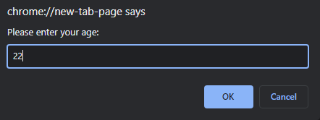

**Output: You can drive.**

1. Using switch in javascript, write a program to create any four browsers cases of your choice and generate alert (“I am using xyz browser) if user select any one of them.

**Code:**

var browser= prompt("Select index of the browser you are using: 1.Google chrome, 2. Mozrilla Forefox, 3. Microsoft Edge, 4. Safari");

switch (browser) {

case 1:

alert( "I am using Google Chrome");

break;

case 2: alert( "I am using Mozrilla FireFox"); break;

case 3:

alert( "I am using Microsoft Edge");

break;

case 4: alert( "I am using Safari"); break;

default:

alert( "I am using any other browser.");

}

**Output:**

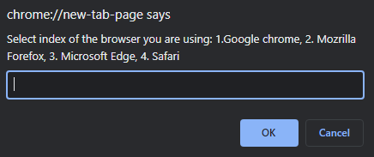 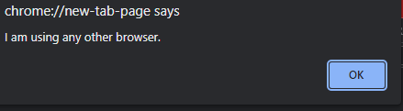

1. Write a javascript arrow function named calculateSupply that:
   1. takes 2 arguments: age, amount per day.
   2. calculates the amount consumed for rest of the life (based on a constant max age).
   3. outputs the result to the screen like so: "You will need NN to last you until the ripe old age of X"

**Code**:

var age = 25;

var PerDay=500;

let totalNeeded = (age, numPerDay) => {

var maxAge = 100;

var totalNeeded = (numPerDay * 365) * (maxAge - age);

return 'You will need ' + totalNeeded + ' to last you until the ripe old age of ' + maxAge;;

}

undefined

totalNeeded()

**Output: 'You will need NaN to last you until the ripe old age of 100'**

1. Create an object to hold information on your favorite recipe. It should have properties for title (a string), servings (a number), and ingredients (an array of strings). Write a method “Recipe” that print the separate lines (one console.log statement for each), log the recipe information so it looks like:

Tea

Serves: 2

Ingredients:

Sugar

Tea

Water

Milk

**Code:**

const make = {

Ttile: 'Tea',

Serving: 2,

Ingredients: ['sugar', 'tea','water','milk'],

recipe: function() {

console.log('Title: ' , this.Title);

console.log('Serves: ' , this.Serving);

console.log('Ingredients: ' , this.Ingredients);

}

};

make.recipe()

**Output:**

**Title: undefined**

**Serves: 2**

**Ingredients:**

**['sugar', 'tea', 'water', 'milk']**

1. Write a javascript program to get the below object to go from:

let obj = {

my: 'name',

is: 'Rudolf',

the: 'raindeer'

}

// to this:

'my name is Rudolf the raindeer'

**Code:**

let obj = {

my: 'name',

is: 'Rudolf',

the: 'raindeer',

details : function() {

console.log( "My " + this.my + " is " + this.is , " the " + this.the);

}

}

undefined

obj.details()

**Output: My name is Rudolf the raindeer**