


DATA ANALYTICS PROJECT
Pharmacy Analytics System
1.Project Overview:
The Pharmacy Analytics System is designed to
streamline pharmacy operations by leveraging data
analytics and forecasting. It integrates multiple data
sources such as inventory records, prescriptions,
supplier invoices, and expiry reports into a unified
platform. The system enables pharmacies to track
medicine stock, monitor expiry dates, analyze supplier
performance, and forecast demand.
2.Problem Statement:
Pharmacies often face challenges such as:
- Overstocking or understocking medicines
- Medicine wastage due to expiry
- Inefficient supplier management
- Lack of real‑time insights into prescription trends
These issues lead to financial losses, poor customer
satisfaction, and operational inefficiencies.
3. Objectives of the Project:
Ensure optimal inventory levels
Reduce medicine wastage through expiry monitoring
Improve supplier performance analysis
Forecast demand accurately to avoid shortages
Provide actionable insights via dashboards




4. Scope of the Project: The project covers:
Data ingestion from multiple sources (POS, inventory,
suppliers, prescriptions)
Data cleaning and transformation
Analytics and KPI generation
Forecasting using ML models
Dashboard visualization for decision‑making
Secure user access and monitoring
5. Technologies Used;
Data Collection & Processing: Python, Pandas, SQL
Database Layer: MySQL, PostgreSQL
Forecasting Engine: Prophet, Scikit‑learn, ARIMA
API Layer: Flask, FastAPI
Security: RBAC, Data Encryption, Backup & Recovery
Architecture:
The architecture illustrates how data sources such as
prescriptions, inventory, and supplier records feed
into the data ingestion layer. Cleaned and
transformed data is stored in a data warehouse,
enabling structured analytics. The analytics engine
and forecasting module generate insights on stock
levels, expiry alerts, and demand prediction. Finally,
results are presented through dashboards, with
built‑in security and monitoring ensuring safe and
role‑based access.


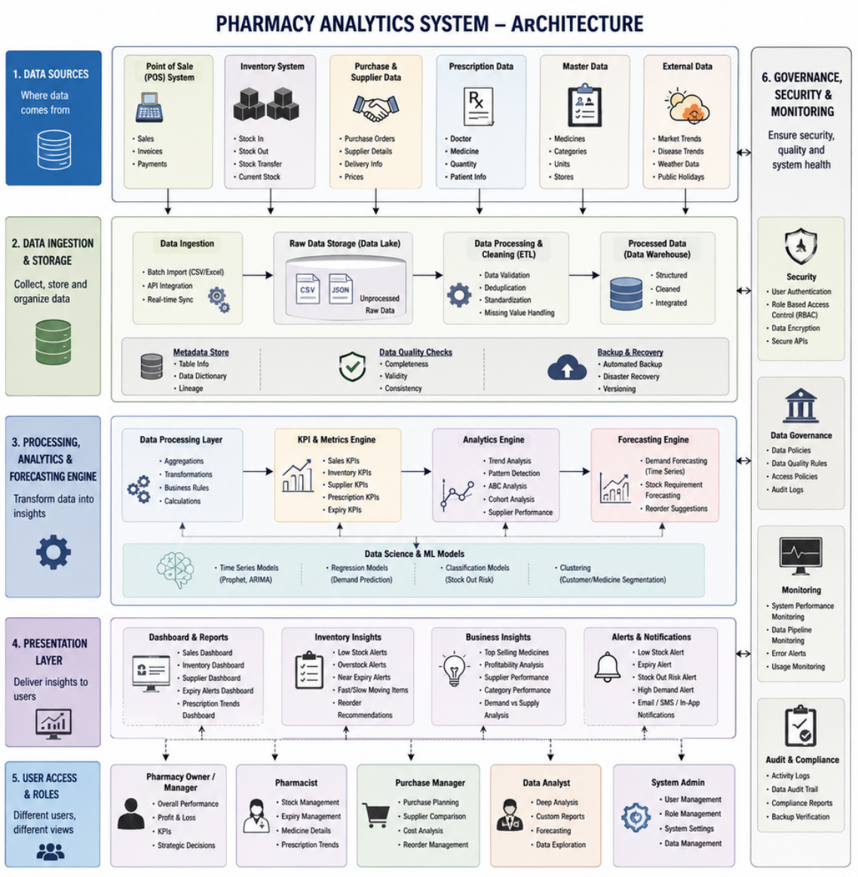

6. Project Architecture Diagram
Data sources --> Ingestion --> Storage --> Analytics -->
Forecasting --> Visualisation --> Security



7. Workflow of the Project:
- Data Sources: POS, inventory, supplier, prescription, external
data
- Data Ingestion & Storage: Raw data stored in Data
Lake →ETL →Data Warehouse
- Processing & Analytics: Cleaning, KPI generation, trend
analysis
- Forecasting Engine: Demand prediction, stock requirement forecasting
- Presentation Layer: Dashboards, alerts, notifications
- User Access & Roles: Different views for managers,
pharmacists, analysts
- Security & Monitoring: Authentication, RBAC, audit logs,
backup
8. Modules of the Project:
- Inventory Management Module
- Expiry Monitoring Module
- Supplier Performance Module
- Prescription Trends Module
- Forecasting & Optimization Module
- Dashboard & Reporting Module
9. Complete Understanding & Roadmap:
- Phase 1: Data ingestion and cleaning
- Phase 2: KPI and analytics engine development
- Phase 3: Forecasting engine integration
- Phase 4: Dashboard and visualization setup
- Phase 5: Security, governance, and monitoring




10. Expected Output:
- Real‑time dashboards showing stock levels, expiry alerts,
supplier performance
- Forecast reports predicting demand and stock requirements- Automated alerts for low stock, near expiry, and supplier
issues
11. Future Scope:
- Integration with AI‑powered recommendation systems
- Mobile app for pharmacists and managers
- Advanced predictive analytics using deep learning
- Integration with blockchain for secure supplier transactions
12. Conclusion:
The Pharmacy Analytics System provides a robust
framework for modern pharmacy management. By combining
data analytics, forecasting, and visualization, it enables
pharmacies to make informed decisions, reduce wastage,
and improve efficiency.
13. References:
- Excel for Data Collection
- Libraries: Pandas, Prophet, Scikit‑learn
- Visualization Tools: Streamlit, Power BI
***************

