Pharmacy Analytics System

Project Overview

The Pharmacy Analytics System is designed to streamline pharmacy operations by leveraging data analytics and forecasting. It integrates multiple data sources such as inventory records, prescriptions, supplier invoices, and expiry reports into a unified platform. The system enables pharmacies to track medicine stock, monitor expiry dates, analyze supplier performance, and forecast demand.

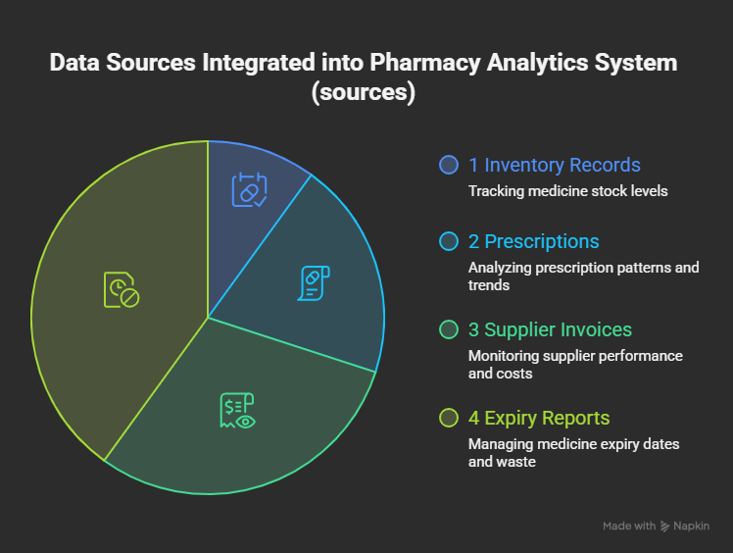

Problem Statement

Pharmacies often face challenges such as:
- Overstocking or understocking medicines
- Medicine wastage due to expiry
- Inefficient supplier management
- Lack of real-time insights into prescription trends
These issues lead to financial losses, poor customer satisfaction, and operational inefficiencies.

Objectives of the Project

- Ensure optimal inventory levels
- Reduce medicine wastage through expiry monitoring
- Improve supplier performance analysis
- Forecast demand accurately to avoid shortages
- Provide actionable insights via dashboards

Scope of the Project

The project covers:
- Data ingestion from multiple sources (POS, inventory, suppliers, prescriptions)
- Data cleaning and transformation
- Analytics and KPI generation
- Forecasting using ML models
- Dashboard visualization for decision-making
- Secure user access and monitoring

Technologies Used

- Data Collection & Processing: Python, Pandas, SQL
- Database Layer: MySQL, PostgreSQL
- Forecasting Engine: Prophet, Scikit-learn, ARIMA
- API Layer: Flask, FastAPI
- Visualization: Streamlit, Power BI
- Security: RBAC, Data Encryption, Backup & Recovery
6. Project Architecture Diagram
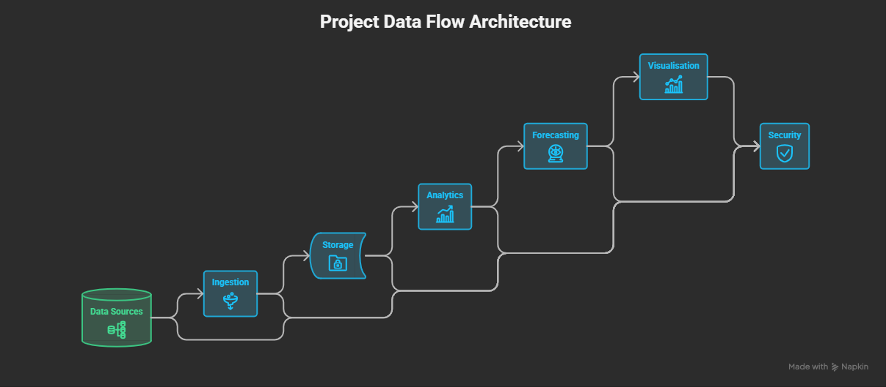

7.Workflow of the Project

- Data Sources: POS, inventory, supplier, prescription, external data
- Data Ingestion & Storage: Raw data stored in Data Lake → ETL → Data Warehouse
- Processing & Analytics: Cleaning, KPI generation, trend analysis
- Forecasting Engine: Demand prediction, stock requirement forecasting
- Presentation Layer: Dashboards, alerts, notifications
- User Access & Roles: Different views for managers, pharmacists, analysts
- Security & Monitoring: Authentication, RBAC, audit logs, backup

8.Modules of the Project
- Inventory Management Module
- Expiry Monitoring Module
- Supplier Performance Module
- Prescription Trends Module
- Forecasting & Optimization Module
- Dashboard & Reporting Module

9. Complete Understanding & Roadmap
- Phase 1: Data ingestion and cleaning
- Phase 2: KPI and analytics engine development
- Phase 3: Forecasting engine integration
- Phase 4: Dashboard and visualization setup
- Phase 5: Security, governance, and monitoring
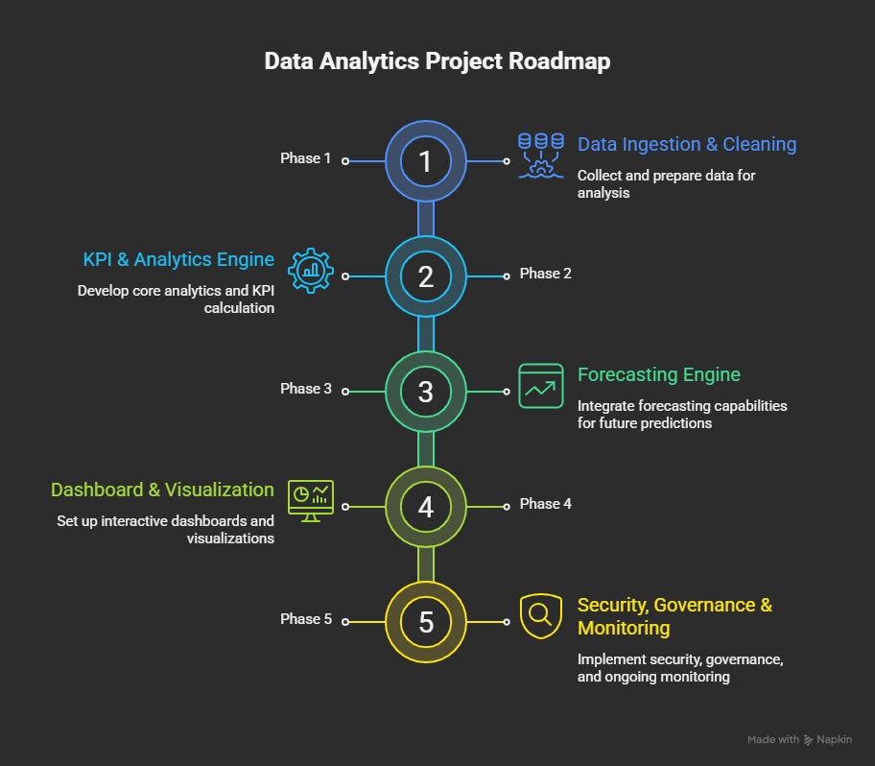

8.Expected Output

- Real-time dashboards showing stock levels, expiry alerts, supplier performance
- Forecast reports predicting demand and stock requirements
- Automated alerts for low stock, near expiry, and supplier issues

9.Future Scope

- Integration with AI-powered recommendation systems
- Mobile app for pharmacists and managers
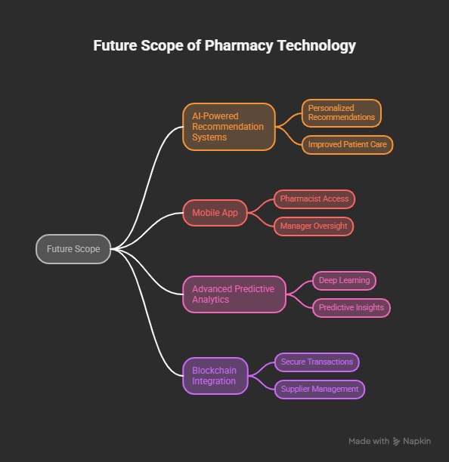
- Advanced predictive analytics using deep learning
- Integration with blockchain for secure supplier transactions

12. Conclusion

The Pharmacy Analytics System provides a robust framework for modern pharmacy management. By combining data analytics, forecasting, and visualization, it enables pharmacies to make informed decisions, reduce wastage, and improve efficiency.
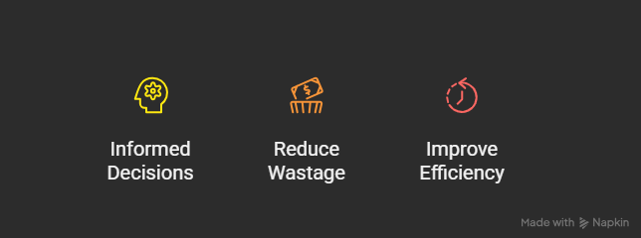

13. References
- Pharmacy Analytics System Architecture (uploaded document)
- Libraries: Pandas, Prophet, Scikit-learn
- Visualization Tools: Streamlit, Power BI

