1. Set up F5 BIG-IP LTM on VMware fusion
   1. For more information, refer (<https://devcentral.f5.com/articles/f5-developer-edition-installing-big-ip-on-vmware-fusion-8>)
2. Set up vSRX on VMware fusion
   1. For more information, refer (vSRX2.0 Junos 15.1-x49-d15.4 on VMware Fusion on MacOSX) <to be updated>
3. Set up Ubuntu virtual machine for testing the solution
   1. For more information, refer (<https://www.askdavetaylor.com/install-ubuntu-linux-vmware-fusion/)>
4. Service chain the three VMs using Fusion bridges
   1. Consider VMware fusion bridge, a layer 2 switch. If two network adapters are connected to the same bridge, the traffic starts flowing. In my setup, I created five custom VMware bridges for the purpose of service chaining. The following was the exact bridge configuration that I used:

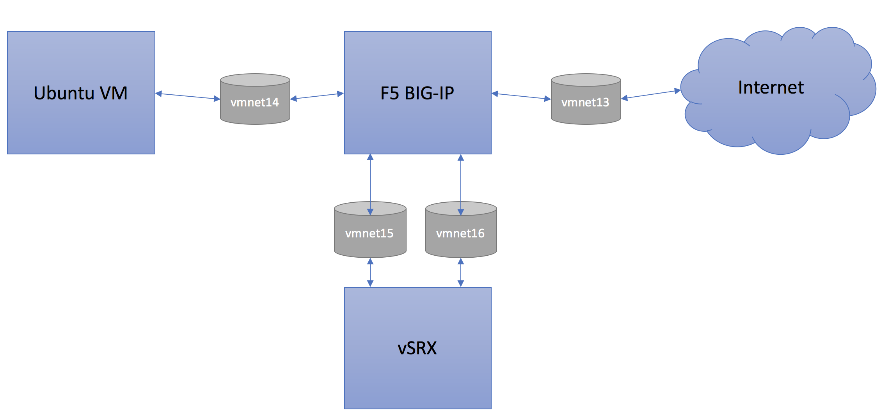

The fifth bridge was used for the purpose of managing all the virtual machines and the mac’s local interface was also connected to the management bridge (vmnet12)

1. Set up F5 SSL orchestrator
   1. For more information, refer (<https://f5.com/Portals/1/PDF/security/F5_BIG-IP_Platform_Palo_Alto_Networks_Next-Gen_Firewall_Solution.pdf>)
2. Set up IPS on vSRX to analyze the decrypted traffic
   1. (<https://www.juniper.net/documentation/en_US/junos/topics/task/configuration/security-ips-configuration-cli.html>)