Exercise 1
#include <iostream>
using namespace std;
void analyzeInvestigation(int numRooms, int &totalMinutes, int &challengingRooms)
{
int minutes;
totalMinutes = 0;
challengingRooms = 0;
for (int room = 1; room <= numRooms; room++)
{
cout << "Enter minutes spent in room " << room << ": ";
cin >> minutes;
totalMinutes += minutes;
if (minutes > 20)
challengingRooms++;
}
}
int main()
{
int numRooms;
int totalMinutes;
int challengingRooms;
cout << "Enter number of rooms: ";
cin >> numRooms;
analyzeInvestigation(numRooms, totalMinutes, challengingRooms);
cout << endl;
cout << "Total investigation time: " << totalMinutes << " minutes" << endl;
cout << "Number of challenging rooms: " << challengingRooms << endl;
return 0;
}
Output:
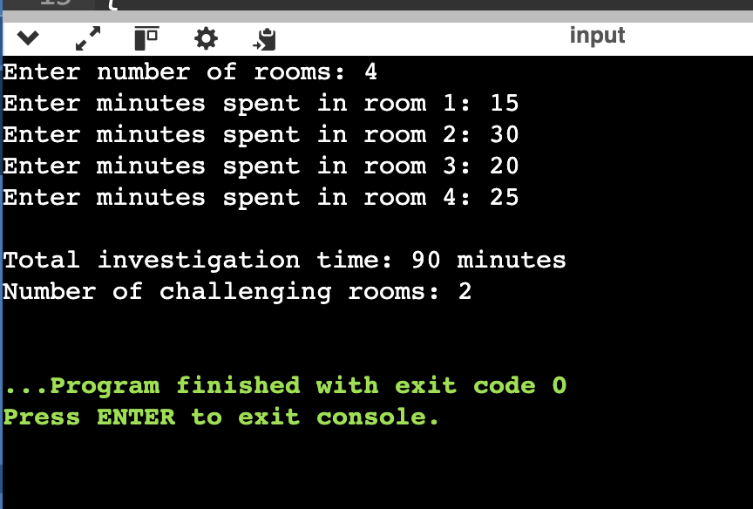

Exercise 2
#include <iostream>
using namespace std;
int minutesUntilMidnight(int elapsedMinutes)
{
return 1440 - elapsedMinutes;
}
int minutesUntilMidnight(int hour, int minute)
{
int elapsedMinutes = hour * 60 + minute;
return minutesUntilMidnight(elapsedMinutes);
}
int main()
{
int hour;
int minute;
int elapsedMinutes;
cout << "Enter hour and minute: ";
cin >> hour >> minute;
cout << "Minutes until midnight: " << minutesUntilMidnight(hour, minute) << endl;
cout << "Enter elapsed minutes for the second clock: ";
cin >> elapsedMinutes;
cout << "Minutes until midnight: " << minutesUntilMidnight(elapsedMinutes) << endl;
return 0;
}
Output:
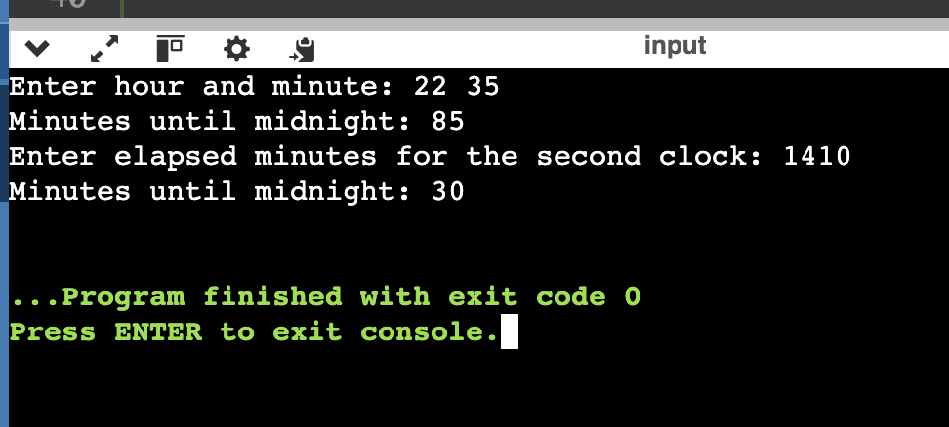

Exercise 3
#include <iostream>
using namespace std;
void investigate(int &energy, int &clues, int difficulty)
{
int cost = 2 * difficulty;
if (energy >= cost)
{
energy -= cost;
clues += difficulty;
cout << "Investigation completed" << endl;
}
else
{
cout << "Not enough energy" << endl;
}
}
void investigate(int &energy, int &clues, int difficulty, int hints)
{
int cost = 2 * difficulty - hints;
if (energy >= cost)
{
energy -= cost;
clues += difficulty;
cout << "Investigation completed" << endl;
}
else
{
cout << "Not enough energy" << endl;
}
}
int main()
{
int energy;
int numRooms;
int clues = 0;
int difficulty;
int thingHelps;
int hints;
cout << "Enter initial energy: ";
cin >> energy;
cout << "Enter number of rooms: ";
cin >> numRooms;
for (int room = 1; room <= numRooms; room++)
{
cout << "Room " << room << " - enter difficulty and help (1/0): ";
cin >> difficulty >> thingHelps;
if (thingHelps == 1)
{
cout << "Enter hints: ";
cin >> hints;
investigate(energy, clues, difficulty, hints);
}
else
{
investigate(energy, clues, difficulty);
}
cout << "Energy: " << energy << " Clues: " << clues << endl;
}
return 0;
}
Output:
