NETWORK AUTOMATION PLATFORM
( N/WAP )
Source of Truth & Platform Architecture Document
enterprise_real_sot
Document Type | Platform Architecture / Source of Truth Reference
Scope | enterprise_real_sot — full lifecycle (NetBox SoT → Config Generation → Deployment → Compliance → Observability → ServiceNow)
Audience | Network Engineers, DevOps Engineers, New Contributors, LLM Project Context
Version | 1.0
Status | Living document — reflects verified repository state as of the date below
Prepared | 7 September 2026

Table of Contents
1. Platform Overview 3
2. Project Directory Overview 6
3. Device Migration 8
4. Source of Truth / NetBox 12
5. Configuration Generation 15
6. Pre-Deployment Validation 18
7. Deployment 20
8. Post-Deployment Validation 22
9. Compliance and Drift Detection 25
10. Observability 26
11. ServiceNow Integration 29
12. CI Pipeline 32
13. CD Pipeline 34
14. Configuration and Artifacts 36
15. Tests 38
16. Real Device Example — SW1_gns3 End-to-End 39

1. Platform Overview
The Network Automation Platform (N/WAP) is a system that automates the management of Cisco network devices, built around NetBox (the central database that stores how the network should be set up). NetBox holds the single, official record of how the network is supposed to be configured. The platform uses that record to automatically build the exact device configuration needed, checks every change before it happens, sends only the specific changes needed to each device over SSH (a secure remote connection), and constantly checks that real devices still match what NetBox says they should be. On top of this, the platform watches for problems — such as a device going offline or its configuration drifting away from what was intended — and both shows these on a dashboard and automatically creates a tracked incident in ServiceNow (an incident-management system).
Rather than being one single program, the platform is made up of several separate, purpose-built parts: a device-migration toolkit that brings older switches into NetBox, an importer that loads data from CSV files into NetBox (populating the "source of truth"), a configuration-generation engine that turns that data into CLI (command-line) instructions for devices, validators that check changes both before and after they are sent, and a separate monitoring and ServiceNow system that watches all the devices independently of the deployment process. Every stage saves timestamped JSON/text files to disk, so there is a complete record of what was intended, what was generated, what was actually sent to devices, and what was observed on the devices afterward.

End-to-End Architecture Flow
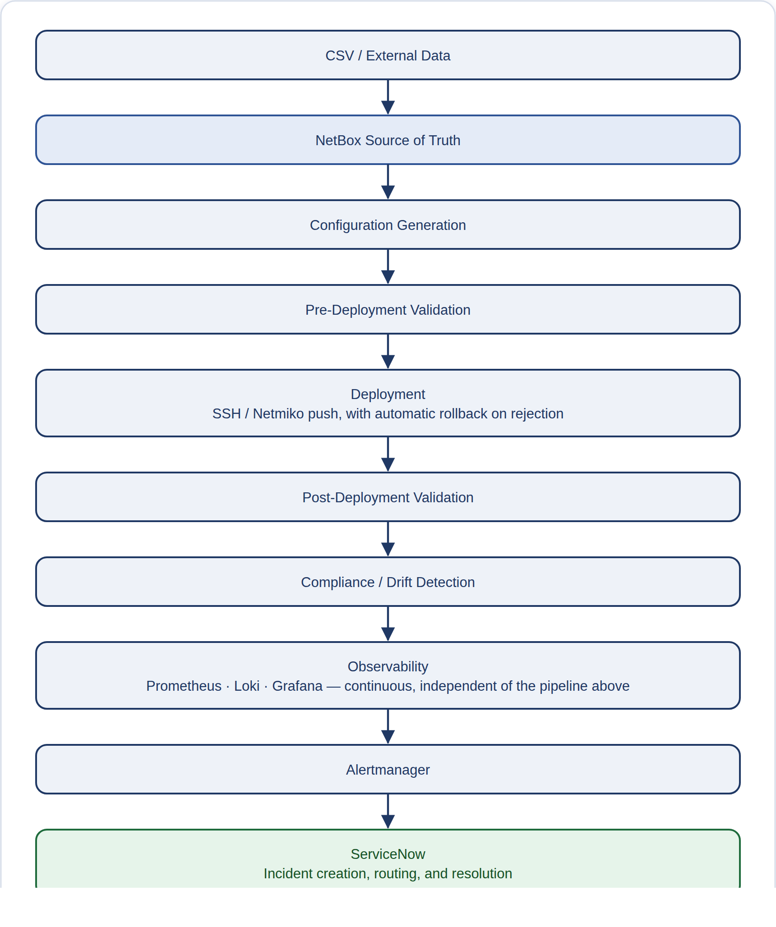
This description matches the codebase as it stands today, with one important caveat that applies throughout this document: each stage, from NetBox through to Deployment, works and is real, but a person currently has to run each one separately as its own command-line tool — they are not yet automatically linked together into one pipeline. Section 13 (CD Pipeline) explains exactly which parts are automated today and which still need a person to trigger them. By contrast, the other half of the flow — Observability, Alertmanager, and ServiceNow — runs on its own continuously and automatically once the Docker Compose stack (the set of monitoring tools) is running.
NOTE
AI/LLM (artificial intelligence) agent architecture is not covered by this document. The repository does contain a gap-analysis document that talks about future AI-agent readiness, but no AI or agent decision-making logic actually exists in the platform's running code, so none is described here.

2. Project Directory Overview
Below is a simplified view of the enterprise_real_sot/ folder, showing only the files and folders that matter for understanding how the system is built:
enterprise_real_sot/│├── device_migration/ Tool that brings old switches into NetBox (the inventory database of all devices)├── python/importers/ Scripts that load CSV data into NetBox (the DCIM, IPAM, and Config Context sections)├── src/parser/ An old, unused tool for merging YAML (structured settings files) — not part of the live system├── csv/ The source data files: device/site info (dcim), addressing (ipam), and configuration settings (config_context)├── config/ App settings plus files that control device migration├── deployment/ Builds device configurations, sends them over SSH (a secure remote connection), can undo changes, and supports multiple protocols├── pre_deployment_validation/ Checks configurations for problems before anything is sent to a device├── post_deployment_validation/Checks whether devices still match what was intended and flags any differences├── observability/ Monitoring tools (Prometheus, SNMP Exporter, Loki, Promtail, Grafana, Alertmanager) run together via Docker Compose (a tool for running several linked programs)├── servicenow/ Connects alerts to ServiceNow (the incident-tracking system) to manage incidents├── artifacts/ Saved output from every stage (pre_deployment / deployments / post_deployment / migration)├── tests/ Automated checks covering the whole system, plus security checks├── docs/ Design notes, remediation reports, and proof documents├── maintenance_mode.py A command-line tool to pause ServiceNow incident alerts during planned outages└── .github/workflows/ Automated checks that run via GitHub Actions (repo root)

Folder | Purpose
device_migration/ | Moves configuration from old Cisco switches into NetBox. It has two workflows: one driven by a manifest file for pairing an old switch with its replacement, and a simpler one for discovering devices in the GNS3 lab. It only reads from devices over SSH (never changes them), and any updates to NetBox are staged for a person to review first.
python/importers/ | A one-way tool that reads the csv/ folder and loads that data into NetBox's DCIM, IPAM, and Config Context sections. This is how data in the CSV files actually becomes the live Source of Truth.
src/parser/ | A tool (YamlLoader, MergeEngine) that combines layered YAML settings files together. It has been confirmed that the real CSV import process does not use this tool — it is kept only for reference and should not be treated as part of the active system.
csv/ | The source data that people edit directly and that is tracked in version control: the list of devices, interfaces, and sites (dcim/), IP addressing (ipam/), and the layered global/site/device configuration settings (config_context/).
config/ | The app's settings (such as the NetBox address and access token, and the CSV folder location), plus YAML manifest files that control the device_migration pipelines and its rules for classifying data into the Source of Truth.
deployment/ | The main engine that builds and sends configurations: it gathers each device's details from NetBox, figures out which protocols apply, generates the CLI (command-line) configuration using plugin modules, connects to the device over SSH using Netmiko (a library for SSH connections to network devices), sends only the changes that are actually needed, and undoes the change if it's rejected.
pre_deployment_validation/ | A checkpoint, built from plugins, that reviews the generated CLI configuration and device details before any connection to the device is made. Right now it includes one working check, for Port Security.
post_deployment_validation/ | Reads the actual state of a device over a read-only SSH connection and compares it, field by field, against the same intended state (from NetBox) used to generate its configuration, then reports whether it is COMPLIANT or has DRIFT (does not match).
observability/ | A self-contained set of 8 monitoring tools, run together with Docker Compose, that watches the 3-device GNS3 lab using SNMP and syslog (standard monitoring protocols). The results are shown in Grafana (a dashboard tool) and trigger alerts through Prometheus and Alertmanager.
servicenow/ | Receives alert notifications from Alertmanager and manages the whole life of an incident — creating, updating, and resolving it — in a real ServiceNow PDI (Personal Developer Instance). It also has a mock mode so it can be tested without an internet connection.
artifacts/ | The output produced by every stage of the process, organized by stage and by the time it was created: generated configurations, change plans, deployment results, compliance reports, and migration data.
tests/ | tests/ci_runner.py is a custom tool that runs 17 layers of checks as part of CI (continuous integration, the automated testing process). tests/test_security_sanity.py is a small set of tests that check for exposed secrets and general good practice.
docs/ | Design notes and reports on fixes made. Several of these files were checked against the actual code during this review, and any differences found are pointed out in the relevant sections below.
maintenance_mode.py | A command-line tool, kept at the top of the project, that talks to the running ServiceNow adapter over HTTP to turn a suppression window on or off — this stops false incidents from being created during planned device outages.
.github/workflows/ | Contains one workflow file, ci-validation.yml, which runs the CI (continuous integration / automated testing) pipeline described in Section 12. It does not contain any deployment automation.
.github/workflows/ (update) | Two more workflow files now exist here: cd-plan.yml and cd-deploy.yml. See Section 13's "CD Automation Update" for what they actually do.

3. Device Migration

How to Run This
Safe preview -- reads the switch and shows what would change, without writing anything to NetBox:
$ python3 -m device_migration.cli --manifest config/migration/hyderabad_access_switches.yaml --discovery-only

To actually write the reviewed result into NetBox:
$ python3 -m device_migration.cli --manifest config/migration/hyderabad_access_switches.yaml --populate-netbox --commit

device_migration/ brings older Cisco switches into the platform. It reads each switch's live configuration over SSH (a secure remote connection), converts it to work on new hardware, and prepares the result as changes to NetBox that a person reviews before anything is finally saved. It has two related workflows: a manifest-driven "legacy pair" migration, where one physical switch is replaced by another (for example, sw-access-01 → sw-access-07), and a simpler discovery workflow for the GNS3 lab's staging devices (R1_gns3 / SW1_gns3 / SW2_gns3). In both cases, the tool only reads from the original device — it never sends any configuration command to the switch being migrated.

Files
cli.py
The command-line starting point for this tool (run as python -m device_migration.cli). It picks the legacy-pair pipeline or the GNS3 staging pipeline depending on whether the word "staging" or "gns3" appears in the manifest's filename, and offers these options: --discovery-only, --stage-intent, --populate-netbox, --dry-run, and --commit.
collector.py
A simple wrapper around the shared SSHCollector tool. It runs a fixed set of read-only "show" commands on the old device and returns the raw CLI (command-line) text for each command.
manifest_loader.py
Reads a migration manifest file (in YAML or JSON, structured settings-file formats) into MigrationPair and PatternMapping objects, which hold the source and target device names, IP address details, and rules (regex patterns) for mapping interface names.
interface_mapper.py
Matches interface names on the old device to interface names on the new device. It first checks a specific override list for that device pair, then falls back to pattern-matching rules (regex) from the manifest. Any interfaces that still can't be matched are reported separately.
parser_engine.py
Turns the raw text from "show" commands into organized data — VLANs, interface details, and the state of each protocol — using the same resource plugins that are also used for post-deployment compliance checking.
populator.py
The engine that populates the Source of Truth (SoT). It sorts the parsed data into global, site, device, DCIM, and IPAM categories, following rules set out in a policy file. It works out exactly what NetBox REST PATCH (update) requests would be needed as a dry run, and only sends those update requests for real — after first taking a backup — when a person explicitly commits the change.
artifact_manager.py
Saves each device pair's raw output, organized data, interface mapping, and summary to the folder artifacts/migration/<source>_to_<target>/, so it can be audited later or reprocessed automatically.
discovery_engine.py
A simpler, self-contained workflow for the GNS3 staging devices. It goes through these steps: collect data, parse it, classify it, stage it, and optionally commit it — with default device type, platform, and site values already built in for the lab setup.
main.py
MigrationOrchestrator runs the whole legacy-pair process for each entry in the manifest: it selects the devices, works out the login credentials, collects data, parses it, maps interfaces, classifies the data, saves the output files, and optionally commits the change to NetBox. Each device pair is handled independently, so a failure in one pair (caught with its own try/except error handling) doesn't affect the others.

Migration Flow
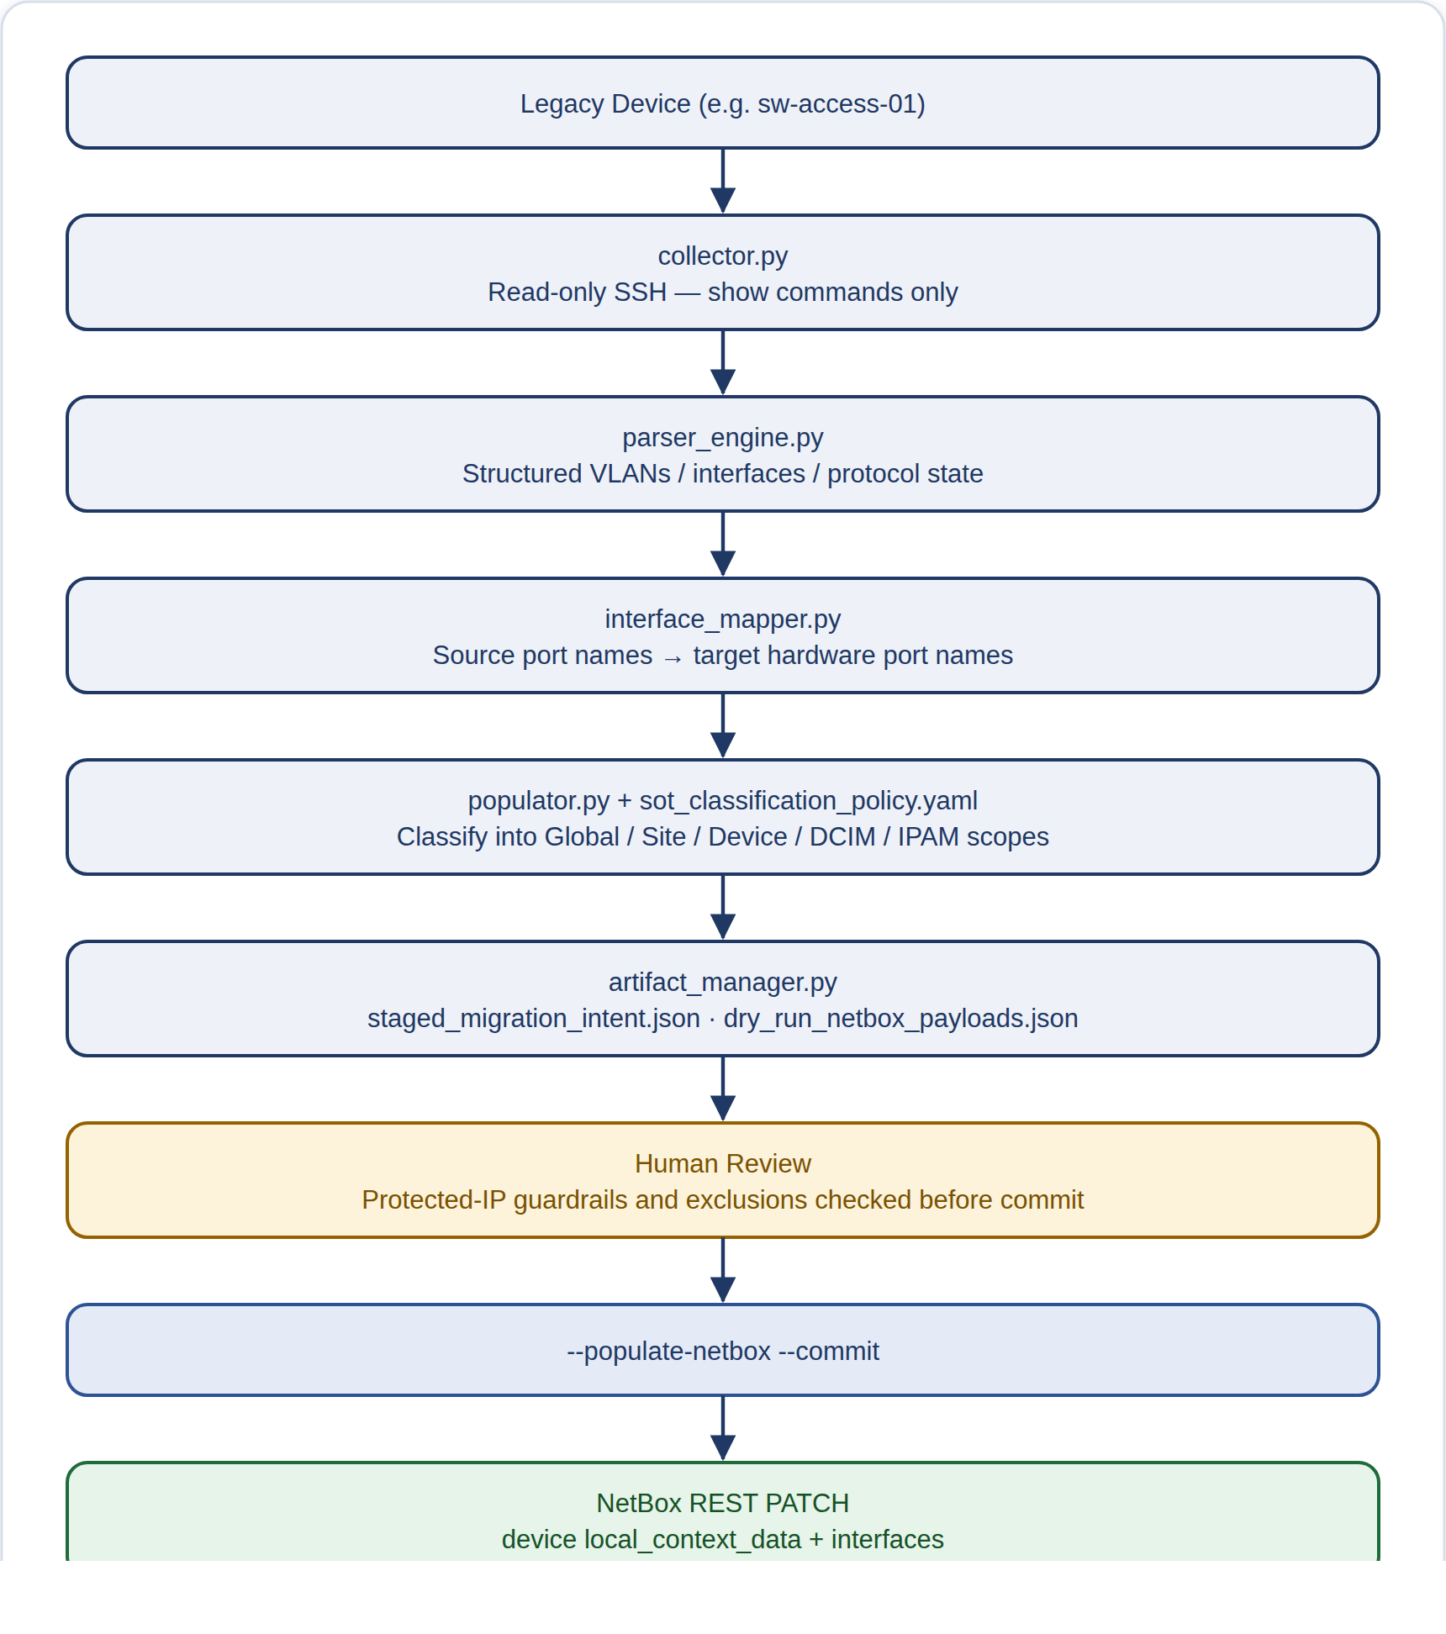
The settings files that drive this: config/migration/hyderabad_access_switches.yaml (the manifest for real production legacy-pair migrations), config/migration/gns3_staging_discovery.yaml (the manifest for GNS3 lab discovery), and config/migration/sot_classification_policy.yaml (the rules for where data gets classified, and which items are protected from being overwritten — Vlan1, Console0, the management IP address, and credentials).
MATURITY NOTE
This part of the system genuinely works, but it has some known rough edges: the --discovery-only and --stage-intent command-line options are accepted but don't actually control what the pipeline does — the staged intent is always generated no matter what. The legacy-pair and GNS3 pipelines each have their own separate copy of the NetBox-syncing logic instead of sharing one. AAA (authentication/authorization/accounting) session data is collected but never actually used in the staged intent. And docs/DEVICE_MIGRATION.md describes an earlier, simpler version of this part of the system than what is actually built — it doesn't mention populator.py, discovery_engine.py, or several of the command-line options at all.

4. Source of Truth / NetBox

How to Run This
Loads every CSV file under csv/ into NetBox, in the correct order (devices first, then addressing, then config context):
$ python python/importers/run_import.py

NetBox is the platform's single source of truth (the one place holding the current, correct information about the network) while the system is running. Data only flows one way into it: an import layer reads the csv/ folder (a set of version-controlled, spreadsheet-like text files) and writes the results into NetBox's DCIM (device and location records), IPAM (IP address records), and Config Context (settings) objects. Every later stage — configuration generation, pre-deployment validation, and post-deployment compliance — reads from NetBox itself at run time, not from the CSV files directly.

Files
common_api.py
A shared connection tool used by every importer to talk to NetBox: it builds an authenticated requests.Session (a reusable, logged-in connection), wraps GET/POST/PATCH requests (ways to read, create, and update data) with error handling, and converts human-readable CSV names (site, role, manufacturer, device, rack) into the internal ID numbers NetBox uses.
import_dcim.py
Fills in NetBox's DCIM (device and location records) in the order each piece depends on the last: manufacturers to roles to platforms to device types to sites to racks to devices to interfaces. It also attaches each device's own config-context CSV file to it as local_context_data.
import_ipam.py
Fills in NetBox's IPAM (IP address records) — VLANs, prefixes (subnets), and IP addresses. It assigns each IP address to its device interface, and sets the device's primary_ip4 field when the CSV marks that IP's role as "primary".
import_config_context.py
Creates NetBox Config Context objects (settings that apply at different levels) in three layers: Global-Defaults (applies to everything), Site-Defaults-<site> (applies to one site), and Device-<name> (applies to one device) — built from the three matching folders under csv/config_context/.
run_import.py
The main script that runs everything: it runs the DCIM, then IPAM, then Config Context imports in that order, then runs a fixed validation check confirming a handful of known objects exist, and prints a summary of what was created, skipped, or failed.
deployment/netbox_client.py
A separate connection tool that only reads from NetBox and never writes to it, with automatic retrying and paged results, used by the deployment and compliance parts of the system to look up information while running.

CSV Data Model
Location | Represents
csv/dcim/ | Physical layout and inventory information: manufacturers, device roles, platforms, device types, regions, site groups, sites, locations, racks, devices, interfaces.
csv/ipam/ | IP addressing data: VLANs (vlans.csv), subnets (prefixes.csv), and which IP address goes to which interface (ip_addresses.csv).
csv/config_context/global/ | One file (global_defaults.csv) applied to every device, with baseline settings such as SSH (remote access), CDP (device discovery), logging, and similar.
csv/config_context/sites/ | One file per site (e.g. hyderabad.csv, gns3-staging.csv) with settings specific to that site, layered on top of the global defaults.
csv/config_context/devices/<site>/<role>/ | One file per device — VLANs, DHCP snooping, IPv6, EtherChannel, and other operational config specific to that device.

SoT Population Flow
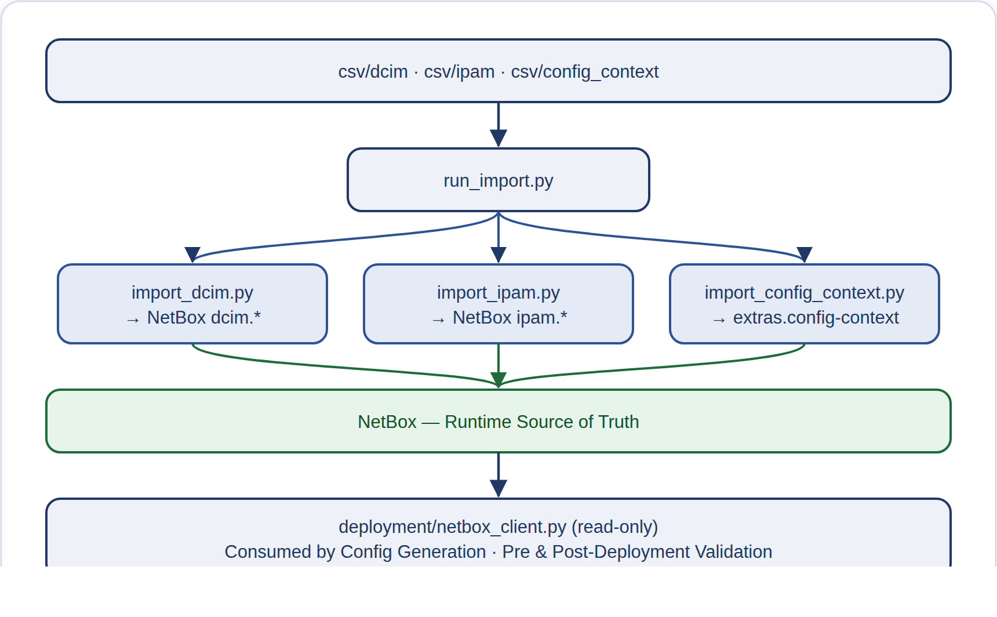
MATURITY NOTE
Confirmed issues worth flagging. First, the same CSV file's device-level settings get written into NetBox twice — once as local_context_data by import_dcim.py, and again as a separate Device-<name> Config Context object by import_config_context.py — and this duplication is not mentioned in docs/NETBOX_DATA_MODEL.md. Second, when importing VLANs, the system checks for existing VLANs using only the VLAN ID number, without checking which site it belongs to, so if the same VLAN ID is used for a second site (GNS3 Staging), it is silently skipped instead of being created. Third, the src/parser/ package (YamlLoader, MergeEngine) contains a different way of combining settings using YAML files (a different data format), but it is not used anywhere in this CSV-based process — it should be treated as unused code, not part of the active system.

5. Configuration Generation

How to Run This
Preview mode -- builds the configuration and runs Pre-Deployment Validation (Section 6), but never connects to a device:
$ python -m deployment.cli --devices site:gns3-staging --protocols all --dry-run

Configuration generation turns NetBox data into exact, repeatable Cisco IOS CLI text (the command-line text that configures a Cisco device) through a series of one-way steps: pick the devices, build one combined set of information per device, filter it through a check based on the device's role, send it to separate protocol plugins (small independent pieces of code each handling one feature), and join together the CLI text each one produces. Each step does only its own narrow job and has no side effects — in particular, protocol plugins never touch NetBox, the CSV files, or the network directly; they only work with the in-memory information they are given.

Core Files
config.py
Loads the NetBox web address and access token, plus SSH (secure remote login) timeout and retry settings, from environment variables, and provides a way to look up login credentials by device role. This module only handles configuration — it doesn't do anything else.
device_selector.py
Converts the criteria a user gives on the command line (device name, site:, role:, custom fields) into the search parameters NetBox needs, and returns the matching device records.
context_builder.py
Retrieves the Global, Site, and Device-level Config Contexts (settings) from NetBox, plus local_context_data, and combines them together in that order of priority (Device settings override Site, which override Global). It also attaches the device's interfaces and IP addresses, producing one combined set of information that every later step uses.
capability_resolver.py
Matches a device's NetBox role to the set of capabilities it supports — base interface, Layer 2 switching (switching within a local network), Layer 3 routing (directing traffic between networks), and global management — using a fixed reference table. A plugin must pass this check before it is even considered for that device.
config_generator.py
Automatically finds every protocol plugin in the deployment/protocols/ folder, puts them in order, and for each one runs four checks in sequence — capability-gate, is_applicable, validate, render — then joins the resulting pieces of CLI text into the final device configuration.
credentials.py
Converts non-sensitive NetBox device information (primary IP address, platform) into connection settings for Netmiko (the library used to connect to devices). Actual secrets, such as passwords, are only ever read from environment variables — never from NetBox.
lifecycle.py
Defines the DeviceLifecycleState and BatchLifecycleState enums (fixed lists of allowed status labels) used to mark results throughout the pipeline, such as VALIDATED, DEPLOYED, and ROLLBACK_SUCCESSFUL.
artifact_manager.py
Creates the pre_deployment output folder, named with a timestamp, and writes the summary report for the batch.
utils.py
One shared function that combines nested dictionaries (data structures of key-value pairs) together, layer by layer; used by context_builder.py to combine the Global, Site, and Device config contexts.
main.py / cli.py
DeploymentOrchestrator and its command-line wrapper manage device selection, building the context, generating the configuration, and pre-deployment validation — this is Phase 1 of a run. Actually deploying the configuration is Phase 2, covered in Section 7.

Protocol Plugin Pattern
Every protocol plugin follows the same standard structure, defined in base_protocol.py: a unique protocol_name, an optional protocol_category, and three methods — is_applicable(context), validate(context), and render(context), which produces the CLI text. Plugins are found automatically while the program runs; none of them is hardcoded into the generator.
interface_base · aaa · cdp · dhcp_snooping · dns · etherchannel · ipv6 · lldp · ntp · port_security · snmp · stp · syslog · vlan · vtp

Generation Flow
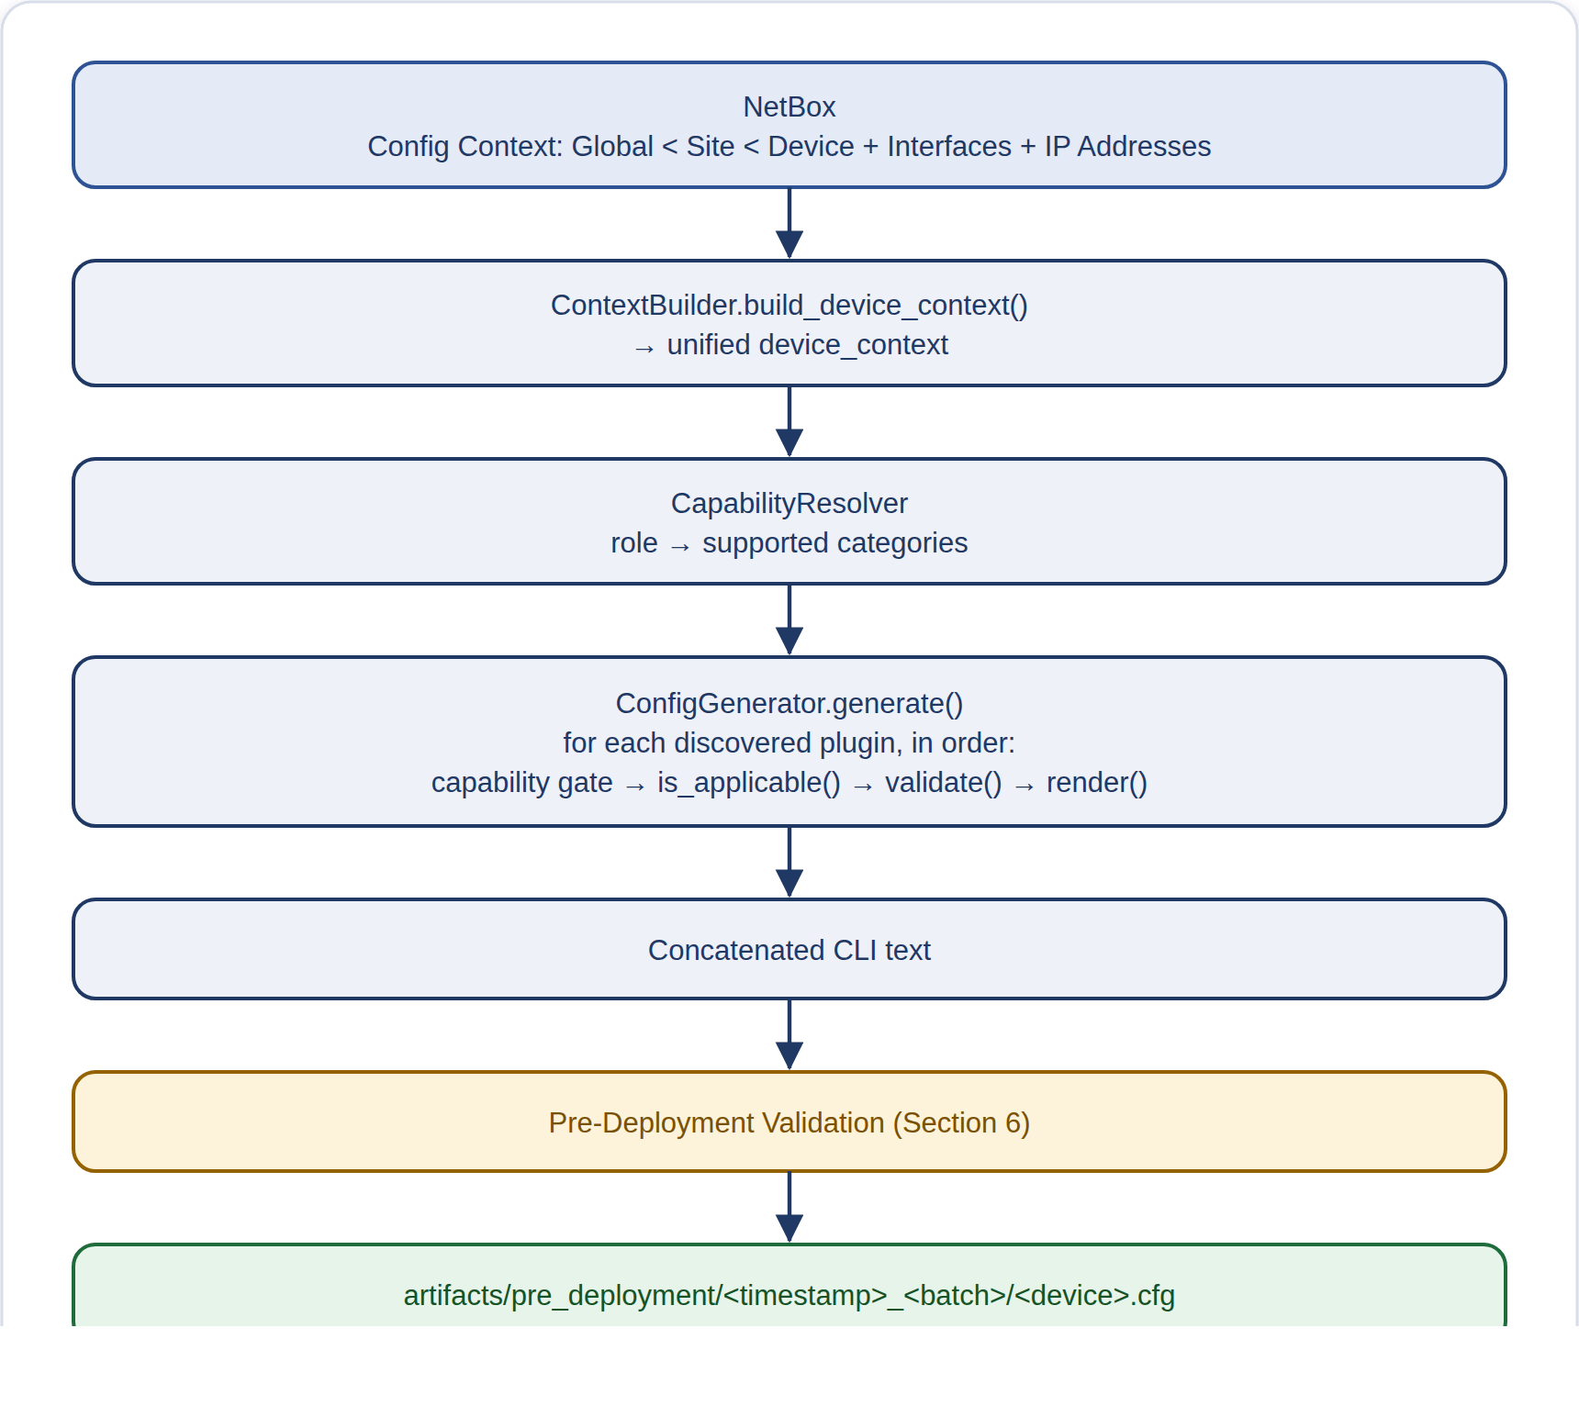
MATURITY NOTE
docs/ARCHITECTURE.md currently describes protocol plugins, connectors, and orchestration as "future" work. In fact, all of this is already built and working today — it's exactly what this section describes. That document is out of date and should not be treated as showing the current state of the project.

6. Pre-Deployment Validation

How to Run This
There is no separate command for this step -- it runs automatically, for every device, as part of the commands shown in Section 5 (Configuration Generation) and Section 7 (Deployment). It cannot be skipped or run on its own.
Pre-deployment validation is a small set of checks that runs on the generated CLI (the text commands for the device) and device details before any SSH (secure remote connection) is made to the device. A controller runs two basic checks first (the CLI is not empty, and the device has a name), then runs every relevant protocol-specific check found by a registry (a list of available checks), in priority order.

Files
base_validator.py
Every validator plugin (a pluggable check module) follows the same structure: validator_name, priority, supports_device(), is_configured(), and validate(), which returns a list of check results.
registry.py
Automatically finds all validator plugin classes under the validators/ folder when the system starts, without needing them to be manually listed in the code. It then filters them by whether they support the device's platform, whether they are configured to run, and an optional list of allowed protocols.
orchestrator.py
Runs the two basic checks, then every relevant plugin in priority order. If one plugin fails with an error, that error is caught so it doesn't stop the rest of the checks. All the results are combined into one validation report.
report.py
A module that only holds data: severity levels (INFO, WARNING, ERROR), rule-type labels (TECHNICAL, POLICY), and the data structures used for each individual check result and the overall report.
validators/port_security.py
The only validator built so far. It only runs when a NetBox interface has port_security.enabled turned on. It checks the allowed range for MAC address limits, the violation mode, and confirms the generated CLI actually includes the port-security lines. It also gives a non-blocking warning (advisory) if sticky MAC is turned off.

Validation Flow
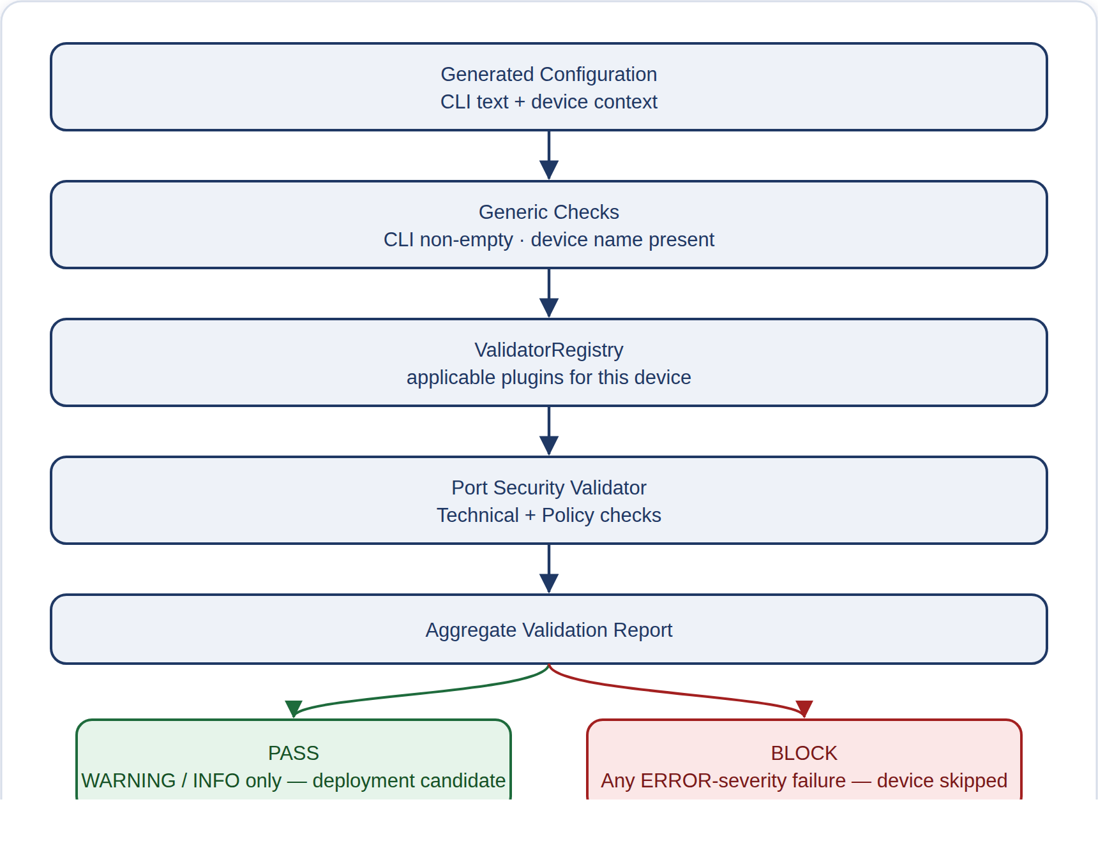
MATURITY NOTE
Currently this covers just one protocol, Port Security, with four checks in total. The plugin system is built to be easily extended: adding a new protocol only requires creating a new BaseProtocolValidator subclass inside validators/, but no additional validators have been built yet. The TECHNICAL/POLICY label exists and is used, but it is for description only, it does not affect whether a check blocks deployment. Only the severity (ERROR vs. WARNING/INFO) decides that.

7. Deployment

How to Run This
Pushes the real configuration to the selected devices over SSH (only the lines that actually need to change):
$ python -m deployment.cli --devices site:gns3-staging --protocols all

Add --save-config to also make the change survive a device reboot (a Cisco "write memory"):
$ python -m deployment.cli --devices site:gns3-staging --protocols all --save-config

Deployment sends an already-checked configuration to a live device over SSH (a secure remote connection) using a tool called Netmiko. It does not just resend the whole configuration blindly, it first reads the device's current running configuration, works out which generated lines are already in place and which need to change, and only sends the lines that need changing. Every attempt, whether it succeeds or fails, is fully recorded on disk for audit purposes.

Files
device_connector.py
Opens the SSH session using Netmiko, compares the generated lines against the device's live running configuration, sends only the commands that need to change, checks the device's response text for known Cisco CLI rejection messages, and triggers a rollback (automatically undoing the change) if one is found.
rollback_manager.py
Works out the exact opposite commands needed to undo whatever configuration sections a failed push affected (interfaces, VLAN blocks, or simple global settings), runs those undo commands, then reads the live device again to confirm it was actually restored before reporting that the rollback succeeded.
lifecycle.py
The same status list documented in Section 5, also used here to mark results as DEPLOYED, ROLLBACK_SUCCESSFUL, or ROLLBACK_FAILED. Two other statuses, AWAITING_APPROVAL and APPROVED, exist in the list but are not used yet, they are reserved for a future approval step.
main.py (Phase 2)
The execution stage of DeploymentOrchestrator: it calls DeviceConnector.deploy() for each candidate device (or runs a dry run/test instead), then hands off to the post-deployment compliance check described in Section 8.

Deployment Flow
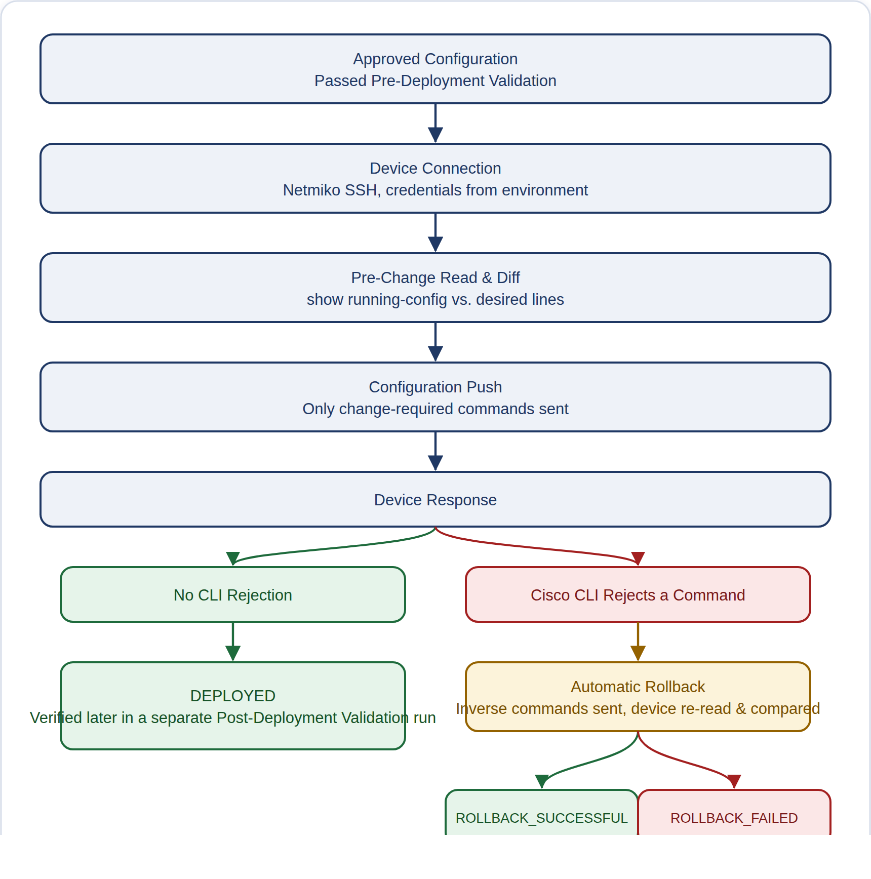
MATURITY NOTE
Automatic rollback only happens in one specific situation, not in every failure case. It only triggers when the device itself rejects a command through its CLI. If the SSH connection fails while sending commands, rollback is deliberately not attempted, because it is not known whether the commands were actually delivered or took effect, so undoing them safely is not possible, and this is explicitly recorded as such. There is no separate manual option to trigger a rollback, no dedicated reachability check before connecting, and no rollback that applies across a whole batch of devices, each device's rollback only affects its own deployment attempt. The AWAITING_APPROVAL and APPROVED statuses exist but are not connected to any actual approval step, in practice an "approved" configuration just means it passed Pre-Deployment Validation.

Every File in deployment/ (Complete List)
The lists above cover the files most relevant to deployment specifically. Since the deployment/ folder also holds the files used earlier in the pipeline (Configuration Generation, Section 5) and later (the CD Pipeline, Section 13), here is every file and subfolder actually inside it, in plain English:
__init__.py
An empty marker file that just tells Python "this folder is a package" so its files can be imported from elsewhere. Nothing to configure here.
config.py
Reads settings from the project's .env file (like the NetBox web address, login token, and SSH timeouts) so every other file in this folder can use them.
logger.py
Sets up one shared, consistent way of printing timestamped log messages (date, module name, severity, message) so every file's output looks the same.
utils.py
One small helper function that combines two settings dictionaries together, letting a more specific setting (e.g. for one device) override a more general one (e.g. for a whole site) without losing anything else.
netbox_client.py
The low-level connector that actually talks to NetBox over the network: handles logging in, retries if the network hiccups, and fetches results a page at a time. Every other file that needs NetBox data goes through this one. Covered in more depth in Section 4.
device_selector.py
Turns what a user typed in (a device name, a site, or a role) into an actual list of matching devices by asking NetBox.
context_builder.py
For one device, pulls together everything NetBox knows about it (its interfaces, IP addresses, and layered settings) into a single combined package. Covered in more depth in Section 5.
capability_resolver.py
Looks at a device's role (e.g. "access switch" vs "router") and decides which categories of settings are even allowed to apply to it, so a router can never accidentally get switch-only settings.
credentials.py
Works out the SSH username, password, and connection details for a device. Passwords are never stored in NetBox or in the code itself — they always come from the environment file.
config_generator.py
Finds every plugin in the protocols/ folder and runs each one against a device's combined settings to produce the actual Cisco command-line text to send.
protocols/ (a folder of 16 files)
One small file per network feature — VLANs, NTP time sync, port security, DNS, and so on. Each file knows how to check whether its feature applies to a device and, if so, generate the exact commands for it. Covered file-by-file in Section 5.
lifecycle.py
A short, shared list of every possible outcome a device or a batch of devices can end up in (e.g. "deployed successfully", "rolled back successfully", "rolled back but failed") so every part of the pipeline uses the same wording.
artifact_manager.py
Creates the timestamped folder used to save each run's results, writes the "manifest" (a signed list of exactly what's safe to deploy, with fingerprints to catch tampering), and later writes the final deployment result file. Covered in more depth in Section 13.
device_connector.py
The file that actually opens the connection to a real device and sends it commands — sending only what's different from what's already there, and automatically undoing the change if the device rejects it.
rollback_manager.py
Works out the exact "undo" commands needed after a failed change, sends them, and then double-checks the device by reading it again — it never just assumes the undo worked.
main.py
The conductor for the whole deployment folder: it decides which devices to work on, calls each of the files above in the right order, and hands off to Post-Deployment Validation (Section 8) afterward.
cli.py
The actual command you type in a terminal to start all this (see "How to Run This" above); it reads your typed options — which devices, dry-run or not, and so on — and hands them to main.py. Covered in more depth in Section 13.
tests/ (a folder of 5 files)
Automated checks that prove the safety rules above actually hold — for example, "never skip the safety check" or "never deploy a tampered file" — without needing a real device. Covered in Section 15.

8. Post-Deployment Validation

How to Run This
Re-reads the live devices (read-only) and compares them against the same intended state used to generate their configuration:
$ python -m post_deployment_validation.cli --devices site:gns3-staging --protocols all

post_deployment_validation/ checks, after deployment and using only read-only commands, whether a device's live state actually matches the intended state that was used to generate its configuration (the same intended state stored in NetBox). It reuses the same logic used during deployment to pick devices and build context, then opens a read-only SSH session, using only show commands and never commands that change configuration, to collect the device's actual state, and compares the two using one shared comparison tool.

Files
main.py
ComplianceOrchestrator is the engine that runs this process. For each selected device, it looks up credentials, builds context, asks a registry for the relevant plugins, and for each plugin runs these steps in order: get the intended state, get the commands needed, collect the device's actual output, read that output, and compare it.
comparator.py
StateComparator is a generic tool that compares two sets of structured data regardless of protocol. Every individual field is marked PASS or DRIFT (meaning it does not match); if a value is missing from the actual device state, it is always marked DRIFT. This one tool is used for every comparison across all resource plugins.
report.py
Data structures that combine field-level PASS/DRIFT results into summaries, per resource, per device, and across the whole fleet of devices, plus a tool that prints the results to the command line.
artifact_manager.py
Writes a full summary.json file for the whole batch, plus, for each device that is not compliant, a separate JSON file listing only the fields that failed.
collectors/ssh_collector.py
The only working collector so far. It uses Netmiko and is confirmed to only use read-only show commands, it never sends configuration changes.
collectors/factory.py
Chooses which collector to use based on connection type. Right now every option leads to SSHCollector; this is a placeholder for other connection types that may be added later.
resources/base_resource.py & registry.py
The plugin structure (extract_desired_state, get_collection_requests, parse_actual_state) and the system that automatically finds these plugins, built the same way as the pre-deployment validator registry.

Resource Plugin Pattern
There are 15 resource plugins, matching the 15 protocol generators in deployment/protocols/ one-to-one, the same list of protocols, but working in reverse. Instead of generating CLI commands, each plugin reads the intended value from NetBox and reads the matching value from the device's live output, putting both into the same format so the shared comparison tool can check them against each other.
interface_base · aaa · cdp · dhcp_snooping · dns · etherchannel · ipv6 · lldp · ntp · port_security · snmp · stp · syslog · vlan · vtp

Compliance Workflow
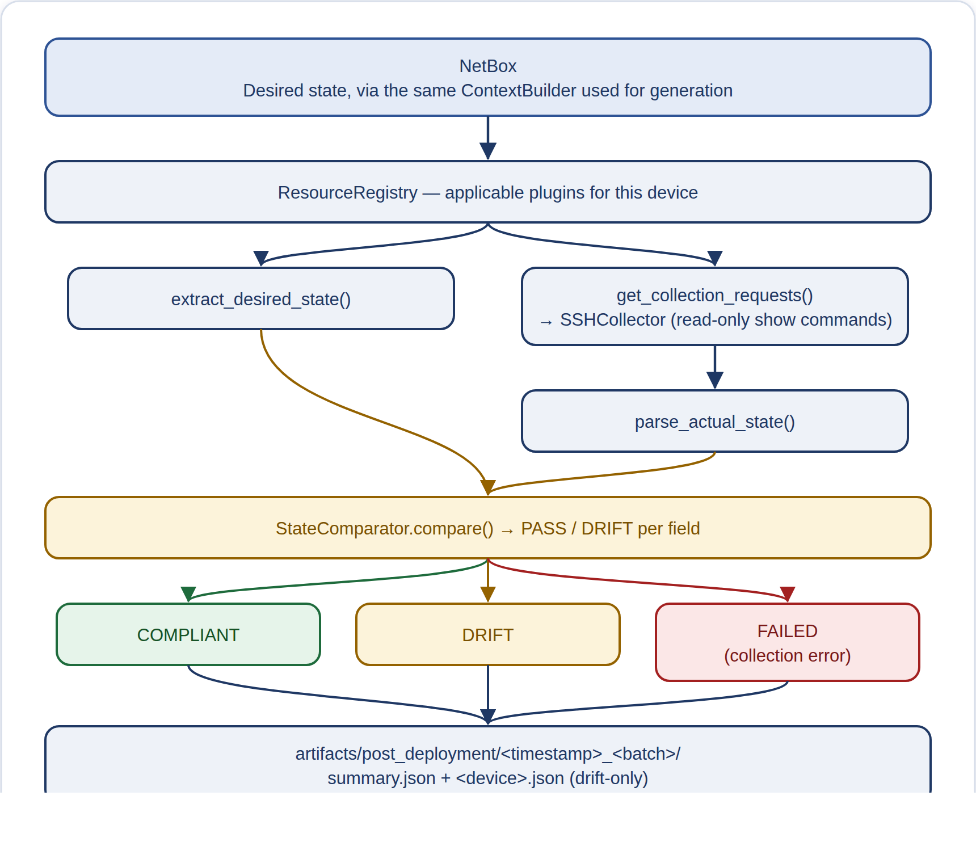
MATURITY NOTE
Each resource plugin has a supports_device() check meant to filter by device platform, but right now it always returns True no matter what, so this filtering does not actually exclude any device yet. Reading the CLI output is done with hand-written text/pattern matching rather than a proper structured parsing tool, so if a device's output format changes, it could quietly produce wrong results, showing drift that is not real, or missing real drift. This layer only reports mismatches, it does not fix anything automatically.

9. Compliance and Drift Detection

How to Run This
This is the same command as Section 8 -- compliance checking and drift detection are the same mechanism here, not two separate tools.
In this platform, compliance checking and drift detection are the same thing, not two separate systems, both terms describe the same result produced by the StateComparator described in Section 8. There is no separate "drift engine": a device is marked COMPLIANT only when every compared field is a PASS, and it is marked DRIFT the moment even one field does not match. There is also no weighting by importance, a minor, cosmetic mismatch is reported exactly the same way as a serious one.
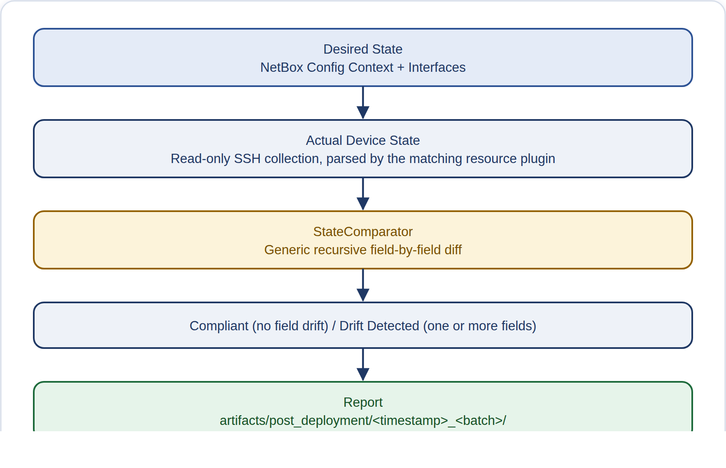
A real example: during SW1_gns3's batch-3 post-deployment run, exactly one drift was found, the spanning-tree mode was expected to be rapid-pvst (based on its NetBox configuration) but the live device actually showed pvst. Section 16 walks through this example, and several other real device fields, in detail.

10. Observability

How to Run This
Fills in the real SNMP community string in the exporter config (only needed once, or after changing it in .env), then starts every monitoring container:
$ python observability/generate_snmp_config.py
$ cd observability && docker compose up -d

The monitoring system is a self-contained set of tools, run together using Docker Compose (a tool that starts and manages multiple linked programs), that watches the health of the three-device GNS3 lab test setup. It is deliberately kept separate from the deployment and compliance process described earlier (there are placeholder hooks for monitoring application-level activity, but they don't do anything yet). It regularly checks devices using SNMP (a standard way devices report their own stats), collects their log messages through a custom relay program, displays both in Grafana (a dashboard tool), and checks alert rules that, when triggered, notify Alertmanager (the tool that manages and sends alerts).

Files & Configuration
docker-compose.yml
Sets up 8 programs — Prometheus (checks device health), SNMP Exporter, Loki (collects logs), Promtail, a custom log relay, Alertmanager (sends alerts), Grafana (dashboards), and the ServiceNow connector — each with health checks and resource limits.
prometheus/prometheus.yml
Regularly collects data from the SNMP Exporter for 3 fixed devices (R1_gns3, SW1_gns3, SW2_gns3), tagged by site, role, and vendor, and loads the alert_rules.yaml file, sending any alerts to Alertmanager.
snmp_exporter/snmp.yml(.template)
The SNMP Exporter module that reads Cisco device stats such as uptime, CPU, memory, and interface data (via OIDs, the standard identifiers SNMP uses to name each stat). The finished file, which contains the real password-like community string, is excluded from version control (git-ignored); only a placeholder template version is saved in the project.
generate_snmp_config.py
Creates the real SNMP Exporter configuration file from the template by filling in the real community string (a shared password-like value) from the platform's .env settings file. This must be done once before the monitoring stack is started.
alertmanager/alertmanager.yml
Groups alerts by site, device, and severity level, sends all severities to webhook receivers (automatic notifications sent to another system), and sets rules so that a device-down alert suppresses its own related interface, CPU, and memory alerts.
alerts/alert_rules.yaml
Six alert rules, written in PromQL (Prometheus's query language): NetworkDeviceDown, HighCpuUtilization, HighMemoryUtilization, InterfaceDown, HighInterfaceErrors, and LinkFlapping — each with a severity level and notes on how to respond.
loki/loki-config.yaml
A single-server Loki setup that stores logs on the local disk and keeps them for 30 days.
syslog/syslog_relay.py
The system that actually receives device logs (syslog) — a Python program listening over UDP/TCP that reads Cisco's RFC 3164 log format (a standard log message layout that Promtail's built-in syslog reader cannot handle) and sends the organized log entries straight to Loki through its HTTP push API.
syslog/promtail-syslog.yaml
Sets up Promtail's built-in syslog listener. It exists in the project files, but its network ports are not opened in the docker-compose setup, so this listener cannot actually be reached. The syslog_relay.py program is the one that actually works.
grafana/dashboards + provisioning/
One pre-built Grafana dashboard called "Network Fleet Devices" with 8 panels showing: whether each device is up or down, uptime, CPU and memory trends, interface status and errors, and a live stream of Loki log messages. It pulls its data from Prometheus and Loki.
config/observability_config.yaml, metric_matrix.yaml, event_matrix.yaml
Reference documents describing an ideal naming scheme for metrics and events, and a table of notification channels (PagerDuty, Slack, email). In practice, these names do not match the actual Prometheus metric names used, and none of these notification channels are actually connected in the alertmanager.yml configuration file — only the ServiceNow webhook connection is actually active.
tests/test_matrix_validation.py
Checks that every configuration file listed above is structured correctly, and includes at least one test based on a real past problem: it fails if any Alertmanager receiver's webhook address stops ending in /webhook, or if the send_resolved setting (which allows sending resolved notifications) is turned off.

Monitoring Architecture
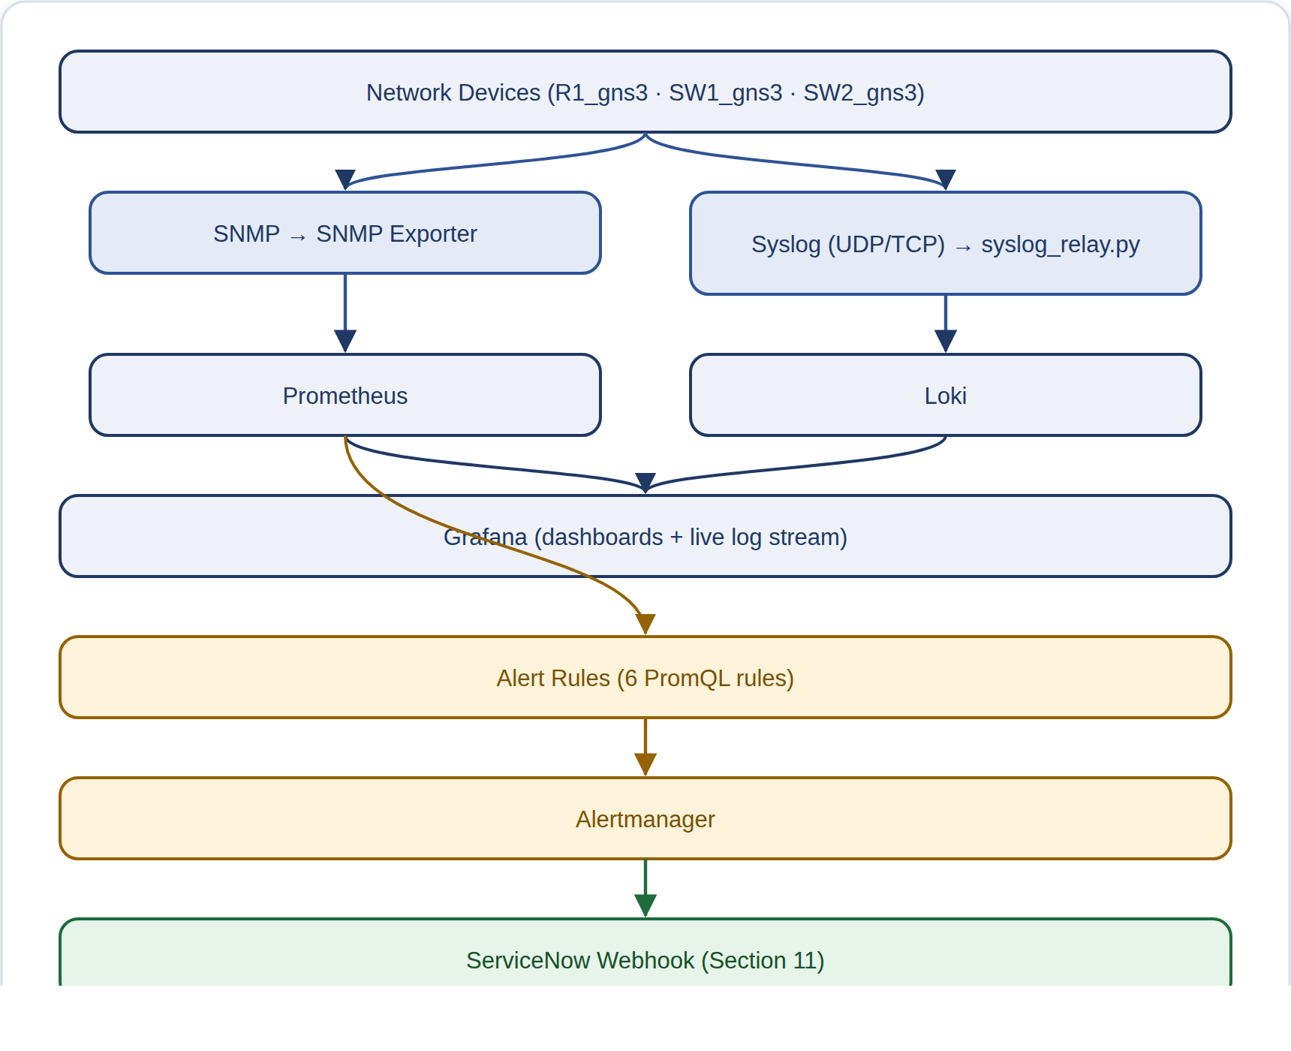
VERIFIED
This is a genuinely working system, not just planning documents: it uses real, version-tracked Docker images with health checks, and passes a full set of structural tests. Its scope is intentionally small (3 lab devices, 1 dashboard, 6 alert rules). The production.env file is a settings profile prepared for future use — it is not proof that the system has actually been deployed to a real production network.

11. ServiceNow Integration

How to Run This
The alert-to-incident path runs automatically inside the Docker stack started in Section 10 -- there is nothing to run by hand for that. To pause it during planned maintenance so it does not create false tickets:
$ python3 maintenance_mode.py enable --reason "Planned GNS3 lab shutdown" --duration 4h
$ python3 maintenance_mode.py status
$ python3 maintenance_mode.py disable

The ServiceNow integration turns an active or resolved Alertmanager alert into a formal, trackable ServiceNow incident (support ticket). It avoids creating duplicate tickets, adds supporting evidence, and routes each ticket to the right team. It can connect to a real ServiceNow PDI (Personal Developer Instance) test system over a secure web connection (HTTPS) using a username and password (Basic Auth), or it can run in a mock mode that simulates the whole process using local JSON files only — useful for automated testing (CI) and for testing without an internet connection.

Files
handlers/webhook_receiver.py
A basic HTTP server (built using Python's standard library) that offers three types of web addresses: /webhook (to receive alerts from Alertmanager), /health (to check the server is running), and /maintenance/* (for maintenance-mode controls). It reads either a single alert or a batch of alerts from Alertmanager and reports back what action was taken for each one: CREATED, UPDATED_FIRING, RESOLVED, SUPPRESSED_MAINTENANCE, or IGNORED.
client/servicenow_client.py
The engine that manages an incident's life cycle and communicates with ServiceNow. It decides whether to CREATE, UPDATE, RESOLVE, or IGNORE an incident, based on whether the alert is currently active or resolved, and whether a matching active incident already exists (tracked by the alert's unique fingerprint). It then makes the actual web requests to ServiceNow's Table API (its data interface), or simulates them if running in mock mode.
client/evidence_enricher.py
Checks live data from Prometheus (whether the device is up or down) and Loki (the most recent relevant log message) to add supporting evidence to the incident's description.
config/settings.py
Loads the ServiceNow web address and login details, automatically detects whether to run in mock mode, and works out which team to assign the incident to based on the device's role in NetBox (the source-of-truth inventory system). It looks for an exact match first, then a partial match for combined role names, and defaults to the Network Operations Center if nothing matches.
models/incident_payload.py
Converts a raw Alertmanager alert into the format ServiceNow expects for an incident. It calculates a unique fingerprint to prevent duplicate tickets (using Alertmanager's own fingerprint, or, if unavailable, a computed code from the device, alert, and interface names), and works out the incident's description and priority.
maintenance.py
Keeps track of maintenance windows (times when alerts should be suppressed) in a JSON file. These can apply globally, to a single device, or to a whole site, and automatically expire, with a grace period after being turned off. This is only checked for active alerts — resolved alerts are never suppressed.
storage/incidents.json
A local record of incidents — active ones organized by their unique fingerprint, plus a history of resolved ones. This is the actual source used to detect and prevent duplicate incidents.
maintenance_mode.py (repo root)
A simple command-line tool, built using Python's urllib library, for the ServiceNow connector's /maintenance/* web addresses, with enable, disable, grace, and status commands. It intentionally keeps no data of its own — the actual maintenance status (managed by servicenow/maintenance.py's MaintenanceState) lives inside the connector's own container, stored in a Docker volume (storage area) the host computer cannot directly see. So this command-line tool works like a remote control, sending commands over HTTP (by default to http://localhost:8000) rather than duplicating that logic itself.

Incident Flow
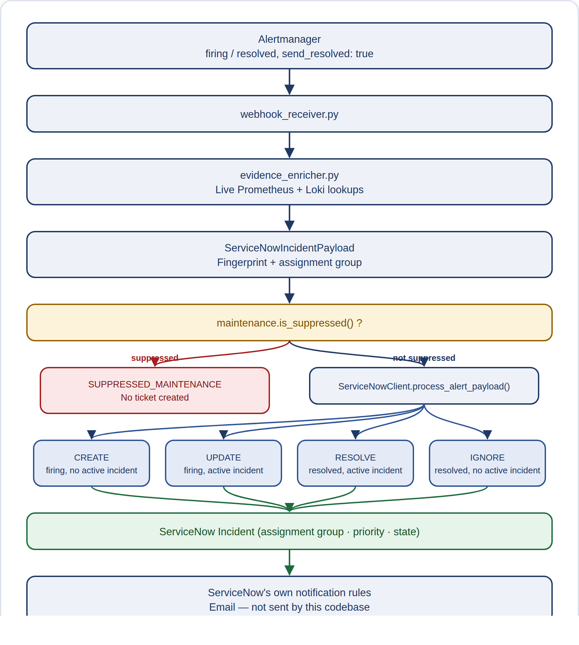
VERIFIED
This is a real, working integration, and its own documentation honestly reports both its successes and its limitations. The file docs/REAL_END_TO_END_ALERT_TO_SERVICENOW_PROOF.md documents an actual test run against a live ServiceNow test system (dev388799.service-now.com), including actually stopping and starting a GNS3 lab device, a real incident number being created, and email records showing state: processed. It also honestly notes two unresolved issues rather than hiding them: a mismatch in priority level and a difference in how time zones are displayed. There is no scheduled job to retry failed API calls — a retry only happens by chance, if Alertmanager happens to resend the same still-firing alert.

12. CI Pipeline

How to Run This
Runs all 17 layers locally, exactly the way GitHub Actions runs them on every push:
$ python3 tests/ci_runner.py

The whole CI (Continuous Integration — automatic checks that run on every code change) process lives in one GitHub Actions workflow file, ci-validation.yml. It has a single job that runs whenever code is pushed or a pull request is opened against main: it downloads the code, installs the packages listed in requirements.txt, and runs one custom checking script, tests/ci_runner.py. The project does not use pytest (a common Python testing tool) — instead ci_runner.py is a custom, roughly 1,060-line script that combines static checks (checks that read the code without running it) with real, mock-based (using fake stand-in devices) automated tests. It runs these as 17 steps in a fixed order, one after another (this grew from an original 12 steps — steps 13-17 were added to cover the safety of Phase 0-4 artifact handling and CD (Continuous Deployment) workflows).

What CI Actually Checks (17 Layers)
Layer | Checks | Method
1 | Python syntax | Compiles every .py file to catch syntax errors (py_compile)
2 | Imports work correctly | Scans the code structure and actually loads every internal package to make sure it works
3 | CSV source-of-truth (SoT) checks | Checks core CSV files have the right structure, required fields, and no duplicates
4 | YAML config validation | Structural checks on every .yaml/.yml file
5 | Capability Resolver tests | 8 hand-written unit tests (small automated checks) verifying each role only gets its allowed protocols
6 | Deploy/rollback tests using a mock (simulated) device | A fake device whose settings can change, used to prove rollback actually restores them
7 | Monitoring (observability) config checks | Checks the structure of Prometheus, Alertmanager, and Compose config files
8 | ServiceNow integration | Real automated tests covering the data sent (payload), duplicate prevention (dedup), and the full process (lifecycle)
9 | Maintenance mode tests | 12 tests checking the logic that suppresses (silences) alerts during maintenance
10 | Rollback manager tests | 13 tests checking rollback decision logic on its own
11 | ServiceNow failure handling | 6 tests for error cases: 401 (unauthorized), 500 (server error), timeout, and connection refused
12 | Security sanity checks | 4 focused checks making sure secrets (passwords/keys) aren't exposed and old issues don't come back
13 | Artifact Manager (manifest) tests | Tests writing and checking manifest.json: hashing (a unique fingerprint) the deployable set, the batch_hash field, detecting tampering or missing files, recording excluded devices, and giving GITHUB_SHA priority
14 | Artifact Deployment (Phase 1) tests | For --use-artifact-dir: the manifest must be re-checked before SSH connects, device identity is re-checked by device_id and blocks any mismatch (no swapping devices), the generation/validation stages are skipped entirely, and --dry-run never actually connects to a device
15 | Post-Deployment Verdict Classification tests | The result status (COMPLIANT, DRIFT, UNREACHABLE, or FAILED) passes through deployment/main.py and both CLIs' (command-line tools') exit codes exactly as-is, never simplified or merged into another status
16 | CD Plan Workflow safety (Phase 3) tests | Confirms the --dry-run planning path used by cd-plan.yml still runs the Context, Config, and Pre-Validation steps and writes a Phase 0 artifact (a saved output file), but never calls DeviceConnector.deploy() and never triggers the CSV-to-NetBox SoT (source of truth) sync
17 | CD Deploy safety (Phase 4) tests | Confirms a non-deployable or missing artifact stops the process before SSH connects, that approval information alone cannot skip the manifest check (gate), and that DRIFT/UNREACHABLE/FAILED results are saved unchanged into deployment_result.json

CI Flow
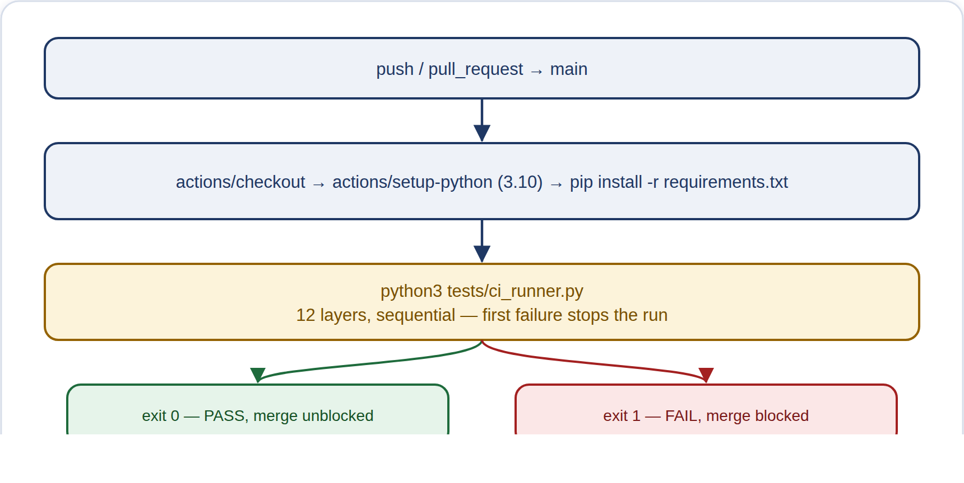
MATURITY NOTE
CI never touches a real device, real NetBox, or real ServiceNow — every test uses static checks or mock (simulated) test doubles, by design. No step in this workflow actually deploys anything; it only checks code and configuration. The file docs/CI_DESIGN.md only describes 4 of the 17 layers, so it should be treated as partially out of date.

1. Syntax
2. Imports
3. CSV SoT
4. YAML
5. Capability check
6. Deployment and rollback
7. Monitoring/observability
8. ServiceNow lifecycle
9. Maintenance mode
10. Rollback manager
11. ServiceNow API failure
12. Security
13. Artifact integrity
14. Artifact deployment
15. Post-deployment status
16. CD plan safety
17. CD deploy safety

13. CD Pipeline

How to Run This
Both stages are started by hand from GitHub Actions -- never automatically -- either by clicking "Run workflow" on GitHub, or with GitHub's own command-line tool, gh:
$ gh workflow run cd-plan.yml -f target=site:gns3-staging -f protocols=all -f interfaces=all
$ gh workflow run cd-deploy.yml -f artifact_run_id=<run ID from the cd-plan run above> -f artifact_name=<artifact name from that run's summary>

This repository has no automated continuous-deployment (CD) pipeline — CD means the process of pushing approved changes out to devices without a person doing each step by hand. The GitHub Actions workflow (GitHub's built-in automation feature) described in Section 12 only handles CI (automated testing) — it never runs deployment/main.py, deployment/cli.py, or post_deployment_validation. Every stage described below is real, working code, but each one has to be run manually, as its own command-line tool, by a person. No script, workflow, or scheduler automatically links them together into one pipeline.

Intended Lifecycle
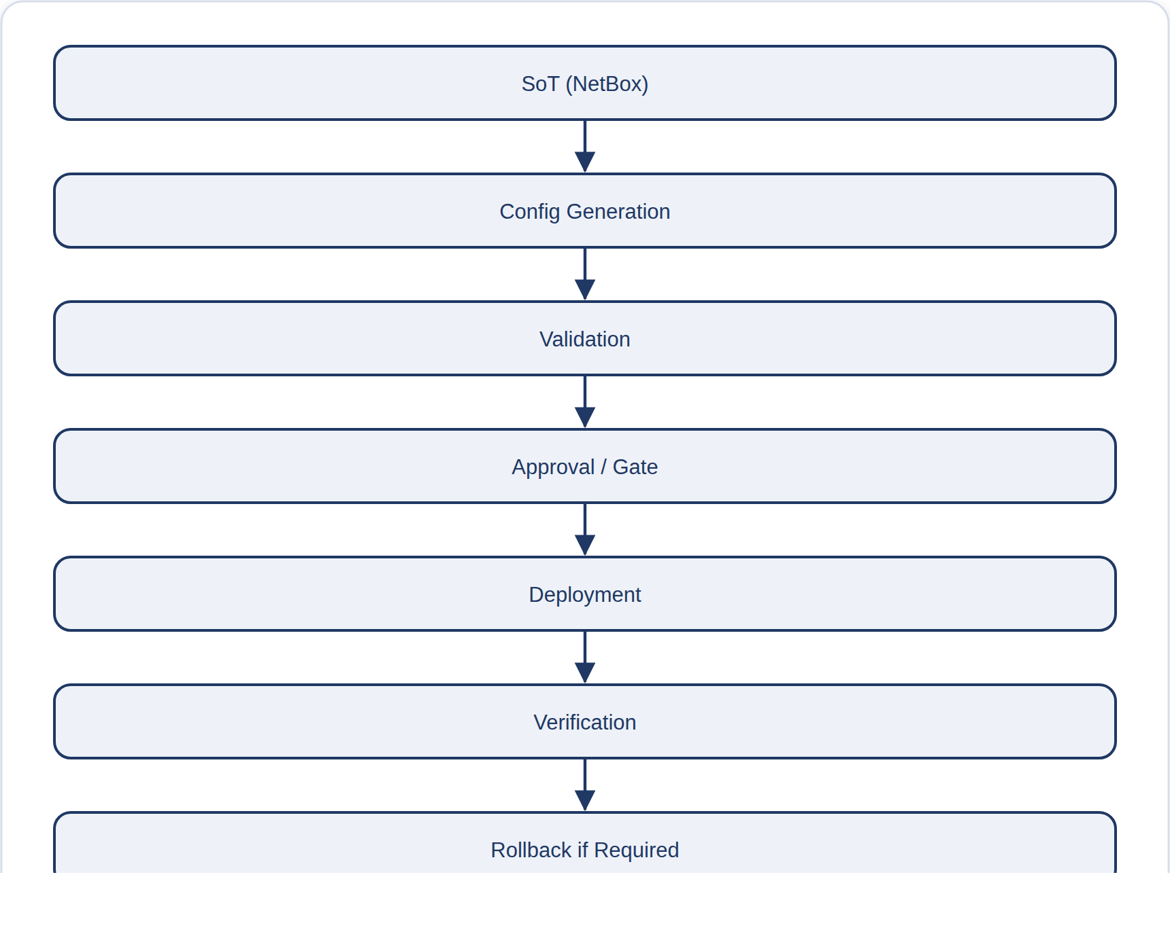

Actual Implementation Status, Stage by Stage
Lifecycle Stage | Status | Evidence
SoT Pre-Sync (CSV → NetBox) | Partially Implemented | Real script (python/importers/import_config_context.py) exists but must be run manually; nothing triggers it automatically.
Context Aggregation | Implemented (as internal step) | context_builder.py runs automatically once deployment/main.py is manually invoked.
Capability & Protocol Filtering | Implemented (as internal step) | capability_resolver.py runs automatically as part of that same manual step, and is checked by automated tests in CI Layer 5.
Config Generation & Pre-Validation | Implemented (as internal step) | config_generator.py and pre_deployment_validation run automatically together, but according to the CI test coverage reports, this specific combination has no dedicated automated test of its own.
Pre-Change Backup & Selective SSH Deployment | Implemented (as internal step) | device_connector.py really does back up the device first and then push only the diff (just the lines that changed, not the whole configuration) — but only when a person runs the command deployment/cli.py --save-config.
Automated Inverse Rollback | Implemented | This genuinely happens automatically within a single deploy() call, and is confirmed by CI's stateful mock-device tests (Layer 6/10) — automated tests that simulate a real device's behavior. But it only covers one device on one deployment attempt at a time; there is no rollback that works across a whole batch of devices.
Approval Gate | Not Implemented | The statuses AWAITING_APPROVAL and APPROVED exist as predefined values (enum values) in lifecycle.py, but nowhere in the codebase does anything actually check for or enforce them.
Post-Deployment Compliance Verification | Partially Implemented | post_deployment_validation/main.py is real and works, with its own command-line tool (CLI) — but it does not run automatically after a deployment; someone has to run it separately, by hand.
End-to-end pipeline chaining all stages | Not Implemented | No workflow, cron job (a scheduled automatic task), or script automatically runs the stages in order: SoT sync, then generation, then validation, then deployment, then verification. Only one workflow file exists in the repo, and it only handles CI (automated testing).

GAP
In practice, "CD" today just means several separate command-line tools that can each be run on their own — they share common code libraries and a shared folder naming convention for storing artifacts (the sets of files being deployed), but they are not wired together into one automated pipeline. Any documentation that describes this as a fully automated CD pipeline should be treated as an aspiration, not a fact; this table reflects the accurate, verified current state.

CD Automation Update
The table above describes the platform before two new GitHub Actions workflows were added: .github/workflows/cd-plan.yml and .github/workflows/cd-deploy.yml. Both are real, working pipelines that a person triggers manually, and both genuinely run deployment/cli.py. This meaningfully updates — without replacing — the "no CD pipeline" picture above: deployment/main.py is no longer run only by a human typing at a local terminal. But the two phases still need a human to hand off between them, so this still does not match a fully automated, auto-chained CD pipeline. See the updated status rows below.

Phase 3 -- cd-plan.yml (Plan Only, No Device Connections)
This is a manual workflow_dispatch (a button a human clicks to start it), taking target/protocols/interfaces inputs that default to site:gns3-staging / all / all. It runs the command `python -m deployment.cli --dry-run --approved-by <actor> --approval-ref <run URL>` against whatever is currently approved in NetBox's source of truth (SoT). The flags --sync-sot and --use-artifact-dir are deliberately never used here — this job only ever builds a fresh artifact (the exact set of files to deploy) from the live SoT; it never replays an old one and never writes CSV data back into NetBox. It then finds the newly created artifacts/pre_deployment/<batch_id>/ folder, writes a summary table using only the structured fields from manifest.json (a signed list of what's safe to deploy) — never the actual .cfg file contents or any secrets — and uploads the artifact using actions/upload-artifact@v4 (kept for 90 days), but only when manifest.json's deployable field is true. The job's real pass/fail decision is based on that deployable flag, not on deployment/cli.py's own, less precise exit code.

Phase 4 -- cd-deploy.yml (Controlled Deployment of an Approved Artifact)
This is also a manual workflow_dispatch, but it requires specifying the exact Phase 3 run to deploy — artifact_run_id and artifact_name (never just "latest") — plus an optional save_config input. It downloads that specific artifact into artifacts/deployed/ (kept separate from the locally-planned artifacts/pre_deployment/ folder), then calls deployment.artifact_manager.verify_manifest() to independently recompute every config file's SHA-256 hash (a unique fingerprint that changes if even one character changes) and the overall batch_hash — before touching any device — and stops immediately if the artifact is marked not deployable or shows signs of tampering. Only after that does it run the actual deployment: `python -m deployment.cli --use-artifact-dir <dir> --approved-by <actor> --approval-ref <run URL>` (note --dry-run is deliberately left out here — this step genuinely pushes configuration to devices). It then reads the resulting deployment_result.json and fails the job unless every device shows both deployment_status=success and a verification_status that is NOT DRIFT, UNREACHABLE, or FAILED — simply pushing the config successfully is not enough to pass. Both workflows include an explicit warning in the file that a GitHub-hosted ubuntu-latest runner cannot reach a NetBox instance set to localhost or the GNS3 lab, and that the resulting connection failure is expected — not a bug to fix.

Phase 0 Artifact Contract -- manifest.json
Both workflows are governed by the same unchangeable manifest.json (a signed record of what's safe to deploy). It is written by the write_manifest() function in deployment/artifact_manager.py and independently re-checked by verify_manifest(), which always recomputes the hashes itself rather than trusting whatever numbers are already recorded:
manifest.json Field | What It Records
schema_version | The version of the manifest's format (currently "1.0"); verify_manifest() rejects the file if this doesn't match.
batch_id / created_at | The batch's folder name and the time it was created, in UTC (Coordinated Universal Time).
git_commit_sha | The Git commit ID: taken from GITHUB_SHA when available (set automatically by GitHub Actions), otherwise from the local command `git rev-parse HEAD`. It is left as null — never made up — if neither is available.
deployable | True only if at least one device passed Pre-Deployment Validation. Phase 4 refuses to proceed with an artifact marked deployable=false, before making any SSH (secure remote login) connection to a device.
devices[] / excluded_devices[] | The list of devices that are safe to deploy (device_id, device_name, device_last_updated, config_file, config_sha256) versus the devices that failed assessment (device_id, device_name, reason). Excluded devices never get a .cfg configuration file or a hash generated for them.
batch_hash | A SHA-256 fingerprint (a unique code that changes if anything changes) calculated over every device's "name:hash" pair, sorted by name so the result is always the same for the same input. verify_manifest() always recalculates this itself rather than trusting the stored value, and also re-hashes every .cfg file independently — this is what catches someone hand-editing the manifest to match a config file that was tampered with.

Updated Stage Status (supplements the table above -- does not replace it)
Lifecycle Stage | Status | Evidence
Approval Gate | Partially Implemented | The --approved-by and --approval-ref flags now carry real audit information (the GitHub user who triggered it, github.actor, and the workflow run URL) through DeploymentRequest into every entry of deployment_result.json. But cd-deploy.yml's own comment in the file says its `environment: gns3-staging-deployment` line "provides NO enforcement by itself" until Required Reviewers is turned on in the repository's Settings — and that has not been done yet. In short: the audit trail is real, but the approval gate that would actually block a deployment is not yet in place.
End-to-end pipeline chaining | Not Implemented | cd-plan.yml and cd-deploy.yml are two separate workflows that can only be started manually (workflow_dispatch) — there is no automatic trigger (like workflow_run, push, or a schedule) connecting them. A person still has to copy the run ID and artifact name from one workflow into the other by hand. What has changed: deployment/main.py is now genuinely run from CI (which was not true when the earlier row in this table was written), and the hand-off between the two workflows is now cryptographically re-verified — verify_manifest() recomputes every hash — rather than just blindly re-running. That is real progress, but it is still not automatic chaining.

GAP (update)
The picture above, where everything was a manual command-line tool, has changed for two of the nine stages: Pre-Change Backup & Selective SSH Deployment and Post-Deployment Compliance Verification can now both run as real, verified steps inside cd-deploy.yml, instead of only through a local command-line invocation. Still true: nothing automatically triggers cd-plan.yml to hand off to cd-deploy.yml, there is no scheduler anywhere in the repo, and the gns3-staging-deployment environment's approval gate is declared but not actually configured. A self-hosted runner (a machine with real network access to NetBox and the GNS3 lab) is still required for either workflow to get past the connectivity step — this has not been implemented in this phase, as the workflow files' own notes state.

14. Configuration and Artifacts

Configuration Files
config/settings.py
The main settings loader that starts the whole system. It reads the NetBox (the source-of-truth inventory database) web address and access token, plus the folder holding the CSV (spreadsheet-style) data files, from a settings file called .env.
config/migration/gns3_staging_discovery.yaml
A discovery manifest (a list) of the three lab devices used for testing — R1_gns3, SW1_gns3, and SW2_gns3 — in the GNS3 virtual lab (software that simulates real network equipment), along with the IP address used to manage each one.
config/migration/hyderabad_access_switches.yaml
A migration manifest (a list) used for the real Hyderabad project, where physical switches are being replaced (sw-access-01 through sw-access-07). It also includes the rules for renumbering the network ports (interfaces) during the switch.
config/migration/sot_classification_policy.yaml
A set of rules that decide where information found on a device gets stored in NetBox, and that protect sensitive settings — such as the management IP address, login credentials, and Vlan1 (the default network) — from being overwritten during migration.

Artifacts Directory
Every stage of the pipeline (the automated sequence of steps) saves its output in the artifacts/ folder, organized by stage and by a timestamp plus device or batch name (in the format <YYYYMMDD_HHMMSS>_<device-or-batch-label>):
Folder | Contents (with a real example path)
artifacts/pre_deployment/ | For each device, the generated configuration files (.cfg candidates) plus one summary.txt file for the batch showing pass/fail per device. Example: 20260822_123609_batch-3/
artifacts/deployments/ | For each device: desired_config.cfg (the target configuration), change_plan.json (the planned changes), a backup of the prior configuration (pre_change_running_config.txt), and deployment_result.json (the outcome). Example: 20260822_123615/SW1_gns3/
artifacts/post_deployment/ | For each device, a JSON file listing only the drift (differences between intended and actual configuration), plus one summary.json for the whole fleet. Example: 20260822_123704_batch_3/
artifacts/migration/ | For each old/new device pair: raw_outputs.json (raw collected data), migration_dataset.json (organized migration data), staged_migration_intent.json (planned changes before applying), and dry_run_netbox_payloads.json (a preview of what would be sent to NetBox, without making real changes). Example: artifacts/migration/gns3_staging/R1_gns3/
artifacts/inventory/ | Snapshots of the old hardware's inventory, taken while discovering devices during a migration.
artifacts/deployed/ | Used only in Phase 4 (the cd-deploy.yml step): this holds the exact same artifact produced in Phase 3, downloaded using actions/download-artifact@v4, before it is checked again and actually deployed. It is kept separate from artifacts/pre_deployment/ so a downloaded, already-approved artifact can never be confused with one that was only planned locally.

These artifacts (saved records of each run) form the platform's audit trail (a record of exactly what happened, for later review). Together, a device's pre_deployment, deployments, and post_deployment folders show exactly what was intended, what was actually sent to the device, and what was actually observed afterward. Section 16 walks through a real example from start to finish.
device_connector.py (the code that connects to and configures devices) now also writes a per-device audit_record.json file, recording the deployment_id, backup_location, deployment_status, failure_reason, rollback_triggered, rollback_status, rollback_verification_result, and a UTC timestamp. It is saved into artifacts/deployments/<deployment_id>/<device_name>/ no matter how the deploy() step ends — already-compliant, rollback success, rollback failure, a general error while sending the change, or plain success — alongside the existing change_plan.json, desired_config.cfg, and pre_change_running_config.txt files.

Supplementary Investigation Reports (docs/)
Six detailed reports were added alongside the CD (continuous deployment) automation and CI (automated testing) coverage work described above. Each is a standalone, evidence-based write-up rather than part of the reference architecture — read them for the full investigation behind the changes summarized in this document.
Report (docs/) | What It Covers
AI_AGENT_READINESS_AND_PLATFORM_GAP_ANALYSIS.md | A read-only audit of the architecture, grading each pipeline flow (for example NetBox to config, SNMP to Prometheus, Alertmanager to ServiceNow, and rollback) as VERIFIED WORKING, PARTIALLY WORKING, BROKEN, or CONFIGURED BUT NOT VERIFIED. Each grade was checked against the actual running system, not just by reading the code.
CI_TEST_COVERAGE_REPORT.md | Documents the state of CI (automated testing) before this update — the original 6-layer test runner, two real test files that existed but were never connected to CI, and zero test coverage for observability, ServiceNow, maintenance mode, and rollback-decision logic — and the work that closed those gaps.
MAINTENANCE_MODE_IMPLEMENTATION_REPORT.md | Explains the false-alarm problem (a planned shutdown of GNS3 or the laptop makes every device look genuinely down), the chosen fix — a suppression window (a time period where alerts are held back) built into the adapter — and the files that implement it.
REAL_END_TO_END_ALERT_TO_SERVICENOW_PROOF.md | A live test under real conditions, not a simulated one: a real GNS3 device was stopped and started using GNS3's own controller API, while observing the whole chain — Prometheus (monitoring) to Alertmanager (alert routing) to the webhook adapter to ServiceNow (the ticketing system) — react naturally on its own. Two real misconfigurations were found and fixed along the way.
ROLLBACK_REMEDIATION_REPORT.md | Traces the root cause of a bug, present before this update, where a rollback (undoing a change) was wrongly reported as successful — the old logic guessed success just from matching the first 3 words of a command, without re-checking the device, so it always reported ROLLBACK_SUCCESSFUL even when untrue. Documents the fix, now living in rollback_manager.py and device_connector.py.
SECURITY_HARDENING_REPORT.md | An audit of passwords and other secrets. It found an SNMP community string (a shared password used for monitoring) written directly into the code, a ServiceNow caller_id written directly into the code, Grafana admin login details written directly into the code, and a .env settings file that anyone on the system could read. Documents the fixes applied, plus the items checked and confirmed to be fine.

15. Tests

How to Run This
The same command as Section 12 runs every layer described here, in order:
$ python3 tests/ci_runner.py

Testing in this project deliberately combines three kinds of checks: pure unit tests (small automated checks of individual pieces of code, with no real files, network, or devices involved), mock/simulated-integration tests (a fake device that remembers its state, standing in for a real device reached over SSH), and checks that validate the structure of configuration files. All of these run through one custom script, tests/ci_runner.py, rather than the popular tool pytest, which is not used anywhere in this repository. There is no test suite that runs against a live, real device — this is a deliberate, documented limit on scope, not something overlooked.
File / Group | What Is Tested
tests/ci_runner.py | The 17-layer CI (automated testing) validation runner described in Section 12. It checks code syntax, imports, the structure of CSV/YAML files, and runs real unit and mock tests covering capability gating (controlling what a device is allowed to do), rollback, observability configuration, ServiceNow, and maintenance mode. Layers 13-17 also check that the artifact manifest (the signed list of what's safe to deploy) hasn't been tampered with, that deployment uses the exact approved artifact, that results are classified correctly, and that the CD Plan/Deploy workflow is safe.
tests/test_security_sanity.py | 4 checks to make sure a past problem doesn't come back: the .env settings file and the generated snmp.yml file are excluded from version control (git-ignored); the .env.example sample file contains no secrets that look real; and the real SNMP community string never reappears anywhere in the tracked source code.
deployment/tests/test_rollback_manager.py | Unit tests for how a rollback plan (undo plan) is built and checked, using manually written sample device-configuration text — including the key case where reading the device's live configuration again still shows the new value, even though rollback commands were reported as "sent".
observability/tests/test_matrix_validation.py | 10 tests that check the structure of every observability (monitoring) configuration file, plus a dedicated check guarding the Alertmanager webhook URL and send_resolved setting against future breakage.
servicenow/tests/*.py | 21 tests total across three files: normalizing the data sent to ServiceNow and the full lifecycle of creating, updating, resolving, and de-duplicating an incident; handling of API failures (error codes 401 and 500, and timeouts) with no automatic retry; and the maintenance-mode logic tested on its own.
deployment/tests/test_artifact_manager.py | Unit tests for writing and verifying manifest.json (the signed list of what's safe to deploy): hashing (creating a unique fingerprint of) the set of devices to deploy, making sure batch_hash always comes out the same for the same input, detecting tampering (such as a hand-edited hash), detecting a missing file, recording which devices were excluded, and which value wins between GITHUB_SHA and the local git commit.
deployment/tests/test_artifact_deployment.py | Unit tests for the --use-artifact-dir option: re-checking the manifest must pass before SSH is allowed, re-querying the device_id blocks a device that has been swapped or doesn't match, ContextBuilder/ConfigGenerator/PreDeploymentValidator are never run again in this mode, and --dry-run (preview mode, no real changes) never actually connects to a device.
post_deployment_validation/tests/test_verdict_classification.py | Unit tests proving results are correctly labeled COMPLIANT, DRIFT, UNREACHABLE, or FAILED (the SSHCollector component correctly tells apart a real connection failure from an unrelated bug), and that these labels pass through unchanged all the way through deployment/main.py and into the exit codes of both command-line tools.
deployment/tests/test_cd_plan_safety.py | Unit tests proving that when cd-plan.yml runs with --dry-run (preview mode), it still writes a Phase 0 artifact, but never calls DeviceConnector.deploy() (so zero SSH connections happen) and never triggers the sync of CSV data into NetBox, the source of truth (SoT).
deployment/tests/test_cd_deploy_safety.py | Unit tests proving that an artifact marked as not deployable, or a missing artifact, is blocked before SSH and before the compliance check even run; that approval information alone cannot bypass the manifest's safety check; and that a valid, approved artifact correctly drives the real deployment using the exact recorded configuration.

16. Real Device Example — SW1_gns3 End-to-End
SW1_gns3 is a layer-2 access switch (a switch that connects end devices to the network) in the GNS3 staging lab, at address 10.10.20.2. Of the three lab devices, it has the most complete real artifact trail (saved records) across every stage of the pipeline, plus a genuine ServiceNow incident record — making it the clearest example of how every part of this document connects together in practice.
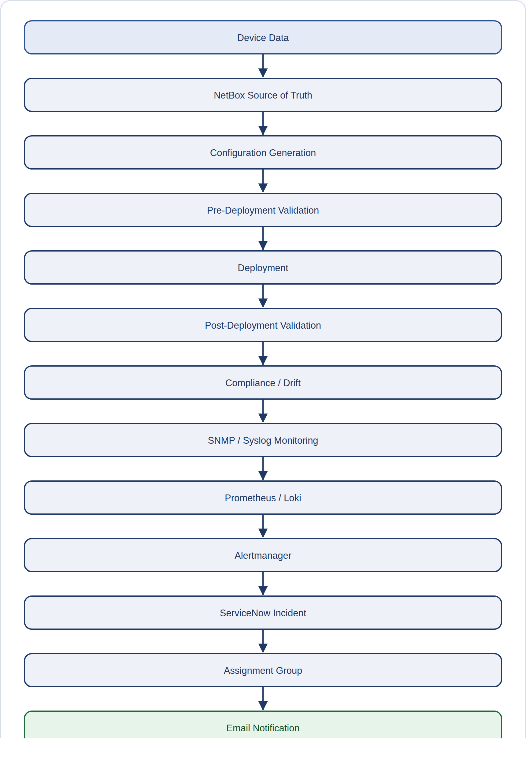

1. NetBox Source of Truth
The file csv/dcim/devices.csv lists SW1_gns3 as a layer-2-access-switch running the cisco-iosv-l2 platform, at site gns3-staging. Its device-specific settings (csv/config_context/devices/gns3-staging/access/SW1_gns3.csv) set VLAN 10 (GNS3_DATA), VLAN 20 (GNS3_VOICE), and STP mode (a protocol that prevents network loops) rapid-pvst. Its management address, 10.10.20.2/24 on Vlan1, comes from csv/ipam/ip_addresses.csv, with role=primary.

2. Configuration Generation
ConfigGenerator (the tool that builds device configurations) turned these settings into artifacts/deployments/20260822_123615/SW1_gns3/desired_config.cfg, including lines such as "interface Vlan1 / ip address 10.10.20.2 255.255.255.0", "cdp run", and "snmp-server location GNS3-Staging-Rack1". The identical configuration also appears as the pre-deployment .cfg for this run.

3. Pre-Deployment Validation
artifacts/pre_deployment/20260822_123609_batch-3/summary.txt recorded SW1_gns3 as PASS alongside R1_gns3 and SW2_gns3 — all 3 devices cleared validation and became deployment candidates, with 0 devices skipped.

4. Deployment
change_plan.json for this run shows 63 desired configuration items, of which 6 were already correct (compliant) and 57 needed a change. deployment_result.json confirms the outcome: the device connected, the deployment succeeded, 57 commands were sent, a backup was saved before the change, and the final state was DEPLOYED with verification_status PENDING_COMPLIANCE (still waiting on the next post-deployment run to confirm).

5. Post-Deployment Validation & Compliance/Drift
The matching batch check (artifacts/post_deployment/20260822_123704_batch_3/SW1_gns3.json) recorded overall_status DRIFT (the device's actual settings didn't match what was intended), with exactly one setting drifted: STP mode was expected to be rapid-pvst but was actually pvst — a direct, traceable mismatch against the intent declared in NetBox in Step 1. An earlier, separate single-device check (20260821_171352_SW1_gns3/) had found 9 drifted settings, spanning DNS, NTP, SNMP, STP, and syslog — showing the device's compliance improving across successive deployment cycles.

6. SNMP / Syslog Monitoring, Prometheus / Loki
SW1_gns3 is a live monitoring target for Prometheus (the tool that regularly collects data from it), set up in observability/prometheus/prometheus.yml at address 10.10.20.2, labeled device_role=access, site=hyderabad, vendor_os=cisco_ios. It also appears in the Grafana fleet dashboard (the visual monitoring dashboard) alongside R1_gns3 and SW2_gns3.

7. Alertmanager → ServiceNow Incident → Assignment Group → Email
servicenow/storage/incidents.json contains a real, resolved incident for SW1_gns3 (INC0010005): a CRITICAL NetworkDeviceDown alert, with work notes recording "Repeated alert firing... SW1_gns3 is UNREACHABLE", routed to the Network Switching assignment group (worked out from its access device role via settings.resolve_assignment_group()), and eventually marked "Alert Auto-Resolved... Reason: Auto-Resolved by Monitoring" once the device came back up. ServiceNow's own notification rules would have sent the matching email for this incident; confirming that final email delivery is outside what this codebase can directly verify — a deliberate, documented limit on scope, explained in docs/REAL_END_TO_END_ALERT_TO_SERVICENOW_PROOF.md.
VERIFIED
Every artifact mentioned in this walkthrough is a real file found in the repository during this review, not a made-up example. The file paths above can be opened directly to see the underlying JSON or text.

