QUESTION:7

🡺use temp;

create table seven(reg_no integer,name varchar(20),gender varchar(20) not null);

ACCORDING TO ASCENDING ORDER:

select reg_no,name,gender

from seven

order by reg_no asc;

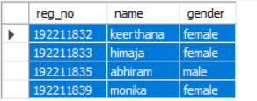

b)age in ascending order:

select sno,faculty_name,age

from seven

order by age asc;

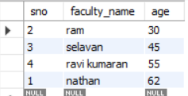

c) SELECT C.Description AS CourseDescription, COUNT(R.StudentID) AS NumberOfStudents

FROM Courses C

LEFT JOIN Registrations R ON C.CourseID = R.CourseID

GROUP BY C.Description;