2)BANK:

CREATE TABLE bank(sno integer,customer name varchar(10),acc_no varchar(10),balance varchar(10),cust_branch varchar(10));

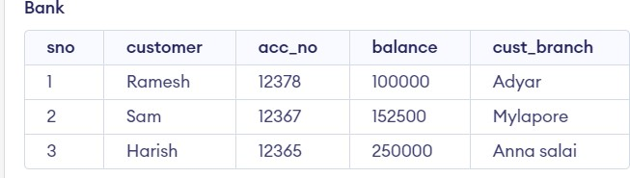

a) SELECT *

FROM Bank

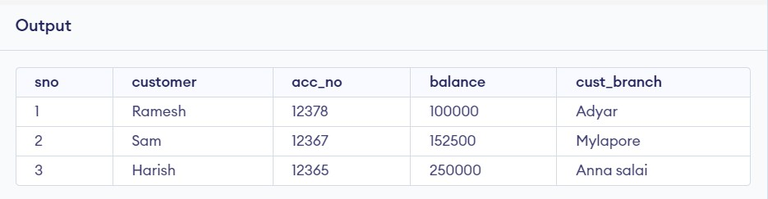

b) SELECT customer

FROM Bank

WHERE balance>100000;

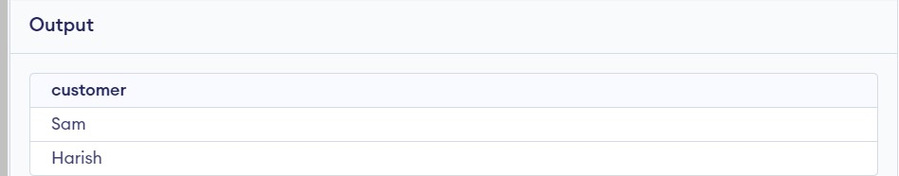

d) SELECT balance

FROM Bank

WHERE balance BETWEEN 100001 AND 200000;

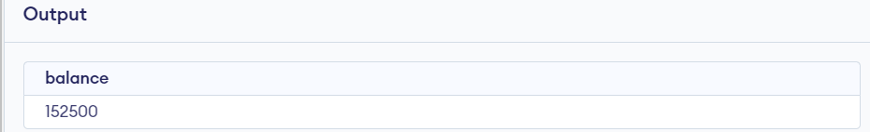

e) UPDATE Bank

SET cust_branch='poonamallee'

WHERE sno=2;

