15) use seven;

create table school(regno int,stuname varchar(20),dob varchar(20));

insert into school values (1221,'ram',24-02-2007);

insert into school values(1248,'anu',03-02-2008);

insert into school values(1275,'ravi',14-02-2006);

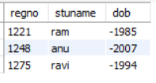

a) create view std_view as

select regno,stuname from school;

select * from std_view;

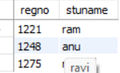

b)create table persons (regno int,stuname varchar(20),dob varchar(20));

insert into persons values (1221,'ram',24-02-2007);

insert into persons values(1248,'anu',03-02-2008);

insert into persons values(1275,'ravi',14-02-2006);

C) create SEQUENCE name1

start with 1

increment by 1

maxvalue 100

cycle;