4)Workers

🡪 CREATE table workers(sno integer,name varchar(20),desigination varchar(20),branch varchar(20));

INSERT INTO workers values('1','kannan','manager','chennai');

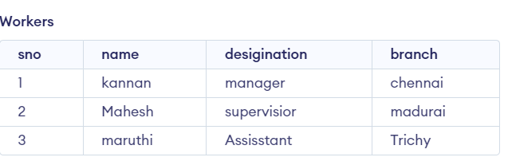

a) ALTER table workers

ADD salary number(6,2);

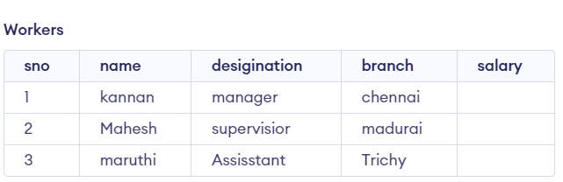

b) ALTER table Workers modify name varchar(30);

c) DESCRIBE Workers;

d)ALTER table workers RENAME column name TO emp;

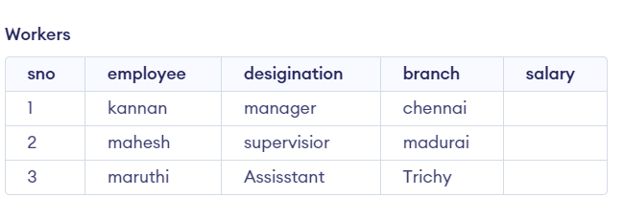

e) DELETE

FROM Workers

WHERE sno=2;

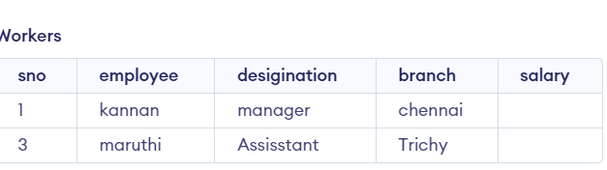

f) DROP table workers;

output: permanently delete data and table