🡺use seven;

create table course(

sno int,name varchar(20),gender varchar(20),facultyname varchar(20),course varchar(20),hiredate int,hallno varchar(20));

insert into course values(1,'ram','male','selvan','DBMS',02-05-2019,'c001');

insert into course values(2,'anu','female','krishna','PDSD',24-10-2017,101);

insert into course values(3,'ravi','male','sam','OS',12-12-2014,615);

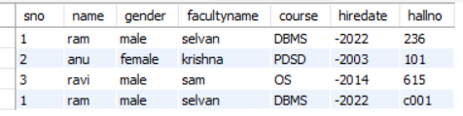

1. select \*

from course

where gender='male';

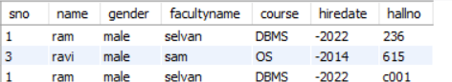

1. select \*

from course

where hiredate>24-112017;

1. select \*

from course

where course='null';