839-Day-4

P1

INPUT:

@relation dataset

@attribute customerID{1,2,3,4,5}

@attribute gender{male,female}

@attribute Age{19,21,20,23,31}

@attribute Annual_income{15,16,17}

@attribute spending_score{39,81,6,77,40}

@data

1 male 19 15 39

2 male 21 15 81

3 female 20 16 6

4 female 23 16 77

5 female 31 17 40

K-Means:

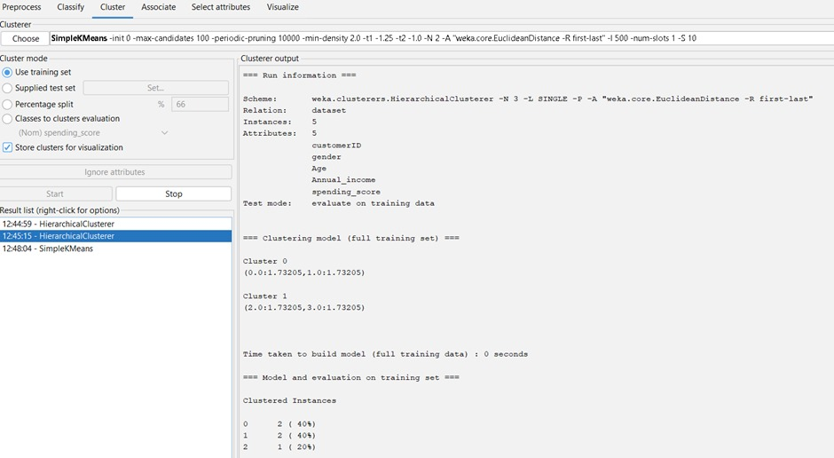

P2:

INPUT:

@relation dataset

@attribute employee{111,222,333,444,555,666}

@attribute gender{male,female}

@attribute Age{28,25,26,30,29}

@attribute Salary{150000,160000,170000,200000}

@attribute Credit{39,27,42,40,64,72}

@data

111 male 28 150000 39

222 male 25 150000 27

333 female 26 160000 42

444 female 25 160000 40

555 female 30 170000 64

666 male 29 200000 70

K-Means;

P3

NAÏVE BAYES:

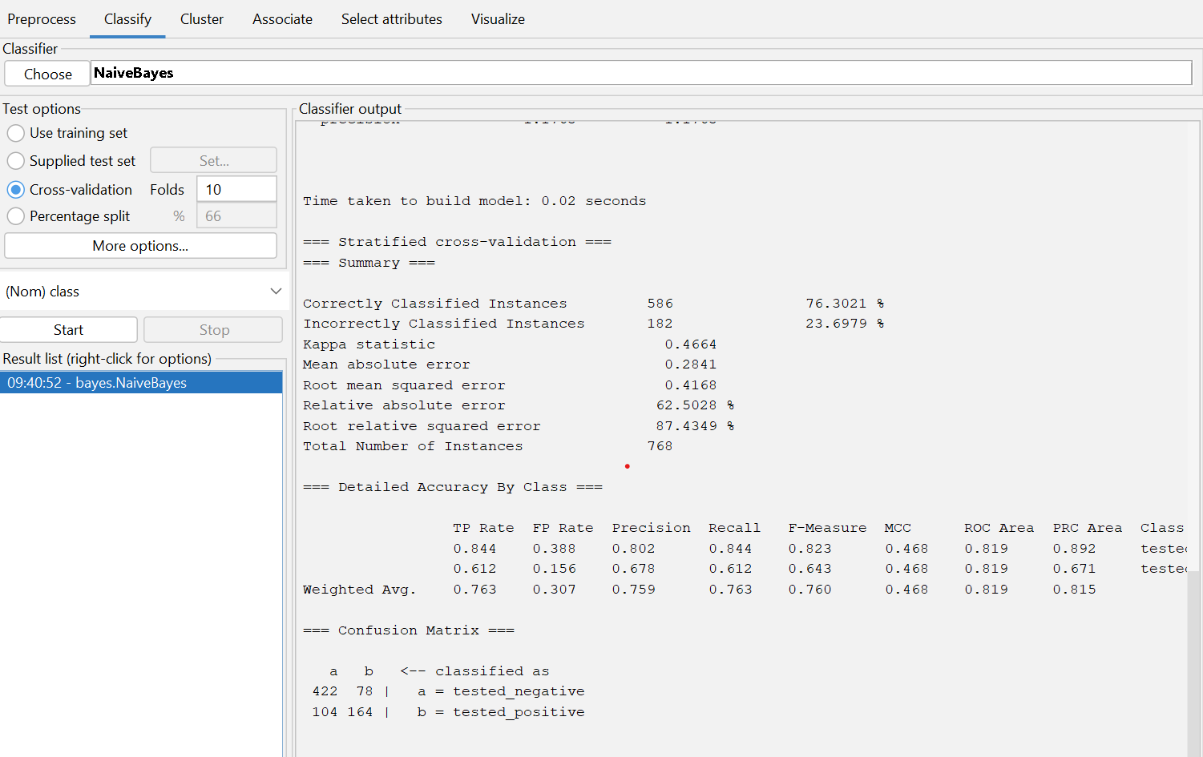

P4

persons <- c("Gopu", "Babu", "Baby", "Gopal", "Krishna", "Jai Dev", "Malini", "Hema", "Anu")

vegetarian <- c("yes", "yes", "yes", "no", "yes", "no", "no", "yes", "yes")

data <- data.frame(Person = persons, Vegetarian = vegetarian)

vegetarian_counts <- table(data$Vegetarian)

print(vegetarian_counts)

if (vegetarian_counts["yes"] > vegetarian_counts["no"]) {

cat("There are more vegetarians.\n")

} else if (vegetarian_counts["yes"] < vegetarian_counts["no"]) {

cat("There are more non-vegetarians.\n")

} else {

cat("The counts of vegetarians and non-vegetarians are equal.\n")

}

OUTPUT:

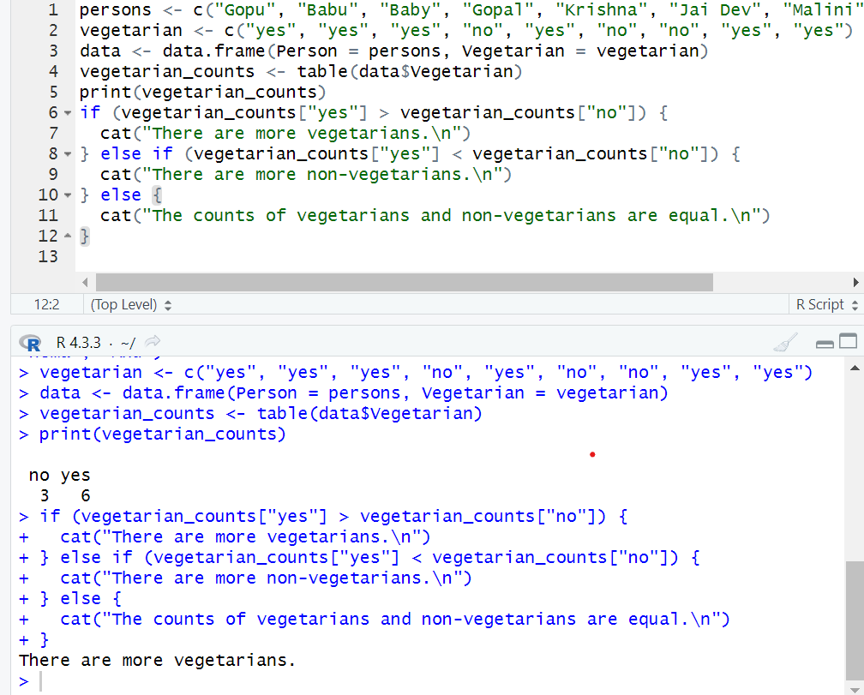

P5

INPUT:

x<-c(4,1,5,7,10,2,50,25,90,36)

y<-c(12,5,13,19,31,7,153,72,275,110)

scatter.smooth(x,y)

OUTPUT:

P6

INPUT:

@relation items

@attribute bread{true,false}

@attribute cheese{true,false}

@attribute egg{true,false}

@attribute juice{true,false}

@attribute milk{true,false}

@attribute yogurt{true,false}

@data

true true true true false false

true true false true false false

true false false false true true

true false false true true false

false true false true true false

FP growth:

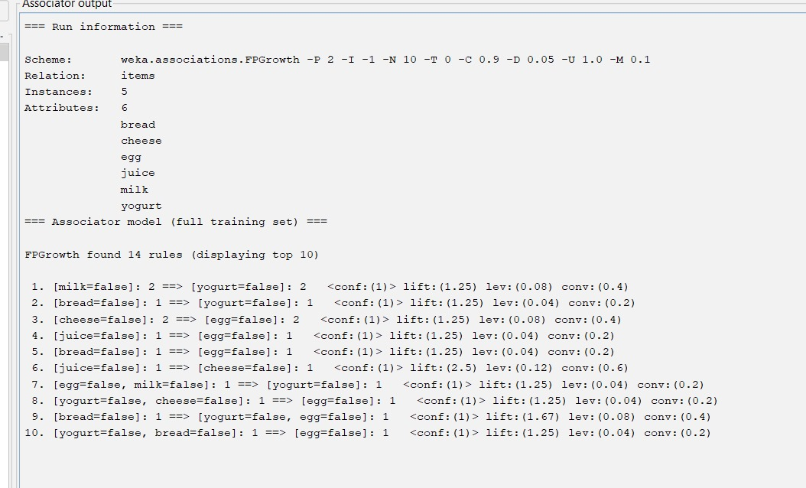

P7

OUTPUT:

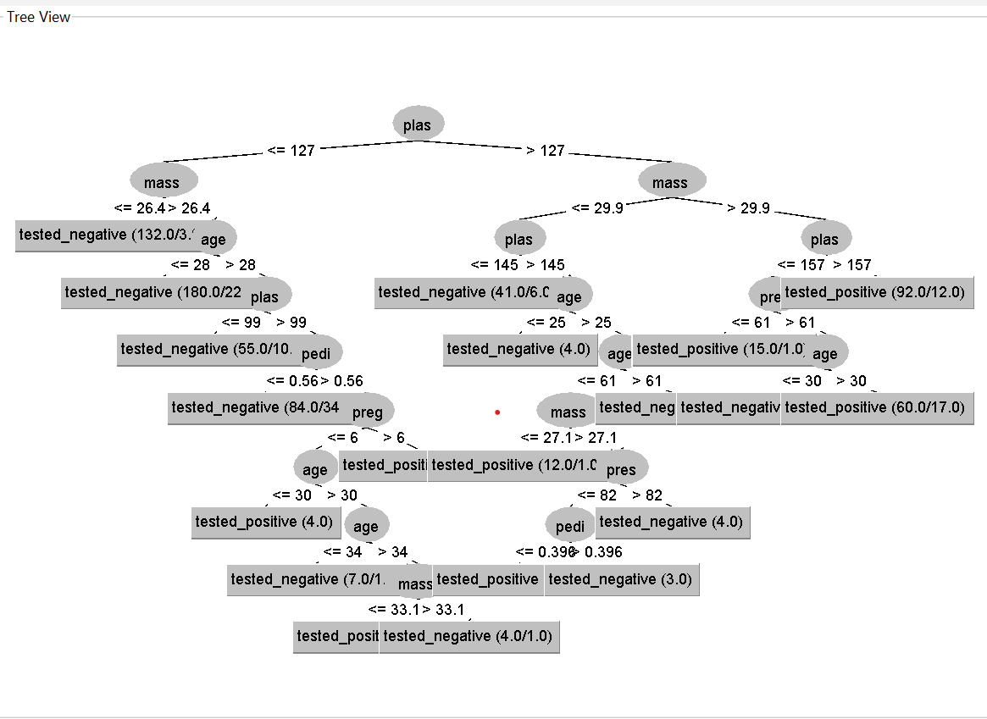

Decision tree:

P8

INPUT:

x<-c(55, 60, 71, 63, 55, 65, 50, 55,58,59,61,63,65,67,71,72,75)

eq_freq_part<-split(x,cut(x,breaks=3))

print(eq_freq_part)

eq_width_part<-split(x,cut(x,breaks=seq(min(x),max(x),length.out=4)))

print(eq_width_part)

num_bins<-3

cluster<-split(x,kmeans(matrix(x),centers=num_bins)$cluster)

print(cluster)

OUTPUT:

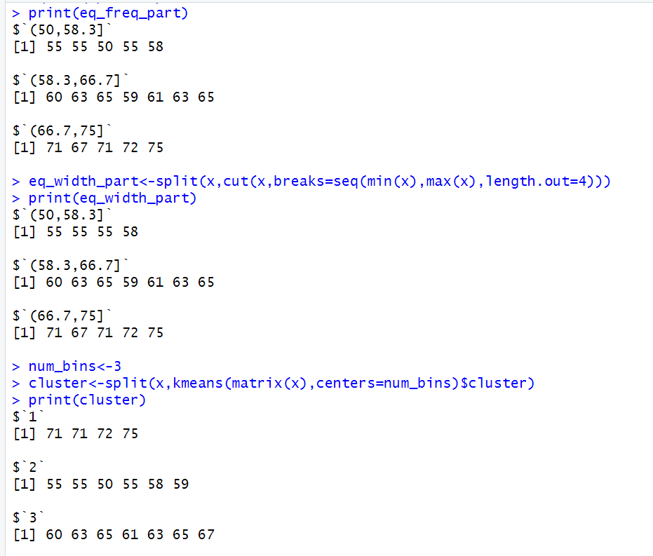

P10

INPUT:

@relation dataset

@attribute sony{t,f}

@attribute bpl{t,f}

@attribute LG{t,f}

@attribute samsung{t,f}

@attribute onida{t,f}

@data

t t t f f

f t f t f

f t f f t

t t f t f

f t f f t

t f f f t

t t t f t

t t f f t

OUTPUT:

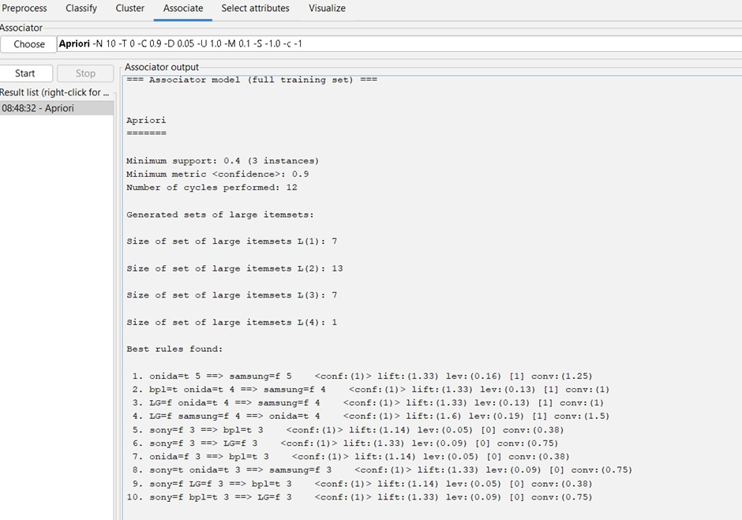

P11

INPUT:

x<-c(100,70,60,90,90)

min_max_normal<-function(x){(x-min(x))/(max(x)-min(x))}

min_max_normalized<-min_max_normal(x)

print(min_max_normalized)

z_score_normal<-function(x){(x-mean(x))/sd(x)}

z_score_normalized<-z_score_normal(x)

print(z_score_normalized)

z_score_mad<-function(x){(x-mean(x))/mad(x)}

z_score_mad_data<-z_score_mad(x)

print(z_score_mad)

decimal_scaling<-function(x){x/10^ceiling(log10(max(abs(x))))}

decimal_scaling_data<-decimal_scaling(x)

print(decimal_scaling_data)

OUTPUT:

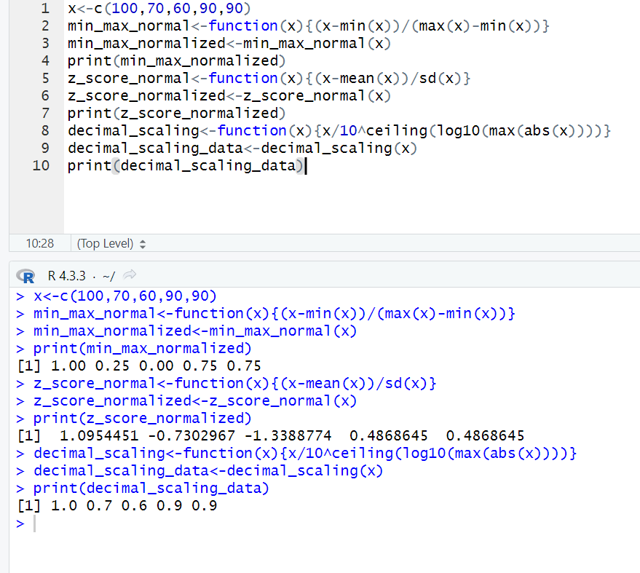

P12

INPUT:

avg_speed<-c(78,81,82,74,83,82,77,80,70)

avg_time<-c(39,37,36,42,35,36,40,38,46)

sd(avg_speed)

sd(avg_time)

var(avg_speed)

var(avg_time)

OUTPUT:

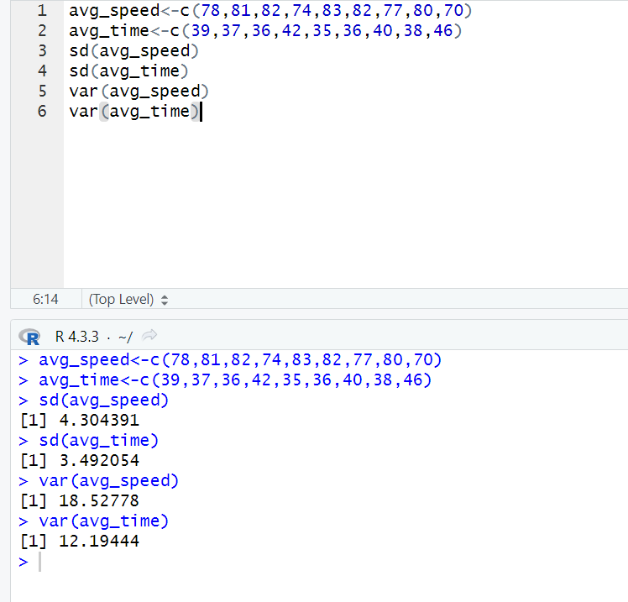

P13

INPUT:

@relation dataset

@attribute M{true,false}

@attribute O{true,false}

@attribute N{true,false}

@attribute K{true,false}

@attribute E{true,false}

@attribute Y{true,false}

@attribute D{true,false}

@attribute A{true,false}

@attribute U{true,false}

@attribute C{true,false}

@attribute I{true,false}

@data

true true true true true true false false false false false

false true true true true true true false false false false

true false false true true false false true false false false

true false false true false true false false true true false

false true false true true false false false false true true

OUTPUT:

FP growth:

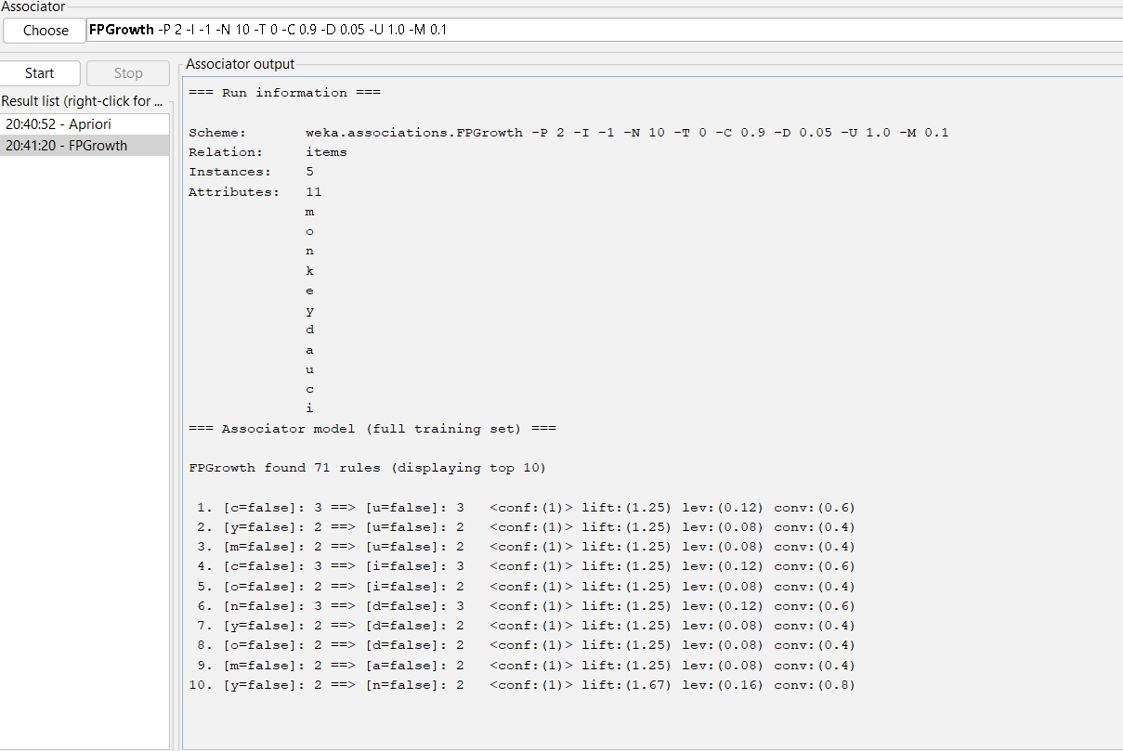

Apriori:

