

**CSE-3200: System Development Project**

**Project Name: Human Activity Recognition Using Smartphone Sensors**

**Submitted by:**

1. Saimoon Al Farshi Oman 2. MD. Nafis Jamil

Roll: **1807018**  Roll: **1807054**

3rd Year, 2nd Semester 3rd Year, 2nd Semester

Department of Computer Science and Engineering

Khulna University of Engineering & Technology (KUET)

**Supervised by:**

**S. M. Taslim Uddin Raju**

Lecturer

Department of Computer Science and Engineering

Khulna University of Engineering & Technology (KUET)

**Approval**

This Project Report has been submitted for examination with the approval of our respected supervisor.

**S. M. Taslim Uddin Raju**

Lecturer

Department of Computer Science and Engineering

Khulna University of Engineering & Technology (KUET)

**Index**

1. Motivation--------------------------------------------------------------------------4
2. Problem Statement----------------------------------------------------------------4
3. Objectives--------------------------------------------------------------------------4
4. Principles---------------------------------------------------------------------------5
5. Methodology-----------------------------------------------------------------------6
6. Implementation-------------------------------------------------------------------10
7. HAR Application-----------------------------------------------------------------11
8. Story Board------------------------------------------------------------------------15
9. Limitation--------------------------------------------------------------------------16
10. Future Scope of Improvement--------------------------------------------------16
11. Conclusion-------------------------------------------------------------------------16
12. Reference---------------------------------------------------------------------------17

**1. Motivation:**

Human activity recognition, or HAR for short, is a process of interpreting specific human motion based on sensor data. HAR has become an important research area due to the vast availability of Smartphones and Wearable devices equipped with multiple sensors. HAR has many human centric applications, notably in eldercare and healthcare as an assistive service. The availability of smartphones among general people is growing everyday. According to Statista[1], the current number of smartphone users in the world today is 6.648 billion, meaning 83.32% of the world’s population owns a smartphone. Nowadays smartphones are equipped with multiple sensors capable of human activity recognition. As most people use smartphones anyway, it doesn’t require any extra cost.

**2. Problem Statement:**

Classical machine learning models are commonly used to predict human activity. However, due to the noisy sensor data, it requires domain analysis and signal processing to extract features from raw data to fit into the machine learning models. Feature engineering requires domain expertise, professional knowledge and involves a huge workload. And also there is a possibility of loss of information such as the time dependency between actions after extracting features. Overall, feature engineering makes the process computation heavy and complex for smartphones. But the recent revolution of Deep Learning Models makes it possible to learn the features automatically instead of handcrafting features. Deep learning methods such CNN and RNN are widely used in this area. We used a stacked two-tier CNN architecture that produces 98% accuracy using only the raw sensor data.

**3. Objective:**

1. Recognition of Human Activity based on real-time sensor data.
2. Build a Deep Neural Network model for Human Activity Recognition.
3. Build a real-time HAR based Android Application.
4. Integrate HAR into a human centric application e.g Elderly Monitoring System.

**4. Principle:**

Sensors behave differently upon different physical activities. Here is how an accelerometer sensor reacted upon 4 different physical activities-

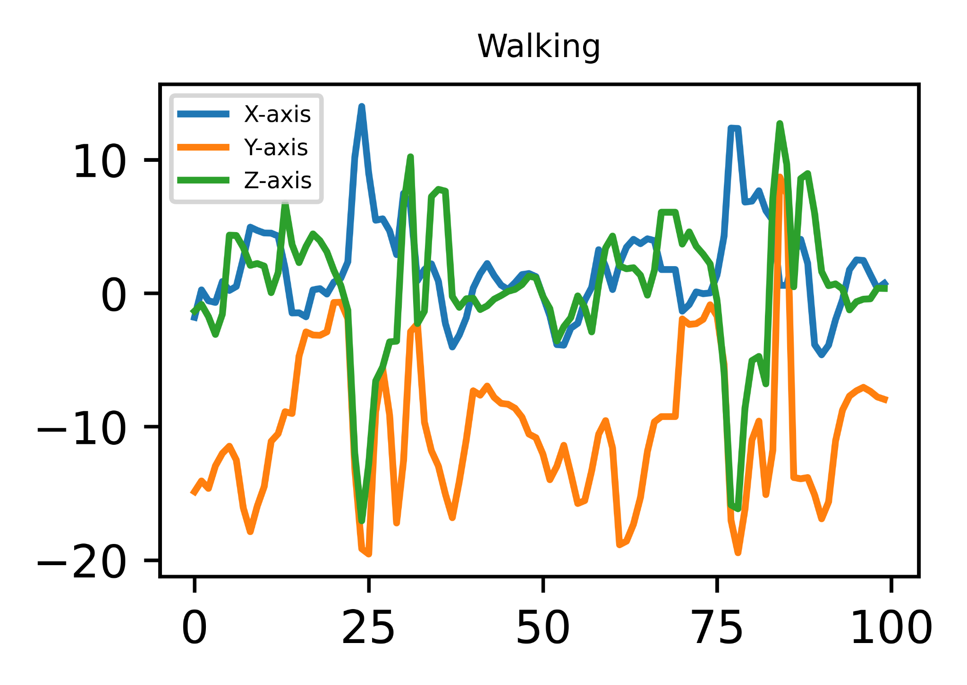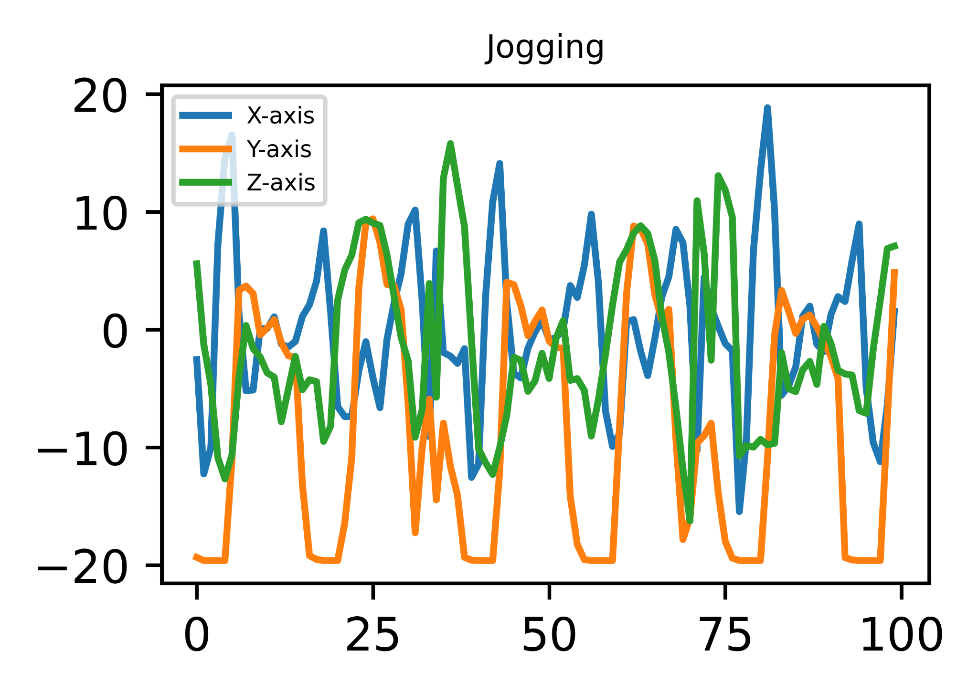

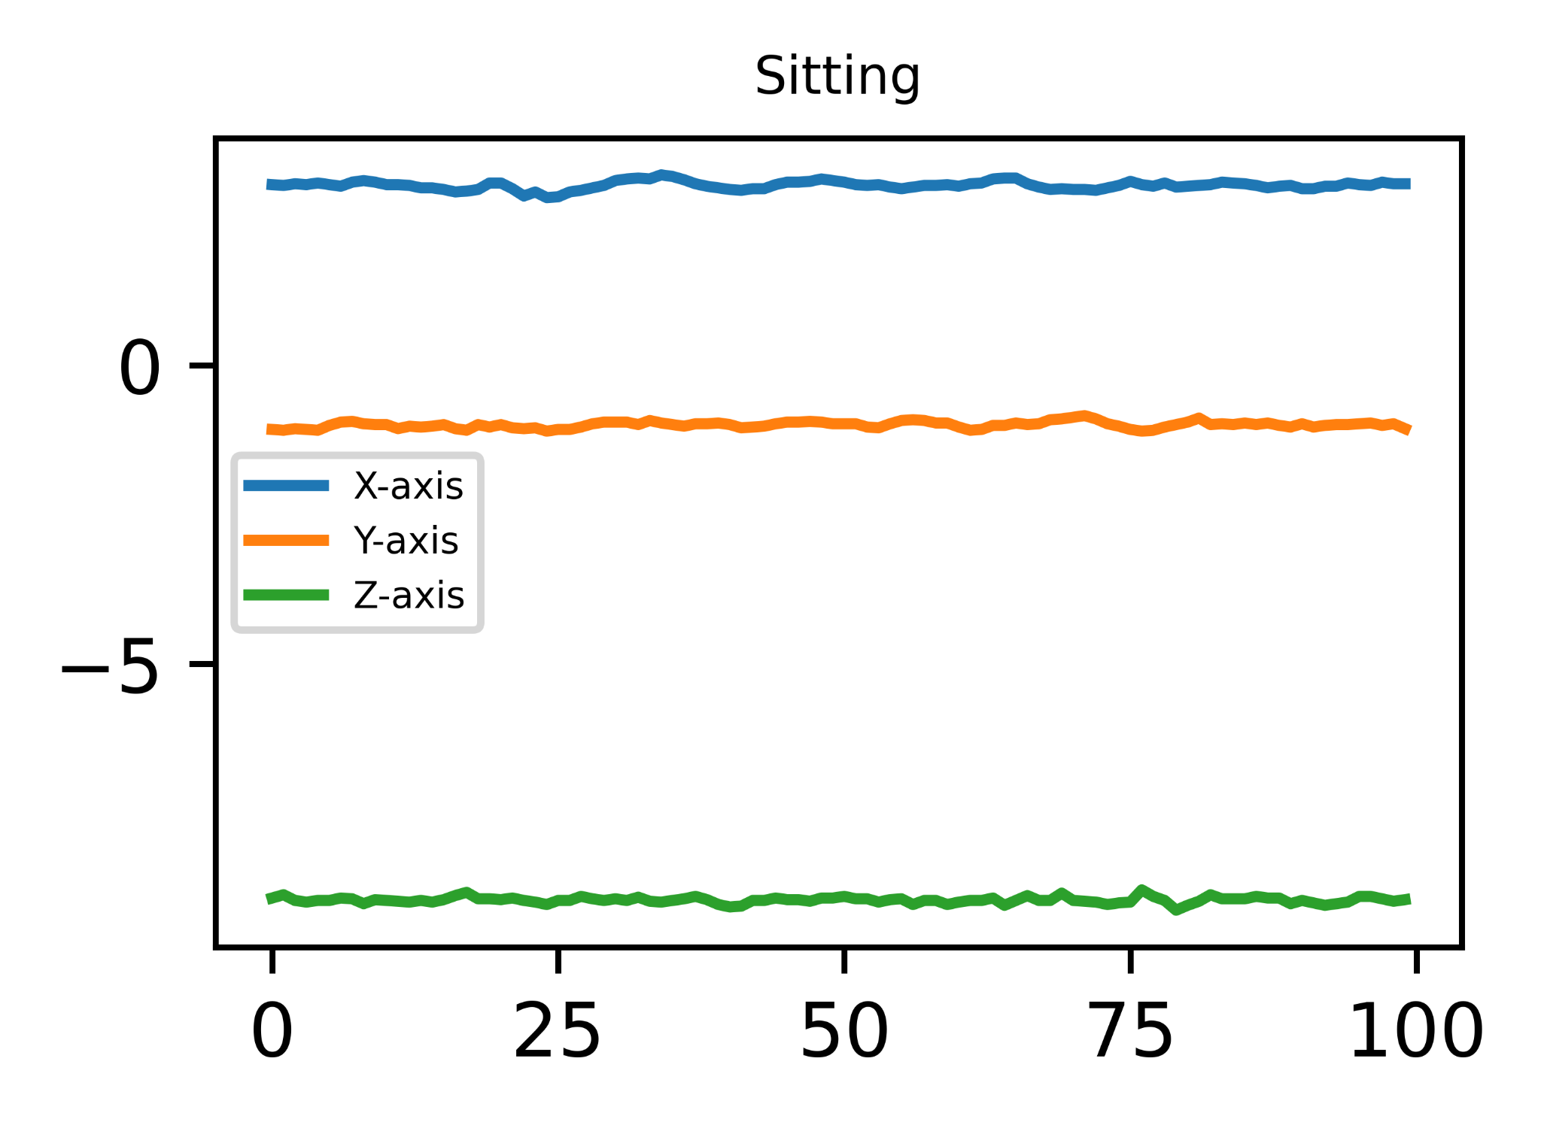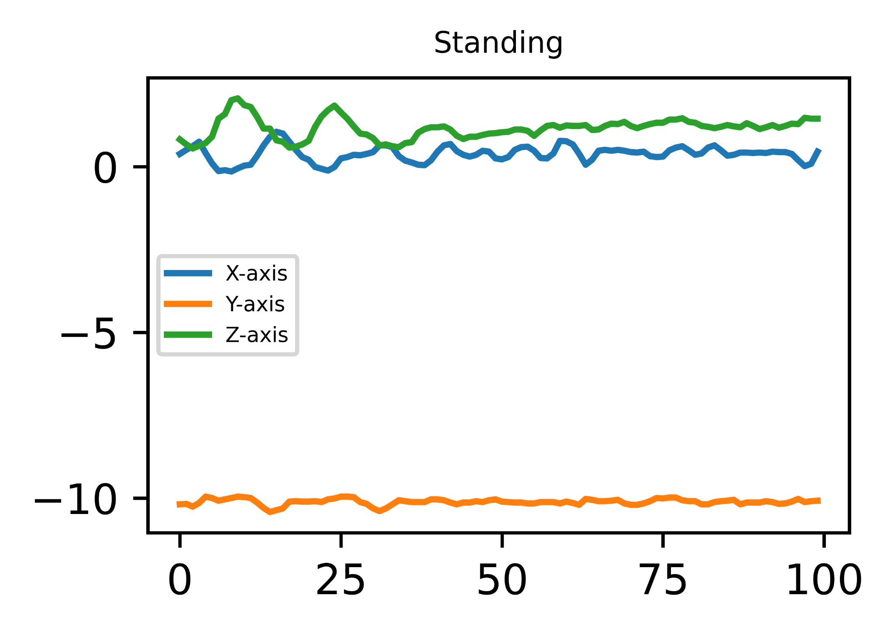

Fig 4.1-4.4: Accelerometer Sensor Data on Various Activities

As we can clearly see that the accelerometer reacted differently upon each different physical activity. So our task was to build a Deep Neural Network that can recognize human activity by distinguishing the sensor signals and find a pattern.

**5. Methodology:**

**5.1 Collecting the Dataset:**

The Sensor Activity dataset was collected from University of Twente’s Pervasive Systems research section. The data was collected for an accelerometer, a gyroscope, a magnetometer, and a linear acceleration sensor upon 7 physical activities - walking, sitting, standing, jogging, biking, walking upstairs and walking downstairs. There were ten participants involved in the data collection experiment who performed each of these activities for 3-4 minutes. All ten participants were male, between the ages of 25 and 30. The data was collected on a Samsung Galaxy SII (i9100) smartphone, putting it on the left and right jeans pocket.

**5.2 Data Preprocessing:**

To recognize an activity a sequence of sensor data is needed. Therefore, sliding window segmentation with 50% overlap was carried out before data input into the model. The sliding window was done on each participant data separately with a window size of 100. Finally the windowed sensor data of 8 participants were concatenated as train data and remaining 2 participant’s data was selected as test data. It was necessary to choose the appropriate window size. If the window is too large, important information will be lost. Otherwise, the computational costs will be increased.

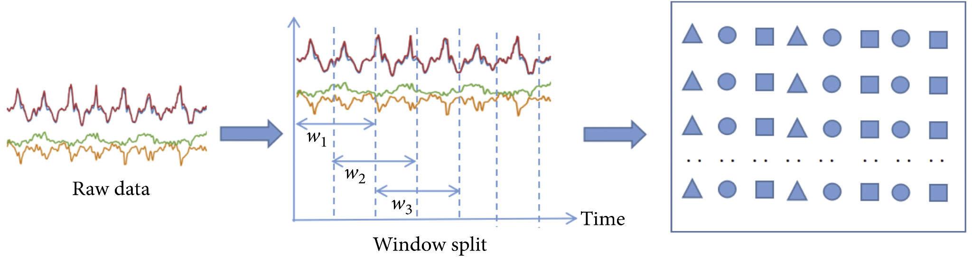

Fig 5.1: Sliding Window Technique for Data Preprocessing

**5.3 Construct a Model:**

We used 1D-CNN based architecture where 2 CNN layers were stacked one upon the other followed by a pooling layer. The convolution layers carry out convolution operations on the input image through the convolution kernel to obtain feature mapping. The pooling layer extracts local features from the feature map of the convolution layer through sampling operation to lessen the size of neurons and the number of parameters. The convolution layers and the pooling layer are stacked to form a deep structure, which can automatically extract the action feature information from the raw sensor data. Relu activation function was used in the CNN layers.

The model was trained with early stopping. Initially the number of epochs were 100. But because of the early stopping callback, the training stopped at epoch no. 70.

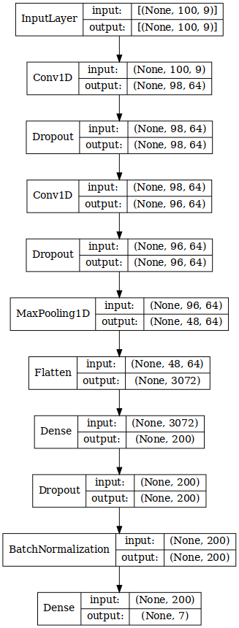

Fig 5.2: Model Diagram

**5.4 Performance Validation:**

Test Accuracy: 98%

Test Loss: .08%

Here are all necessary plots and charts for performance validation-

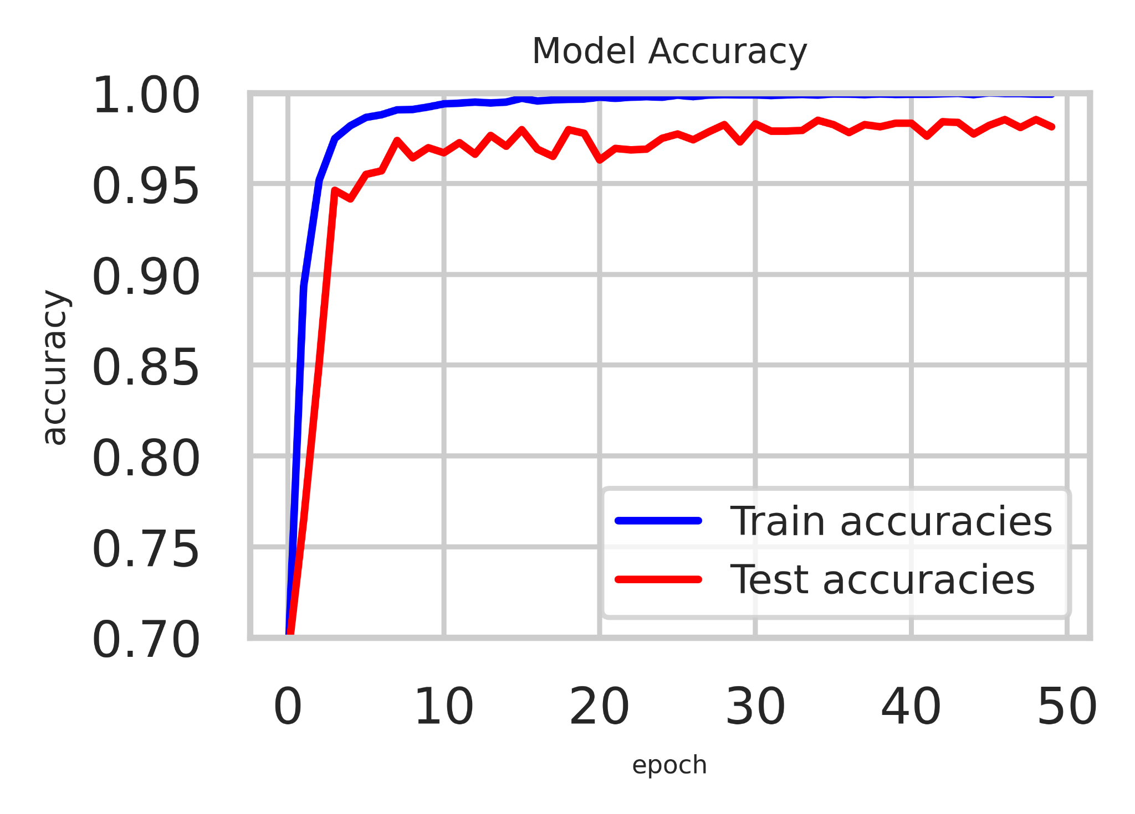 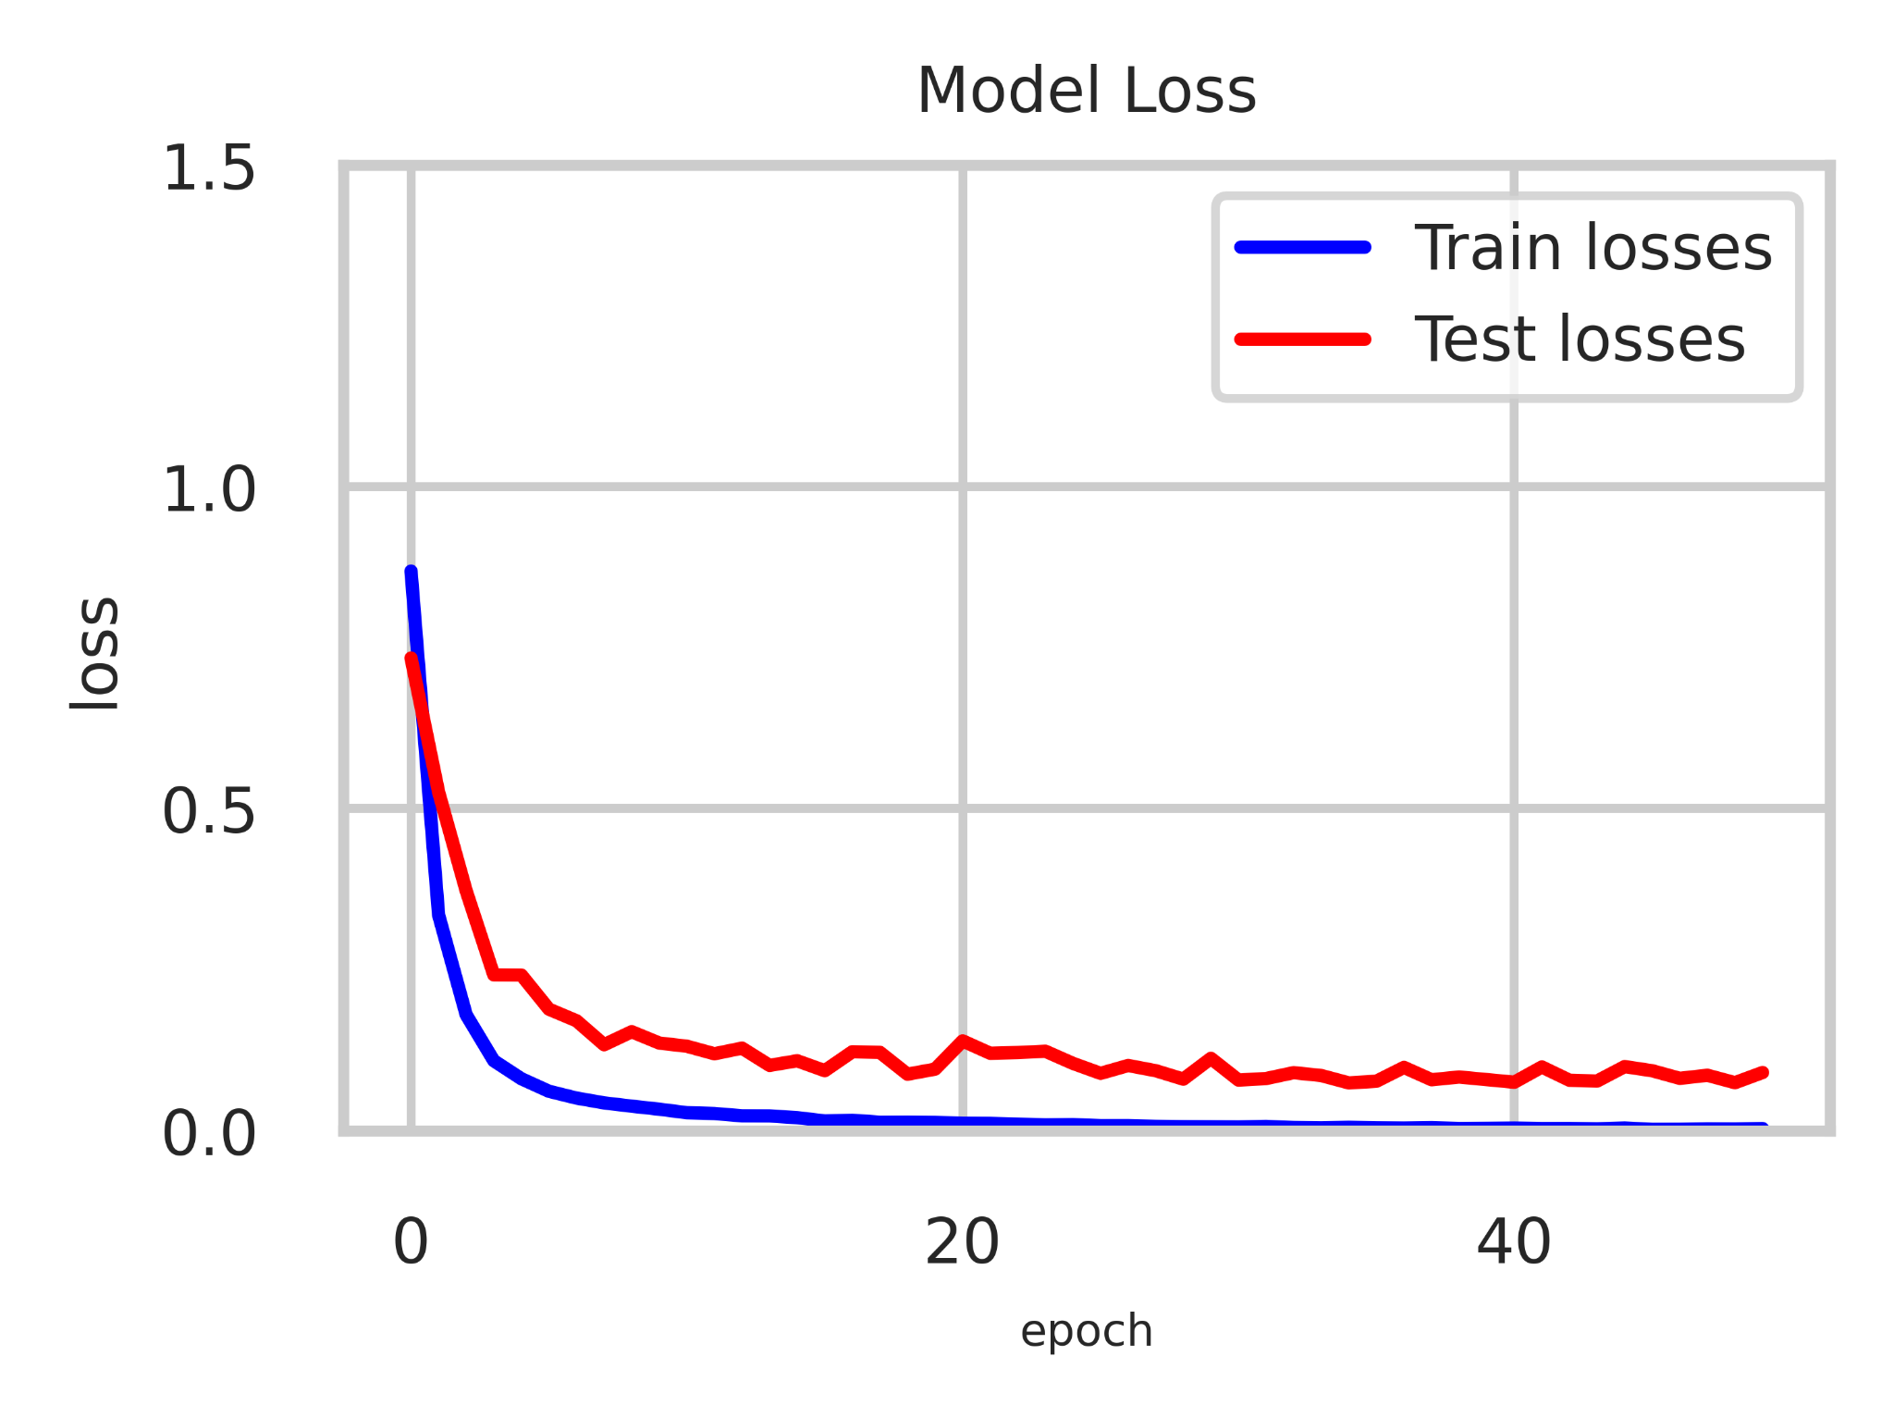

Fig 5.3: Train/Test Accuracy vs Epoch Fig 5.4: Train/Test Loss vs Epoch

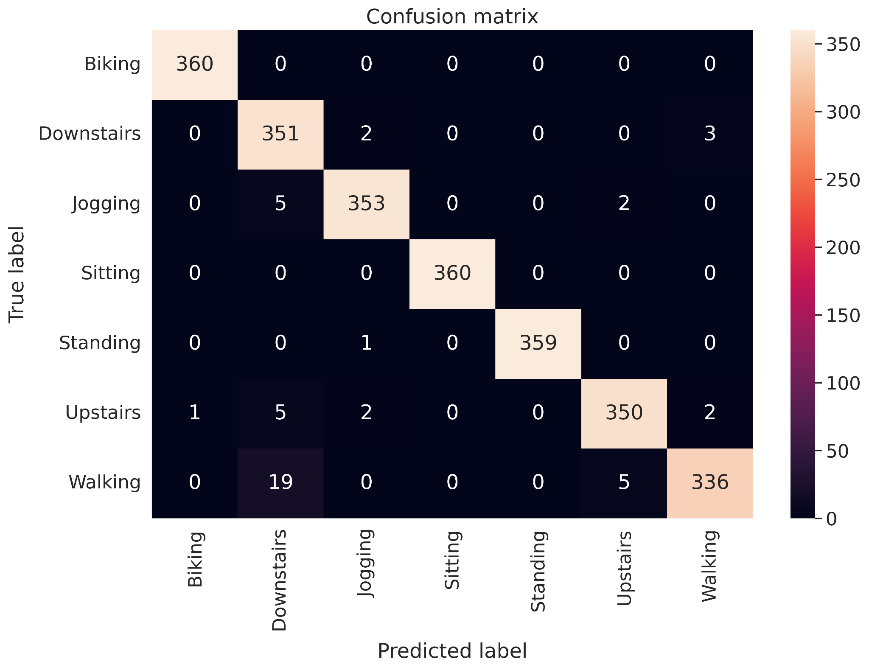

Fig 5.5: Confusion Matrix

**6. Implementation:**

**6.1 Front-end:** The front-end consisted of a simple UI. It showed the Physical Activities along with their probabilities. The activity with highest probability was spoken out with TextToSpeech functionality.

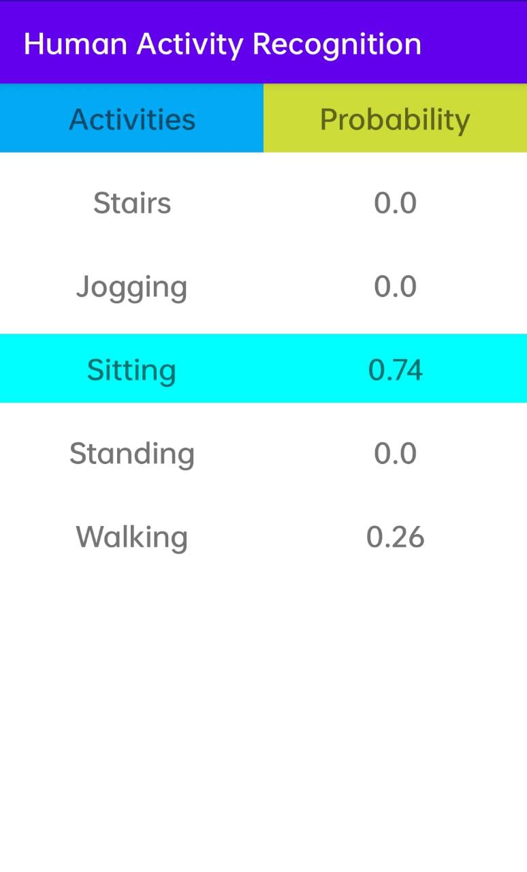

Fig 6.1: HAR UI

The sensor data was repeatedly collected in an ArrayList and converted to JSON format before being sent to the server.

**6.2 Networking** : Okhttp library was used for back and forth data communication between the app and the server. Okhttp “POST” method was used.

**6.3 Back-end:** The back-end was a python based flask app. The model was loaded. Upon receiving the sensor values, the output was predicted and sent back to the app as JSON format. Tensorflow and Keras library were used. The back-end server ran on an CUDA supported GPU for better performance.

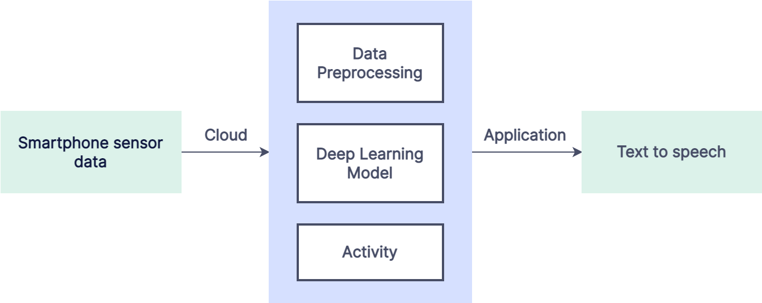

Fig 6.2: Flow Diagram of HAR

**7. HAR Based Application:**

**7.1 Elderly Monitoring System:**

Human activity recognition can be used with elderly monitoring system where one can know elder’s activity using HAR and location from GPS. Elder can send SOS in case of any emergency. So, elder’s location and activity can be monitored real time from any distance.

**7.2** **Description:**

This application has two panel. One is for monitoring child and another is for the child which include a SOS in case of emergency.

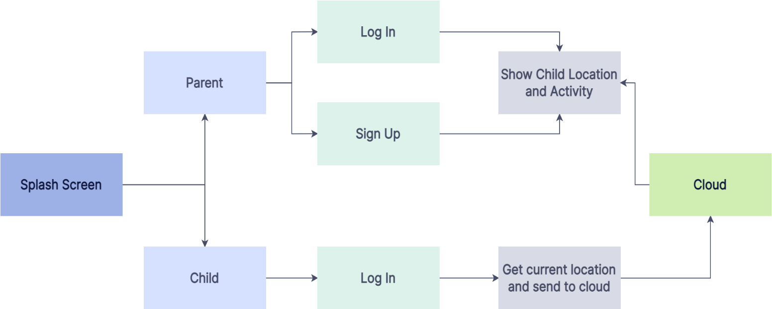

Fig 7.1: Complete Workflow of Application

In background flask is running and it is handling the connection between database and server. SQLAlchemy database is used in background to store child location and activity.

**Parent UI:**

The parent part includes a simple user interface show the location and activity of child. The location can also be viewed in map.

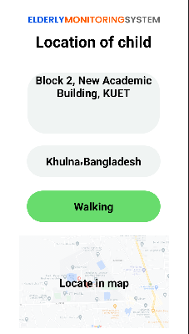

Fig 7.2: Parent UI

**Child UI:**

The child part includes a simple user interface with a SOS button.



Fig 7.3: Child UI

This part gets the current location continuously and send it to parent. Pressing emergency call button an emergency call will go to parent phone number.

**7.3 Storyboard:**

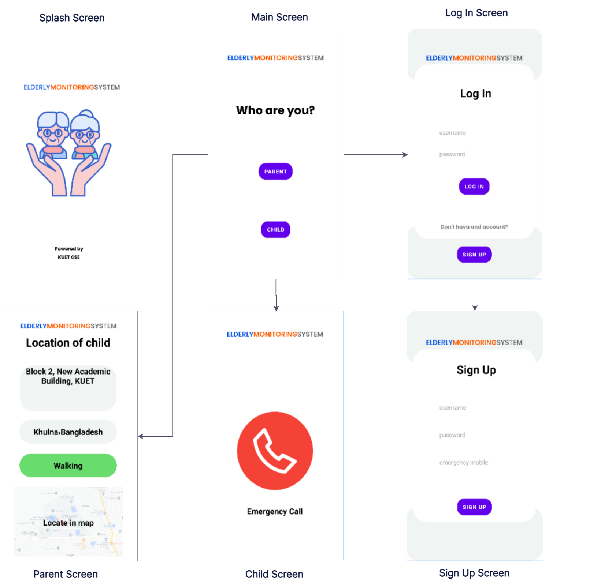

Fig 7.4: Storyboard of Application

**8. Limitation:**

Changing smartphone varies sensor data. So, by changing smartphone some activity may not detect accurately. Some similar activity like jogging, walking, upstairs, downstairs the sensor data varies a little. For this our system faces difficulties to detect the accurate activity.

**9. Future Scope of Improvement:**

In future, we have plans to expand this project on different levels. Such as:

* More accurately detect similar activity like jogging, walking etc.
* Getting the accurate value of detecting activity by placing smartphone anywhere in body.
* Try to develop this system using less computation.

**10. Conclusion:**

We can detect one’s activity using smartphone sensor, as smartphone is a most important daily needed component. As most of the people use smartphone, by using smartphone sensor we can detect human activity. HAR has many human centric applications, notably in eldercare and healthcare as an assistive service. Smartphone sensors can be used to detect human activity.

**11. References:**

1. C. Chen, R. Jafari and N. Kehtarnavaz, “A survey of depth and inertial sensor fusion for human action recognition,” *Multimedia Tools & Applications*, vol. 76, no. 3, pp. 4405-4425, 2017
2. Y. Chen and C. Shen, “Performance analysis of smartphone-sensor behaviour for human activity recognition,” *IEEE Access*, vol. 5, no. 99, pp. 3095-3110, 2017.
3. D. Tao, Y. Wen and R. Hong, “Multicolumn bidirectional long short-term memory for mobile devices-based human activity recognition,” *IEEE Internet of Things Journal*, vol. 3, no. 6, pp. 1124-1134, 2016.
4. Z. Chen, Q. Zhu, C. S. Yeng and L. Zhang, “Robust human activity recognition using smartphone sensors via CT-PCA and online SVM,” *IEEE Transactions on Industrial Informatics*, 2017.
5. F. Foerster, M. Smeja, J. Fahreberg Detection of posture and motion by accelerometry: a validation study in ambulatory monitoring. Computers in Human Behavior 15 (1999) 571-583
6. Ling Bao and Stephen S. Intille Activity Recognition from User-Annotated Acceleration Data[C]// International Conference on Pervasive Computing. Springer, Berlin, Heidelberg, 2004:1-17.
7. A. Jain and V. Kanhangad, “Human Activity Classification in Smartphones Using Accelerometer and Gyroscope Sensors,” *IEEE Sensors Journal*, vol. 18, no. 3, pp. 1169-1177, 2017.
8. N. Jalloul, F. Poree, G. Viardot, *et al*., “Activity Recognition Using Complex Network Analysis,” *IEEE Journal of Biomedical and Health Infromatics*, vol 22, no. 4, pp. 989-1000, Jul. 2018.
9. E. Fullerton, B. Heller and M. Munoz-Organero, “Recognizing Human Activity in Free-Living Using Multiple Body-Worn Accelerometers,” IEEE Sensors Journal, vol. 17, no. 16, pp. 5290-5297, 2017.
10. D. G. Lowe. Object recognition from local scale-invariant features. In Computer vision, 1999. The proceddings of the seventh IEEE international conference on, volume 2, pages 1150-1157. Ieee, 1999.
11. X. Jiang, Y. Lu, Z. Lu and H. Zhou. Smartphone-Based Human Activity Recognition Using CNN in Frequency Domain. Asia-Pacific Web (APWeb) and Web-Age Information Management (WAIM) Joint International Conference on Web and Big Data 2018, pp 101-101.
12. Y. Chen, K. Zhong, J. Zhang, Q. Sun and X. Zhao. LSTM Networks for Mobile Human Activity Recognition. International Conference on Artificial Interlligence: Technologies and Applications (ICAITA 2016)
13. <https://flask.palletsprojects.com/en/2.2.x/>
14. <https://square.github.io/okhttp/>
15. <https://developer.android.com/docs>
16. <https://keras.io/api/>
17. <https://docs.sqlalchemy.org/en/14/>