**DEVELOPED CODE**

#association rules library

->library(arules)

#association rules visualization

->library(arulesViz)

#data set location in the local computer

->groceries <- read.csv("D:\\mywork\\R project\\Market_basket_analysis_3rd_yr\\groceries.csv")

#applying the apriori algorithm

->rules <- apriori(groceries)

#data mining using apriori algorithm

->rules <- apriori(groceries, parameter = list(supp = 0.0001, conf = 0.8))

# Show the top 5 rules, but only 2 digits

->options(digits=2)

inspect(rules[1:5])

#We can get summary info. about the rules that give us some interesting information such as:

#The number of rules generated: 1993

#The distribution of rules by length: Most rules are 4 items long

#The summary of quality measures: interesting to see ranges of support, lift, and confidence.

#The information on the data mined: total data mined, and minimum parameters.

summary(rules)

#sorting the rule by support in decreasing order

->rules<-sort(rules, by="support", decreasing=T)

->inspect(rules[1:5])

#This shows how many values comes under the given condition

->rules

#you can remove redundant rules generated by following command

subset.matrix <- is.subset(rules, rules)

subset.matrix[lower.tri(subset.matrix, diag=T)] <- NA

redundant <- colSums(subset.matrix, na.rm=T) >= 1

rules.pruned <- rules[!redundant]

rules<-rules.pruned

->redundant_rules <- is.redundant(rules)

->redundant_rules

->summary(redundant_rules)

->rules<-rules[!redundant_rules]

->rules

->inspect(rules[1:10])

#target items to generate rules ,here we targeted margarines

->rules_margarine <- apriori(groceries,parameter = list(supp = 0.001, conf = 0.8), appearance = list(default = "rhs", lhs = "margarine="))

#target items to generate rules ,here we targeted citrus_fruits

->rules_margarine <- apriori(groceries,parameter = list(supp = 0.00000001, conf = 0.1), appearance = list(default = "rhs", lhs = "citrus.fruit=canned beer"))

#targets under citrus_fruits

1. What are customers likely to buy before buying citrus.fruits
2. What are customers likely to buy if they purchase citrus.fruits?

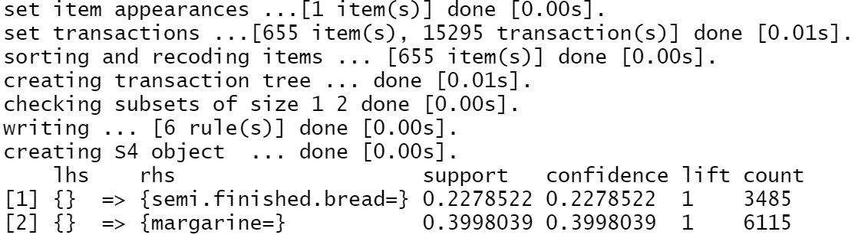

**There are 6 rules under the given condition**

->inspect(rules_margarine[1:2])

#Visualization

->plot(rules, method = "graph")

->plot(rules, method = "graph", interactive = T)