IFT 598: Middleware Prog & Database Sec (2022 Fall)

Module 3 Assignment: ERD Diagram

Name: Sai Mrunaal Chatlapally

Class: 2022Fall-P-IFT458-IFT598-82341-82345

Date: 10-01-2022

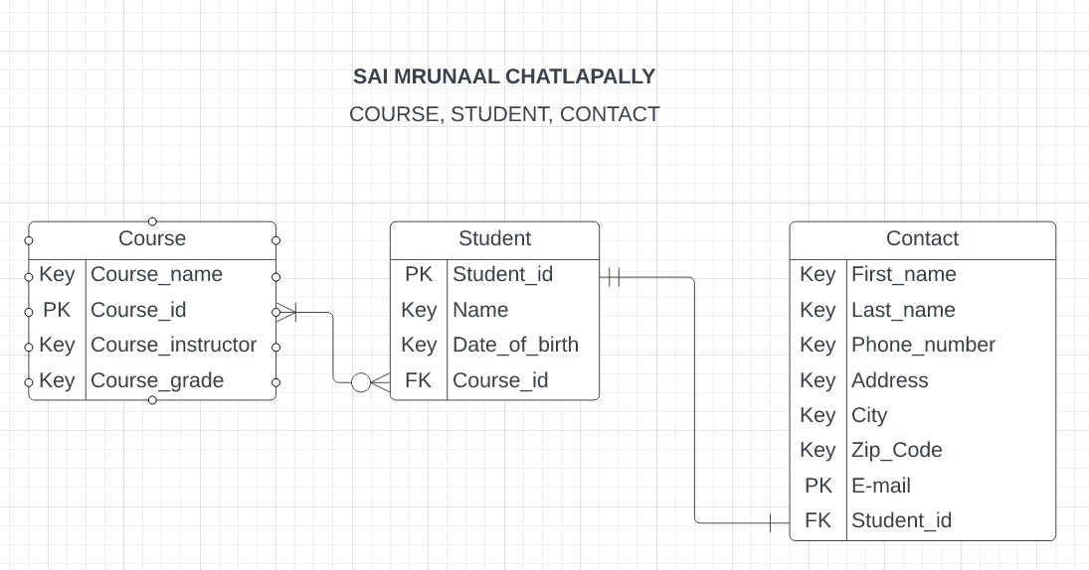

* Developed the ERD Diagram in lucid chart.

We can see we have 3 entities namely Course, Student and Contact along with their attributes and relationship among entities.

|  |  |  |
| --- | --- | --- |
| **Course** | **Student** | **Contact** |
| Course_name | Student_id | First_name |
| Course_id | Name | Last_name |
| Couse_instructor | Date_of_birth | Phone_number |
| Course_grade | Course_id | Address |
|  |  | City |
|  |  | Zip_code |
|  |  | E-mail |
|  |  | Student_id |

First Row contains Entities and the entries in the table are attributes.

* Course entity has Course_id as primary key which links up course and student entities.
* Student entity has Course_id as foreign key.
* Student entity Student_id as primary key which links up student and contact entity.
* Contact entity has E-mail as primary key and Student_id as foreign key.

**ERD Cardinality:**

Course Student

* Student can be registered in one or many courses.
* Course can have 0 or many students.

Student Contact

* Each contact can have one and only one student.
* Each student should have one contact.

**Estimating Project Cost:**

* To complete the project, we break it down into three parts one each for Course, Student and contact.
* Since it is a small project each part of the project can be completed in five days in which three days are spent for each part, one day for debugging and one day for checking everything and testing with edge cases.
* One person can be allocated to complete the whole project.
* Direct costs include the cost spent to recruit the employee and indirect costs include legal fees, insurance etc.

**Mitigating Project Risk:**

* We have to eliminate or mitigate any issues which may cause failure of project budget, completion dates and performance objective.
* We perform both qualitative and quantitative analysis to analyse the risk. Qualitative analysis use risk assessment forms while Quantitative analysis uses project risk management software.