Pictures
 |  | 
 | 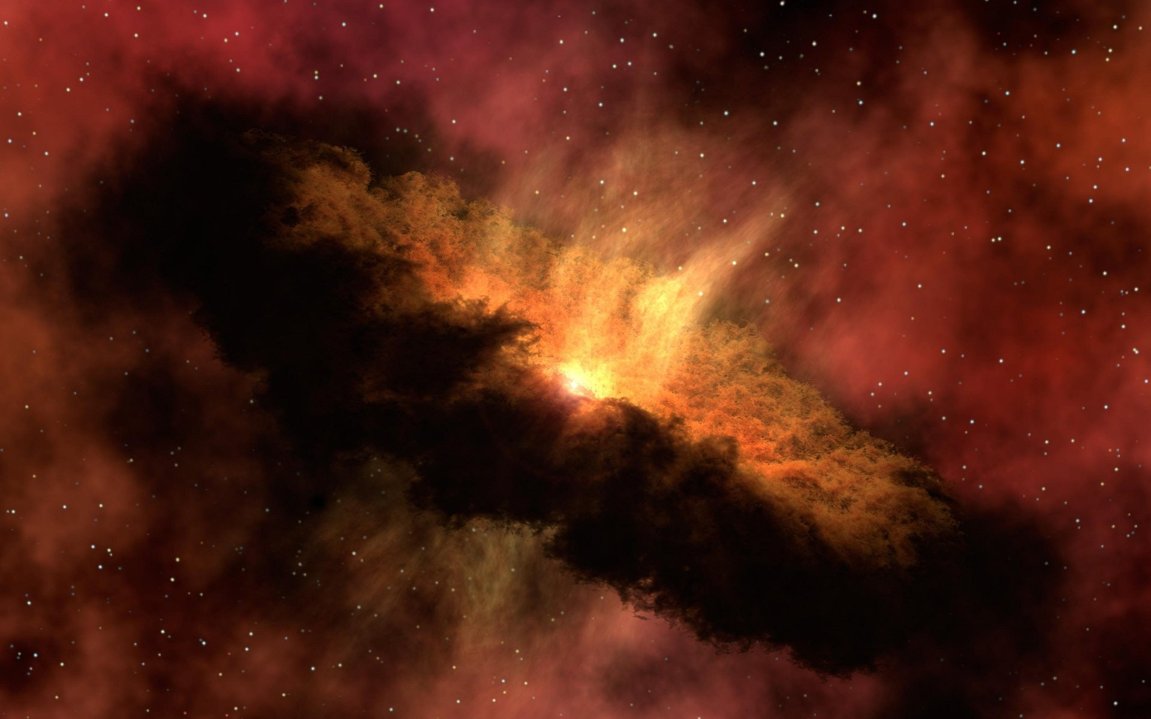 | 

Quiz 2
Operating Systems
Roll number ___________ Name_____________
what are some of the most well known operating system kernel structures? (Marks = 10)
Following are previous time quantum values in micro seconds for some processes. Can we guess which one are the CPU bound or IO bound?

PID Previous Quantum (NS)
3000 123.4
3120 2.45
2135 80.1
4124 0.234

