Table of Contents

Halcyon DeliveryLens: solution design, AWS architecture and 5-day execution plan
Problem 2 · Late deliveries at Halcyon Logistics · EvoHack 2026 · AWS · Team InfinityStacks (Sravan Kumar D · Sai M · Dinesh K)
Built only on the AWS services the team requested (01-infra-request.md): Amazon Bedrock (Claude) · IAM · S3 · ECR · Secrets Manager · RDS PostgreSQL · CloudWatch · Amplify (frontend) · EC2. Code lives on GitHub; the AI tools are Claude Chat and Claude Code.
Find where on-time delivery actually breaks, fix each break point with AI, and prove the number moves before the $680K routing contract is signed.
Inputs this plan is built on: - 00-problem-2-halcyon.docx (problem statement) - Swarna’s briefing call - the 22 Oct kickoff and the guidelines PDF - 00-kickoff-and-brief.md (our analysis of those)
The dataset hasn’t arrived yet. The design is data-agnostic: we build against a canonical schema with a synthetic generator, and map the real dataset onto it on arrival (§7.4).

Contents
- Executive summary
- What we are judged on, and how this design scores
- Problem decomposition: the FDE “See → Deconstruct → Reframe”
- Solution overview and features
- End-to-end flow
- Architecture: logical, AWS deployment, data flow
- Data design
- Analytics engine: attribution and the what-if simulator
- AI inside the product: agents
- AI-first delivery: the agent pipeline that builds it
- API and UI design
- Security, compliance, Responsible AI
- Testing and evidence strategy
- AWS services by phase
- 5-day execution plan
- Repo structure and conventions
- Risks and mitigations
- Demo and presentation plan
- Open questions for the stakeholder

1. Executive summary
- The client’s belief: “routing is broken; a $680K routing engine will lift on-time delivery from 71% to the 94% benchmark and stop the churn of 9 accounts worth $14.2M.”
- Our hypothesis, to be proven with data: lateness comes from several process steps. Many orders are already late before a carrier touches them:
  - manual keying of email orders (14 clients use non-standard formats)
  - the 8am pick-list cutoff
  - stock held in the wrong warehouse
  - carrier choice made from a cost spreadsheet
  - failed delivery attempts
  - no carrier visibility (3 of 6 carriers have no API) A routing engine can only fix the transit share.
- What we build: Halcyon DeliveryLens, an AWS-hosted, AI-powered delivery control tower that:
  - Reconstructs every order’s journey, step by step (order → WMS → pick → dock → carrier → delivery).
  - Attributes each late delivery to the step(s) that caused it, as a waterfall: “71% → 94%: intake +x pts, cutoff +y, allocation +z, carrier +w, failed delivery +v”.
  - Answers the vendor question: the share of lateness a routing engine could fix, the resulting best-case OTD ceiling, and a go / reshape / no-go recommendation.
  - Fixes the break points with AI agents running on Amazon Bedrock (Claude):
    - an email order intake agent
    - a carrier advisor
    - an at-risk shipment and exception agent
    - a complaint triage agent
    - an executive Q&A agent
  - Proves the impact with a what-if simulator that replays history with each fix switched on, and with new synthetic orders, so OTD before and after is measurable.
- Delivery model: 3 humans plus a pipeline of agents covering BA, data analyst, architect, developer, tester, security, DevOps and adoption. Every agent run is logged to the repo (ai-logs/).

2. What we are judged on, and how this design scores

2.1 Level 1: the must-have checklist (miss one and we’re out)
Must-have | How we satisfy it | Evidence we submit
Discovery | Question log rounds 1 and 2; every answer mapped to a design decision; assumption register | hackathon/work/discovery/ question log, assumptions.md, the “Answer → decision” table in the deck
Agent pipeline (across roles, not just code assist) | BA, data analyst, architect, dev, test, security, DevOps and adoption agents (§10) | ai-logs/ transcripts per role + ai-logs/INDEX.md
AI services (AI inside the solution) | 5 Bedrock-powered agents in the product (§9) | Live demo + agent_runs table + CloudWatch
Live app demo (working, deployed prototype) | Amplify URL → React SPA; FastAPI in Docker on EC2 (image from ECR) + RDS PostgreSQL | URL in README; health endpoint; deploy pipeline run
UI | 8 screens (§11.2) covering the whole flow | Playwright screenshots
Backend (working APIs, data, logic) | FastAPI + PostgreSQL, ~20 endpoints, attribution engine, simulator | OpenAPI at /api/docs; pytest report
Testing | Unit, integration, E2E, LLM evals, security scans, attribution accuracy on planted data | evidence/test-report.md, CI artifacts
Not eliminated | Deadline 29 Oct EOD; we stay on the problem statement; synthetic data only | Submission checklist §15.6

2.2 Level 2: 100 points
Criterion (points) | What earns it here
Solution Design & Functional Completeness (25) | Core workflow runs end to end on AWS: ingest → reconstruct → attribute → recommend → fix → prove. Tested and secured (§12, §13).
Technical Creativity, Problem-Solving & UX (15) | Counterfactual attribution waterfall; a “routing-addressable share” that answers the vendor question; a live email-to-order agent. The flow runs on AI, not on individuals.
AI-First Delivery (30) | The agent pipeline from business analysis through user adoption (§10), shown on one slide with logs. The biggest block, so we plan for it from day 1.
Problem Fit & Business Outcome (20) | We challenge the brief with evidence, quantify OTD uplift per fix, and set it against the $680K vendor spend and the $14.2M at-risk revenue. Consultant framing.
Communication, Impact & Future Scope (10) | Customer story for the COO and CFO, a clear vendor recommendation, a 30/60/90-day rollout, scale-out to the other 270 clients.

2.3 The FDE lens weightings → where our time goes
Lens (%) | Our artefact
See, understand the system (15) | Process map with the † steps validated; data profiling report
Deconstruct, name the real problem (20) | Late-delivery attribution waterfall; routing-addressable share
Reframe, design the outcome (20) | “Fix the 3 break points, not just routing”; target OTD and KPI tree
Build, a working slice (20) | DeliveryLens on AWS
Prove, show the evidence (20) | Simulator plus before/after on synthetic new orders, attribution accuracy, test evidence
Customer story (5) | Opening and closing narrative for the COO and CFO

3. Problem decomposition

3.1 The system as described (process map, † = organiser’s guess to verify)
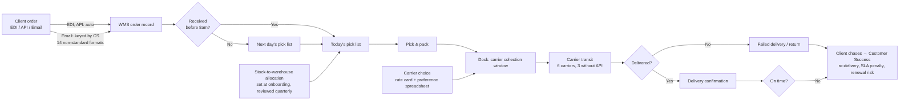

3.2 Hypotheses: where on-time breaks (each is tested against the data)
ID | Break point | Mechanism | Data signal that confirms it | Fix (what we build)
H1 | Order intake | Email orders keyed by hand; non-standard formats lead to delays and errors (SKU, qty, address) | received→WMS lag by channel; error/amend rate on email orders; the 14 clients over-index on late | Email Intake Agent (Bedrock): structured extraction, validation, review queue
H2 | 8am cutoff | Orders after 8am lose a day before picking starts | Late rate by order-arrival hour; step-change at 08:00 | Wave planning: 2–3 waves a day (simulated); cutoff aligned to carrier collection windows
H3 | Inventory allocation | Stock fixed per warehouse at onboarding, so it sits far from demand, goes out of stock or splits | Late rate by ship-from vs nearest warehouse; backorders; split shipments | Allocation advisor: rebalancing recommendations per client and SKU
H4 | Carrier selection | Chosen on cost and preference, not performance; one preferred carrier overloaded | OTD by carrier × lane × volume; preferred-carrier share over time | Carrier Advisor Agent: scorecard-based choice (OTD, cost, capacity)
H5 | Last mile and visibility | Failed attempts (address, availability); 3 carriers have no events, so problems surface late | Failed-attempt rate by reason; event coverage per carrier | Address validation + At-risk Exception Agent with proactive alerts
H6 | Reactive exception handling | CS learns only when the client chases; the expedite desk treats symptoms | Complaint lag after the miss; complaints per late order | Complaint Triage Agent + proactive client comms drafts
H7 | Measurement | On-time definition (promised vs requested), missing timestamps from non-API carriers | Null or late timestamps; definition from discovery | Data-quality report and a single OTD definition
The vendor question: the routing engine addresses H4 and part of H5 (transit and carrier selection). DeliveryLens computes the routing-addressable share of late deliveries and the OTD ceiling if routing were perfect. If that ceiling is well below 94%, the $680K buys a partial fix. Our recommendation is then reshape: fix H1–H3 first (cheap, internal), then run the vendor PoC only on the lanes where transit is the real cause.

3.3 Reframed outcome (the measurable target)
- North-star KPI: on-time delivery (OTD) %, defined with the stakeholder; default is delivered on or before the promised date.
- Target: a path from 71% toward the 94% benchmark, with the uplift attributed per fix.
- Guardrail KPIs:
  - cost per shipment (carrier choices mustn’t simply buy speed)
  - complaint count
  - email-order processing time
  - failed-attempt rate
- Business KPIs:
  - revenue at risk across the 9 accounts ($14.2M) → OTD per at-risk account
  - avoided SLA penalties
  - vendor spend avoided or redirected

4. Solution overview and features

4.1 Feature map (MoSCoW for 5 days)
# | Feature | Priority | Fixes | AI?
F1 | Data hub: upload, schema mapping, validation, data-quality report | MUST | H7 | AI schema-mapping assist
F2 | Order Journey: per-order step timeline with step durations vs standard | MUST | See | –
F3 | Root-Cause Attribution: per-delivery primary/secondary cause + OTD waterfall | MUST | Deconstruct | AI explanations
F4 | Vendor Decision Lens: routing-addressable share, OTD ceiling, go/reshape/no-go memo | MUST | Reframe | AI-drafted memo
F5 | What-if Simulator: switch fixes on/off, replay history, projected OTD per fix | MUST | Prove | –
F6 | Email Intake Agent: email → structured order, confidence, review queue | MUST | H1 | Bedrock
F7 | Ask DeliveryLens: executive Q&A over curated views, with citations | MUST | Adoption | Bedrock
F8 | Carrier Scorecard + Carrier Advisor Agent | SHOULD | H4 | Bedrock
F9 | At-risk Shipments + Exception Agent: risk score + proactive client message draft | SHOULD | H5/H6 | ML + Bedrock
F10 | Complaint Triage Agent: classify the inbox by root cause, link to orders | SHOULD | H6 | Bedrock
F11 | At-risk Accounts view: the 9 accounts, OTD trend, causes, actions | SHOULD | Outcome | –
F12 | Allocation advisor (warehouse rebalancing suggestions) | COULD | H3 | –
F13 | Agent activity / audit log screen | MUST (cheap) | AI-first evidence | –
F14 | Demo login (JWT, password in Secrets Manager) | SHOULD | Security | –
MVP = F1–F7 + F13, which covers every L1 must-have. SHOULDs are added in the order F8 → F9 → F10 → F11.

4.2 Personas
- COO (sponsor): the vendor decision, OTD trend, waterfall, simulator.
- CFO: ROI, vendor spend versus revenue at risk.
- VP Customer Success: at-risk accounts, complaint triage, proactive messages.
- Warehouse supervisor: cutoff and wave impact, dock-miss list.
- Order-entry / CS staff: email intake review queue.
- Carrier management / procurement: carrier scorecard and advisor.

5. End-to-end flow

5.1 Business flow (what the user experiences)
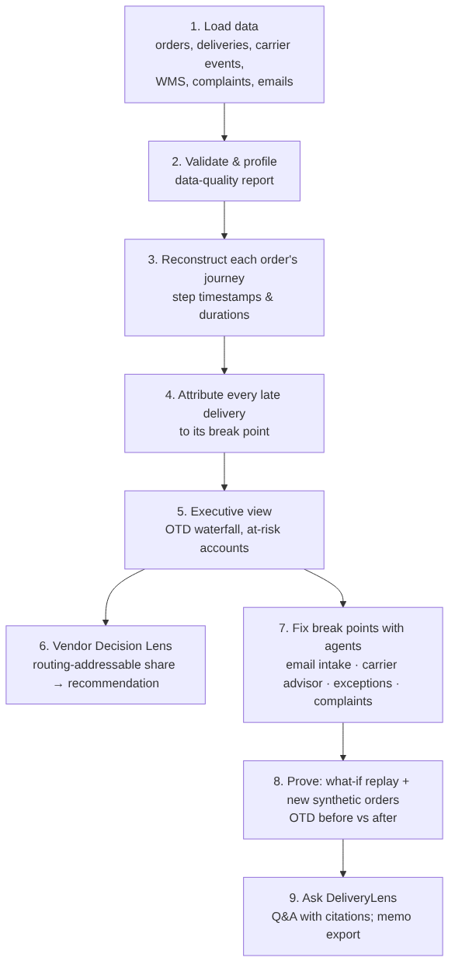

5.2 Live email-intake sequence (the demo’s “AI at work” moment)
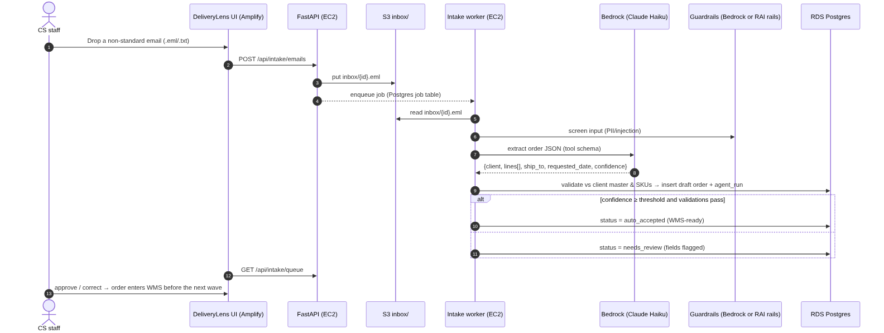

6. Architecture

6.1 Logical architecture
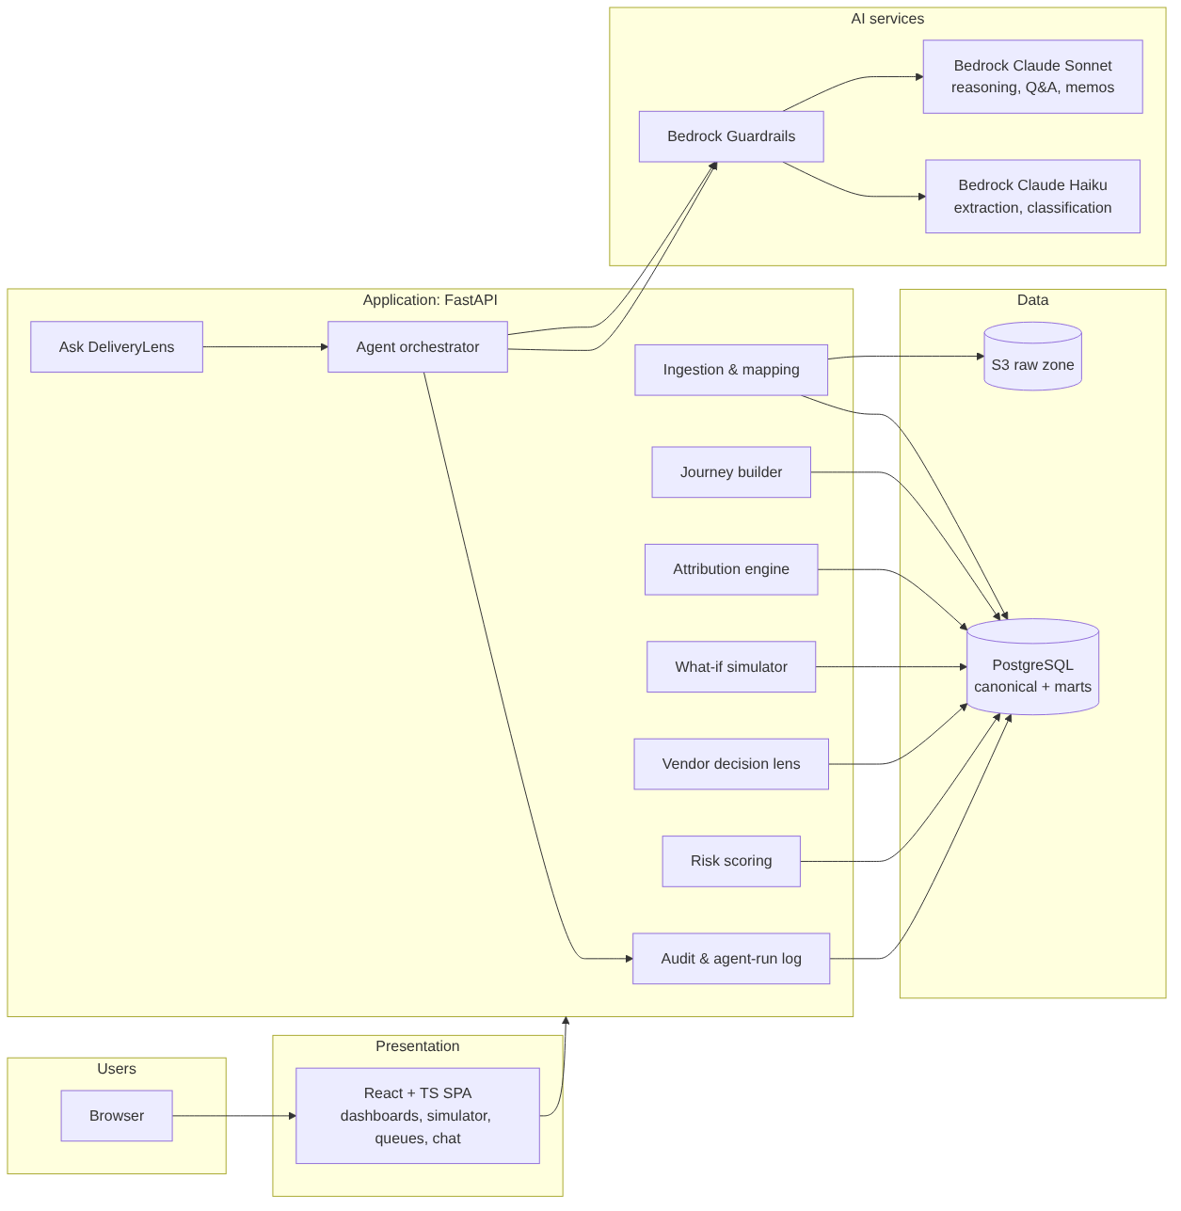

6.2 AWS deployment architecture
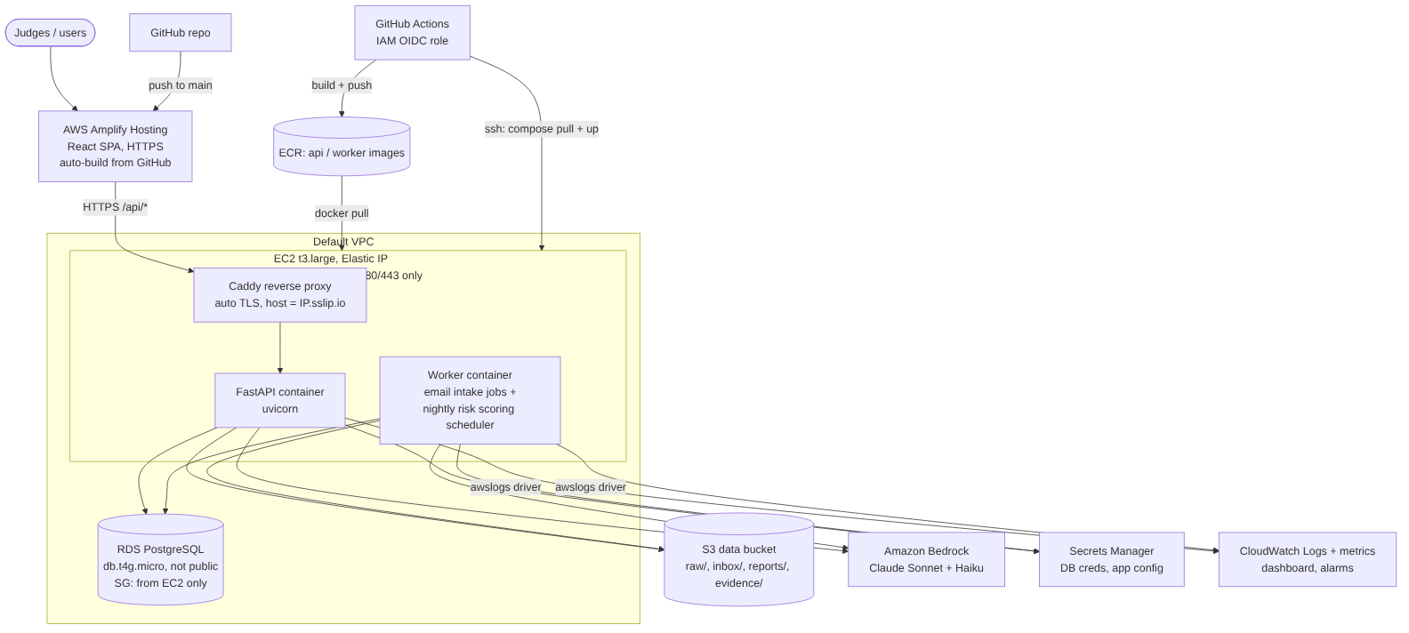
Design choices (ADR summary): - ADR-01, EC2 + Docker Compose for the backend. EC2 was requested, it’s the simplest thing to run in 5 days, and the same docker-compose file runs on laptops on Days 1–2 and on EC2 on Day 3. There are two containers from one image: api (FastAPI) and worker (background jobs). One t3.large is enough for 48k rows and demo traffic. - ADR-02, Amplify Hosting for the SPA. Amplify was requested. It builds from GitHub on every push to main and serves over HTTPS. That gives frontend CI/CD for free. - ADR-03, HTTPS on EC2 via Caddy, with no domain needed. An HTTPS page on Amplify can’t call a plain-HTTP API, because browsers block mixed content. Caddy obtains a Let’s Encrypt certificate automatically for the hostname <elastic-ip>.sslip.io. - Fallback: an Amplify reverse-proxy rewrite of /api/<*> to the EC2 endpoint. - ADR-04, PostgreSQL on RDS only. 48k deliveries is small and SQL is enough. DuckDB is used only for local exploratory analysis. - ADR-05, Bedrock for all in-product AI. It runs in the AWS account, so no data leaves AWS. The EC2 instance role authenticates to Bedrock through IAM; there are no API keys. - ADR-06, deterministic analytics and LLM narration. OTD maths, attribution and simulation are plain Python, testable and reproducible. LLMs extract, classify, explain and answer, and never compute KPIs. - ADR-07, background jobs in a worker container instead of Lambda/EventBridge. Those services weren’t requested. - Email intake: the upload goes to S3 inbox/, and the API writes a row to a Postgres jobs table. The worker picks jobs up with SELECT … FOR UPDATE SKIP LOCKED, calls Bedrock and writes the result. - Nightly risk scoring: APScheduler inside the worker. - It’s the same event-driven pattern, with no extra AWS services. - ADR-08, scripted infrastructure instead of CDK. The infra is a handful of resources: - infra/scripts/*.sh (AWS CLI) creates the S3 bucket, ECR repos, secret, security groups and RDS instance. - infra/ec2-user-data.sh bootstraps Docker, Caddy and the CloudWatch log driver. - Every step is idempotent and documented in the runbook. - If the provisioned IAM role allows CloudFormation, the same resources can move to a template.

6.3 Data flow (zones)
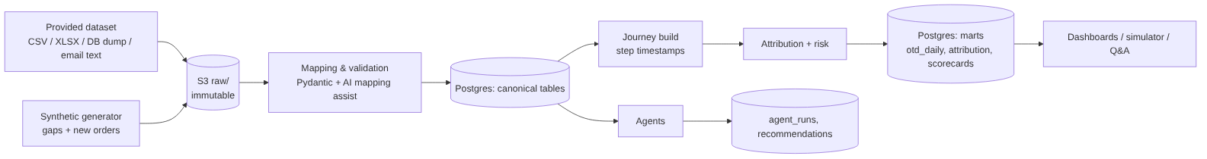

7. Data design

7.1 Canonical schema (built before the dataset arrives)
Table | Key fields
clients | client_id, name, tier, annual_revenue, at_risk_flag, order_channel, email_format_type
warehouses | warehouse_id, name, region, lat, lon, pick_cutoff_time, waves_per_day
carriers | carrier_id, name, has_api, preferred_flag, contracted_capacity
rate_card | carrier_id, lane (origin→dest region), service_level, cost, standard_transit_days
carrier_preferences | warehouse_id, lane, rank, carrier_id (from the preference spreadsheet)
products / inventory | sku, warehouse_id, on_hand, allocated_client_id
orders | order_id, client_id, channel (EDI/API/EMAIL), received_at, entered_wms_at, requested_date, promised_date, ship_to_*, status
order_lines | order_id, sku, qty, allocated_warehouse_id, backorder_flag
shipments | shipment_id, order_id, warehouse_id, carrier_id, pick_list_date, picked_at, packed_at, dock_ready_at, carrier_pickup_at, split_flag
delivery_events | shipment_id, event_type (pickup / in_transit / attempt / delivered / failed / returned), event_at, reason_code, source (API/manual)
deliveries (derived, 1 per shipment) | first_attempt_at, delivered_at, final_status, failed_attempts, on_time_flag, days_late
complaints | complaint_id, client_id, received_at, text, linked_order_id, category, severity
email_orders | email_id, client_id, raw_text, received_at, parsed_json, confidence, status
agent_runs | run_id, agent, model, input_ref, output_json, tokens_in/out, latency_ms, guardrail_action, created_at
recommendations | rec_id, type, target, rationale, evidence_refs, status
simulation_runs | sim_id, levers_json, baseline_otd, projected_otd, per_lever_uplift_json

7.2 Derived step metrics (journey_steps)
For each shipment we compute the step durations and compare each with its standard:
Step | Measured as | Standard (default; replaced by discovery answers)
Intake | entered_wms_at − received_at | EDI/API ≤ 15 min; email ≤ 2 business hours
Cutoff wait | pick_list_date − entered_wms date | 0 days if entered before the cutoff
Warehouse | dock_ready_at − pick-list start | ≤ 1 shift
Dock → pickup | carrier_pickup_at − dock_ready_at | Same day collection window
Transit | first_attempt_at − carrier_pickup_at | rate_card.standard_transit_days for the lane
Last mile | delivered_at − first_attempt_at | 0 (first attempt succeeds)

7.3 Synthetic data generator (Day 1, data/synth/generate.py)
- Volume: 280 clients, 5 warehouses, 6 carriers (3 without API), 6 months, about 48k deliveries. This mirrors the brief.
- Plants known causes at controlled rates, so attribution accuracy is measurable:
  - email keying delay and errors (concentrated in 14 clients)
  - after-8am arrivals
  - wrong-warehouse allocation and splits
  - an overloaded preferred carrier
  - transit delays on specific lanes
  - failed attempts (bad address, recipient unavailable)
  - missing timestamps for non-API carriers
- Calibrated so baseline OTD ≈ 71%.
- Also generates email order texts in 14 messy formats, about 200 of them, with a gold JSON each, for the extraction eval.
- Also generates complaint texts linked to late orders.
- --seed makes runs reproducible.
- --new-orders N produces fresh orders for the before/after proof.

7.4 When the real dataset arrives (half-day budget, any day)
- Drop the files into S3 raw/ or data/raw/. Run the profiler: columns, types, nulls, ranges, keys, join coverage.
- The schema-mapping assistant (Claude) proposes a source→canonical column map. A human approves it, and it is saved as mapping.yaml.
- The loader applies the mapping, validates against the Pydantic models, and writes a data-quality report. That report doubles as discovery evidence: “what the data says vs what people say”.
- Re-run journey → attribution → marts. Compare with the synthetic baseline and note differences as findings.
- Keep the synthetic generator for the gaps the real data lacks (for example email text or carrier events for non-API carriers), and label synthetic rows with source='synthetic'.

8. Analytics engine

8.1 Late-delivery attribution: counterfactual replay
This is the core “Deconstruct” asset. For each delivery we know the actual step durations and each step’s standard.
- Primary cause per late delivery: the step with the largest excess over its standard (ties go to the earliest step). Secondary cause: the next largest excess.
- Counterfactual OTD per step: for step s, recompute each delivery’s arrival as if s had met its standard (all other steps actual) and recount on-time. Then uplift(s) = OTD_cf(s) − OTD_actual. Swarna asked for exactly this: “10% here, 15% here, 10% there.”
- Combined uplift: fixing all steps together. The individual uplifts don’t add up because causes overlap, so we show both the standalone and the combined figure, plus a Shapley-style order-independent split (computable: 6 steps, 64 subsets).
- Routing-addressable share = the uplift from the transit + carrier-selection steps only. Routing ceiling OTD = OTD_actual + that uplift. This is the evidence for the $680K decision.
- Cuts: by client (with the 9 at-risk accounts flagged), channel, warehouse, carrier, lane, weekday and hour-of-arrival.
Output: the attribution table and the otd_waterfall mart. The UI shows a waterfall chart, 71% → step uplifts → combined ceiling, beside the benchmark at 94%.

8.2 What-if simulator
- Levers:
  - email intake via the agent: intake time → standard, error rate → measured agent error rate
  - pick waves: 1 → 2 or 3 per day, cutoff moved
  - allocation rebalancing for the top N SKUs
  - carrier choice by scorecard instead of the preference spreadsheet, with capacity respected
  - address validation: failed-attempt rate reduced by an assumed X%
  - proactive exception handling: failed attempts recovered within 1 day
- Method: a deterministic replay of the history with the lever’s effect applied to the affected step. Each effect size is a parameter with a stated assumption and source (discovery answer, measured agent eval, or a cited assumption).
- Output: projected OTD, uplift per lever, the 9 at-risk accounts’ projected OTD, and the cost delta (carrier cost from the rate card).
- Proof on new data: generate N new synthetic orders, run them through as-is and to-be pipelines (the to-be pipeline uses the real email agent output), and compare measured OTD.

8.3 Risk scoring (F9)
- Gradient-boosted classifier (scikit-learn), trained on features known at dispatch: channel, hour, warehouse, carrier, lane, split flag, client and carrier history.
- Report AUC and calibration in the test evidence.
- Each day, the top-risk shipments go to the Exception Agent.

9. AI inside the product
All agents run on Amazon Bedrock through one llm_client, which handles: - model routing (Haiku for extraction and classification; Sonnet for reasoning, Q&A and memos) - guardrails on input and output: - Bedrock Guardrails, if the provisioned role allows bedrock:ApplyGuardrail - otherwise the PII and prompt-injection rails from our own RAI gateway (rai_platform/ in this repo). These work offline, need no extra AWS service, and are a differentiator to show - structured outputs via the tool/JSON schema - retries and timeouts - logging every call to agent_runs and CloudWatch
A MockLLM provider keeps tests and offline development working.
Agent | Trigger | Input → output | Model | Human-in-loop | Guardrails
Email Intake Agent | UI upload → S3 inbox/ → worker job | Raw email → order JSON (client, lines, SKUs, qty, ship-to, dates) + per-field confidence | Haiku | Below the confidence threshold → review queue | PII filter on logs; validation against the client and SKU master; injection screening
Root-Cause Explainer | Click on a late delivery or account | Journey + attribution rows → plain-English cause narrative with evidence IDs | Sonnet | Read-only | Must cite row IDs; numbers come only from inputs
Carrier Advisor | New shipment / UI | Lane, weight, date, scorecard → ranked carriers + rationale + cost/OTD trade-off | Sonnet (tool: scorecard query) | Planner accepts or overrides | Capacity constraint enforced in code
Exception Agent | Nightly (worker scheduler) + on demand | Top-risk shipments → recommended action (expedite, carrier swap, call client) + client message draft | Sonnet | CS approves before any message | Tone/policy guardrail; no auto-send
Complaint Triage Agent | Batch over the complaint log | Complaint text → category (H1–H6), severity, linked order, suggested reply | Haiku | CS reviews | PII redaction
Ask DeliveryLens | Chat box | Question → SQL over read-only curated views (allow-listed) → answer + table + citations | Sonnet | – | SELECT-only role; row limit; out-of-scope refusal
Vendor Memo Writer | Vendor Lens “Generate memo” | Attribution + simulator outputs → 1-page go/reshape/no-go memo for the COO and CFO | Sonnet | Team edits | Numbers inserted from the API, not generated
Schema-Mapping Assistant | Dataset upload | Source columns + samples → mapping proposal | Sonnet | Human approves mapping.yaml | Runs on samples only
Agent evaluation (part of Prove): - Email extraction: field-level accuracy on 200 gold emails (target ≥ 95% on mandatory fields). - Complaint triage: accuracy and confusion matrix on the labelled synthetic set. - Q&A: 30 golden questions with expected numbers (exact match, since the numbers come from SQL). - Explainer: a citation-presence check.

10. AI-first delivery
This is 30 points: the agent pipeline that builds and runs the project, across roles.
Role (human owner) | Agents and skills (in .claude/) | Output artefact
Business analyst (H1) | fde-discover, meeting-analyzer, requirements-clarity, process-mapper, product-discovery, devil, Product Manager agent | Question log, assumption register, process map, PRD
Data analyst (H2) | Data Engineer agent, repomix-explorer, Python EDA via Claude Code | Profiling report, DQ report, attribution validation
Architect (H2) | senior-architect, c4-architecture, database-designer, agent-designer, Software Architect agent | This document, ADRs, diagrams
Developer (H2, H3) | subagent-driven-development, test-driven-development, Backend Architect, Frontend Developer, AI Engineer, find-docs | Code, PRs
Tester (H3) | Test Automation Engineer, API Tester, Reality Checker, webapp-testing, verification-before-completion | Test reports, Playwright screenshots, eval scores
Security (H3) | AppSec Engineer, security-and-hardening, ship-gate, Privacy Engineer | Threat model, scan reports
DevOps (H2) | DevOps Automator, SRE, ci-cd-and-automation, shipping-and-launch | AWS CLI infra scripts, EC2 bootstrap, GitHub Actions pipeline, Amplify config, runbook
Adoption and pitch (H1) | Technical Writer, Executive Summary Generator, fde-pitch, data-storytelling, pptx | User guide, training quick-card, deck, demo script
AI usage logs (a deliverable): - ai-logs/<role>/<date>-<topic>.md: exported Claude Code session summaries (prompt → agent → artefact). - ai-logs/INDEX.md: a table of role, agent, task, artefact link, and human reviewer. - In-product agent calls are logged in agent_runs; a sample export goes in ai-logs/runtime/. - Rule: every artefact in the repo names the agent that produced it and the human who reviewed it.

11. API and UI design

11.1 API (FastAPI, /api, OpenAPI at /api/docs)
Method | Path | Purpose
GET | /health | Liveness + DB + Bedrock reachability
POST | /datasets · GET /datasets/{id}/profile | Upload + profile
POST | /datasets/{id}/mapping/suggest · PUT /mapping | AI mapping suggestion, approve
POST | /pipeline/run | Rebuild journey → attribution → marts
GET | /kpis/otd?group_by= | OTD overall and by dimension
GET | /attribution/waterfall · /attribution/causes?filters | Waterfall + cause breakdown
GET | /orders/{id}/journey | Per-order timeline
POST | /orders/{id}/explain | Root-Cause Explainer agent
GET | /vendor/assessment · POST /vendor/memo | Routing-addressable share, memo
POST | /simulate · GET /simulations/{id} | What-if
POST | /intake/emails · GET /intake/queue · POST /intake/{id}/approve | Email agent flow
GET | /carriers/scorecard · POST /carriers/advise | Scorecard + advisor
GET | /risk/shipments · POST /risk/{id}/action | At-risk list + exception agent
POST | /complaints/triage · GET /complaints | Triage
POST | /ask | Ask DeliveryLens
GET | /agents/runs | Agent audit log

11.2 UI screens (React + TS, Tailwind + shadcn/ui, ECharts)
- Executive Cockpit: OTD vs benchmark, trend, the 9 at-risk accounts, complaints, top causes, “Ask DeliveryLens” box.
- Root-Cause Waterfall: 71% → per-step uplifts → ceiling, with filters (warehouse/carrier/channel/client) and drill-down to orders.
- Order Journey: a timeline per order with step bars vs standards and an “Explain” button.
- Vendor Decision Lens: routing-addressable share gauge, routing ceiling vs combined-fix ceiling, cost comparison, “Generate memo”.
- What-if Simulator: lever toggles and sliders, projected OTD, per-lever bars, at-risk accounts projection.
- Email Intake: upload or inbox list, extracted fields with confidence highlights, approve/correct.
- Carriers and Risk: scorecard table, advisor panel, at-risk shipments with exception actions.
- Data and Agents: dataset profile and DQ report; agent-run audit log (model, tokens, latency, guardrail actions).
Design system: use the ui-ux-pro-max or taste-skill “logistics operations dashboard” direction, with 3–5 colours and one typeface.

12. Security, compliance, Responsible AI
- Data:
  - Synthetic or provided data only; no real personal data.
  - S3 is SSE-encrypted with public access blocked.
  - RDS is encrypted, not publicly accessible, and reachable only from the EC2 security group.
- Identity:
  - IAM least privilege. The EC2 instance role has:
    - bedrock:InvokeModel on two model ARNs
    - S3 access on the data bucket only
    - read access to the app secret
    - ECR pull
    - CloudWatch Logs write
  - CI uses a GitHub OIDC role (ECR push only), so there are no long-lived AWS keys.
  - The EC2 SSH deploy key lives in GitHub Secrets.
  - App login: a simple shared demo login (JWT), with the password held in Secrets Manager.
- Network:
  - The EC2 security group allows 443/80 from anywhere (80 only so Caddy can do the ACME challenge and redirect).
  - SSH (22) is open only to the team’s IPs and the GitHub runner deploy step, or is closed between deploys.
  - RDS is not publicly accessible; its security group allows 5432 from the EC2 security group only.
  - Caddy terminates TLS and adds HSTS and security headers.
  - FastAPI CORS is restricted to the Amplify domain.
  - IMDSv2 is required on the instance.
- Secrets: DB credentials live in Secrets Manager. There are no secrets in the repo; gitleaks runs in CI.
- App:
  - Pydantic validation on every input.
  - Upload size and type limits.
  - Parameterised SQL.
  - Ask DeliveryLens runs with a read-only DB role against allow-listed views, with a LIMIT and a statement timeout.
- AI:
  - Guardrails: PII masking, prompt-attack filter, denied topics. Uses Bedrock Guardrails if permitted, otherwise the rai_platform rails.
  - LLMs never compute KPIs.
  - Agents cite evidence.
  - Human approval before any outbound action.
  - Every call is logged (who, what, model, tokens, guardrail outcome).
- Supply chain: pip-audit, npm audit, bandit, Trivy image scan in CI.
- Compliance note for the pitch:
  - The data stays in the AWS region.
  - Bedrock doesn’t use our prompts to train models.
  - The stack maps cleanly onto the client’s security review.

13. Testing and evidence strategy
Layer | Tool | What it proves | Evidence file
Unit | pytest | Attribution rules and counterfactual maths on hand-built cases; simulator levers | evidence/pytest-report.html
Attribution accuracy | pytest + synthetic planted causes | Precision/recall of the primary cause vs the planted truth | evidence/attribution-accuracy.md
Integration | pytest + testcontainers Postgres | Ingest → journey → marts; API contracts | CI log
LLM evals | pytest + gold sets | Email extraction field accuracy; triage accuracy; Q&A exact-match | evidence/llm-evals.md
E2E | Playwright | 6 critical user flows on the deployed URL, with screenshots | evidence/e2e/
Security | bandit, pip-audit, npm audit, Trivy, gitleaks, OWASP ZAP baseline | No high or critical findings | evidence/security.md
Performance (light) | Locust, 50 users | p95 latency for the key endpoints | evidence/perf.md
Model | sklearn metrics | Risk model AUC and calibration | evidence/risk-model.md
Acceptance | Reality Checker agent + human | Every acceptance criterion → evidence link | evidence/acceptance-matrix.md

14. AWS services by phase
Only the 9 requested services are used.
Phase | AWS service | Exactly what we use it for
Discover (done) | – | Question log; Claude Chat and Code for analysis
Build, local (D1–D2) | Bedrock (if laptop credentials exist; otherwise MockLLM) | Develop and evaluate the agents against real Claude early
Foundation (D3 morning) | IAM | EC2 instance role (Bedrock, S3, Secrets, ECR pull, Logs) and GitHub OIDC role (ECR push)
 | S3 | halcyon-dl-data bucket: raw/ (dataset), inbox/ (emails), reports/ (memos, exports), evidence/
 | ECR | Repositories deliverylens-api (one image runs both api and worker)
 | Secrets Manager | deliverylens/app: DB URL, demo login, model IDs, guardrail ID
 | RDS PostgreSQL | db.t4g.micro (or small), not public, automated backups on
Deploy backend (D3) | EC2 | t3.large Amazon Linux 2023 + Elastic IP; Docker Compose runs Caddy + api + worker
 | CloudWatch | awslogs log driver → log groups /deliverylens/api, /deliverylens/worker; CPU/status alarms
Deploy frontend (D3) | Amplify | Connected to the GitHub repo; builds frontend/ on every push to main; env var VITE_API_URL
AI in production (D3–D4) | Bedrock | Claude Sonnet (reasoning, Q&A, memos) + Haiku (extraction, triage); Guardrails if permitted
CI/CD (D4) | IAM (OIDC) + ECR + EC2 | GitHub Actions: test → scan → build → push to ECR → SSH to EC2 docker compose pull && up -d. Amplify deploys the frontend on its own
Operate and prove (D4–D5) | CloudWatch | Dashboard: API latency and errors (from structured logs via metric filters), agent calls and tokens, worker job lag; alarms
Harden (D5) | IAM / EC2 / RDS / S3 | Least-privilege review, IMDSv2, SG audit, S3 block-public-access, RDS encryption check
Rough cost for the week, to be confirmed: - EC2 t3.large: about $0.09/h, so about $12 for the week. - RDS t4g.micro: about $3. - Amplify, S3, ECR, CloudWatch: a few dollars. - Bedrock tokens: about $10–40. - Well under $100 in total. Stop the EC2 and RDS instances overnight if the event allows it (the data persists).

15. 5-day execution plan
Calendar (deadline: code, deployed app and AI logs by Thu 29 Oct EOD):
Day | Date | Theme | AWS?
D1 | Sat 24 Oct | Build core: data, analytics, API, UI skeleton | Local (Docker Compose)
D2 | Sun 25 Oct | Build agents + UI + tests; feature-complete MVP locally | Local
D3 | Mon 26 Oct | Deploy foundation: IAM, S3, ECR, Secrets, RDS, EC2 (Docker + Caddy), Amplify, Bedrock live; round-2 answers applied | AWS
D4 | Tue 27 Oct | Worker jobs + CI/CD + CloudWatch; real dataset (if it’s here); SHOULD features; E2E on cloud | AWS
D5 | Wed 28 Oct | Harden, prove, freeze: security, evals, evidence pack, AI logs, demo dry-runs | AWS
Buffer | Thu 29 Oct | Final submission: repo, URL, AI logs. Then the deck (L1 ~2–3 Nov, L2 ~4–6 Nov) | –
Roles, a suggested split (swap freely; role convergence is part of the score): - H2 = Sai M: architect, AI and data, AWS deployment and DevOps. Sai owns the D3–D5 deployment phase. - H1 = Sravan Kumar D: FDE lead for business, discovery, UX and the pitch. - H3 = Dinesh K: full-stack, QA and security.

Day 0: today, Fri 23 Oct (pre-work, about 2 hours)
- ☐ Submit round-2 follow-up questions (§19) in the discovery log format, today. Answers come Mon 26.
- ☐ Post the infra request (AWS) once in the Teams group, from the SPOC.
- ☐ Create the repo skeleton (§16) and the ai-logs/ convention. Agree OTD definition v0 and step standards v0.
- ☐ Create the GitHub repo (as requested) and give all 3 members access; confirm it is the designated submission repo.

D1, Sat 24 Oct: data, analytics core, skeleton
Block | H1 (business/UX) | H2 (data/AI/infra) | H3 (full-stack/QA)
09–11 | PRD v1 from discovery (spec-driven-development); acceptance criteria per feature; KPI tree | Canonical schema + Pydantic models + Alembic migrations | Repo scaffold: FastAPI + React/Vite + Docker Compose (Postgres) + CI lint/test
11–14 | Process map v2 (process-mapper) with † steps flagged; assumption register | Synthetic generator with planted causes; baseline OTD ≈ 71% | API skeleton: health, KPIs, orders/journey; UI shell + routing + design system
14–17 | Wireframes for 8 screens (ui-ux-pro-max); demo storyline v0 | Journey builder + attribution engine (TDD); counterfactual waterfall | Executive Cockpit + Waterfall screens wired to the API
17–19 | Email gold set: 14 formats, 200 emails (with an agent) | Attribution accuracy test vs planted truth | Order Journey screen; Playwright smoke
Exit gate D1: docker compose up runs locally; the waterfall shows on synthetic data; attribution accuracy is measured; CI is green.

D2, Sun 25 Oct: agents, simulator, feature-complete MVP (local)
Block | H1 | H2 | H3
09–12 | Vendor Decision Lens copy + memo template; user guide v0 (Technical Writer agent) | llm_client (Bedrock + Mock), Email Intake Agent + eval harness | Simulator API + UI (levers, projected OTD)
12–15 | Q&A golden questions (30); demo script v1 | Ask DeliveryLens (read-only views, text-to-SQL, citations); Root-Cause Explainer | Email Intake screen + review queue; Vendor Lens screen
15–18 | Run all flows as the COO persona (Persona Walkthrough agent); UX fixes list | Vendor assessment endpoint + Memo Writer; agent_runs logging | Pytest coverage on engine/API; Playwright for 6 flows locally
18–20 | Update ai-logs/INDEX.md; pod log | Deploy kit ready: infra/scripts/*.sh, ec2-user-data.sh, docker-compose.prod.yml + Caddyfile, amplify.yml; dry-run on a local VM/container | Bandit / pip-audit / npm audit; fix highs
Exit gate D2: all MUST features (F1–F7, F13) work locally end to end; tests green; LLM evals run; the deploy kit has been dry-run.

D3, Mon 26 Oct: AWS foundation and first cloud deploy
Block | H1 | H2 | H3
09–10 | Read the round-2 answers; update the assumption register, standards and OTD definition → decision log | Verify AWS access and IAM permissions; check Bedrock Claude model access (Sonnet, Haiku) in the region; raise any gap in the infra group by 10:00 | Dockerfile hardening (non-root, slim); confirm the GitHub repo and Amplify access
10–13 | Apply answers to the PRD and acceptance criteria; tweak the simulator assumptions | Run infra/scripts: S3 bucket, ECR repo, Secrets Manager secret, security groups, RDS PostgreSQL; IAM instance role | Build and push the image to ECR; connect Amplify to GitHub (amplify.yml), set VITE_API_URL
13–16 | If the dataset has arrived: mapping review with the Schema-Mapping Assistant | Launch EC2 with user-data and an Elastic IP; docker compose up (Caddy + api + worker); Caddy TLS on <eip>.sslip.io; switch llm_client to Bedrock; run migrations + seed on RDS | Smoke test the Amplify URL → EC2 API; fix CORS, mixed-content and config bugs
16–19 | Cloud walkthrough; capture screenshots for the deck | CloudWatch log groups via the awslogs driver; first alarms | Playwright E2E against the Amplify URL
Exit gate D3: the public Amplify URL works end to end on AWS (EC2 + RDS + Bedrock). This covers the L1 “live app demo”, UI, backend and AI services.

D4, Tue 27 Oct: event-driven, CI/CD, real data, SHOULD features
Block | H1 | H2 | H3
09–12 | Real-data findings (“people say vs data says”) → discovery insights slide draft | Worker on EC2: email-intake jobs (S3 inbox/ + Postgres job queue) and the nightly risk-scoring scheduler | CI/CD: GitHub Actions (OIDC) → test → scan → build → push to ECR → SSH deploy to EC2; Amplify auto-deploys the frontend
12–15 | Customer Success flow: at-risk accounts view copy; proactive message templates | Load the real dataset (§7.4) → re-run attribution; Carrier Advisor | Carrier scorecard + At-risk screens
15–18 | KPI and ROI model v1 (financial-analyst): OTD uplift → revenue retained vs $680K | Exception Agent + Complaint Triage Agent | E2E for the new flows; regression on the cloud
18–20 | ai-logs curation per role | Risk model metrics → evidence | Security: ZAP baseline vs the cloud URL; fix findings
Exit gate D4: CI/CD deploys on merge; the real or synthetic dataset loads on cloud; SHOULD features (F8–F11) are live, or deliberately cut and logged.

D5, Wed 28 Oct: harden, prove, freeze
Block | H1 | H2 | H3
09–12 | Before/after proof run: new synthetic orders, as-is vs to-be; final waterfall + vendor recommendation | IAM least-privilege review; security groups and IMDSv2; RDS snapshot; CloudWatch dashboard final | Full regression on the cloud; evidence/ pack (tests, evals, security, perf)
12–15 | Vendor memo final; README (how to run, URL, architecture) | Runbook (start/stop/redeploy/restore) + teardown script; data reset endpoint for the demo | Acceptance matrix (every criterion → evidence) with the Reality Checker
15–18 | Demo dry-run ×2 on the cloud, timed at 20 minutes | Fix blockers only | Record a backup demo video (demo-video / ui-demo)
18–20 | Code freeze; tag v1.0-submission | Final deploy from the tag | Final smoke + screenshots
Exit gate D5: tag pushed; URL stable; evidence/ and ai-logs/ complete; two clean dry-runs.

Thu 29 Oct (buffer and submit)
- ☐ Submit the repo link + URL + AI usage logs before EOD. Keep the stack running for L1.
- ☐ Start the deck in the mandated 7-section order (§18). Rehearse Q&A with scenario-war-room.

15.6 Submission checklist (L1 self-audit)
- ☐ Discovery log (rounds 1 + 2) + “answer → decision” table
- ☐ Agent pipeline across roles: ai-logs/INDEX.md covers BA, data, architect, dev, test, security, DevOps, adoption
- ☐ AI services in the product: 5+ Bedrock agents live; agent_runs populated
- ☐ Deployed prototype URL reachable; /api/health green
- ☐ Usable UI covering the full flow
- ☐ Working APIs, data and logic; OpenAPI docs
- ☐ Test evidence pack
- ☐ No real personal data; within the problem statement; submitted before the deadline

16. Repo structure and conventions
halcyon-deliverylens/
├─ README.md # what, URL, how to run, architecture image
├─ docs/ # this design, ADRs, process map, PRD, user guide
├─ discovery/ # question log, answers, assumption register, decision log
├─ data/
│ ├─ synth/generate.py # synthetic generator (+ gold sets)
│ ├─ raw/ (gitignored) # provided dataset
│ └─ mapping.yaml # source → canonical mapping
├─ backend/
│ ├─ app/{api,core,models,services/{journey,attribution,simulator,vendor,risk},agents,llm}/
│ ├─ migrations/
│ └─ tests/{unit,integration,evals}/
├─ frontend/ # React + TS + Vite
├─ backend/app/worker/ # email-intake jobs + nightly scheduler (same image as api)
├─ infra/
│ ├─ scripts/ # AWS CLI: s3, ecr, secrets, sg, rds, iam (idempotent)
│ ├─ ec2-user-data.sh # Docker, compose, awslogs, Caddy bootstrap
│ ├─ docker-compose.prod.yml
│ └─ Caddyfile
├─ amplify.yml # Amplify build spec for frontend/
├─ e2e/ # Playwright
├─ evidence/ # test, eval, security, perf reports, screenshots
├─ ai-logs/ # agent usage logs per role + INDEX.md
└─ .github/workflows/ # CI/CD
- Branches: main is protected and deployable; feature branches use short PRs; review is done by an agent plus one human.
- Conventions:
  - Conventional commits.
  - Every PR links the acceptance criterion it fulfils and the ai-logs entry for the agent that wrote it.

17. Risks and mitigations
Risk | Impact | Mitigation
Dataset arrives late or differs from expectations | Re-work | Canonical schema + mapping layer + synthetic generator; a half-day budget reserved for the mapping
AWS access arrives after Mon morning | Lose deploy days | Everything runs in Docker Compose; the deploy kit is dry-run on D2; escalate in the infra group at 10:00 Mon
Bedrock model access not approved quickly | No in-product AI on the cloud | Check at the D3 start; escalate immediately; fallback is an approved Claude API key in Secrets Manager (same llm_client)
Browser blocks the HTTP API from the HTTPS Amplify page (mixed content) | UI can’t reach the API | Caddy auto-TLS on <eip>.sslip.io; fallback Amplify reverse-proxy rewrite /api/<*>
Single EC2 instance is a single point of failure | Demo outage | Elastic IP + restart: always; RDS holds all state; AMI snapshot after D5; redeploy from ECR in under 10 minutes (runbook)
Provisioned IAM role lacks a needed permission (e.g. Guardrails, SG edits) | Blocked step | List the required actions in the D3 09:00 check; fall back to rai_platform rails for guardrails
The Claude Code 5-hour window | Slower build | Stagger the three members’ sessions; Haiku for bulk tasks; caveman mode for internal chats
Over-scoping | Missed deadline (elimination) | MoSCoW; MVP gate on D2; cut SHOULDs on D4 if needed
Attribution challenged by judges | Credibility | Show the planted-truth accuracy and the counterfactual method; state the assumptions
LLM hallucination | Trust | LLMs never compute KPIs; citations; evals; Guardrails
Demo failure | L2 score | Data-reset endpoint, backup video, two dry-runs, a frozen tag

18. Demo and presentation plan (30 minutes = 20 demo/PPT + 10 Q&A, mandated order)
- Discovery insights and the key problem (3 min): “Leadership thinks routing; the data says X% of late orders were already late before dispatch.” Show the questions asked, the answers applied, and the assumptions tested.
- Solution approach and architecture (2 min): the logical and AWS diagrams (§6).
- AI agents used (3 min): the delivery pipeline (§10) and in-product agents (§9), with log excerpts.
- Quality, validation and security (2 min): the evidence pack summary (§13), security controls (§12).
- Metrics and business impact (3 min): the waterfall; the routing ceiling vs the combined-fix ceiling; the vendor recommendation; OTD uplift → revenue retained vs $680K.
- Future scope (1 min): live carrier APIs, WMS integration, rollout across all 280 clients, a reusable “delivery diagnostics” offering for other Evoke customers.
- Live demo (6 min): Cockpit → Waterfall → Vendor Lens → drop an email (the agent extracts it live) → Simulator (“switch on 3 fixes → OTD x% → y%”) → Ask DeliveryLens.
The demo can open the talk instead, but all 7 sections must appear. The panel is the client (COO and CFO). Speak to their decision: sign, reshape or reject.

19. Open questions for the stakeholder
Round 2 is due today. One question per row in the discovery log format; priority in brackets.
- [High] How is “on-time” measured: against the promised or requested date, at first attempt or at final delivery? Is the 71% computed on all 48,340 deliveries? (Swarna said 75%.)
- [High] What are the standard times per step: email keying SLA, pick-to-dock, collection windows per warehouse, standard transit per carrier and lane?
- [High] Does the dataset include timestamps for each step (received, WMS entry, pick-list date, picked, dock, pickup, attempts, delivered)? Which are missing for the 3 carriers without an API?
- [High] What exactly is the $680K vendor PoC scope and its success criteria? Which lanes and carriers does it cover? Is there an exit clause if the PoC misses the target?
- [High] Which 9 accounts are threatening to leave, and what do their complaints cite (lateness, wrong items, communication)?
- [High] Is the 8am cutoff fixed by labour or shift rules, or could we add a second pick wave? What are the carriers’ collection windows?
- [Medium] What share of orders come by email, and what error and amend rate do keyed orders have? Can we get sample emails from the 14 non-standard clients (synthetic is fine)?
- [Medium] How often does an order ship from a warehouse other than the nearest, or split across warehouses? Is stock rebalanced between quarterly reviews?
- [Medium] Which carrier has the preferred-supplier agreement, and has its volume or OTD changed since the agreement was signed?
- [Medium] What are the failed-delivery reason codes, and what is the re-delivery process and lead time?
- [Medium] What does a late delivery cost: SLA penalty terms, credits issued in the last 90 days?
- [Medium] When did OTD start falling? Was there an event (new carrier deal, new clients, volume growth, staff change)?
- [Low] Which region or regions do the 5 warehouses serve, and is there seasonality in the 6 months?
- [Low] Are there any constraints on the solution (hosting, data residency, approved tools, the vendor’s integration needs)?
- [Low] Who would use the tool day to day (CS, warehouse supervisors, carrier management)? Who must approve the vendor decision besides the COO and CFO?

