1. What the judges want
This page explains the hackathon rules in simple words, so the whole team aims at the same target.

The journey, one picture
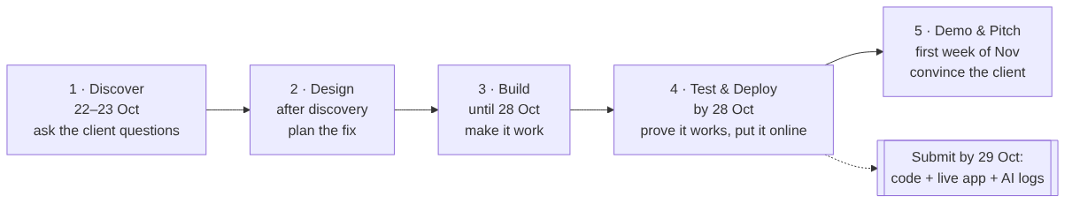
What this shows - The hackathon has five steps, in order. You cannot skip one. - The hard deadline is 29 October. By then we must hand in three things: 1. the code on GitHub 2. a working app that is online 3. logs showing how we used AI agents - The presentation comes later, in the first week of November.

Round 1: the pass/fail checklist
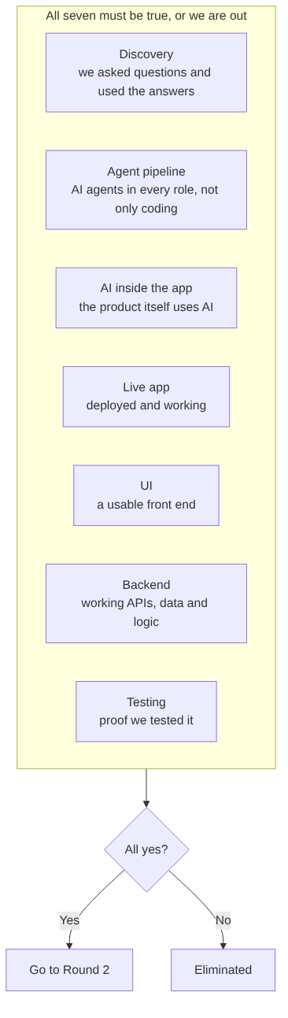
What this shows - Round 1 is a checklist. Every box must be ticked. - For example: if we build a beautiful app but it only runs on a laptop, “Live app” is missing, and we are out. - We are also out if we: - miss the deadline - drift away from the problem - break the rules (for example by using real customer data)

Round 2: how the 100 points are split
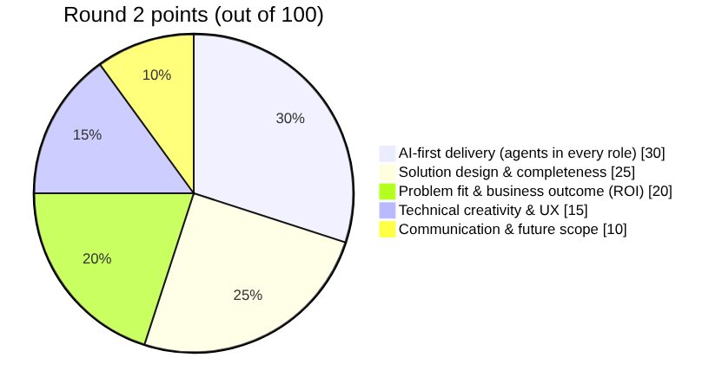
What this shows - The biggest slice, 30 points, is about how we used AI agents across the whole project: business analysis, design, coding, testing, deployment, documentation. - Example: “The BA agent turned the stakeholder call into a list of assumptions. The test agent wrote and ran our browser tests.” We must be able to show logs for this. - 20 points are for thinking like a consultant: 1. name the real problem 2. propose the fix 3. prove the return on investment - The judges play the client (Halcyon’s COO and CFO). We speak to them as a client, not as our managers.

The “FDE lens”: what good thinking looks like
What this shows, using our problem as the example - See: we mapped how an order travels, from the client’s email to the truck and the doorstep. - Deconstruct: the data shows five different reasons for late deliveries, not one. - Reframe: leadership asked for “a routing engine”. We say “fix the five causes, starting with the three cheap ones”. - Build: DeliveryLens, a working app. - Prove: on-time delivery goes from 71% toward 96.6% in the data, cause by cause. - Customer story: “Here is why you were about to spend $680K on the wrong fix.”

The presentation (30 minutes)
What this shows - 20 minutes of talk and demo, then 10 minutes of questions. - These seven sections are compulsory, in this order. The live demo can sit anywhere. - At least one team member must present.

