2. The problem: late deliveries at Halcyon Logistics

The story in one picture
What this shows - Halcyon moves goods for 280 business clients, using 5 warehouses and 6 trucking companies (carriers). - Only 71 of every 100 deliveries arrive on time. Good companies manage 94. - Clients are angry, and 9 of them, worth $14.2 million a year, say they may leave. - The COO and CFO think the routes are the problem, and are about to sign a $680,000 contract for routing software. - We are the advisers. We must say whether that is the right fix, and prove it.

How an order travels today
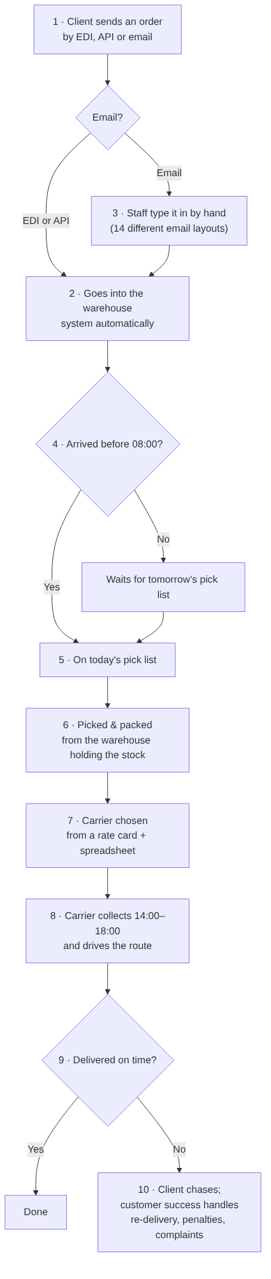
What this shows, step by step with examples 1. A client orders, in one of three ways: - EDI (an automatic system-to-system feed) - API - email 2. EDI and API orders flow into the warehouse system on their own. 3. Email orders are typed in by hand. Example: Client 190 sends an email in its own layout, and a staff member copies the address and items into the system. That is easy to get wrong or incomplete. 4. Each warehouse prints its pick list at 08:00. An order that arrives at 08:05 waits until the next day. For a same-day order, that almost guarantees it will be late. 5. Workers pick the goods from the shelves and pack them. 6. If the nearest warehouse has no stock, the order ships from a further one. Example: an order for the West ships from the Midwest, about 1,600 miles away. 7. Someone picks a carrier using a price list and a spreadsheet, so cheaper usually wins. 8. The carrier collects between 14:00 and 18:00 and drives the route. 9. If it arrives late, the client chases, and the customer success team spends time fixing it.

What the stakeholder told us (Swarna, briefing call)
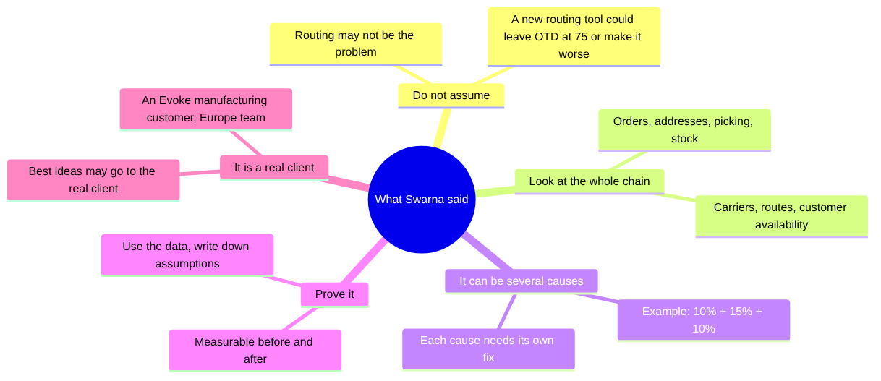
What this shows - Swarna warned us not to accept “routing is broken” without proof. - She expects more than one cause, each with its own fix, and wants numbers that prove the fix works. - This is a real Evoke customer problem, so a strong answer may be shown to the real client.

Our questions for the client (discovery)
We send questions through the L&D question log. Answers come back within 24 hours. These are the questions that matter most now that we have the data:
# | Question | Why we ask (example of how the answer changes our plan)
1 | Is “on time” measured against the promised date, as in the data (on_time = delivered on or before promised_date)? | If they use a different date, every number changes
2 | Why do 12% of orders arrive with an incomplete address, and 28% of email orders? Who fixes the address, and when? | This is our biggest cause. If nobody checks addresses before picking, our address-check agent is the fix
3 | Can same-day orders that arrive after 08:00 still be accepted as same-day? Could there be a second pick wave? | Same-day orders after 08:00 are on time only 39% of the time
4 | How is stock split between warehouses, and how often is it rebalanced? | 12% of orders ship from a further warehouse because the nearest had no stock
5 | Why is Carrier F (the preferred supplier) used in the Northeast and Southeast, where it is on time only about 55% of the time? | Carrier choice by region is a quick win
6 | What exactly will the $680K routing tool change: routes only, or also carrier choice? | It tells us how much of the problem the vendor can fix
7 | Every late delivery in the data has a $34 redelivery cost. Is that right, or a recording rule? | It affects the cost numbers we show the CFO
8 | Three carriers have no API (D by portal, E and F by batch file). How quickly do their delivery updates arrive? | 12 of 34 complaints say “nobody told us it would be late”
The full list we already sent, and the answers, live in docs/reference/ and docs/working/.

