5. The plan to 29 October
Deadline: Thursday 29 October, end of day. By then: code on GitHub, the app live on AWS, and the AI usage logs. The presentation deck follows straight after, for the first week of November.

The plan on one page
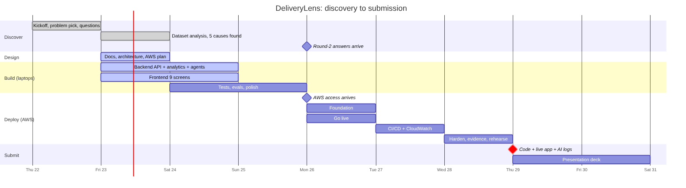
What this shows - Discovery: done. We picked the problem, asked questions and analysed the dataset. - Fri 23 to Sun 25: build and test the whole app on laptops. The AI runs in “mock” mode until Bedrock is ready. - Mon 26 to Wed 28: deploy on AWS, in your planned three deployment days. - Thu 29: submit. Then finish the deck.

Who does what
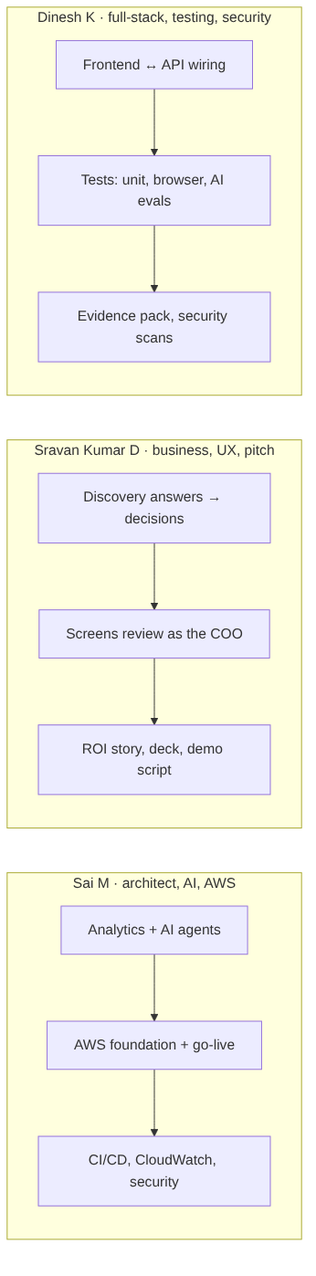
What this shows: a suggested split; swap freely. Each person also does some work outside their main role (role convergence counts in the score), and AI agents help in every role (see 07-how-we-work-with-ai-agents.md).

Day by day

Fri 23 Oct (today): data, design, start building
Done / doing | Output
Analyse the dataset; find the 5 causes | analysis/, docs/03-what-the-data-says.md ✅
Write plain-English docs and architecture | docs/01–07
Build backend (API, analytics, agents in mock mode) | backend/ + tests
Build frontend (9 screens) | frontend/ + tests
Write AWS deploy scripts with placeholders | infra/
CI on GitHub Actions (tests on every push) | .github/workflows/
End of day check: the app runs on a laptop with one command (docker compose up); tests pass.

Sat 24 Oct: finish and polish the build
Task | Who (+ AI agent)
Review every screen as the COO; list fixes | Sravan + UX researcher agent
Fix the list; improve charts | Dinesh + frontend developer agent
AI evals: order-intake accuracy on sample emails | Sai + test automation agent
Browser tests for the main flows | Dinesh + test automation agent
End of day check: all main flows work end to end locally; no failing tests.

Sun 25 Oct: tests, security, rehearse locally
Task | Who (+ AI agent)
Security scan (dependencies, code) and fixes | Dinesh + AppSec agent
Dry-run the deploy scripts against a local Docker setup | Sai + DevOps agent
First demo run-through on a laptop; demo script v1 | Sravan
End of day check: ready to deploy the moment AWS access arrives.

Mon 26 Oct: AWS day 1, live
Time | Task
09:00 | Check the AWS access: region, IAM permissions, Bedrock Claude access. Raise gaps in the infra group by 10:00
09:00 | Read the round-2 answers; update assumptions and numbers
10:00–13:00 | infra/scripts: IAM role, S3, ECR, Secrets Manager, RDS
13:00–16:00 | EC2 launch + Docker + Caddy; load data into RDS; switch AI to Bedrock
16:00–18:00 | Connect Amplify to GitHub; smoke-test the live URL
End of day check: the live Amplify URL works end to end with real Claude.

Tue 27 Oct: AWS day 2, automate and watch
Task
GitHub Actions: test → build → push to ECR → deploy to EC2
CloudWatch: log groups, alarms, a small dashboard
Browser tests against the live URL
Fill the ROI story with any new numbers from the round-2 answers
End of day check: a push to main updates the live app automatically.

Wed 28 Oct: AWS day 3, harden and prove
Task
Security review: IAM least privilege, security groups, RDS not public, encryption
Evidence pack: test reports, AI eval scores, screenshots, security scan results
AI usage logs complete for every role (ai-logs/)
Two timed demo rehearsals on the live URL; record a backup video
Code freeze: tag v1.0
End of day check: everything for submission is ready.

Thu 29 Oct: submit
- Submit the repo link, the live URL and the AI logs before end of day.
- Keep AWS running for the Round 1 check.
- Build the deck in the required 7-section order.

What could go wrong, and our backup
Risk | Backup
AWS access is late on Monday | The app runs on laptops, so we can demo locally and deploy within hours once access arrives
Bedrock Claude not enabled | “Mock” AI mode keeps everything working; we ask L&D to enable the model
The browser blocks the API (HTTP vs HTTPS) | Caddy gives HTTPS automatically; backup is an Amplify proxy rule
Scope too big | Must-haves first (the Round 1 checklist); extra screens only after
Demo fails live | Backup video and a “reset demo data” button

