4. Our solution and its architecture
DeliveryLens is a web app for Halcyon’s leaders and teams. It: 1. shows why deliveries are late 2. fixes the causes with AI agents and simple rules 3. proves how much on-time delivery improves
Every diagram below is followed by a plain-English explanation.

4.1 What DeliveryLens does: one cause, one fix
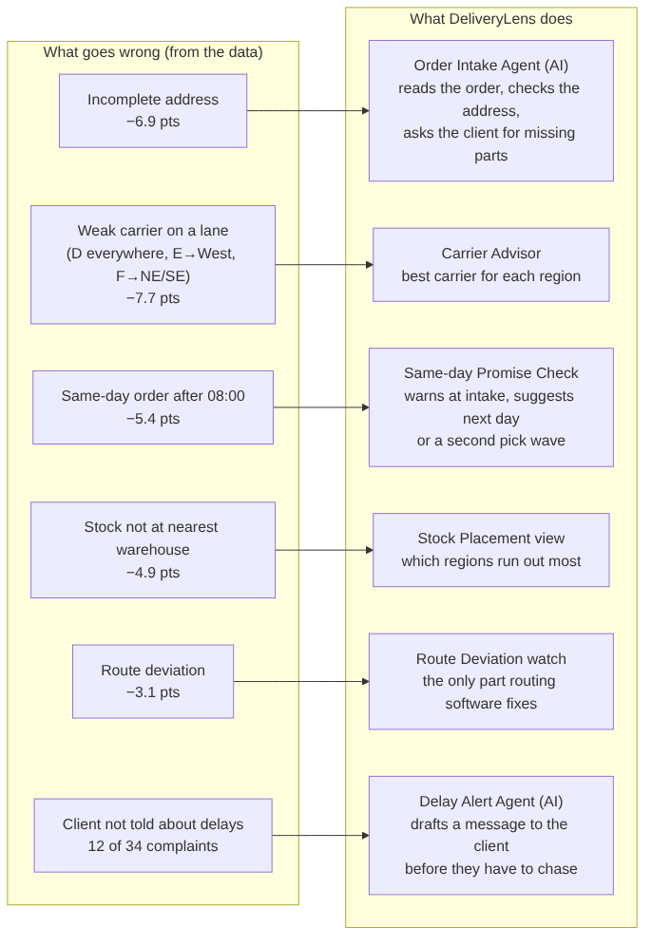
What this shows: every cause found in the data has its own fix, matching Swarna’s “different steps need different solutions”. - Example: an email order arrives without a postcode. 1. The Order Intake Agent reads the email and spots the missing postcode. 2. It drafts a short reply asking the client for it, before the order reaches the pick list. 3. Today, that order would be on time only 35% of the time.

4.2 Who uses it (system context)
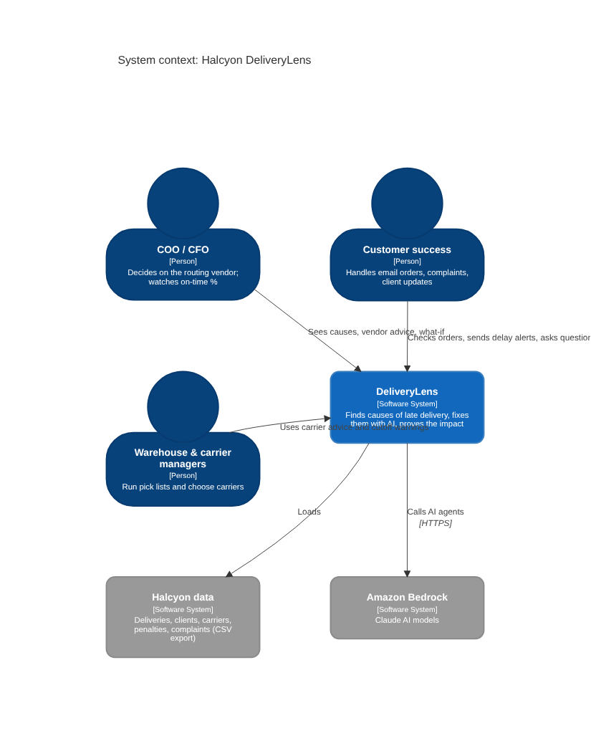
What this shows - Three groups of people use DeliveryLens: - leaders look at the big picture and the vendor decision - customer success uses the AI agents every day - operations follow the carrier and cutoff advice - DeliveryLens reads Halcyon’s data and calls Claude through Amazon Bedrock.

4.3 The parts of the system (containers)
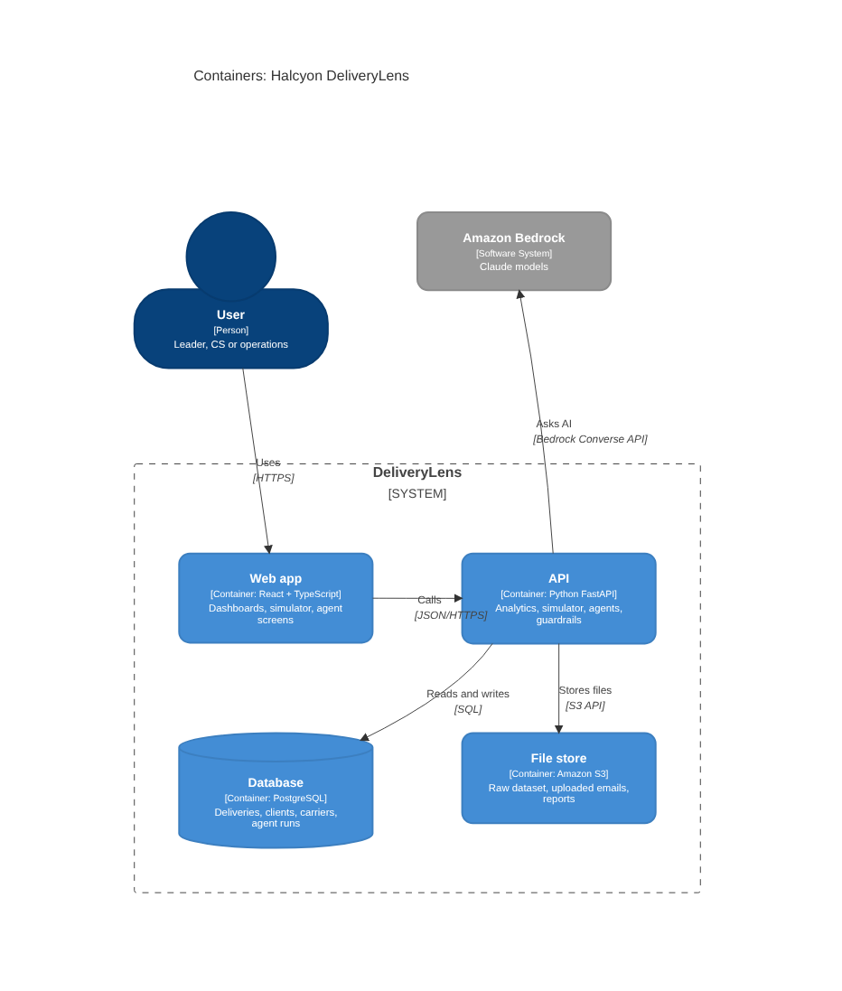
What this shows: the system has four parts. - Web app: what people click on. - API: the brain. It does the maths and runs the AI agents. - Database: where the 48,340 deliveries and every AI call are stored. - File store: keeps the original files.
The API is the only part that talks to the AI.

4.4 Where each AWS service is used
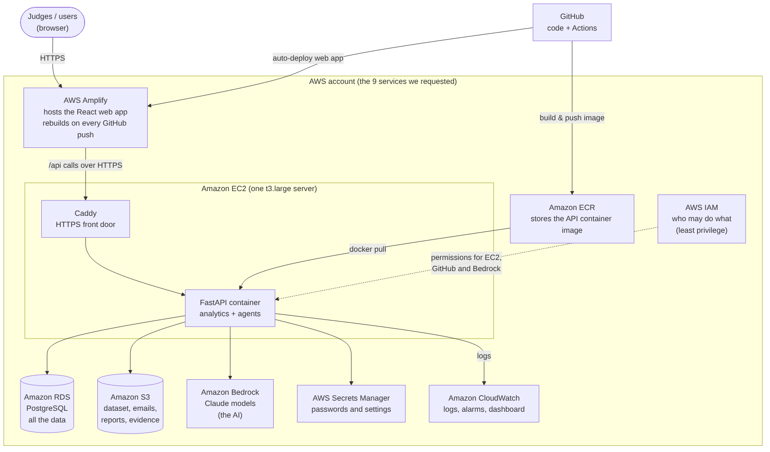
What this shows, one service at a time
AWS service | Job in DeliveryLens | Example
Amplify | Hosts the website | The judges open https://main.<id>.amplifyapp.com
EC2 | Runs our API in a Docker container | One server; Caddy adds HTTPS
ECR | Keeps the API container image | GitHub builds the image, EC2 pulls it
RDS (PostgreSQL) | Stores the data and the AI logs | 48,340 deliveries, 280 clients, every agent run
S3 | Stores files | The original dataset, uploaded emails, generated reports
Bedrock | The AI | Claude reads an email order and finds the missing postcode
Secrets Manager | Keeps passwords out of the code | Database password, demo login
CloudWatch | Watches the app | Error logs, an alarm if the API stops
IAM | Controls access | The EC2 server may call Bedrock but cannot delete S3 data

4.5 When each AWS service comes in (phases)
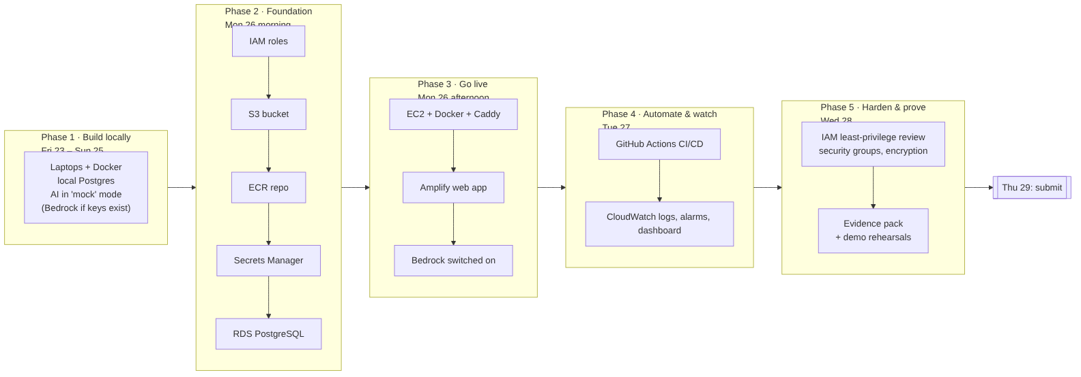
What this shows - We build and test everything on laptops first; AWS arrives Monday 26. - On Monday we create the basic AWS pieces (IAM, S3, ECR, Secrets Manager, RDS), then put the app online (EC2, Amplify, Bedrock). - Tuesday adds automatic deployment and monitoring; Wednesday is for security and proof. - Example: on Monday afternoon we switch the setting LLM_PROVIDER=mock to bedrock, and the same Order Intake Agent starts using real Claude.

4.6 How a request flows (data flow)
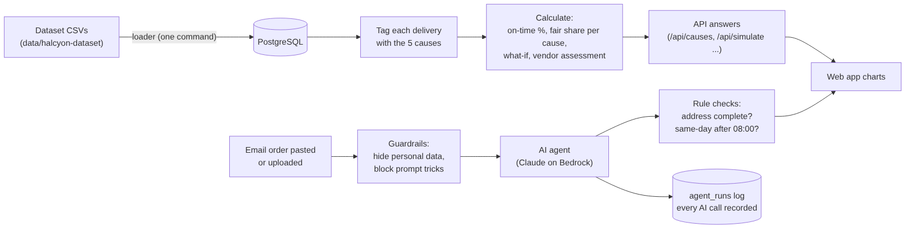
What this shows - Top row, the numbers: we load the CSVs, tag each delivery with its causes, and calculate the results. The maths is plain Python, so the same data always gives the same number. - Bottom row, the AI: text such as an email order passes through guardrails, then to Claude. The answer is checked by simple rules, and every AI call is recorded. - Example: Claude extracts “ship to: 12 Harbor Rd, Savannah” and a rule notices the postcode is missing, so the order is flagged “incomplete address” before it is picked.

4.7 The AI agents inside the product
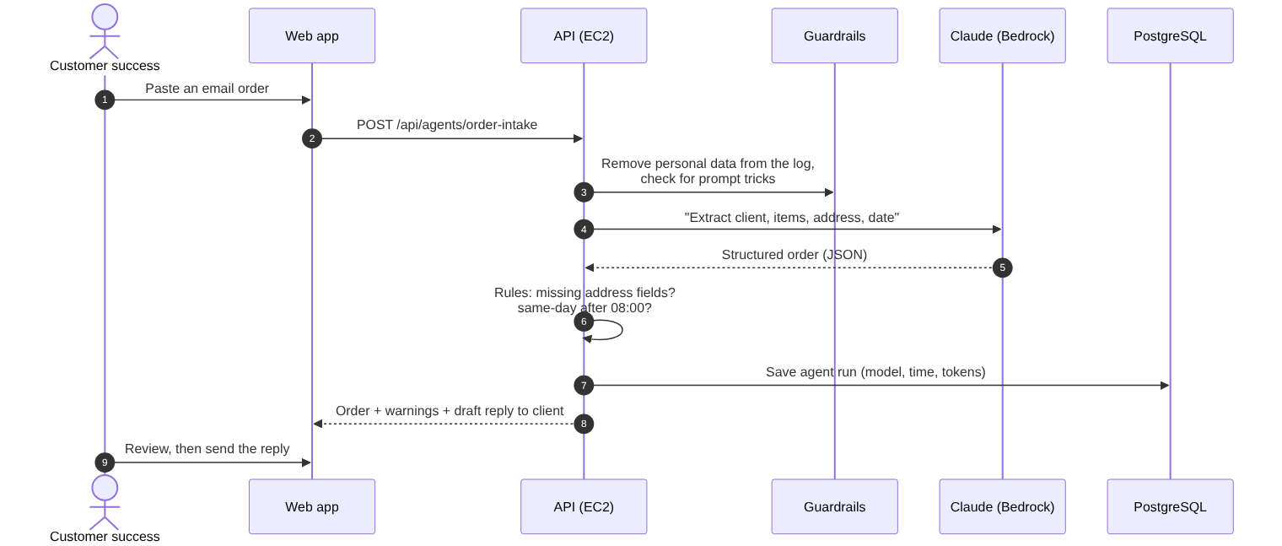
What this shows: the life of one AI call, using the Order Intake Agent as the example. AI does the reading; simple rules do the checking; a person approves before anything goes to a client.
Agent | What it does | Example
Order Intake Agent | Reads an email order, finds missing address parts, flags same-day-after-08:00 | “Postcode missing. Draft: ‘Please confirm the postcode for order ORD-1234.’”
Delay Alert Agent | Writes a message to the client before they chase | “Your order D012345 will arrive 1 day late because the nearest warehouse ran out; it ships from W2 today.”
Ask DeliveryLens | Answers leaders’ questions with numbers from our analysis | “Which carrier is worst in the Southeast?” → “Carrier F: 54% on time to the Southeast when nothing else is wrong; A, B and C are about 99%.”
Safety rules for all agents: - AI never calculates the KPIs; the code does. - Personal data is hidden in the logs, and prompt-injection attempts are blocked. - A person approves every message before it goes out. - Every call is logged.

4.8 The screens
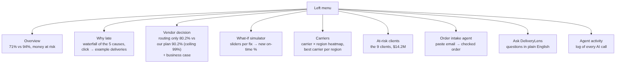
What this shows: the nine screens. - Leaders mostly use the first four: overview, why late, vendor decision, simulator. - Teams use carriers, at-risk clients, order intake and ask. - Agent activity is our evidence for the judges.

4.9 Security in one picture
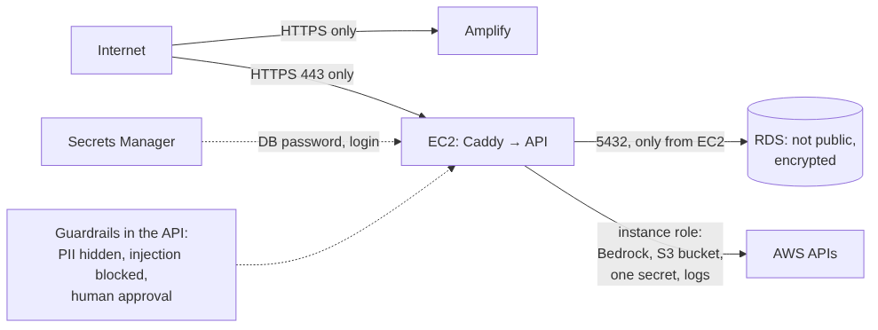
What this shows - Only HTTPS is open to the internet. - The database can’t be reached from outside; only our server can talk to it. - The server has exactly the AWS permissions it needs and no more. - Passwords live in Secrets Manager, not in the code. - The AI has guardrails, and a person approves every client message. - We use only the synthetic hackathon data, no real personal data.

4.10 Main design choices (and why)
Choice | Why, in one line
One EC2 server running Docker | It is one of the services we requested, and it runs the same way on a laptop and in AWS
Amplify for the website | Requested; free HTTPS; deploys itself from GitHub
PostgreSQL on RDS | 48k rows is small; SQL is enough; requested
Maths in plain Python, AI only for reading and writing text | Numbers are always correct and repeatable; the AI cannot invent a KPI
Claude through Bedrock | Data stays in AWS; no API keys; requested
“Mock” AI mode | The app works and tests pass even before Bedrock access arrives
Caddy for HTTPS on EC2 | Browsers block an HTTPS page from calling a plain HTTP API; Caddy fixes this with no domain needed (<ip>.sslip.io)

