7. How we work with AI agents
AI-first delivery is the biggest scoring area: 30 of 100 points. The judges want to see AI agents used in every role, from business analysis to adoption, not only for writing code. This page shows how we do that and where the proof lives.

The agent pipeline
What this shows: each role in the project has an AI agent doing the heavy lifting, and a human checking the result. - Example: the Backend Architect agent built the API and its tests, and Sai reviewed it. - Example: the data analysis that found the five causes was done by Claude Code and checked by the team against the raw CSVs.

Who does what: humans and agents
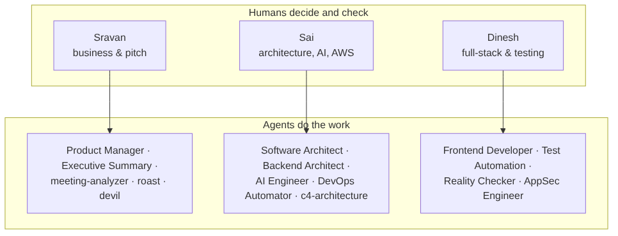
What this shows: three humans, each leading a small group of agents. The humans give the direction, review every output, and own the decisions. The agents and skills are stored in .claude/agents/ and .claude/skills/, so every team member gets the same setup from git.

Where the proof lives
Evidence | Where | Example
AI usage log per role | ai-logs/ (index in ai-logs/INDEX.md) | ai-logs/backend-agent-2026-10-23.md: what the backend agent built, the skills it used, the test results
AI calls made by the product | agent_runs table, the “Agent activity” screen, CloudWatch logs | Every Order Intake Agent call: model, time taken, tokens, guardrail flags
Skills and agents available | .claude/skills/ (95), .claude/agents/ (43), catalogue in tools/fde-toolkit/README.md | fde-design, c4-architecture, test-driven-development
Reproducible analysis | analysis/root_cause_analysis.py → analysis/output/findings.json | Re-run it and get exactly the same 71.0% / 90.2% realistic / 99.0% ceiling

Rules we follow when using agents
- A human reviews every agent output before it is merged or sent to anyone.
- Agents never compute KPIs inside the product. The code does the maths; AI reads and writes text.
- Every agent session gets a log entry in ai-logs/ (who, what, which skills, the result, the reviewer).
- No real personal data goes to any AI tool; only the synthetic hackathon data.
- Prove before claiming. “Done” means tests pass, screenshots exist, or the URL works.

