Start here
If you read only one page, read this one. It explains, in plain words: 1. what problem the client has 2. what DeliveryLens does about it 3. where the AI agents are, and why 4. how to run it on your laptop, with a real AI (Google Gemini) giving the answers 5. which screen to open first

1. The client’s problem, in one picture
What this shows - Halcyon Logistics delivers goods for 280 business clients. - Only 71 of every 100 deliveries arrive on time. Good companies manage 94. - Nine unhappy clients, worth $14.2 million a year, say they may leave. - The bosses think the routes are the problem. They are about to buy $680,000 of routing software. - Our job: find out what is really wrong, and fix it.

2. What the data told us: five problems, not one
We checked all 48,340 deliveries. Lateness comes from five places in the chain above:
# | Problem | Where in the chain | Example | On-time points lost
1 | Weak carrier on a lane | 🚚 Carrier choice | Carrier D is late in every region; Carrier F is late to the Southeast | 7.7
2 | Incomplete address | ⌨️ Order typed in | Email says “Savannah” but no street or postcode | 6.9
3 | Same-day order after 08:00 | 🕗 Pick list | Order at 09:30 promised “today”, but the list was printed at 08:00 | 5.4
4 | Stock not at the nearest warehouse | 📦 Picking | Order for California ships from the Midwest | 4.9
5 | Driver goes far off the planned route | 🛣️ Delivery | Planned 150 km, drove 190 km | 3.1
The routing software can only fix #5, plus part of #1. That is why we advise not to sign it as it stands.

3. What DeliveryLens does, and where the AI is
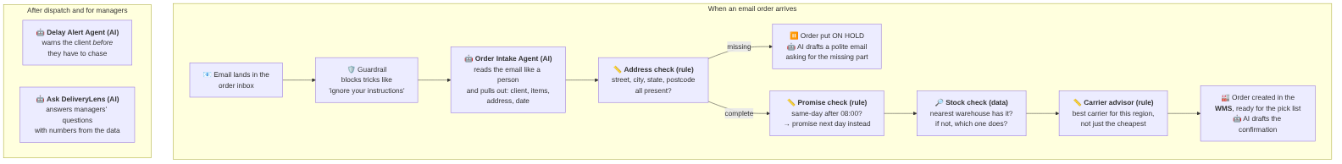
What this shows - AI agents (🤖) do the language work: reading messy emails, and writing replies and explanations. That is what AI is good at. - Rules (📏) and data lookups (🔎) do the checking and the maths. These must always give the same, explainable answer, so we don’t let AI guess them. - Guardrails (🛡️) stop misuse and keep personal data out of the logs. - A person approves every message before it goes to a client.
How the agents are built: our own small Python “pipeline”. Each step is a plain function, and the AI steps call one shared AI client that can use Mock (canned, offline), Google Gemini (for demos on your laptop) or Amazon Bedrock / Claude (on AWS). No heavy framework. Every AI call is recorded, and you can see them on the “Agent activity” screen.

4. Run it on your laptop with Gemini (real AI answers)
Where the key goes: create the file backend/.env (copy backend/.env.example) and set:
LLM_PROVIDER=gemini
GEMINI_API_KEY=paste-your-key-here
GEMINI_MODEL=gemini-2.5-flash
- backend/.env is never committed to git (it is in .gitignore). Keep the key only there.
- Restart the backend after changing it. Check that it worked: open http://localhost:8000/api/health. It should say "llm_provider": "gemini" and "llm_ready": true.
- To go back to offline canned answers, set LLM_PROVIDER=mock.
The commands:
cd backend
python -m venv .venv && source .venv/bin/activate # Windows: .venv\Scripts\activate
pip install -r requirements.txt
python -m app.loader # loads the dataset + sample emails into SQLite
uvicorn app.main:app --reload --port 8000
# second terminal
cd frontend
npm install
npm run dev # open http://localhost:5173

5. Which screen to open first
What this shows: the best order to explore the app (and to demo it). Every screen has a “What am I looking at?” panel at the top that explains each number and button. For a full tour with pictures, read 08-user-guide.md.

6. What is real, and what is simulated
Thing | Real or simulated?
48,340 deliveries, clients, carriers, penalties, complaints | Real hackathon dataset from the stakeholder (synthetic data, but it is “their” data)
The 5 causes and all percentages | Calculated from that data by analysis/root_cause_analysis.py
The 12 emails in the Order desk | Written by us to show typical cases, good and bad, because the dataset has no email text
The warehouse system (WMS) | A simple table in our database that stands in for the client’s WMS
AI answers | Mock (canned) by default; Gemini when you add a key; Claude on Bedrock on AWS
Costs in the business case | Our estimates, clearly labelled, for the client to confirm

