6. AWS setup guide (Monday 26 October)
A step-by-step guide to put DeliveryLens live on AWS using only the 9 services we requested. Every step is a script in infra/scripts/, and every script is safe to run twice.

The order of steps
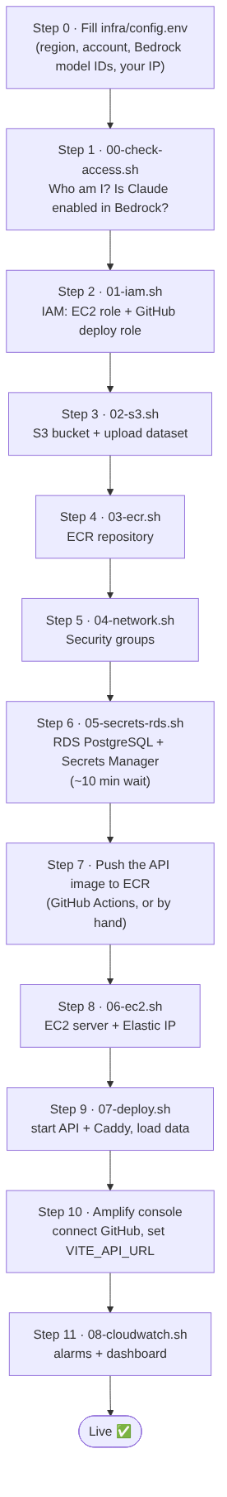
What this shows: the steps run from top to bottom, about 2–3 hours in total, most of it waiting for RDS. Each box names the script to run.

Step 0: fill in the placeholders
cp infra/config.env.example infra/config.env
# edit infra/config.env and replace every <PLACEHOLDER>
Placeholder | Where to get it | Example
<AWS_REGION> | From L&D or the IT team (Satya) | ap-south-1
<AWS_ACCOUNT_ID> | aws sts get-caller-identity | 123456789012
<BEDROCK_HAIKU_MODEL_ID>, <BEDROCK_SONNET_MODEL_ID> | Printed by step 1 | an Anthropic Claude model or inference-profile ID
<YOUR_PUBLIC_IP> | Search “what is my ip” | 203.0.113.10
<AMPLIFY_APP_ID> | After step 10; then re-run step 6 to update the secret | d1abc2xyz

Step 1 to Step 11: what each one does
What this shows: the AWS resources that will exist after setup. All names start with deliverylens, so they are easy to find and to delete afterwards (99-teardown.sh).
Step | Run | What happens | How to check
1 | bash infra/scripts/00-check-access.sh | Prints your identity, the Claude models you can use, and OK/FAIL for each service | Every line says OK. Post any FAIL in the infra Teams group
2 | bash infra/scripts/01-iam.sh | Creates the two IAM roles with least privilege | Prints the GitHub deploy role ARN; save it as GitHub secret AWS_DEPLOY_ROLE_ARN
3 | bash infra/scripts/02-s3.sh | Private, encrypted bucket; uploads data/halcyon-dataset to raw/ | aws s3 ls s3://deliverylens-data-<account>/raw/halcyon-dataset/
4 | bash infra/scripts/03-ecr.sh | Image repository with scan-on-push | Prints the image URI
5 | bash infra/scripts/04-network.sh | API: 443/80 open, 22 from your IP only. DB: 5432 from the API only | Save the printed API security group ID as GitHub secret EC2_SG_ID (the deploy job opens SSH for itself only while it deploys, then closes it)
6 | bash infra/scripts/05-secrets-rds.sh | Creates PostgreSQL (private, encrypted) and stores the connection string, model IDs and a demo password in Secrets Manager | Prints the RDS endpoint
7 | Push to main (GitHub Actions builds and pushes), or build by hand, see below | The API image lands in ECR | aws ecr list-images --repository-name deliverylens-api
8 | bash infra/scripts/06-ec2.sh | Starts the server, installs Docker, attaches a fixed IP | Prints https://<ip-with-dashes>.sslip.io
9 | bash infra/scripts/07-deploy.sh | Copies the compose file, pulls the secret and the image, starts API + Caddy, loads the data once | Ends with the /api/health JSON
10 | Amplify console → New app → GitHub → halcyon-deliverylens, branch main | Builds frontend/ using amplify.yml. Set env var VITE_API_URL=https://<ip-with-dashes>.sslip.io | Open the Amplify URL; the Overview page shows 71%
11 | bash infra/scripts/08-cloudwatch.sh | Log retention, error metric, 3 alarms, dashboard | Open the printed dashboard link
Build and push the image by hand (only if GitHub Actions is not set up yet):
source infra/config.env
aws ecr get-login-password | docker login --username AWS --password-stdin $AWS_ACCOUNT_ID.dkr.ecr.$AWS_REGION.amazonaws.com
docker build -f backend/Dockerfile -t $AWS_ACCOUNT_ID.dkr.ecr.$AWS_REGION.amazonaws.com/deliverylens-api:latest .
docker push $AWS_ACCOUNT_ID.dkr.ecr.$AWS_REGION.amazonaws.com/deliverylens-api:latest

How updates reach AWS after Monday
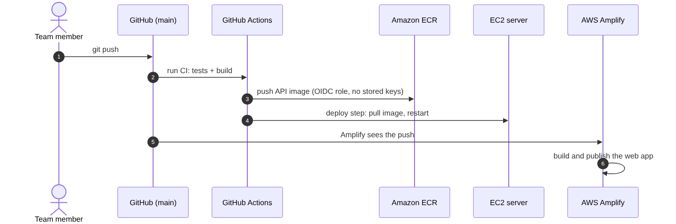
What this shows: after setup, a git push to main updates everything. 1. GitHub Actions runs the tests, builds the API image and pushes it to ECR. 2. GitHub Actions opens SSH for its own IP only, tells the EC2 server to pull the new image and restart, then closes SSH again. 3. Amplify rebuilds the website on its own.
Nobody copies files by hand.

If something goes wrong
Problem | Likely cause | Fix
Website loads but shows “API unreachable” | VITE_API_URL missing or wrong in Amplify, or CORS | Set the variable in Amplify and redeploy; check CORS_ORIGINS in the secret matches the Amplify URL
https://…sslip.io fails | Port 80 or 443 blocked, or the certificate is not ready yet | Check the security group; wait one minute; docker logs the caddy container
AI answers say “mock” | LLM_PROVIDER not bedrock, or model access missing | Update the secret, run 07-deploy.sh again; check step 1 output
AccessDenied from Bedrock | Model not enabled, or wrong model ID for the region | Use the inference-profile ID printed in step 1
RDS connection refused | Security group | Re-run 04-network.sh; the DB accepts traffic only from the API security group

After the hackathon
Run bash infra/scripts/99-teardown.sh (it asks you to type DELETE). L&D will revoke access anyway.

