Kids Water Bottles

1. 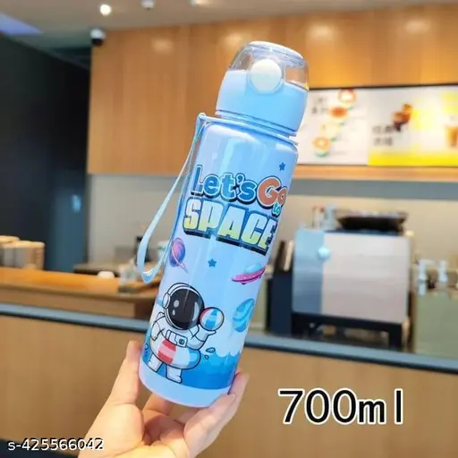**Stainless Steel**:
   * **Single-Wall**: Lightweight and typically not insulated. Best for basic hydration needs.
   * **Double-Wall Insulated**: Features a vacuum insulation layer between the walls that helps maintain the temperature of beverages, keeping drinks cold for up to 24 hours and hot for 12 hours.
2. **Electro-polished Stainless Steel**:
   * This finish helps to prevent corrosion, resists stains, and is non-reactive with the liquid inside.

**Benefits of Steel Water Bottles:**

* **Durability**: Stainless steel is tough and resistant to rust, corrosion, and damage from drops or impacts.
* **Eco-Friendly**: Using a steel bottle helps reduce reliance on disposable plastic bottles, which are harmful to the environment.
* **Non-Toxic**: Stainless steel is a safer option compared to plastic, as it doesn't contain harmful chemicals like BPA (Bisphenol A), which can leach into liquids from plastic.
* **Temperature Control**: Insulated bottles keep your drinks at your preferred temperature for longer. This is great for hot coffee, tea, or cold water.
* **Taste Preservation**: Unlike plastic, steel doesn't absorb odors or flavors, keeping the taste of your drinks pure.

**Maintenance:**

* **Cleaning**: Most steel water bottles are easy to clean and dishwasher-safe, but it’s often recommended to clean them by hand to preserve the insulation properties.

**Avoiding Scratches**: While steel is durable, it’s best to avoid abrasive scrubbing on the inside to maintain the bottle’s integrity and to keep the inside smooth