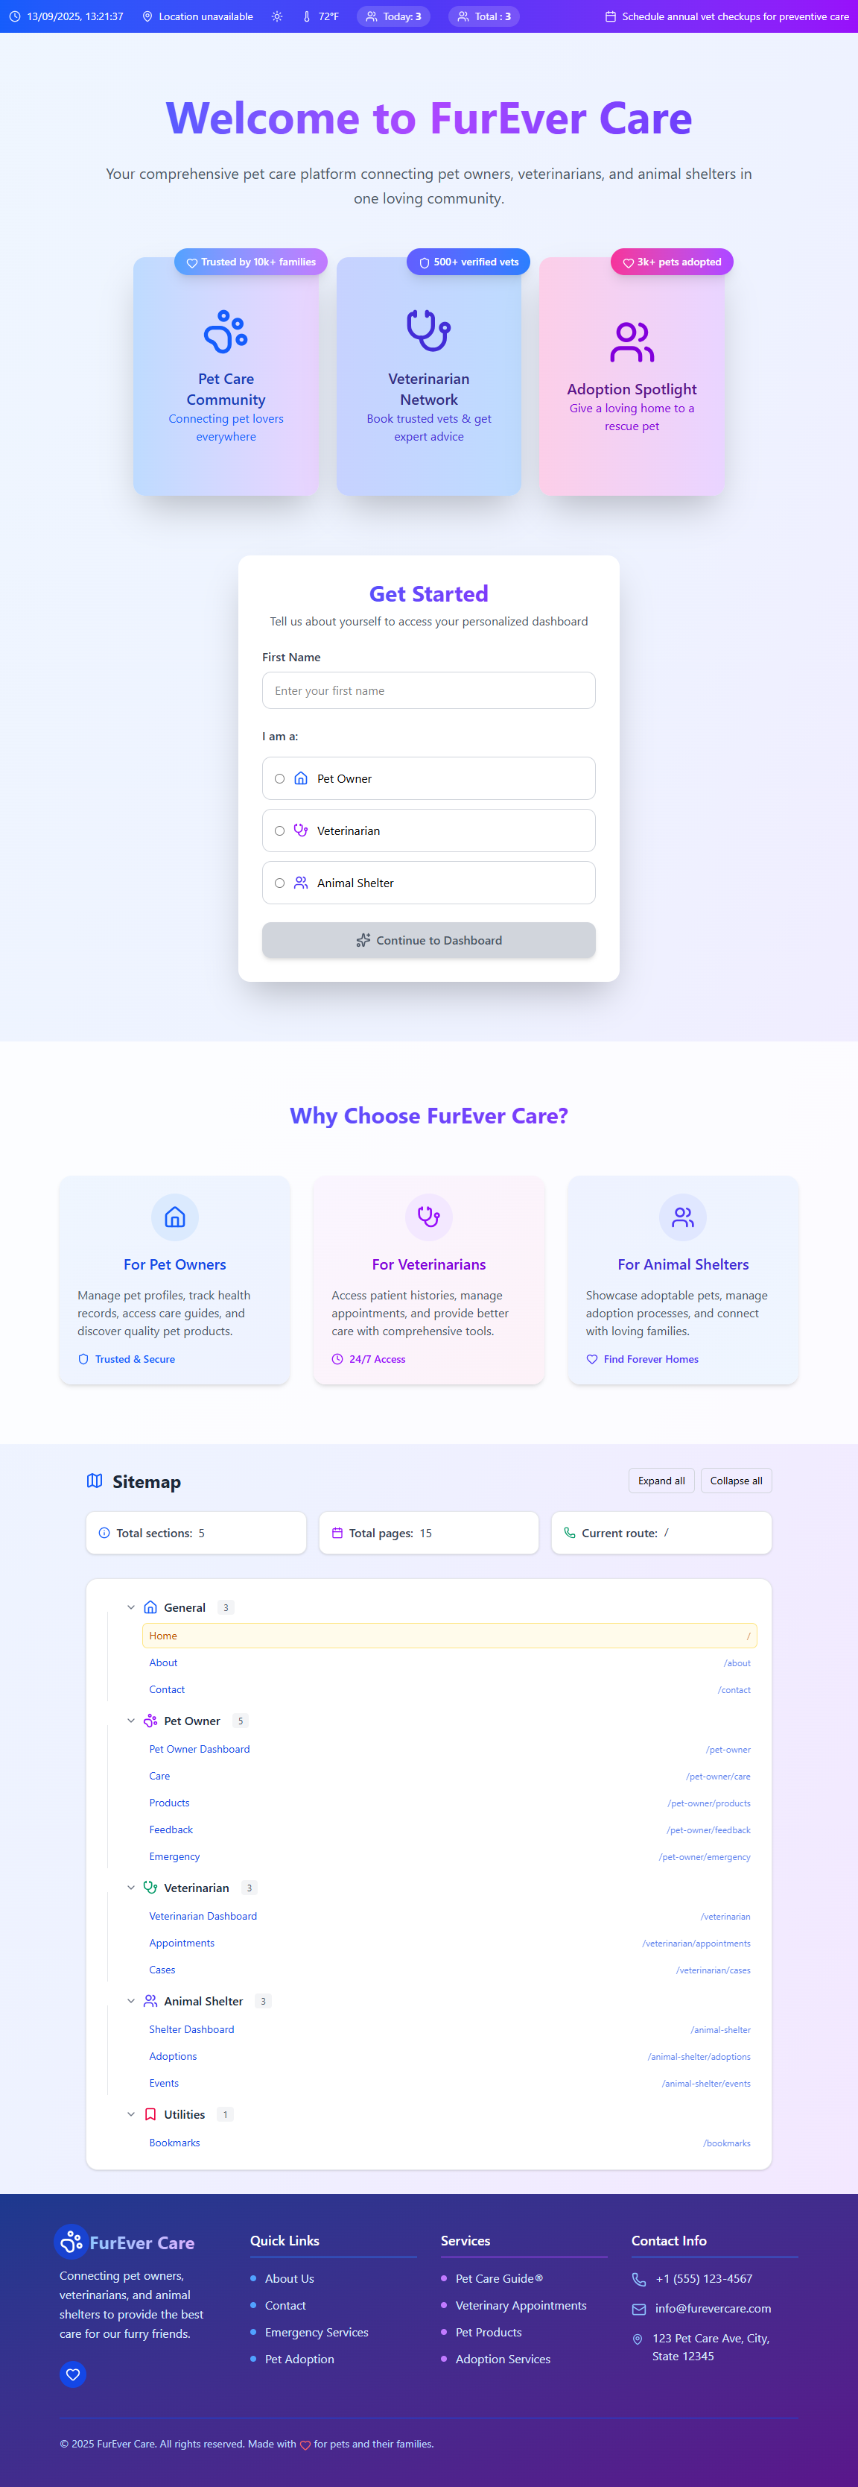

FurEver Care

They Deserve Forever Love



CONTENTS

Cvc

1. Background and Necessity for the Website
2. Proposed Solution
3. Purpose of the Document
4. Scope of Project
5. Constraints
6. Functional Requirements
7. Non-Functional Requirements
8. Interface Requirements
9. Hardware
10. Software
11. Project Deliverables



|  |  |
| --- | --- |
| **TEAM MEMBERS**  **SFC-Logic Lords** | |
| Mr. AQIB HUSSAIN | Student1639071 |
| Mr. MUHAMMAD HAMZA | Student1636596 |
| Mr. AREES AZHAR HUSSAIN | Student1640847 |
| Mr. AZFAR IMRAN | Student1636877 |
| **Miss Aqsa Noor** | Faculty |

# 1. Background and Necessity for the Website

In today's fast-paced world, pet owners face difficulties in organizing pet care activities such as feeding schedules, grooming routines, health monitoring, and product selection. Additionally, navigating different Websites for pet products such as food, toys, and grooming essentials can be inconvenient.

There is a growing requirement for a single, user-friendly platform that not only provides care guidance, but also lists recommended pet products

Here are some reasons why such a Website would be required:

♣ Centralized Pet Management:

To help pet owners track pet profiles, medical records, and essential care routines in one place.

♣ 24/7 Access to Information:

Offers convenient access to pet care details, vet appointments, and product recommendations anytime, anywhere.

♣ Promotes Pet Wellness:

Provides timely care tips, feeding advice, and health alerts to improve overall pet well-being.

♣ **Supports Adoption and Rescue:**

Helps animal shelters showcase adoptable pets and streamline adoption requests through an online platform.

♣ Enables Product Discovery:

Offers curated listings of pet food, grooming supplies, and toys making it easier for owners to shop.

♣ Build a Pet-Loving Community:

Encourages engagement through blogs, tips, and community posts helping users share experiences and learn.

♣ Paperless & Eco-Friendly:

Encourages sustainable, paper-free management of pet care and communication with service providers.

# 2. Proposed Solution

The proposed solution is a Website called 'FurEver Care' for Pet Care. The Website should enhance the efficiency and effectiveness of pet care services where users can manage pet profiles, view appointments, and access various petrelated resources. The system should support categories for pet owners, veterinarians, and shelters; enable users to manage pet medical history and provide sorting and filtering for services and products.

Additionally, detailed information about each pet, upcoming vaccinations, grooming sessions, health records, and available pet products should be displayed. The platform should aim to simplify pet care management while promoting better health, timely services, and community engagement.

# 3. Purpose of the Document

* The purpose of this document is to present a detailed description of the Website ‘FurEver Care’ an online pet care platform through which users can manage pet profiles, view appointments with veterinarians or groomers, access pet health records, and explore pet-related products and services.
* This document outlines the objectives and features of the Website, its user interfaces, the functions it is expected to perform, and the constraints under which it must operate. It is intended to serve as a reference for both the stakeholders and the developers involved in designing, building, and maintaining the Website.

**Sample Sitemap (with examples)**

**Landing Page**

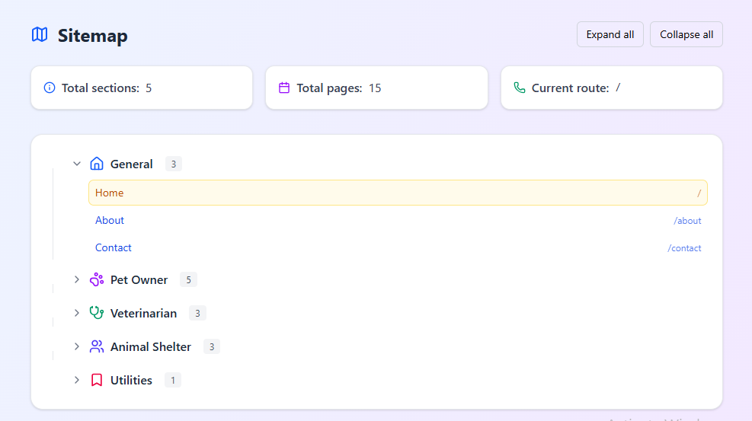

♣ Upon selecting an option, the respective page should be displayed, where relevant information can be accepted by the user via a form. Based on the type of user appropriate menus should be displayed.

# 4. Scope of Project

The Website will offer a range of features aimed at improving the overall experience for pet owners, veterinarians, and animal shelters. It will include static pet profile and care sections that allow users to view and manage essential information about their pets. The platform will support multimedia features, enabling access to engaging content related to pet training, grooming, and general wellness. Users will also be able to explore static product listings for essential pet supplies such as food, toys, and grooming items. For shelters, the Website will showcase pets available for adoption, complete with filtering options based on type, age, breed, and location to enhance discoverability. For veterinarians, a dedicated dashboard will be provided, allowing them to view appointments, review pet medical histories, and view treatment records thus, streamlining veterinary services and improving care coordination.

# 5. Constraints

The Web portal will not have any facility to store information on the server. Information can be fetched from JSON/TXT files and users can view the same being displayed, however, information cannot be written to the files from within the portal.­­­­­­­

# 6. Functional Requirements

The portal will be designed as a Single-Page-Application (SPA) and responsive Website with a set of pages and menus that represent choice of activities to be performed. The pages, menus, and other visual elements must be designed in a visually appealing manner with attractive fonts, colors, and animations. All of these should also be laid out in a responsive manner.

**Menu and Web Page Functionality:**

Following are the functional requirements of the portal:

1. **Home page:**

The home page should accept the first name from the user and display a personalized welcome message on other pages. At the top corner, the user's first name should be displayed for the entire duration that the portal is loaded. The home page must also accept category of users in the form of radio button selection. Based on selection, respective pages and menus will be displayed. Refer to the Sitemap section to see sample menus.

**2.For Pet Owner:**

Collect information of pets such as name, species, breed, age, and so on using a form.

**3.Pet Care Sections:**

* Pet Profile (Static) – Species, breed, age, vaccination info, and so on
* Feeding Guide – Charts for puppies, adults, cats, and so on
* Grooming Videos – Brushing, bathing, and trimming (embedded)
* Health Tips Audio/video – Oral care, weight, and common conditions
* Training Tips – Audio + text-based guides

Scrolling ticker with location (HTML5 Geolocation), time, and updates should be displayed.

**4.** **Pet Product Showcase:**

* **Categories:**
* Dog/Cat Food
* Toys
* Grooming Essentials
* Bedding and Apparel
* Health Supplements

**Each product card includes:**

* **Product name**
* **Image**
* **Description**
* **Price**
* **Buy Now button (nonfunctional)**

Loaded via JSON – Use AngularJS/ReactJS or plain JS to load cards dynamically.

**All this data can be sorted, filtered, or searched via text box.**

# 7.Non-Functional Requirements

There are several non-functional requirements that should be fulfilled by the Website.

The Website should be:

**Safe to use:**

The Website should not result in any malicious downloads or unnecessary file downloads.

**Accessible:**

The Website should have clear and legible fonts, user-interface elements, and navigation elements.

**User-friendly:**

The Website should be easy to navigate with clear items and other elements and easy to understand.

**Operability:**

The Website should operate in a reliably efficient manner. Performance: The Website should demonstrate high value of performance through speed and throughput. In simple terms, the Website should be fast to load and page redirection should be smooth.

**Capacity:**

The Website should support large number of users. **Availability:** The Website should be available 24/7 with minimum downtime.

**Compatibility:**

The Website should be compatible with latest browsers.

# 8. Interface Requirements

**8.1 Hardware**

* Intel Core i5 Processor or
* higher
* 8 GB RAM or higher
* Color SVGA monitor
* 500 GB Hard Disk space
* Mouse
* Keyboard

**8.2 Software**

Technologies to be used:

* **IDE:** Visual Studio Code, Coffee Cup, Notepad++, or any other HTML editor
* **Frontend:** HTML5, CSS3, Bootstrap (optional), JavaScript, Figma,Toolkit, jQuery, Angular/ReactJS, and XML
* Data Store: JSON/TXT

# 9. Project Deliverables

You will design and build the project and submit it along with a complete project report that includes:

* Problem Definition
* Design specifications
* Diagrams such as flowcharts for various activities, Data Flow Diagrams, and so on
* Source Code
* Test Data Used in the Project
* Project Installation Instructions (if any)

Documentation is considered a very important part of the project. Ensure that documentation is complete and comprehensive. The consolidated project will be submitted as a zip file with a ReadMe.doc file listing assumptions (if any) made.

Submit a video clip demonstrating the working of the Website. Optionally, a live hosted URL can be supplied for the site. Over and above the given specifications, you can apply your creativity and logic to improve the portal.

User Interface (UI) design, wireframes, or mockups.

Component breakdowns for frontend development (e.g., home page, search/filter functionality, feedback form, etc.).

**Home Page:**

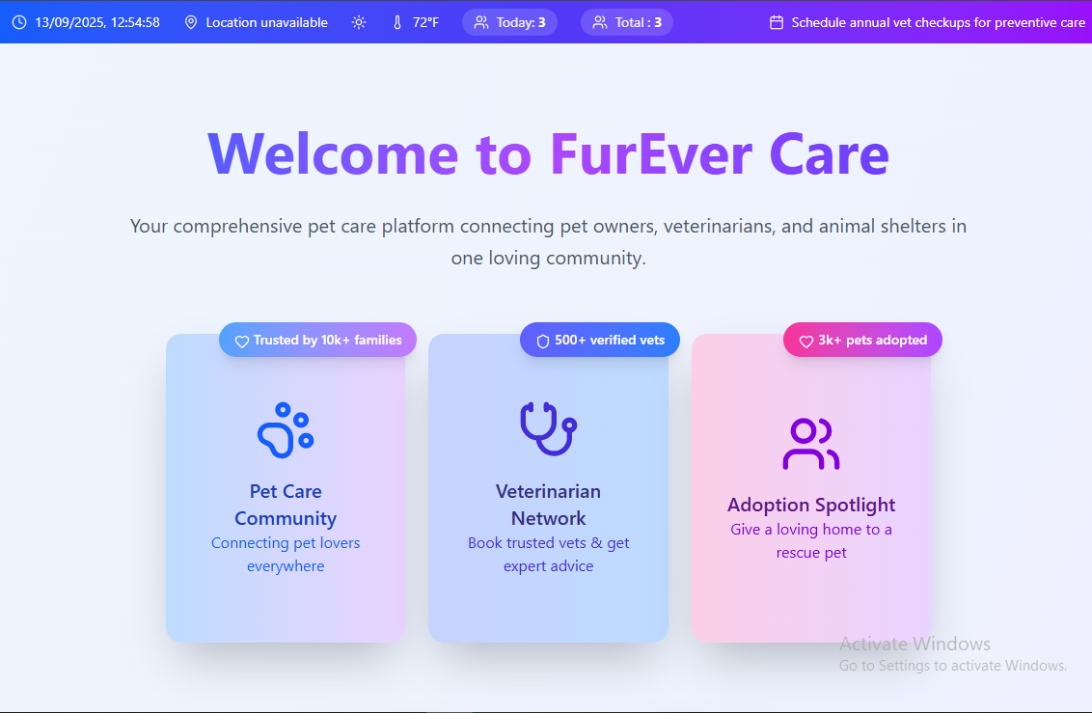

**Pet Owner Detail:**

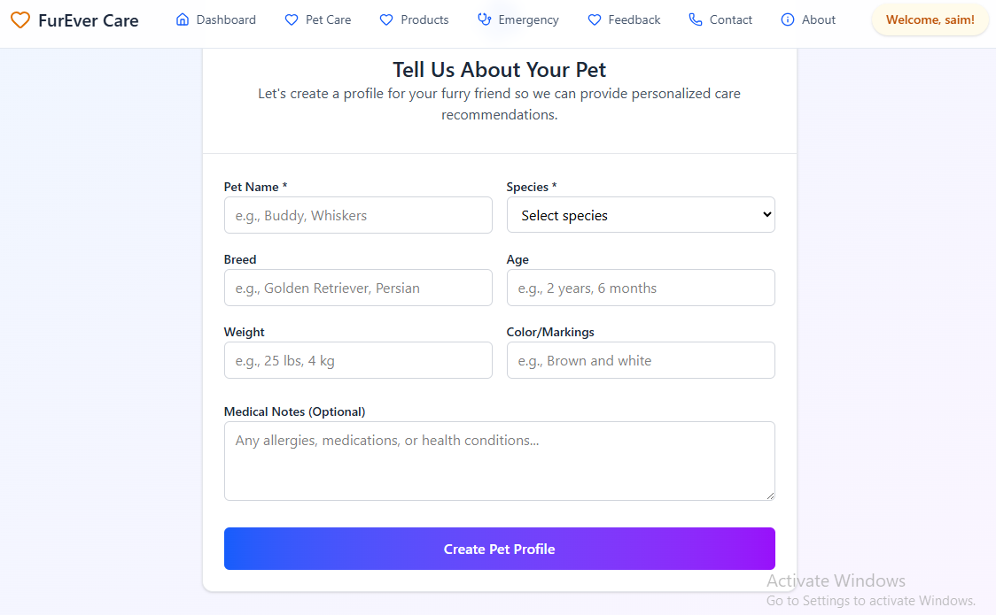

**Pet Owner:**

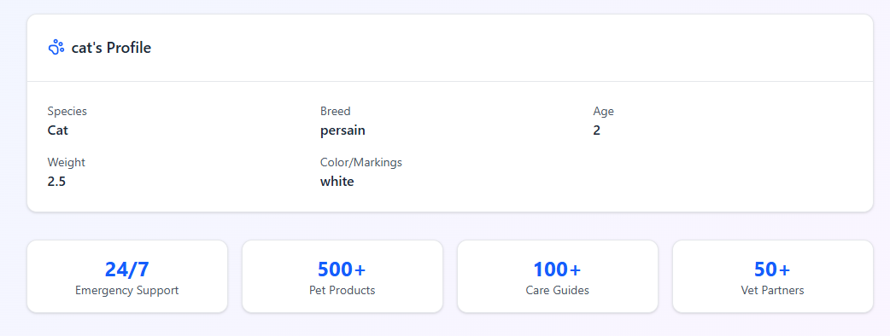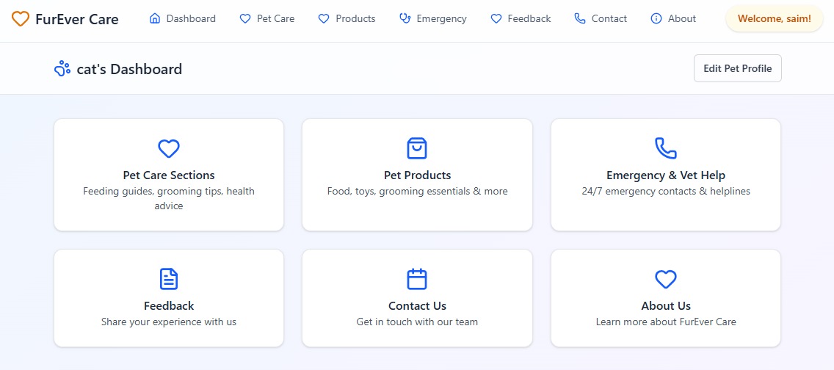

**Pet Owner Products:**

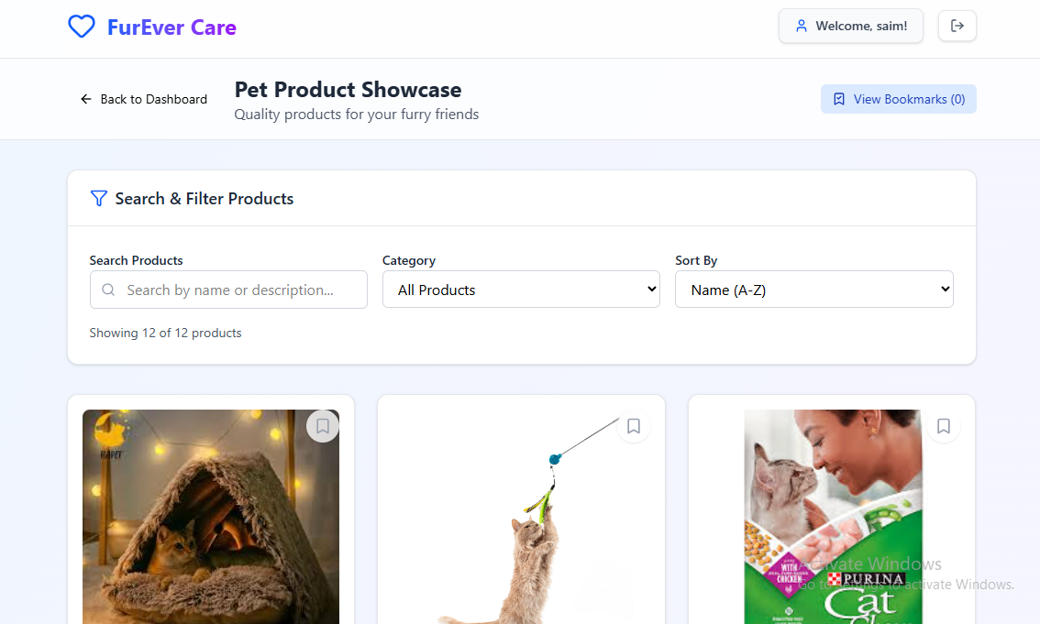

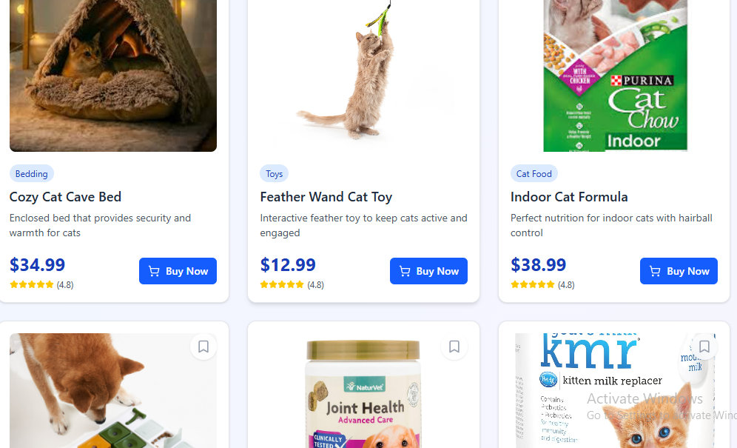

**Pet Owner Emergency**

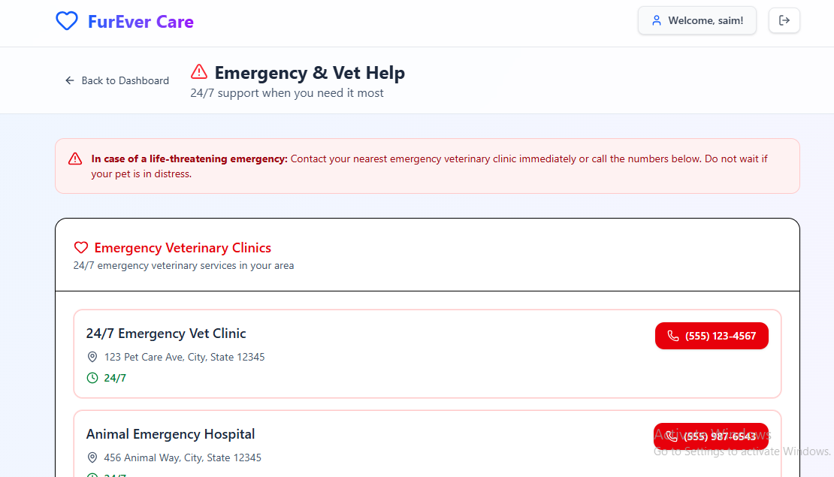

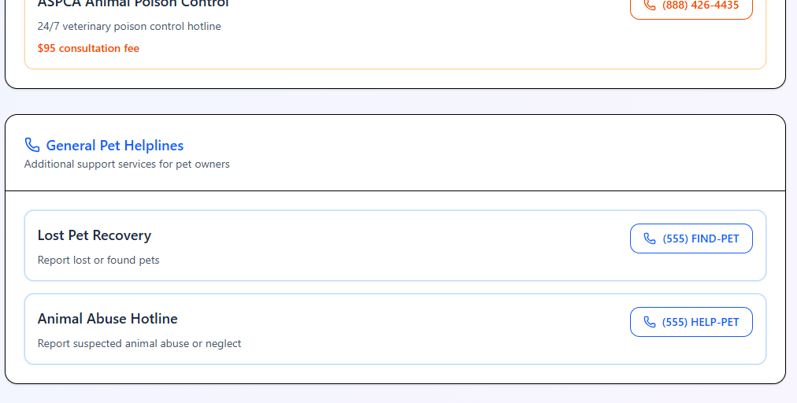

**Pet Owner Feedback**

## 

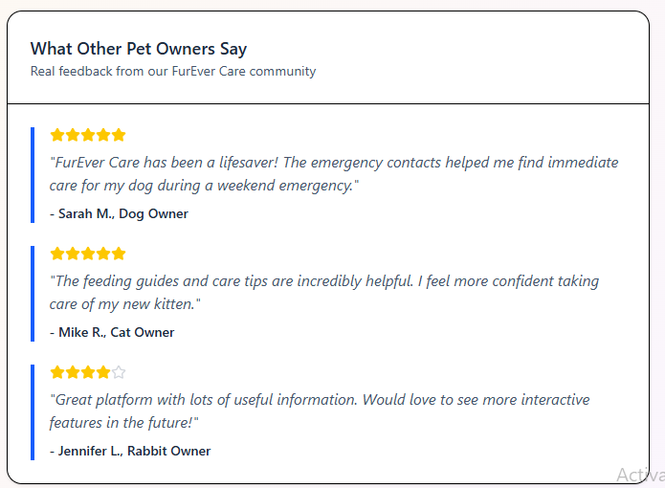

**Pet Owner Contact Us**

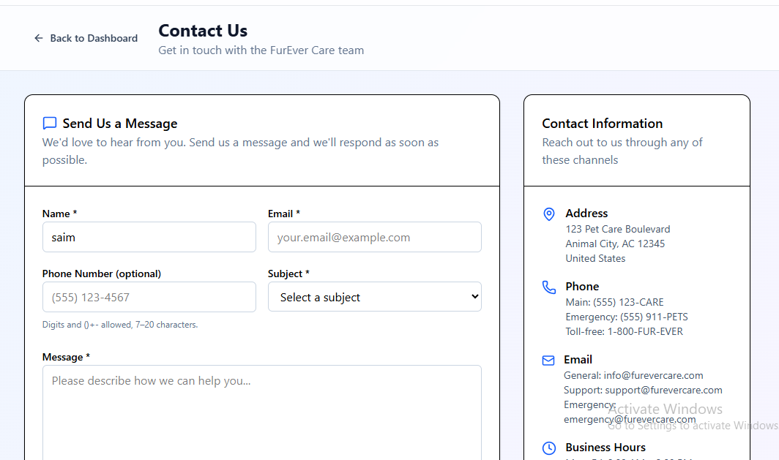

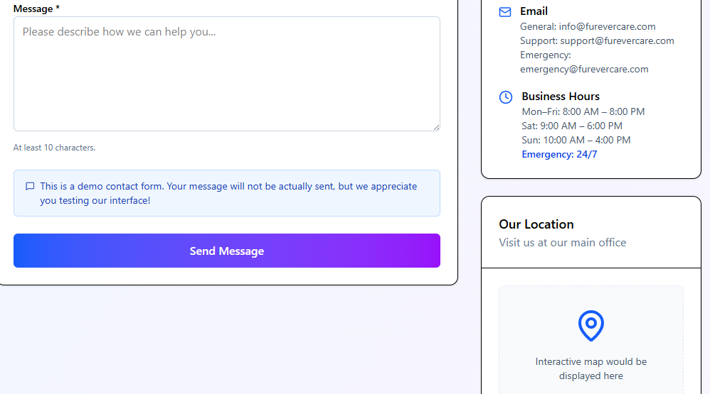

**About Us:**



