

LIFELINK

Cvc

Project Report

CONTENTS

Cvc



1. Background and Necessity for the Website
2. Proposed Solution
3. Purpose of the Document
4. Scope of Project
5. Constraints
6. Functional Requirements
7. Non-Functional Requirements
8. Interface Requirements
9. Hardware
10. Software
11. Project Deliverables



|  |  |
| --- | --- |
| **TEAM MEMBERS**  **SFC-TECHARMY** | |
| Mr. SHARJEEL KHAN | JavaScript Developer/JSON/VIDEO |
| Ms. SAMAN HANIF | Website Designing |
| Ms. SUMAIRA AMJAD | Documentation/Website Designing |
| Mr. MUHAMMAD HUSNAIN GHOURI | Website Designing/JSON |
| **Sir Faiz Ali** | Faculty |



# 1. Background and Necessity for the Website

* + - This ambulance Website is a significant healthcare innovation that leverages technology to address the critical requirement of efficient and timely emergency medical transportation. Here are some reasons why such a Website would be required:

* **Prompt Assistance**:

This Website will help individuals request for ambulance services promptly and conveniently. It will also help them keep track of all the necessary updates such as the type of ambulance, their individual costs, their availability, and so on.

* **Forge the Connection:**

This Website will help patients and medical emergency services to work together for saving a life. It will provide users with a secure and reliable platform to book ambulance services during critical situations.

* **Support and Maintenance**:

Considering the vitality of this service, the Website must be available to its users/patients 24/7. This information promotes responsible and holistic approach to improve the emergency standards.

–

* **Searching, Sorting, and Filtering Capabilities:**

With a wide range of ambulance options, users may have specific preferences as per their requirements. The Website's search, sort, and filter features allow users to find all the ambulances that match their criteria efficiently. This saves time and enhances the overall user experience by narrowing down options based on their preferences.

* **Customer Engagement and Loyalty:**

A well-designed Website can foster customer engagement and loyalty by offering the best and fastest ambulances at critical times. This engagement strengthens the relationship between the customer and emergency services, thereby leveraging technology to provide rapid, efficient, and life-saving assistance to individuals.



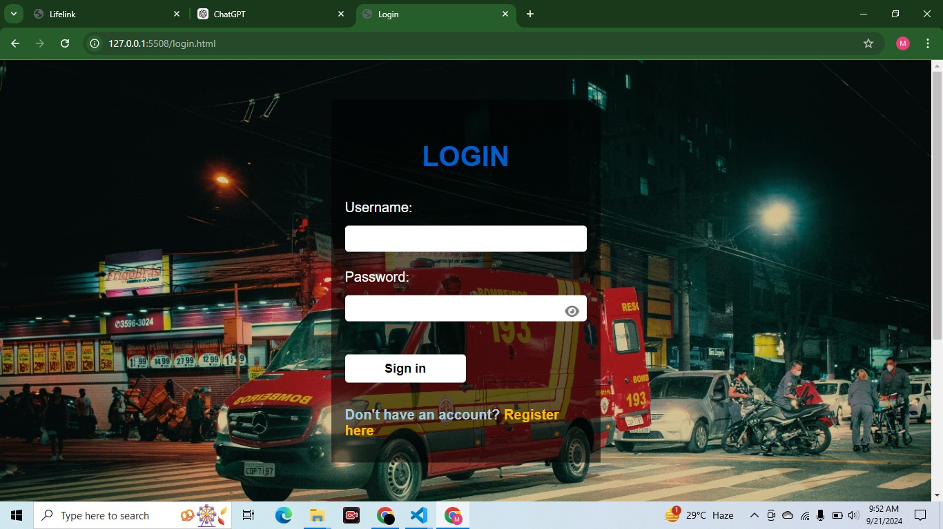

# 2. Proposed Solution

The proposed solution is a Website called 'Life Link' for ambulances. The Website should enhance the efficiency and effectiveness of medical emergency services where users can browse and view different ambulances based on their requirements. It should also provide categories for different types of ambulances, offer sorting

and filtering options, and allow users to search for a specific ambulance. Additionally, detailed information for each ambulance such as cost and availability should be displayed.

# 3. Purpose of the Document

* The purpose of this document is to present a detailed description of the Website, Life Link, an online ambulance service through which users can view different types of ambulances available near them. This document explains the purpose and features of the Website, the interface of the Website, what the Website will do, and the constraints under which it must operate. This document is intended for both stakeholders and developers of the Website.



Stakeholders and developers of the portal can use this document.

**Sample Sitemap (with examples)**

 **Landing Page**

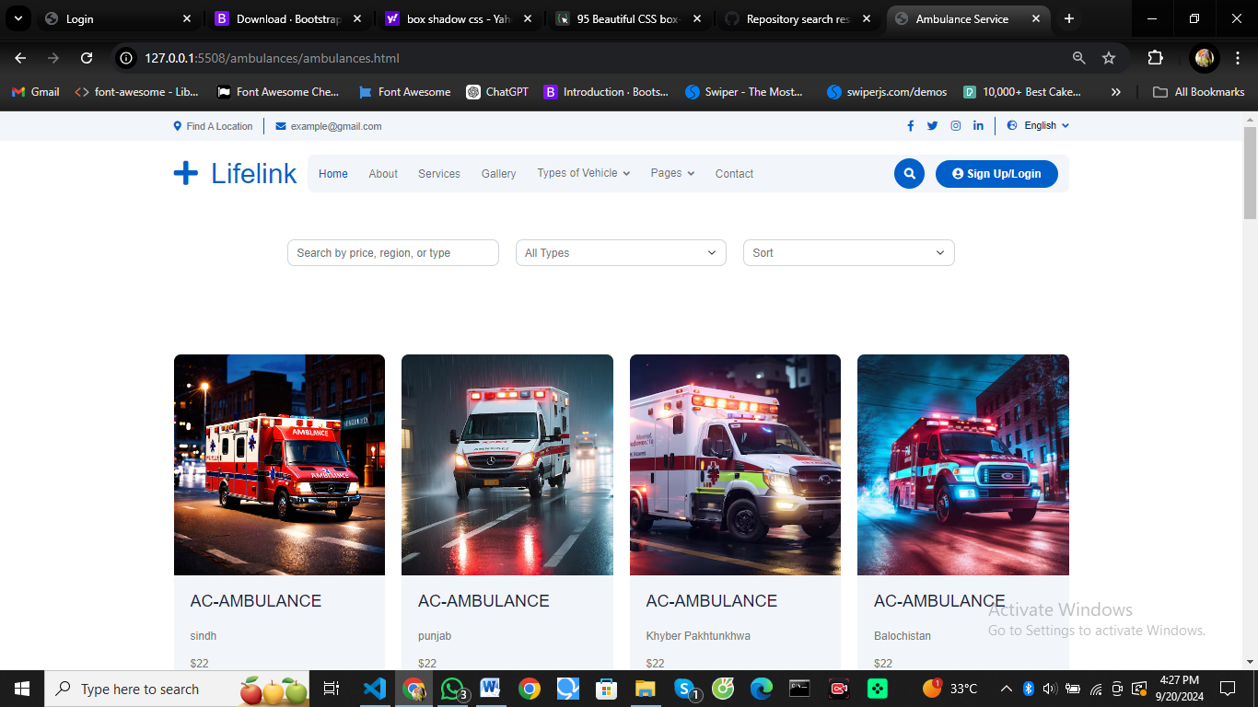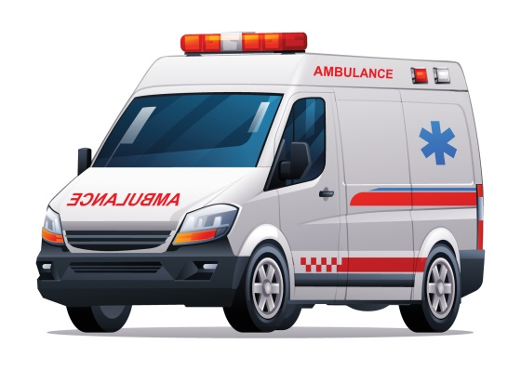

Upon selecting an option, such as ambulance types, it should display different types of vehicles, their size, and price

 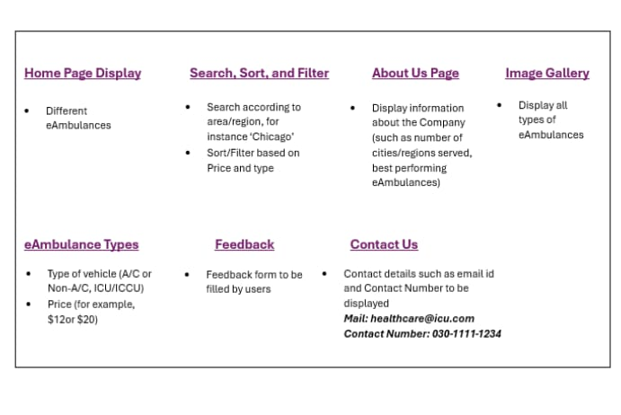

* Hard-coded values will be displayed since, there is no scope for database fetching in this Website.

# 5. Scope of Project

The scope of this project is to develop a responsive and visually appealing Web portal for the users. This portal allows users to seamlessly and quickly search for the best ambulance for their requirement in any situation. Key features will include real-time availability, cost comparisons, and user-friendly navigation. The goal is to ensure that users can find the right emergency medical transport with minimal effort and maximum efficiency.

# 6. Constraints

The Web portal will not have any facility to store information on the server. Information can be fetched from JSON/TXT files and users can view the same being displayed. However, information cannot be written to the files from within the portal.­­­­­­­

# 7. Functional Requirements

The portal will be designed as a Single-Page-Application (SPA) and a responsive Website with a set of pages and menus that represent choice of activities to be performed. The pages, menus, and other visual elements must be designed in a visually appealing manner with attractive fonts, colors, and animations wherever applicable. All of these should also be laid out in a responsive manner.

Following are the functional requirements of the portal:

1. **Home page:**

The Website should allow users to browse through the catalog and view individual ambulance listings.

1. **About Us Page:**

Users should be able to view information about the company and creators of the site. The company information can include number of cities/regions served by them and best performing ambulances.

1. **Images Gallery:**

Users should be able to view different ambulance images uploaded on the Website.



1. **Search, Sort, and Filter menus:**

* Users should be able to search for different types of ambulances and sort/filter them as per their requirements. One can search according to the area/region, for example, user can type ‘Chicago’ and it should display the ambulances available in this particular region. Sort and Filter should display based on users requirement such as costs or type of vehicle he/she wants.

1. **Ambulance Type:**

* The ambulance type menu should display the type/kind of vehicle, size, and equipment along with its costs to the users. The menu can also include specialization of the ambulance, such as A/C or Non-A/C, ICU or ICCU, and so on.
* For example, users can search based on price $12 so it should display the ambulances available for this cost range.

1. **Feedback:**

* The Feedback option should enable users to provide their feedback about the ambulance Website through a feedback form.

1. **Contact Us:**

* The Contact Us field should display the contact information of the creators of the Website. An email id and Contact Number can be displayed here.

1. **Sitemap**:

* To help users understand the flow of the Website, you will create a Sitemap and add it to the home page of your Website.

**Technical Considerations:**

• Use HTML5, CSS3, Figma Toolkit, Bootstrap, jQuery, and JavaScript to build the User Interface (UI).

• Use either Angular or React JS to develop the application's frontend and add dynamic and responsive features along with SPA functionality.

• Use JSON/TXT files to handle data retrieval.

• Ensure the application is responsive and compatible with different screen sizes.

**Tasks:**

1. Design the UI for the LifeLink Website including the catalog display, searchbar ,sorting options, and eAmbulance information section
2. Create necessary components and services to display the Ambulance type and handle searching ,sorting, and filtering operations.
3. Implement the Website’s required functionalities.
4. Implement GPS functionality as applicable.
5. Optionally, use REST APIs if you are well-versed with them.
6. Test the Website's functionality including browsing, searching, and adding feedback. Deploy the Website to a local Web server such as XAMPP for testing purposes



# 8.Non-Functional Requirements

There are several non-functional requirements that should be fulfilled by the Website.

The Website should be:

**Safe to use:** The Website should not result in any malicious downloads or unnecessary file downloads.

**Accessible:** The Website should have clear and legible fonts, user-interface elements, and navigation elements.

**User-friendly:** The Website should be easy to navigate with clear and easy to understand elements.

**Operability:** The Website should reliable and efficient.

**Performance:** The Website should demonstrate high value of performance through speed and throughput. In simple terms, the Website should have minimal load time and smooth page redirection.

**Capacity:** The Website should support large number of concurrent users.

**Availability:** The Website should be available 24/7 with minimum downtime.

**Compatibility:** The Website should be compatible with latest browsers and devices.

# 1.9 Project Deliverables

You will design and build the project and submit it along with a complete project report

that includes:

* Problem Definition

* Design Specifications

* Diagrams such as flowcharts for various Activities, Data Flow Diagrams, and so on

* Test Data Used in the Project

* Project Installation Instructions (if any)

# 1.9.1 Problem Definition

A clear and concise statement of the problem the project aims to solve. For this project, the problem definition would focus on providing an efficient and user-friendly platform for users to browse, search, and filter ambulance services.

# 1.9.2 Design Specification

Detailed documentation of the design aspects of the project. This should cover the overall architecture of the website, including how different components such as UI elements, backend services, and data handling are designed. It should also include:

User Interface (UI) design, wireframes, or mockups.

Component breakdowns for frontend development (e.g., home page, search/filter functionality, feedback form, etc.).

# 1.9.3 FlowChart Diagram

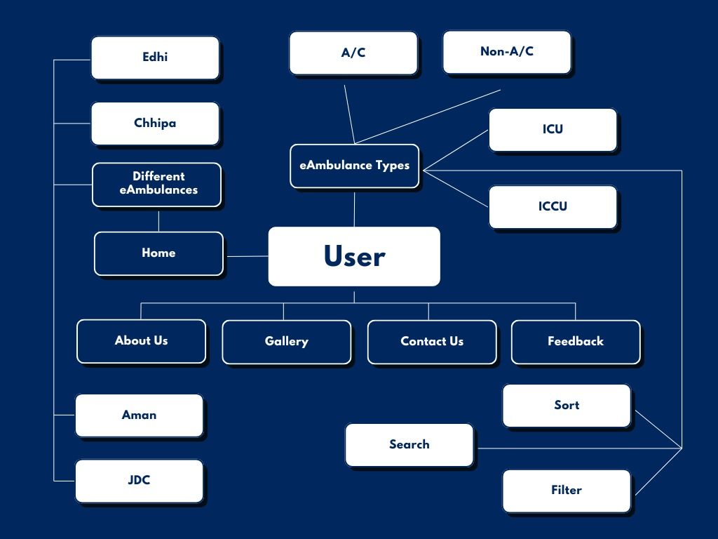

# .9.3 DataFlow Diagram

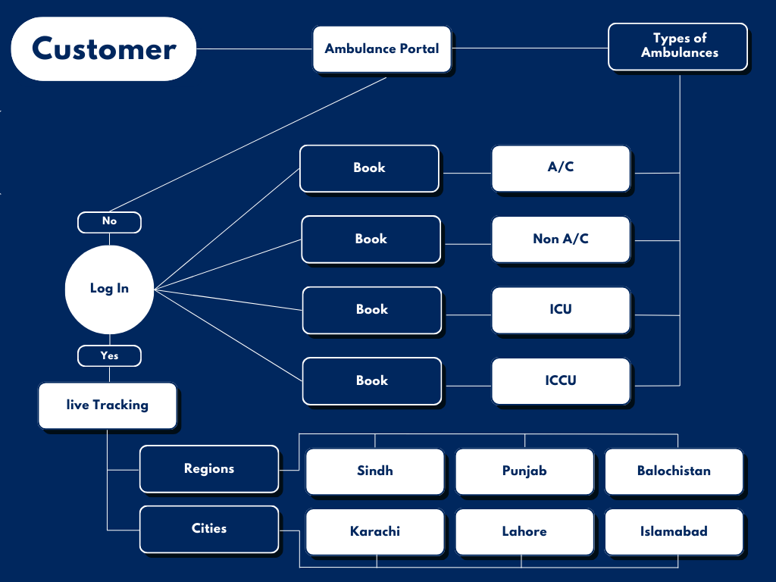



# 1.9.4 Test Data Used in the Project

Provide the test cases and test data that were used to verify the functionality of the website. This should cover:

Search, filter, and sort functionalities.

UI responsiveness across different devices.

Feedback form submission and other user interactions.

# 1.9.5 Project Installation Instructions (if any)

Detailed instructions for installing and running the project on a local or remote server. If XAMPP or another web server is required, the instructions should include:

How to install necessary software (e.g., Node.js, XAMPP).

How to configure the project (e.g., downloading dependencies, configuring ports).

How to start the website on a local machine or server.

Any additional environment setup (e.g., connecting to a backend data source or API, setting up JSON files).