Problem 1: Vote Prediction

You are hired by one of the leading news channels CNBE who wants to analyse recent elections. This survey was conducted on 1525 voters with 9 variables. You must build a model, to predict which party a voter will vote for based on the given information, to create an exit poll that will help in predicting overall win and seats covered by a particular party.

**1.1 Data Inferences**

1. Features Vote and Gender are of Object Type and Categorical in nature.
2. Age feature provides information about the voter’s age.
3. National and Household economy are provided in the features “economic.cond.national” and “economic.cond.household”.
4. Blair feature will give information about the Voter’s assessment of the Labour Leader, rating will be between 1 and 5, latter being better.
5. Hague feature will give information about the Voter’s assessment of the Conservative Leader, rating will be between 1 and 5, latter being better.
6. Europe feature will explain the sentiment of Eurosceptic among the voters, range beings at 1 and ends at 11, where in the latter is maximum Eurosceptic.
7. Feature “political.knowledge” gives information about the knowledge of Parties on the integration of US policies with Europe, range starts from 0 to 3, where in the latter is of the best knowledge.

**1.2 Data Shape**

1. Data set contains 9 Features and 1525 Voter details.

**1.3 Data Validation**

1. No nulls are seen in the data set.
2. Total duplicates found are 8 in the data set, will be dropping them as their count is insignificant, considering data set size.
3. Vote feature has two Categories “Labour” and “Conservative” and has no anomalies.
4. Gender feature has two Categories “Female” and “Male” and has no anomalies.

**1.4 Outliers**

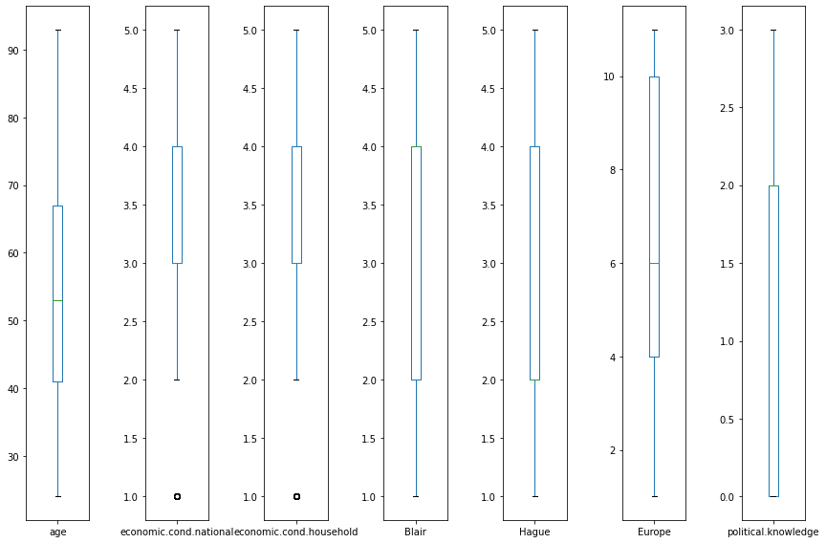

1. National and Household economy features have very insignificant Q1 outliers.
2. Other columns have no outliers.

**1.5 Correlation Analysis**

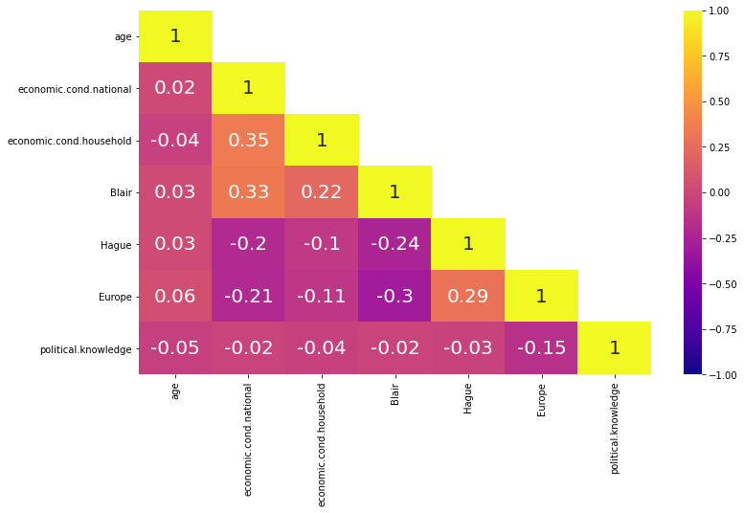

1. Age feature has no correlation with any other features of the dataset, it means, age has no effect in the voter’s understanding on the other features of the dataset.
2. National Economy has a weak-positive-correlation with household economy and Blair-Labour Leader’s rating.
3. National Economy has a weak-negative-correlation with Eurosceptic sentiment. Other features will not have any affect.
4. Labour Leader’s rating-Blair has a negative correlation with Conservative Leader’s rating-Hague and vice versa.
5. Eurosceptic rating has a negative correlation with the political knowledge of the voter.

**1.6 Uni-Variate Analysis**

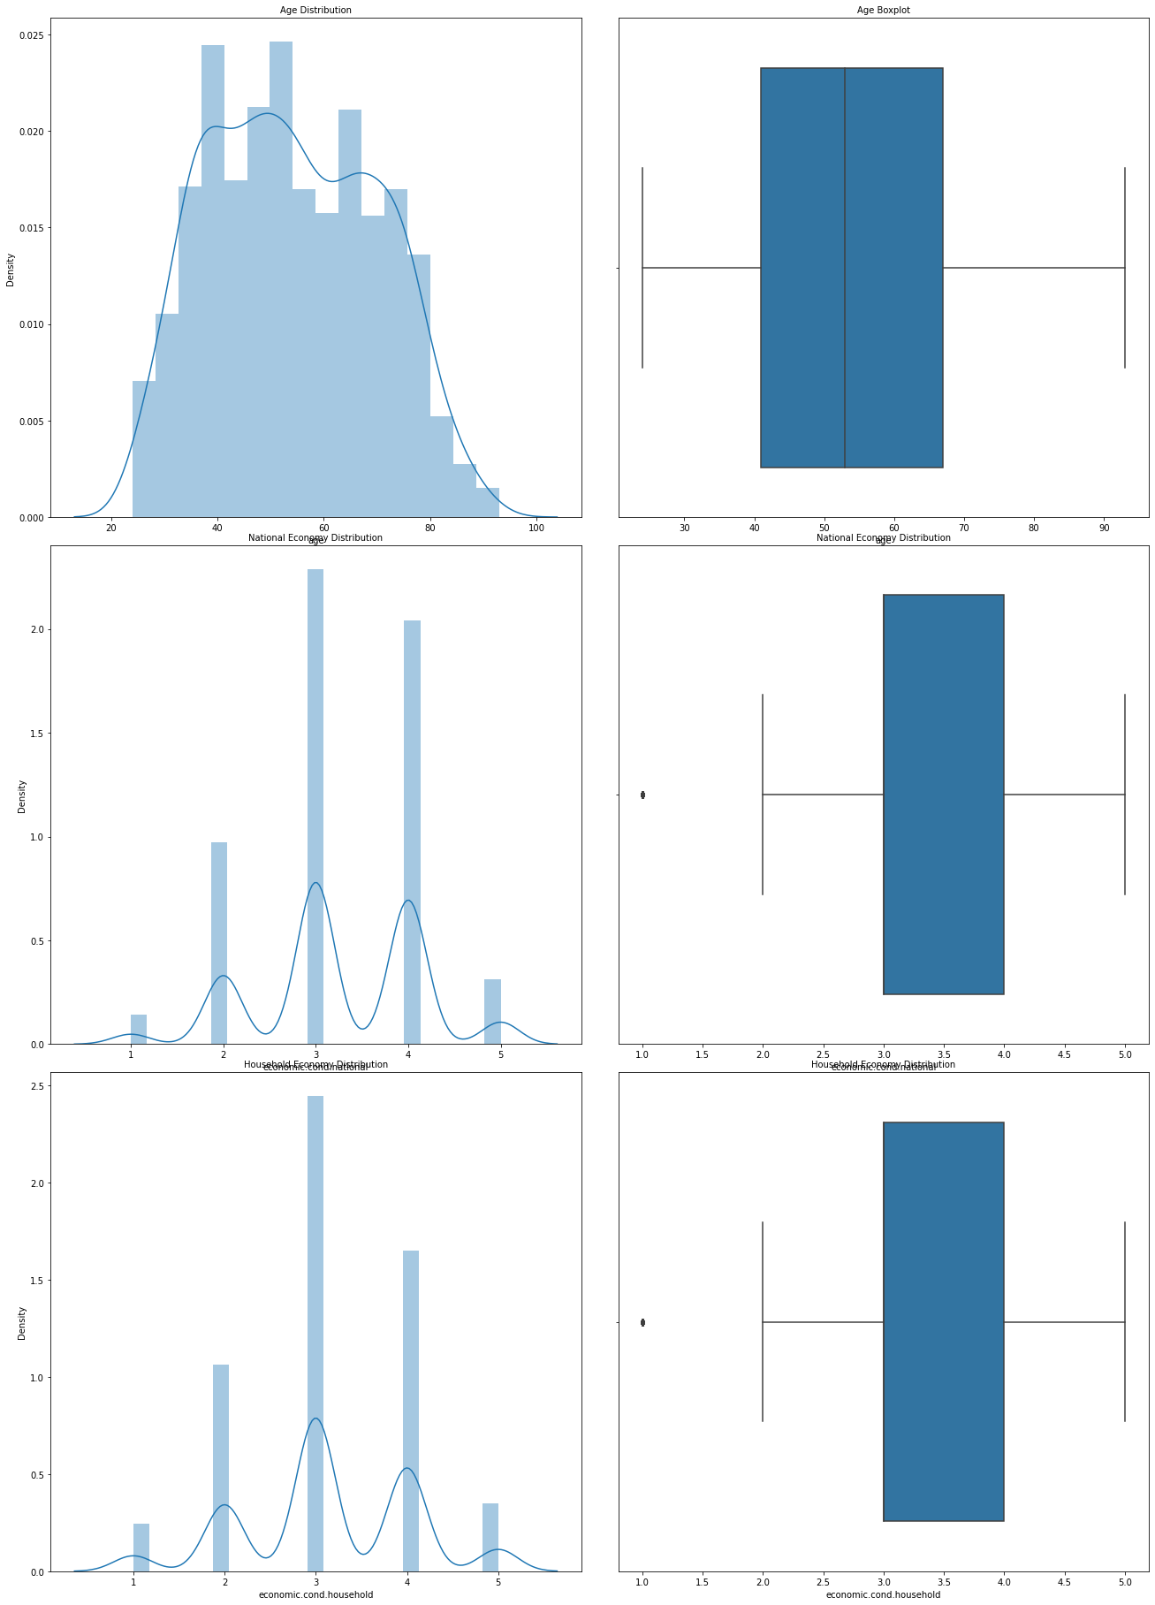

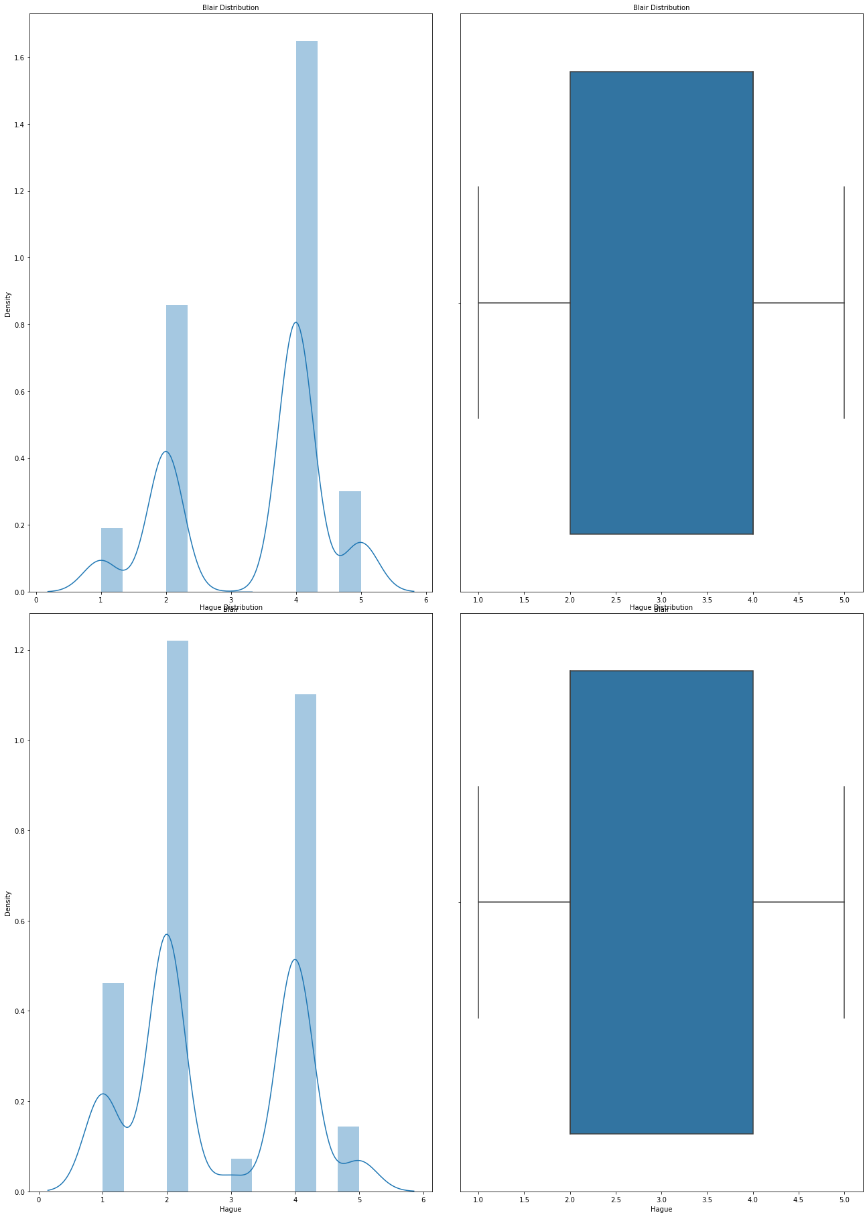

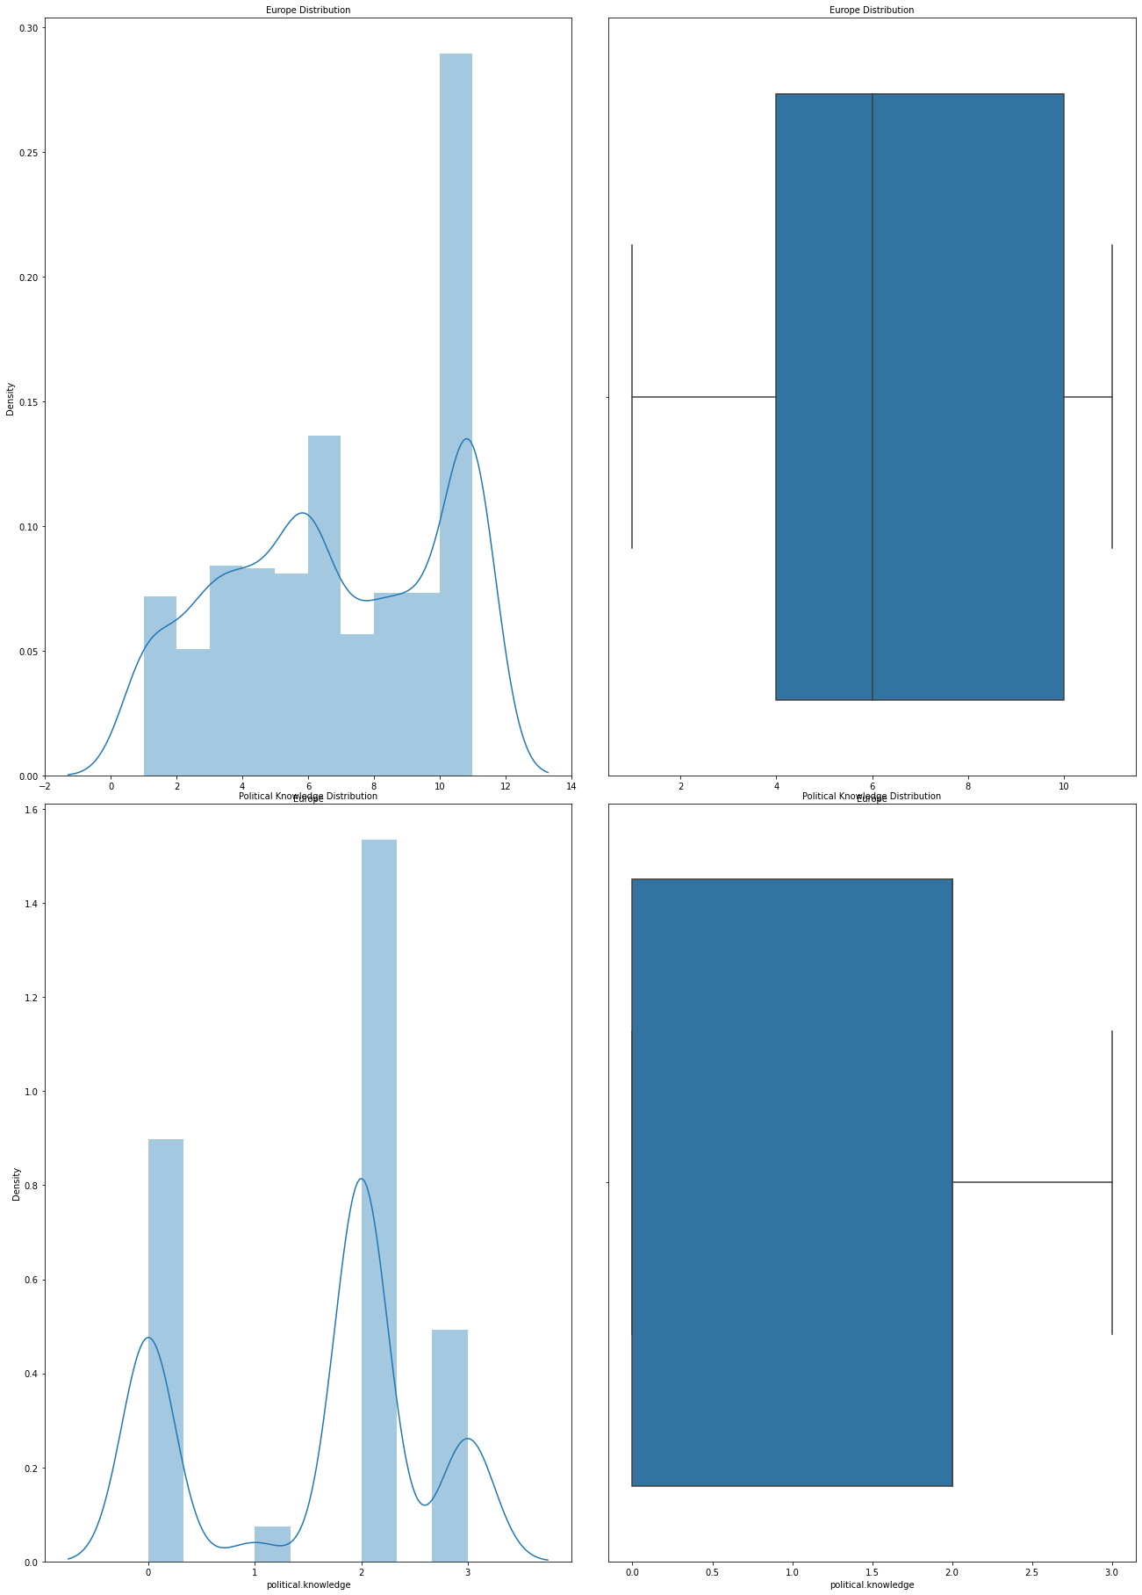

1. Age feature has a slight right skewed distribution, younger age group has significant effect in voting.
2. National Economy distribution is a normal distribution with evenly spaced classes and frequency of class3 is higher than others.
3. Household Economy distribution is a normal distribution with evenly spaced classes and frequency of class3 is higher than others.
4. Blair and Hague distribution are left skewed and right skewed distributions with Classes 2 and 4 have maximum count of voters.
5. Europe distribution is a left skewed with peak count at the right. Median is however on the left skew.
6. Political knowledge is a left skewed distribution with maximum count at the category 2.

**1.7 Vote vs Other Features**

Conservative party voters have a higher age in comparison to the age of Labour party voters. He min and max age is alike in both parties.

National economic condition of the voters, for the Labour party is higher in comparison to the Conservative Party.

Household economic condition of the voters, for the Labour party is higher in comparison to the Conservative Party.

Labour party voters have a similar rating for their leader Blair. Conservative party voters have rated Blair from 2 to 4.

Conservative party voters have a similar rating for their leader Hague. Conservative party voters have rated Hague from 2 to 4.

Labour Party voters have an average Eurosceptic rating and Conservative Party voters have a higher Eurosceptic ratings.

Conservative party voters have a higher political knowledge in comparison to the Labour party voters.

**1.8 Categorical column analysis**

Female and Male voters contribution to the Conservative and Labour party is 50 and 50 percent.

**1.9 Pair plot**

**1.10 Data Encoding**

**1.11 Data Scaling**

**1.12 Train and Test split**

 **and** 

**1.13 Logistic Regression**

**LogisticRegression(max_iter=10000, n_jobs=2, penalty='none', random_state=123,solver='newton-cg', verbose=True)**

**1.14 Test Prediction probabilities**

**1.15 Accuracy Score – Training data**

**0.83**

**1.16 ROC Curve – Training data**

**1.17 Accuracy Score – Testing Data**

**0.85**

**1.18 ROC Curve – Testing Data**

**1.19 Confusion Matrix and Classification Report – Training data**

**1.20 Confusion Matrix and Classification Report – Testing data**

**1.21 GridSearchCV for Logistic Regression**

**Best Model**



**Test probabilities for the best model**

**Confusion matrix and Classification report – Training data**

**Confusion matrix and Classification report – Testing data**

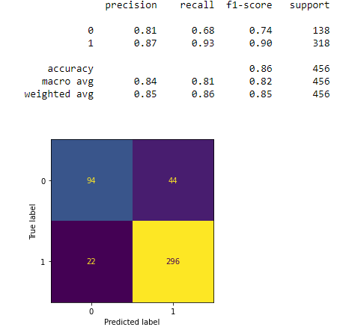

**Important Features**

**Linear Discriminant Analysis**

Confusion matrix and Classification report – Training data

Confusion matrix and Classification report – Testing data

AUC and ROC curve – Training and Testing data

Naïve Bayes

Training data

Testing data

KNN

KNN-5 Training data

KNN-5 Testing data

KNN-7 Training data

KNN-7 Testing data

Bagging

Metrics on Training data

Metrics on Test data

Ada Boost

Training data

Testing data

Gradient Boost

Training data

Testing data

Summary

# 2  Problem Statement

**In this project, we are going to work on the inaugural corpora from the nltk in Python. We will be looking at the following speeches of the Presidents of the United States of America:**

**President Franklin D. Roosevelt in 1941 President John F. Kennedy in 1961 President Richard Nixon in 1973**

Total characters in President Roosvelt speech is: 7571

Total sentences in President Roosvelt speech is: 68

Total words in President Roosvelt speech is: 1526

Total characters in President Kennedy speech is: 7618

Total sentences in President Kennedy speech is: 52

Total words in President Kennedy speech is: 1543

Total characters in President Nixon speech is: 9991

Total sentences in President Nixon speech is: 68

Total words in President Nixon speech is: 2006

