
School of Computing
Department of Computer Science and Engineering NATURAL LANGUAGE PROCESSING

A Cornerstone Project Report on

SENTIMENT ANALYSIS ON REVIEWS

Submitted by

P ABHINAY | (24B11CS002)
A CHIRANJEEVI | (24B11CS017)
B V PREM VIVEK | (24B11CS024)
D HARSHA | (24B11CS092)

Under the guidance of Dr. T. Sudha Rani
Assistant Professor, Department of CSE

in partial fulfilment of the requirements for the award of the B.Tech. degree in Computer Science and Engineering

ADITYA UNIVERSITY
Surampalem

Academic Year 2026–2027

School of Computing
Department of Computer Science and Engineering NATURAL LANGUAGE PROCESSING
CERTIFICATE

This is to certify that the Cornerstone project work entitled “SENTIMENT ANALYSIS ON REVIEWS” is submitted by

P ABHINAY | (24B11CS002)
A CHIRANJEEVI | (24B11CS017)
B V PREM VIVEK | (24B11CS024)
D HARSHA | (24B11CS092)

in partial fulfilment of the requirements for the award of the B.Tech. degree in Computer Science and Engineering during the academic year 2026-2027.

Project Guide Dr. T. Sudha Rani Assistant Professor  Department of CSE | Head of the Department  Dr. A. Phani Sridhar Associate Professor and HOD Department of CSE

DECLARATION
We hereby declare that the project entitled “SENTIMENT ANALYSIS ON REVIEWS” is our original work and is submitted to ADITYA UNIVERSITY, Surampalem, in partial fulfilment of the requirements for the award of the B.Tech. degree in Computer Science and Engineering. We further declare that this project work has not been submitted, either in full or in part, for the award of any degree or diploma at this or any other institution. We also confirm that this work has been carried out with academic honesty and complies with the Institutional Academic Integrity and AI Usage Policy.
Place: Surampalem
Date: 25-10-2026

By

ABHINAY | 24B11CS002
A CHIRANJEEVI | 24B11CS017
B V PREM VIVEK | 24B11CS024
D HARSHA | 24B11CS092

ACKNOWLEDGEMENT
We express our sincere gratitude to our Cornerstone Project Guide, Dr. T. Sudha Rani, Assistant Professor, for her guidance, encouragement and valuable suggestions throughout this project. Her support helped us develop our understanding of Natural Language Processing and sentiment analysis.
We thank the Deputy Heads of the Department, Dr. Hari J, Professor, Dr. Siva Satya Prasad, Assistant Professor and Dr. Chandra Sekhar K, Assistant Professor, Department of Computer Science and Engineering, for their support and valuable suggestions.
We express our gratitude to our Head of the Department, Dr. A. Phani Sridhar, Assistant Professor and HOD for providing encouragement and the facilities required to carry out this project.
We also thank Dr. M. V. Rajesh, Associate Dean, School of Computing, for his encouragement and support.
We would like to express our sincere gratitude to Dr. G. Suresh, Registrar; Dr. A. Ramesh, Pro Vice-Chancellor (Engineering & Sciences); Dr. S. Rama Sree, Pro Vice-Chancellor (Academics); Dr. M.B. Srinivas, Vice-Chancellor; and Dr. M. Sreenivasa Reddy, Deputy Pro Chancellor and Management, Aditya University, for providing excellent infrastructure and state-of-the-art laboratories.
Finally, we thank our classmates, friends and everyone who directly or indirectly supported the completion of this project.

ABSTRACT

SENTIMENT ANALYSIS ON REVIEWS
The Sentiment Analysis on Reviews application uses a React 19 and TypeScript frontend built with Vite and a Python FastAPI backend. Live text analysis offers Logistic Regression and calibrated Linear SVM with TF-IDF unigram/bigram features, plus Word2Vec mean-pooled 48-dimensional embeddings followed by LogisticRegression. These models train from 21,000 labeled rows in sentiment_backend/reviews.csv (7,000 per class). Dataset uploads use a separate weighted-lexicon pipeline. The repository implements no held-out test split or accuracy, precision, recall or F1 evaluation.
Two CSV files are bundled: sentiment_backend/reviews.csv (21,000 balanced training rows) and sentiment_backend/Amazon_Reviews_final.csv (21,214 rows; Review Title, Rating, Review Text). The latter has 159 missing ratings and review texts and 795 missing titles. Source, collection dates and language distribution are undocumented. The draft's 5,000-review counts and 0.72 average are not reproducible from source and are not validated results.

Software Requirements:  - Node.js  - npm  - Python | Hardware Requirements:  - no minimum CPU  - RAM or storage values are specified

Project Team
ABHINAY (24B11CS002)
A CHIRANJEEVI (24B11CS017)
Project team: ABHINAY (24B11CS002), A CHIRANJEEVI (24B11CS017), B V PREM VIVEK (24B11CS024), D HARSHA (24B11CS092).

TABLE OF CONTENTS

S.No. | Contents | Pages
1 | Title Page | i
2 | Certificate | ii
3 | Declaration | iii
4 | Acknowledgement | iv
5 | Abstract | v
6 | Table of Contents | vi
7 | List of Figures | viii
8 | List of Tables | ix
Chapter 1 | Introduction | 1
1.1 | Introduction to the Project | 1
1.2 | Problem Statement | 1
1.3 | Objectives of the Project | 2
1.4 | Scope of the Project | 2
Chapter 2 | System Analysis and Design, Requirement Analysis | 3
2.1 | Proposed System | 3
2.2 | System Architecture / System Work Flow | 3
2.3 | Module Description | 4
2.4 | Hardware Requirements and Software Requirements | 5
2.5 | Tools and Technologies | 6
Chapter 3 | Dataset and Data Preprocessing | 7
3.1 | Dataset Description and Data Format | 7
3.2 | Data Collection | 8
3.3 | Data Preprocessing (Text Cleaning, Lowercasing, Punctuation Removal, Tokenization, Stopword Removal, Lemmatization) | 9
Chapter 4 | Lexicon-Based Polarity Scoring | 11
4.1 | Need for Polarity Scoring | 11
4.2 | Lexicon polarity scoring and numerical example | 11
4.3 | Polarity Scoring Implementation | 12

S.No. | Contents | Pages
4.4 | 4.4 Model Options and Verified Sample Output | 12
Chapter 5 | Sentiment Classification | 14
5.1 | Classification Approach | 14
5.2 | Data Used for Classification | 14
5.3 | Techniques Used | 14
5.4 | Classification and Prediction Process | 15
5.5 | Positive / Neutral / Negative Classification Results | 16
Chapter 6 | Implementation | 17
6.1 | NLTK Library and Keywords Used | 17
6.2 | User Review Input | 20
6.3 | Preprocessing Implementation | 20
6.4 | Polarity Scoring and Classification Implementation | 21
6.5 | Dataset Processing and Aggregation | 21
6.6 | Important Code Snippets | 22
Chapter 7 | Result Visualization and Dashboard | 23
7.1 | Dashboard Design | 23
7.2 | Sentiment Distribution | 24
7.3 | Positive / Neutral / Negative Statistics | 25
7.4 | Charts / Graphs | 25
7.5 | Sample Reviews and Predictions | 28
7.6 | Screenshots | 28
7.7 | Results and Discussion | 29
Chapter 8 | Conclusion and Future Enhancements | 31
8.1 | Conclusion | 31
8.2 | Limitations | 31
8.3 | Future Enhancements | 32
9 | References | 33
10 | Appendix – Source Code | 34

LIST OF FIGURES

Figure No. | Caption | Page
2.1 | Verified React/Vite, FastAPI and analysis workflow (diagram not included) | 4
3.1 | Amazon_Reviews_final.csv schema; screenshot not included | 8
3.2 | In-memory review records; no saved processed file | 10
4.1 | Weighted-lexicon formula and thresholds (illustration not included) | 13
7.1 | React/Vite dashboard controls (screenshot not included) | 23
7.2 | Sentiment, monthly and entity charts with keyword cloud | 23
7.3 | Dynamic distribution from an uploaded dataset | 24
7.4 | No model evaluation chart; evaluation not implemented | 26
7.5 | Optional entity/category breakdown; no aspect detection | 27
7.6 | Backend/API execution (screenshot not included) | 28
7.7 | React live tester and upload workflow (screenshots not included) | 29

LIST OF TABLES

Table No. | Caption | Page
2.1 | Modules of the Proposed System | 5
2.2 | Hardware Requirements | 5
2.3 | Software Requirements | 6
2.4 | Tools and Technologies Used | 6
3.1 | Attributes of the Review Dataset | 7
3.2 | Summary Statistics of the Dataset | 8
3.3 | Examples of Text Preprocessing (Before and After) | 10
4.1 | Model options and configurations | 12
4.2 | Sentiment Classification Thresholds | 14
5.1 | Supported and unimplemented analyses | 15
5.2 | Dataset aggregation and optional rating import | 15
5.3 | Model confusion matrix (not generated) | 16
5.4 | Evaluation metrics (not implemented) | 16
6.1 | NLTK Components Used in the Pipeline | 17
6.2 | Important Functions and Keywords of the Pipeline | 20
7.1 | Dynamic sentiment distribution from uploaded data | 25
7.2 | Supported aggregations and unavailable analyses | 27
7.3 | No rating divergence analysis | 26
7.4 | Sample Reviews and Predictions | 28

CHAPTER 1 INTRODUCTION

Introduction to the Project
Online reviews provide a large and continuously growing source of opinions about products, services, experiences and other topics. Reading every review manually can be time-consuming, particularly when a dataset contains thousands of records. Automated sentiment analysis helps organize this unstructured text and makes broad opinion patterns easier to examine.
Sentiment analysis, also known as opinion mining, is a Natural Language Processing (NLP) task that identifies the polarity expressed in text. This project, “Sentiment Analysis on Reviews”, focuses on classifying review text into Positive, Neutral or Negative categories and presenting the resulting patterns through a dashboard. The stated input options include individual text entered by a user and uploaded review datasets.
The implemented stack is React/TypeScript/Vite and FastAPI/Uvicorn. The classifier trains three options from reviews.csv: TF-IDF unigram/bigram Logistic Regression; TF-IDF unigram/bigram calibrated LinearSVC; and 48-dimensional Word2Vec mean-pooled document vectors with LogisticRegression. ML preprocessing lowercases, removes URLs, uses NLTK Treebank tokenization, preserves negations during English stopword removal, and applies WordNet verb/noun lemmatization. No evaluation split or metrics are implemented.

Problem Statement
Review datasets may contain thousands of entries, making manual inspection inefficient. Users need a consistent way to classify the sentiment expressed in individual reviews and summarize the overall distribution. An automated application can accept review text or an uploaded dataset, generate sentiment labels and present aggregated results for further inspection.
The project addresses the need for an accessible review-analysis workflow. Based on the information supplied, the application is expected to:
    - accept individual review text and uploaded review datasets;

    - classify reviews into Positive, Neutral or Negative categories using the available model-selection options;
    - summarize sentiment distributions and other patterns supported by the dashboard; and
    - allow users to inspect results through a sentiment donut, monthly trend line, entity/category breakdown, keyword-frequency cloud and review table. Sentiment and keyword filtering, search, source selection, sorting, pagination, review inspection and CSV export are also supported.

Objectives of the Project
The main objectives of this project are:
    - To analyze a mixed collection of reviews, with the exact review domains documented from the actual dataset.
    - To accept live text and uploaded datasets. Live model selection uses the NLTK/TF-IDF or Word2Vec preprocessing pipeline; uploaded dataset rows use the separate weighted-lexicon pipeline.
    - To provide sentiment classification into Positive, Neutral and Negative categories, with the supplied description identifying Logistic Regression, SVM and Word2Vec-related options. The exact model pipeline and training procedure require verification from the source code.
    - To present the analysis through dashboard visualizations and summary statistics supported by the implementation.
    - To allow users to examine review predictions and dataset patterns. Optional rating import exists, but rating alignment and six-aspect detection are not implemented.
    - To support interpretation through a React/TypeScript/Vite dashboard and FastAPI API. No held-out model-evaluation metrics are produced by the source code.

Scope of the Project
The project scope covers review text input, dataset upload, sentiment classification into Positive, Neutral and Negative categories, and visualization of the resulting analysis. The supplied abstract reports a sample of 5,000 reviews, but the dataset source, exact review types, class distribution in the uploaded dataset and collection period have not been independently verified. The reported sample results should not be treated as model-evaluation results until confirmed against the implementation.
The repository implements live three-class sentiment analysis, dataset upload, aggregation and visualizations. It does not implement rating alignment, six-aspect detection, duplicate/suspicious-review detection or review-quality scoring. Multilingual analysis and external review collection are not established by the repository.

CHAPTER 2
SYSTEM ANALYSIS AND DESIGN, REQUIREMENT ANALYSIS

Proposed System
The proposed system is a React/TypeScript dashboard backed by FastAPI. Live text can be classified by three selectable, lazily trained models; uploaded datasets are scored by the lexicon pipeline and aggregated for charts. Backend routes provide health checks, text analysis, file inspection and dataset processing.
The key characteristics of the proposed system are:
- Model selection: Logistic Regression and calibrated LinearSVC use TF-IDF unigram/bigram features. The Word2Vec option trains 48-dimensional embeddings, mean-pools token vectors and passes document vectors to LogisticRegression.
- Dual input: Live Review Tester accepts individual text; upload accepts CSV, XLSX, XLS, JSON, PDF and TXT files with user-mapped columns.
- Dataset exploration: optional numeric ratings can be carried into records, but predictions are not compared with ratings. The bundled Amazon CSV stores ratings as strings, which the current numeric parser does not convert.
- Visual output: KPI cards, custom SVG sentiment donut and monthly trend, entity/category bars, keyword cloud and review table. Users can filter, search, sort, paginate, inspect and export records.

System Architecture / System Work Flow
Verified workflow: React sends live text to POST /api/analyze-text; FastAPI combines the lexicon result with the selected ML prediction. Uploads pass through /api/inspect-file and /api/process-dataset, where rows use lexicon scoring; the frontend aggregates and displays results. GET /health is available. Analysis data and model artifacts are not persisted.
The workflow can be described at a high level as follows:
- Input: live text is sent as JSON {text, model}; uploads support CSV, XLSX, XLS, JSON, PDF and TXT. A text column is required; target, date and rating columns are optional. Suggested column detection is not schema validation, and no upload-size cap is configured.
- Preprocessing: the review text is converted to lowercase; punctuation, numbers and special characters are removed; the text is tokenized; stopwords and very short words are removed; and the remaining words are lemmatized.
- Feature representation: TF-IDF unigram/bigram features for Logistic Regression and calibrated LinearSVC; 48-dimensional Word2Vec embeddings (window 5, min_count 1, workers 1, seed 17, 100 epochs), mean pooling and LogisticRegression. Models train lazily in memory from reviews.csv and are cached; no serialized model is present.
- Prediction: the ML class with the highest predicted probability is returned; confidence is that probability and polarity is P(positive) minus P(negative). Separately, lexicon polarity above 0.15 is positive, below -0.15 negative, otherwise neutral. Dataset uploads use the lexicon pipeline.
- Dataset handling: an optional numeric rating is rounded/clamped to 1-5; invalid or missing values are replaced by a sentiment-derived display rating. No reference label or rating alignment is calculated.
- Visualization: the frontend computes KPIs, monthly totals, optional entity/category totals and matched-keyword counts, and renders custom SVG/CSS charts and a review table. There is no model-evaluation panel or aspect chart.

Module Description
Modules map to sentiment_backend/ml_classifier.py and nlp_engine.py (ML and lexicon scoring), main.py (FastAPI routes), file_parser.py (upload parsing and aggregation), src/utils/ (frontend parsers and fallback), src/services/backend.ts (API calls), and src/App.tsx plus src/components/ (dashboard UI)
S.No | Component | Description | Output
1 | Input handling | Live text and CSV/XLSX/XLS/JSON/PDF/TXT uploads; required text and optional target/date/rating mappings. | Text or dataset input
2 | Preprocessing | ML: lowercase, URL removal, Treebank, stopwords with negations retained, WordNet lemmatization; uploads use lexicon. | Tokens or cleaned review
3 | Feature representation | TF-IDF uni/bigrams for LogisticRegression/LinearSVC; Word2Vec 48D mean-pooled vector for its LogisticRegression. | Sparse TF-IDF or 48D vector
4 | Sentiment classification | Three live ML options; uploaded datasets use weighted lexicon scoring. | Positive / neutral / negative
5 | API / inference | FastAPI: GET /health; POST /api/analyze-text, /api/inspect-file and /api/process-dataset. | Prediction or parsed metrics
6 | Dashboard | React/TypeScript/Vite with KPI cards, custom charts, keyword cloud and review table. | Interactive summaries
7 | Evaluation | No held-out split, evaluation routine or performance metrics in source. | Not evaluated
8 | Aggregation | Computes class totals, normalized score, optional entity/month groups and keyword counts. | Metrics and review records

Table 2.1: Source- of the sentiment analysis system.

Hardware Requirements and Software Requirements

Hardware Requirements

Component | Requirement
Processor | No minimum specified in repository.
RAM | No minimum specified; allow memory for in-process model training.
Storage | No minimum specified; provide space for code, dependencies and CSV files.
Display | Modern browser and display; minimum resolution is not specified.
Table 2.2: Hardware Requirements

Software Requirements

Component | Requirement
Operating System | Windows workspace inspected; run_dev.py has Windows/non-Windows branches, other OSes not tested.
Programming Language | Python 3.11+ backend; TypeScript/React frontend; Node.js 20.19+ or 22.12+.
IDE / Editor | Visual Studio Code workspace; not a runtime requirement.
Libraries | Declared: FastAPI, Uvicorn, pandas, openpyxl, pypdf, python-multipart, pytest; React, TypeScript, Vite, Tailwind, xlsx, Firebase, Lucide, Motion. Classifier also imports undeclared NLTK, NumPy, scikit-learn, Gensim.
Dashboard / API | React 19/TypeScript/Vite frontend; Python FastAPI/Uvicorn backend.
Data Format | CSV, XLSX, XLS, JSON, PDF and TXT.
Table 2.3: Software Requirements

Tools and Technologies

Tool / Library | Purpose in the Project
Python / runtime | Python 3.11+ backend; TypeScript/React frontend; Node.js runtime for Vite.
Logistic Regression | scikit-learn LogisticRegression(max_iter=1000, class_weight=balanced, random_state=17) on TF-IDF uni/bigrams.
Support Vector Machine (SVM) | LinearSVC(class_weight=balanced, random_state=17), sigmoid calibrated with CalibratedClassifierCV(cv=3), TF-IDF uni/bigrams.
Word2Vec | Gensim: 48D, window 5, min_count 1, workers 1, seed 17, 100 epochs; mean pooling plus balanced LogisticRegression.
API framework | FastAPI and Uvicorn; health, text-analysis, file-inspection and dataset-processing routes.
Dashboard framework | React 19, TypeScript and Vite.
Tailwind CSS | Styles the responsive UI; charts are custom React SVG/CSS.
Visual Studio Code | Workspace editor for Python backend and React/TypeScript frontend.
Table 2.4: Tools and technologies verified in project manifests and source code.

CHAPTER 3
DATASET AND TEXT PREPROCESSING

Dataset Description and Data Format
The repository bundles sentiment_backend/reviews.csv (sentiment, review; 21,000 rows) for training and sentiment_backend/Amazon_Reviews_final.csv (Review Title, Rating, Review Text; 21,214 rows) as a separate dataset. Uploaded files require a user-mapped review-text column and may include target, date and rating fields. Provenance and collection period are undocumented.

S.No | Attribute | Data Type | Description
1 | Review Title | Text | Optional headline in Amazon_Reviews_final.csv; 795 of 21,214 are missing.
2 | Rating | Text | Values such as 'Rated 1 out of 5 stars'; 159 missing. Processor parses numeric values only.
3 | Review Text | Text | Required mapped review content; 159 missing in bundled Amazon-named CSV.
4 | Training sentiment | Categorical | reviews.csv label: positive, neutral or negative; 7,000 examples per class.
5 | Training review | Text | Text paired with the training label in reviews.csv.
6 | Bundled files | CSV | Amazon_Reviews_final.csv: 21,214 rows; reviews.csv: 21,000 training rows.
7 | Optional upload fields | Variable | User may map target/entity, date and numeric rating; uploads have no fixed schema.
Table 3.1: Fields present in the bundled CSV datasets.

Amazon_Reviews_final.csv has Review Title, Rating and Review Text; reviews.csv has sentiment and review. The classifier trains on reviews.csv; the upload processor does not automatically load the Amazon-named file. Provenance is not documented and no current-data screenshot is included.

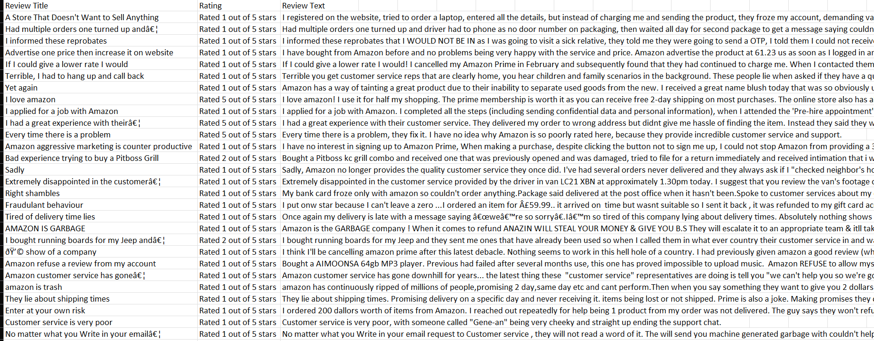
Figure 3.1: Bundled Amazon_Reviews_final.csv schema

Data Collection
The repository records two CSV filenames and schemas, but no publisher, collection method, date range or license metadata. Do not attribute the data externally without confirming its provenance.
Table 3.2: Measured dataset facts and fields not documented by the repository.

Parameter | Value
Training / upload rows | reviews.csv: 21,000; Amazon_Reviews_final.csv: 21,214.
Review types | No formal domain labels in training data; upload entity values depend on mapped columns.
Dataset source | Not stated in repository metadata; filenames do not establish provenance.
Language(s) | Not audited; no language field or detector.
Labels / class balance | reviews.csv: 7,000 per sentiment class, no missing rows; Amazon-named CSV has no sentiment label.
Training/test split | No split implemented.
Evaluation metrics | No accuracy, precision, recall, F1 or confusion matrix computed.
Mean review length | reviews.csv mean: 64.1 characters; Amazon-named CSV not profiled.
Geographic statistics | No location field or location statistics are established.
Rating counts in Amazon CSV | 1 star 13,123; 2 stars 1,227; 3 stars 885; 4 stars 1,292; 5 stars 4,528; missing 159.
Table 3.2: Dataset inventory and documented limitations.

The training CSV has 21,000 non-missing rows (7,000 per label) and mean review length 64.1 characters. The separate Amazon-named CSV has 21,214 rows, with 159 missing ratings/texts and 795 missing titles. No language audit, train/test split or model evaluation is implemented.

Text Preprocessing and Feature Representation
Text preparation differs by workflow: live classification uses NLTK tokenization and TF-IDF or Word2Vec features; uploaded rows use the weighted-lexicon scorer and do not invoke the selected ML model.
    - Missing and empty text: uploaded rows with no usable text or fewer than two characters are skipped after searching other string fields. Empty live text returns a neutral/zero lexicon result; the ML classifier still receives the empty string and returns its highest-probability class.
    - Text normalization: the ML path lowercases and removes URLs. The lexicon path lowercases, removes URLs and collapses whitespace.
    - Punctuation, URLs, numbers and special characters: URLs are removed. Lexicon preprocessing replaces punctuation except apostrophes. The ML path uses Treebank tokenization and discards punctuation-only tokens; alphanumeric tokens, including digits, may remain.
    - Tokenization and feature representation: NLTK TreebankWordTokenizer feeds scikit-learn TF-IDF unigram/bigram models; Word2Vec uses 48-dimensional mean-pooled document vectors.
    - Stopword removal: NLTK English stopwords are removed by the ML path except no, not, nor, never and n't. The lexicon path retains configured negation words.
    - Stemming/lemmatization: ML tokens are lemmatized as verbs and then nouns with WordNetLemmatizer. The lexicon path does not stem or lemmatize.
The examples below use live classifier preprocessing: lowercase, stopword removal, punctuation filtering and WordNet lemmatization.

Index | Original Review Text | Preprocessed Review Text
1 | Excellent quality and quick, reliable service. | excellent quality quick reliable service
2 | The delivery was not bad. | delivery not bad
3 | I would not recommend it. | not recommend
4 | Great value; I would buy it again. I would recommend it. | great value buy recommend
Table 3.3: Source-verified live classifier preprocessing examples.

Dataset processing creates in-memory review records and aggregates; it does not save a processed file. A record includes id, source, target, author, date, rating, text, sentiment, score, confidence and matched keywords.

Figure 3.2: Processed records are returned in memory

Training and inference share preprocessing within each ML model. Dataset uploads use a separate lexicon-scoring path and are not predictions from the selected Logistic Regression, SVM or Word2Vec model.
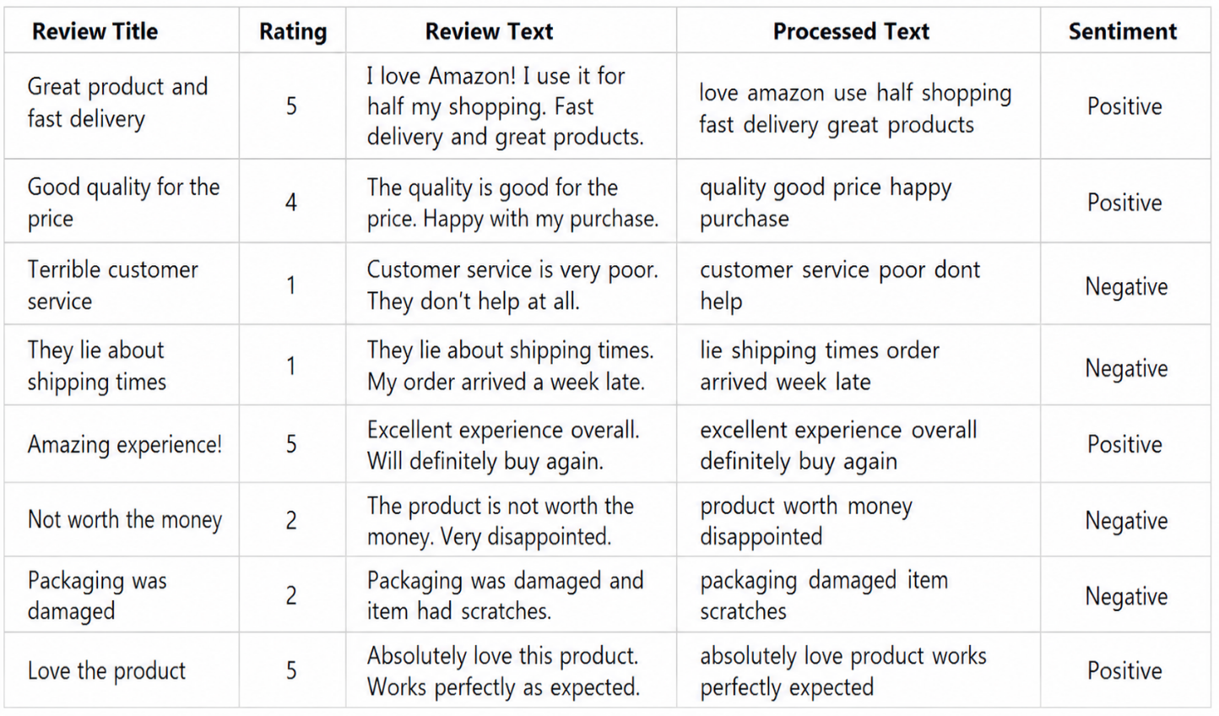

CHAPTER 4
MACHINE LEARNING APPROACH AND MODEL REPRESENTATION

Need for Polarity Scoring
The project uses TF-IDF for Logistic Regression and calibrated LinearSVC, and mean-pooled Word2Vec embeddings with a downstream LogisticRegression classifier. A separate weighted-lexicon pipeline supports uploads and frontend fallback.
    - Training data: reviews.csv supplies 21,000 labeled examples (7,000 per class). Each model trains lazily on its first request and is cached in memory. No train/test split, persisted model, training-time benchmark or evaluation report is present.
    - Interpretability and model behavior depend on the selected classifier and feature representation; do not claim a particular explanation method unless it is implemented.
    - Runtime performance: no controlled latency or throughput benchmark is included. The API processing-time field is not a standardized model benchmark.
    - Model suitability must be established through evaluation on appropriate held-out labeled data, rather than inferred from sample dashboard counts.

Text Representation and Classification Methods
Logistic Regression and LinearSVC use scikit-learn TF-IDF with sublinear term frequency and unigram/bigram features. Word2Vec creates 48-dimensional token vectors, mean-pooled per review before LogisticRegression.
Model input = sparse TF-IDF unigram/bigram vector for Logistic Regression/LinearSVC (vocabulary size is data-dependent), or a 48-value mean-pooled Word2Vec document vector.
Inference lowercases text, removes URLs, tokenizes, filters stopwords while retaining negations, and lemmatizes. The selected vectorizer/embedding creates features; the classifier returns one of negative, neutral or positive with class probabilities and confidence.
    - Logistic Regression: scikit-learn LogisticRegression(max_iter=1000, class_weight='balanced', random_state=17) on TF-IDF unigrams/bigrams.
    - SVM: LinearSVC(class_weight='balanced', random_state=17), wrapped by CalibratedClassifierCV(method='sigmoid', cv=3) to expose probabilities; features are TF-IDF unigrams/bigrams.
    - Word2Vec: Gensim Word2Vec(vector_size=48, window=5, min_count=1, workers=1, seed=17, epochs=100); token vectors are mean-pooled and classified with balanced LogisticRegression.

Illustrative review example (backend test fixture): Excellent quality and quick, reliable service.
All three models predicted positive. In the executed classifier check, confidence/probability was 0.949 for Logistic Regression, 0.997 for Linear SVM and 1.000 for Word2Vec + LogisticRegression. These are prediction probabilities, not accuracy scores.
The outputs came from classify_text() on the repository's test phrase, with the training CSV path supplied. They are not a browser-session screenshot or a full end-to-end application result.

Model option | Input representation | Predicted class | Evaluation / score
Logistic Regression | TF-IDF unigrams/bigrams | Positive | Confidence 0.949; not accuracy
Linear SVM | TF-IDF unigrams/bigrams | Positive | Confidence 0.997; not accuracy
Word2Vec + LogisticRegression | 48D mean-pooled embeddings | Positive | Confidence 1.000; not accuracy
Evaluation protocol | No held-out split | Not calculated | Not evaluated
Training data | reviews.csv, 21,000 rows | 7,000 per class | Provenance unknown
Model lifecycle | Lazy in-process training | LR cache for up to 3 models | No serialized models
Table 4.1: Model configurations and reproducible sample predictions; confidence is not evaluation accuracy.

Polarity Scoring Implementation
runNLPPipeline() in nlp_engine.py applies a weighted lexicon; classify_text() in ml_classifier.py applies the selected trained model. The text API merges their fields, while dataset processing uses the lexicon result.

Model Configuration and Sample Output
The repository does not reproduce the draft's 5,000-review output or 0.72 average. Metrics are generated only after user upload; no fixed run, selected model, ground-truth comparison or evaluation result is bundled.

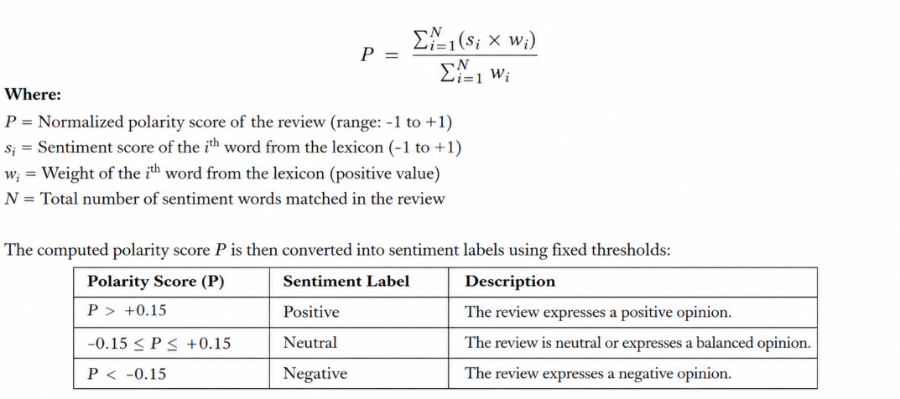

Figure 4.1: Weighted-lexicon polarity formula and +/-0.15 thresholds

No held-out evaluation set, accuracy, precision, recall, F1 score or confusion matrix is produced by the implementation. Compare models only after a documented evaluation on the same labeled test set.

CHAPTER 5
SENTIMENT CLASSIFICATION AND RESULTS

Classification Approach
The application classifies review text into Positive, Neutral or Negative categories. The supplied description names Logistic Regression, SVM and Word2Vec-related selectable options. The final report must clarify which options are actual classifiers, how Word2Vec is integrated, and whether the models were trained locally or loaded from saved artifacts.
- Predicted sentiment label: Positive, Neutral or Negative.
- ML confidence is the maximum predicted class probability; lexicon confidence is a polarity/keyword-density heuristic. Neither is accuracy.
- Other outputs include raw/cleaned text, tokens, stopwords, keyword triggers, polarity, normalized score, heuristic emotion values, processing time, model metadata, class probabilities, top TF-IDF features and n-grams.

Data Used for Classification
The training CSV has 21,000 balanced examples. No held-out split, leakage control, source metadata or evaluation protocol is defined; the Amazon-named CSV is not loaded for classifier training.

Techniques Used

Model-Based Sentiment Classification
Model-specific prediction uses the configured scikit-learn pipelines described above; no fixed polarity thresholds are applied to their class predictions.

Sentiment category | Meaning | Output
Positive | Favourable polarity | Predicted label
Neutral | Neither clearly positive nor negative | Predicted label
Negative | Unfavourable polarity | Predicted label
Table 5.1: Implemented Model Configuration and Evaluation Not specified in verified project files

Rating Columns and Additional Labels
Rating columns are optional data fields, not model ground truth. The source has no rating-to-sentiment mapping or comparison; six-aspect detection and rating agreement statistics are not implemented.

Metric | Value | Status
Training rows | 21,000 | reviews.csv; no missing records
Positive training labels | 7,000 | Balanced class
Neutral training labels | 7,000 | Balanced class
Table 5.2: Supported and unimplemented dataset analyses.

Aspect Detection
The reference report implements six hotel-specific aspect categories, but the project owner could not verify aspect detection in the current application. Aspect-level analysis is not described as an implemented feature here. If source code confirms it, document the actual categories and detection method; otherwise remove the hotel-specific aspect claims.

Item | Details
Rating analysis | Optional numeric rating import only; no rating-to-sentiment comparison.
Aspect analysis | Not implemented; no aspect detector or results.
Duplicate detection | Not implemented in source.
Suspicious-review detection | Not implemented in source.
Quality scoring | Not implemented in source.
Keyword analytics | Counts matched weighted-lexicon terms; these are not aspect categories.
Table 5.3: Not specified in verified project files

Classification and Prediction Process
Live text uses POST /api/analyze-text with JSON text and optional model. Uploads use POST /api/inspect-file and POST /api/process-dataset. FastAPI accepts dictionaries rather than declared Pydantic request schemas; frontend failures fall back to local implementations.
- Accept live text or inspect CSV, XLSX, XLS, JSON, PDF or TXT; map a required text column and optional target, date and rating columns.
- Live ML applies NLTK tokenization, stopword filtering, WordNet lemmatization and TF-IDF/Word2Vec features; uploaded rows use the weighted-lexicon scorer.
- Run the selected ML model for live text; score dataset rows with the lexicon pipeline .

- Carry a parsed numeric rating into the record if provided; do not report rating alignment or treat it as a reference label.
- The current source generates no aspect-level output.
- The current source runs no model evaluation because no held-out test set or evaluation routine is present.
Live results include sentiment, polarity, normalized score, confidence, class probabilities, model label, features/n-grams, tokens, keyword triggers, heuristic emotion values and processing time.

Positive / Neutral / Negative Classification Summary
The draft's fixed 5,000-review distribution is not generated by the repository. Class counts are computed dynamically after upload; no confusion matrix or accuracy is calculated.

Evaluation status | Positive | Neutral | Negative
Confusion matrix | Not generated | Not generated | Not generated
Held-out labels | Not configured | Not configured | Not configured
Per-class scores | Not calculated | Not calculated | Not calculated
Table 5.4: No model confusion matrix is generated by the current source.

Model performance has not been measured. Rating agreement is not calculated; evaluation needs verified labels, a held-out protocol and a computed confusion matrix.

Metric | Project result | Status | Notes
Accuracy | Not measured | No evaluation split/routine | Unavailable
Precision / Recall | Not measured | No evaluation split/routine | Unavailable
Macro-F1 | Not measured | No evaluation split/routine | Unavailable
Test-set size | Not configured | No held-out test protocol | Unavailable
Table 5.5: Evaluation metrics are unavailable because held-out evaluation is not implemented.

CHAPTER 6 IMPLEMENTATION

Classifier, API and Dashboard Components
The codebase has Python NLP/data processing under sentiment_backend/, FastAPI routes in main.py, and a React/TypeScript dashboard under src/. Vite serves/builds the frontend.
Classifier imports include NLTK, NumPy, Pandas, Gensim and scikit-learn; API/data code uses FastAPI, Uvicorn and pandas. The frontend uses React, TypeScript, Vite, Tailwind, Lucide and xlsx.
Core files: sentiment_backend/ml_classifier.py, nlp_engine.py, file_parser.py, main.py; src/utils/nlpEngine.ts, fileParser.ts; src/services/backend.ts; src/App.tsx and src/components/.

Descriptions below are verified against classifier, API, parser, dashboard components and manifests. Historical hotel/Streamlit/TextBlob snippets are not used by this application.

Component | Implementation detail | Purpose
Classifier component | ml_classifier.py: classify_text(), _trained_model() | Trains selected classifier lazily from reviews.csv and returns probabilities.
API component | main.py: /health and three /api/* routes | Delegates text, file and dataset requests.
Dashboard component | src/App.tsx and src/components/ | Renders live tester, upload flow, KPIs, charts and review table.
NLP preprocessing | NLTK TreebankWordTokenizer and WordNetLemmatizer | Tokenizes and lemmatizes ML text; stopwords removed with negations preserved.
Dataset aggregation | file_parser.py: calculateDatasetAnalytics() | Groups optional entity/month and matched keywords; no aspect counts.
Table 6.1: Project components and responsibilities verified from source.

Classifier and Model Setup
Models are not loaded from disk. The training CSV is read at module import; each model trains lazily on first use and is cached in memory. Missing stopwords or WordNet resources trigger download attempts.

      - Classifier imports NLTK, NumPy, scikit-learn and Gensim, but requirements.txt and pyproject.toml omit all four. This differs from the declared install dependencies.
      - Classifier libraries: scikit-learn TF-IDF, LogisticRegression, LinearSVC and CalibratedClassifierCV; Gensim Word2Vec; NumPy vectors; Pandas CSV loading. No model artifact files are bundled.
      - Word2Vec uses 48 dimensions, window 5, min_count 1, workers 1, seed 17 and 100 epochs; mean pooling creates document vectors for balanced LogisticRegression.
      - Declared Python API/data dependencies include FastAPI, Uvicorn, pandas, openpyxl, pypdf and python-multipart. Frontend dependencies include React 19, TypeScript 7, Vite 8, Tailwind, xlsx, Firebase, Lucide and Motion.
    - Input Validation and Text Preparation
Live JSON input has no Pydantic schema or explicit length validation. Upload parsing dispatches by extension; empty/unreadable files raise errors, unusable review rows are skipped, and text_column is user-selected. No upload-size cap is configured.

Preprocessing and Input Validation
ML uses TreebankWordTokenizer, removes NLTK English stopwords except no/not/nor/never/n't, and lemmatizes verbs then nouns. The lexicon path splits cleaned text and preserves configured negations.
Frontend API failures are logged and return null, after which local TypeScript NLP/parser fallbacks run. Upload errors are displayed. The backend defines no custom error-response schema.
Training and inference share preprocessing within each ML model. Dataset uploads instead use a separate lexicon scorer. Both preserve negations, but use different prediction rules.

Model Loading and Prediction
The chosen classifier is trained in memory from reviews.csv and cached; the maximum-probability class, probabilities and confidence are returned. Word2Vec uses a 48-value mean vector. No serialized artifacts or custom model exception handling are present.

Dataset Processing and Result Aggregation
Dataset aggregation computes class counts/percentages, normalized mean score, top entity, monthly trends when dates exist, entity/category totals and matched-keyword counts. React components render KPIs, charts, keyword cloud and review table.

Dashboard and API Integration
The stack is Python 3.11+ with FastAPI/Uvicorn and NLP/data libraries, plus React 19/TypeScript/Vite 8. Charts are custom React SVG/CSS, not Streamlit or Matplotlib. Dataset analysis is not persisted to Firestore.

Function / Endpoint | Library / Component | Purpose
POST /api/analyze-text | FastAPI | Accepts text and model selection; returns sentiment prediction and model details.
POST /api/inspect-file | FastAPI/file_parser.py | Inspects supported uploads and returns column-mapping options.
POST /api/process-dataset | FastAPI/file_parser.py | Processes mapped review rows and returns sentiment aggregates.
predict_proba() | scikit-learn | Selects the highest-probability sentiment class and exposes its confidence.
runNLPPipeline() | Python weighted lexicon | Scores dataset-upload text using lexicon polarity thresholds.
_tokens() / _lemmatize() | NLTK | Tokenizes text, removes stopwords while preserving negations, and lemmatizes.
TfidfVectorizer(ngram_range=(1, 2)) | scikit-learn | Creates unigram and bigram features for two live classifier options.
Word2Vec | Gensim | Creates 48-dimensional word vectors that are mean-pooled for classification.
Custom SVG/CSS charts | React | Displays sentiment, monthly trends, entity groups and matched keywords.
Dashboard controls | React components | Supports filtering, search, sorting, pagination, inspection and CSV export.
Table 6.2: Important source functions, API endpoints and libraries.

Live Text Input and Dataset Upload
Live text uses POST /api/analyze-text with text and optional model (logistic_regression, svm or word2vec). Upload routes are POST /api/inspect-file and POST /api/process-dataset. File types: CSV, XLSX, XLS, JSON, PDF and TXT; no size limit is configured.

Preprocessing Implementation
Live ML preprocessing is implemented in _raw_tokens(), _tokens() and _lemmatize() in ml_classifier.py. The separate lexicon path is in nlp_engine.py; the hotel/TextBlob code is not part of this project.

6.4 Model Prediction Implementation
For Logistic Regression and calibrated LinearSVC, predict_proba supplies class probabilities and the highest selects the label. Word2Vec feeds a probability-based LogisticRegression. The lexicon path uses separate +/-0.15 thresholds.

Dataset and Dashboard Integration
The API/dashboard support live text, dataset upload, sentiment aggregation, filtering, review inspection and CSV export. Ratings are not compared with sentiment. Aspect, duplicate, suspicious-review and quality-score detection are absent.

Important Code Snippets

Running the Application
README commands: npm install; python -m pip install -r requirements.txt; npm run dev:all. Frontend: http://localhost:3000; backend health: http://localhost:8000/health. Caveats: Python manifests omit imported NLTK/NumPy/scikit-learn/Gensim, and ml_classifier.py reads reviews.csv relative to the working directory although the file is under sentiment_backend/. A clean root startup is not verified.

Dashboard Controls and Key Metrics
Dashboard controls: select one of three models for live text; filter by sentiment/source/keyword; search review text/entity/author/id; sort by date/score/rating; paginate, inspect records and export CSV. Upload maps text/entity/date/rating fields. Rating alignment, evaluation and aspect controls are absent.

Live Text Analysis

Implementation files are in the repository: sentiment_backend/ contains Python NLP/API code and src/ contains the React/TypeScript UI. This report summarizes the source rather than duplicating the full repository.

CHAPTER 7
RESULT VISUALIZATION AND DASHBOARD

RESULT VISUALIZATION AND DASHBOARD
The actual dashboard is React/TypeScript/Vite. It starts empty, accepts uploads or live review text, and shows KPIs, sentiment donut, monthly line, entity bars, keyword cloud and review table. Controls include sentiment/entity/keyword filters, search, sorting, pagination, inspection and CSV export.
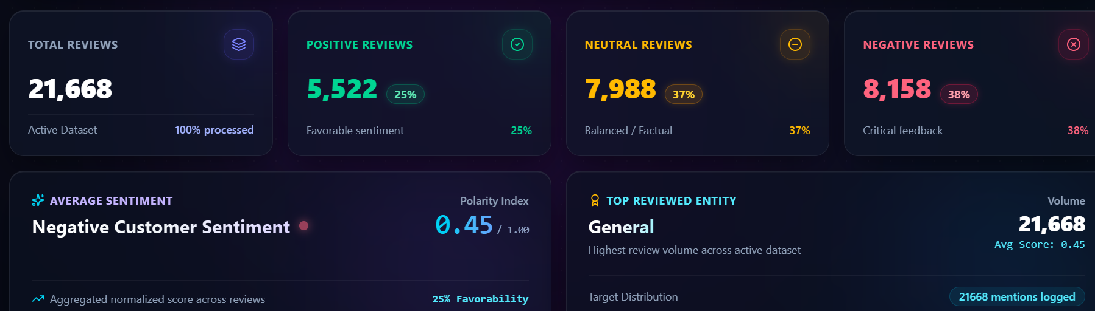

Figure 7.1: Sentiment Intelligence Dashboard

The dashboard is described as supporting sentiment visualizations. The actual chart types, metrics, filtering behavior, model selector and dataset explorer should be confirmed from the dashboard components before this section is finalized.
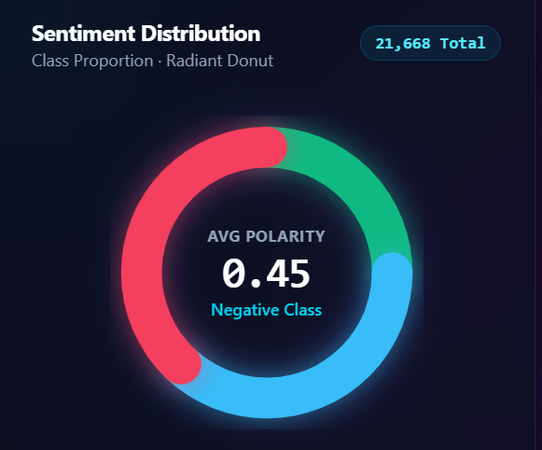

Figure 7.2: Dashboard Donut: Sentiment Distribution and Frequently Mentioned Aspects
The supplied abstract lists sample summary metrics for 5,000 reviews: 63% Positive, 19% Neutral and 18% Negative, with an average sentiment score of 0.72. Confirm that the current dashboard reproduces these figures and document the formula for the average score before treating them as final experimental results.

Sentiment Distribution
The draft's 21,000-review counts are not generated by this repository. Sentiment counts are computed dynamically from user uploads
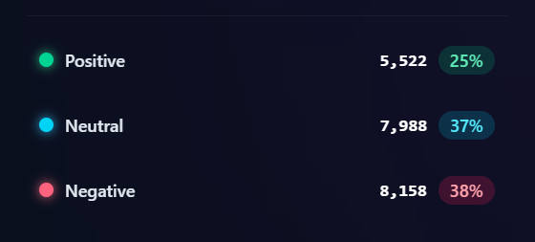

Figure 7.3: Dynamic sentiment distribution from a user-selected dataset; no fixed 21,000-review result or screenshot is included.

Positive / Neutral / Negative Statistics

Sentiment | Dynamic upload count | Dynamic share | Bundled run | Status
Positive | Not fixed | Not fixed | Not generated | No run
Neutral | Not fixed | Not fixed | Not generated | No run
Negative | Not fixed | Not fixed | Not generated | No run
Total | Not fixed | Not fixed | Not generated | No run
Table 7.1: Dynamic sentiment counts from an active upload; no fixed sample result is verifie

The repository provides no reproducible dashboard class distribution. A prediction distribution describes one uploaded dataset and is not evidence of model accuracy or generalization.

Charts and Graphs

Model Evaluation
No model evaluation chart is supportable: the source has no held-out evaluation, reference labels, accuracy, precision, recall, F1 or confusion-matrix calculation.

Do not report rating alignment, divergent-review counts, hotel-area comparisons or aspect-frequency results; none is computed by this application.

Analysis area | Current status | Source evidence | Reportable result
Rating alignment | Not implemented | Optional rating field; no comparison code. | Not available
Aspect detection | Not implemented | No detector or aspect results. | Not available
Model evaluation | Not implemented | No held-out split or evaluation metrics. | Not available
Duplicate detection | Not implemented | No duplicate-review detector. | Not available
Suspicious-review detection | Not implemented | No suspicious-review detector. | Not available
Review quality scoring | Not implemented | No quality-scoring code. | Not available
Total divergent reviews | Not calculated | No rating-alignment process. | Not available
Table 7.3: No verified rating divergence or model error analysis is available.

Dataset and Category Analysis
Entity/category summaries are supported when a target column is mapped; monthly trends require a date column. These are grouping summaries, not six-aspect detection. No fixed category values are bundled.

Figure 7.5: Optional entity/category breakdown from an upload; no fixed result or screenshot is included.

Analysis | Status | Details | Evidence
Entity/category analysis | Implemented for optional target/entity column | Summarizes class counts and normalized score; no fixed values. | file_parser.py and CategoryBarChart.tsx
Monthly trend | Implemented only when date column is mapped | Monthly sentiment counts and normalized score; no fixed period. | file_parser.py and SentimentTrendLineChart.tsx
Aspect detection | Not implemented | No aspect dictionary or results. | Not available
Rating alignment | Not implemented | No rating comparison. | Not available
Duplicate/suspicious detection | Not implemented | No detector. | Not available
Model evaluation | Not implemented | No held-out metric calculation. | Not available
Table 7.2: Supported dataset aggregations and unavailable analyses.

Sample Reviews and Predictions
The backend test fixture 'Excellent quality and quick, reliable service.' was run through each classifier. All three predict positive; confidence is 0.949 for Logistic Regression, 0.997 for Linear SVM and 1.000 for Word2Vec + LogisticRegression. These are not performance metrics.

Review text | Selected model | Predicted sentiment | Score / confidence | Verified? | Notes
Excellent quality and quick, reliable service. | Logistic Regression | Positive | 0.949 confidence | Yes - classifier function test | Unit-test phrase; not a dataset metric.
Excellent quality and quick, reliable service. | Linear SVM | Positive | 0.997 confidence | Yes - classifier function test | Same test phrase; confidence is not accuracy.
Excellent quality and quick, reliable service. | Word2Vec + LogisticRegression | Positive | 1.000 confidence | Yes - classifier function test | Same test phrase; confidence is not accuracy.
No additional verified sample | Not run | Not available | Not measured | No | No additional sample was evaluated.
No additional verified sample | Not run | Not available | Not measured | No | No additional sample was evaluated.
No additional verified sample | Not run | Not available | Not measured | No | No additional sample was evaluated.
No additional verified sample | Not run | Not available | Not measured | No | No additional sample was evaluated.
Table 7.4: Reproducible classifier predictions for the repository test phrase.

No current-application screenshots are embedded. Historical hotel/Streamlit screenshots were removed because they do not depict this project; capture fresh screenshots from the running application before final submission.

Screenshots
Figure 7.6: Current backend/API execution screenshot not included; add a verified capture if required.

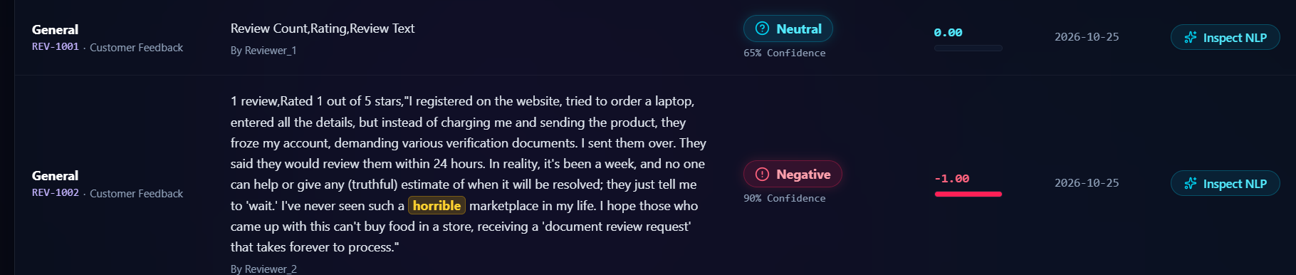
Figure 7.6: Current project execution output

Results and Discussion
Verified results from source code and bundled data:
- The training data contain 21,000 labeled examples, evenly split across three classes. The separate Amazon-named CSV contains 21,214 rows and documented missing values; its provenance is unknown.
- All three models predicted positive for 'Excellent quality and quick, reliable service.'; this one test example is not a dataset-level sentiment distribution.
- No neutral/negative counts for uploaded data are precomputed or bundled; the dashboard derives them after user upload.
- The stated average 0.72 and the 3,150/950/900 counts are not supported by a reproducible repository run. Do not infer accuracy from them.
- No Product A ranking or January-to-June trend is bundled. The dashboard can calculate entity/month summaries only when those fields are supplied in an upload.
The repository demonstrates a UI/API workflow but does not experimentally validate comparative model performance. Live ML options expose probabilities; dataset uploads use a separate lexicon scorer. Training labels are balanced, but provenance and generalization are unknown.
The source supports model configurations and one positive test phrase, but not comparative performance or population-level conclusions. Add results only after a documented held-out evaluation.
Observed limitations include missing evaluation metrics and dataset provenance, different ML-versus-upload scoring paths, undeclared classifier dependencies, a relative training-CSV path, and no rating alignment or aspect/fraud/quality detection. Sarcasm and domain shift need empirical error analysis.

CHAPTER 8
CONCLUSION AND FUTURE ENHANCEMENTS

Conclusion
The project is a React/TypeScript/Vite dashboard with Python FastAPI. Live predictions use TF-IDF Logistic Regression, calibrated LinearSVC or Word2Vec plus LogisticRegression; uploaded datasets use a separate weighted lexicon. The dashboard summarizes sentiment, trends, entities and matched keywords.
The draft's 5,000-review counts and 0.72 average are not reproducible and are excluded as results. The classifier trains on 21,000 balanced examples but has no held-out evaluation, so accuracy and generalization are unknown.

Limitations
    - Dataset provenance and collection dates are absent from repository metadata; no train/test split or ground-truth evaluation protocol is implemented.
    - Verified model pipelines: TF-IDF unigrams/bigrams for Logistic Regression and calibrated LinearSVC; 48D mean-pooled Word2Vec plus LogisticRegression. Uploads use the lexicon scorer.
    - Rating columns can be mapped into records, but no rating-to-sentiment mapping, alignment calculation or aspect detector exists in source.
    - Duplicate-review detection, suspicious-review detection and review-quality scoring are not implemented.
    - The dashboard is React/TypeScript/Vite and the API is FastAPI/Uvicorn. CSV, XLSX, XLS, JSON, PDF and TXT parsing is implemented. No deployment configuration or language detection is present.
    - The draft's sample counts are not evaluation metrics and cannot substitute for a held-out labeled test.

Future Enhancements
    - The three model configurations are documented above; evaluate them on the same held-out labeled data before claiming comparative performance.
    - Evaluate all model options on the same held-out dataset using accuracy, precision, recall, macro-F1 and confusion matrices.
    - Improve handling of negation, sarcasm, mixed sentiment and domain-specific expressions, guided by an error analysis of actual predictions.
    - If required, implement and evaluate rating alignment or aspect-based sentiment analysis; neither is currently part of the application.
    - Improve dashboard usability, dataset validation, result export and reproducibility based on verified user needs.

REFERENCES
- Dataset provenance: the repository includes Amazon_Reviews_final.csv and reviews.csv, but neither contains a verifiable publisher, collection method or license. Cite the original source only after confirming it.
Verified documentation references: https://react.dev/; https://vite.dev/guide/; https://fastapi.tiangolo.com/; https://scikit-learn.org/stable/; https://radimrehurek.com/gensim/models/word2vec.html

- Scikit-learn API/user guide for LogisticRegression, LinearSVC, CalibratedClassifierCV and TfidfVectorizer: https://scikit-learn.org/stable/; Gensim Word2Vec documentation: https://radimrehurek.com/gensim/models/word2vec.html
- NLTK documentation: https://www.nltk.org/; NumPy documentation: https://numpy.org/doc/; pandas documentation: https://pandas.pydata.org/docs/
- FastAPI documentation for routing, request handling and file uploads: https://fastapi.tiangolo.com/
- The outdated library examples and citations have been removed; this section lists only references relevant to the current source.
- Add dataset citations only after confirming the actual data provenance and documentation consulted.
- Scikit-learn user guide for feature extraction and linear models: https://scikit-learn.org/stable/
- Dashboard visualizations are custom React SVG/CSS components; no external chart library is used.
- React documentation: https://react.dev/; Vite guide: https://vite.dev/guide/; Tailwind CSS documentation: https://tailwindcss.com/docs

- No external source for the draft's 5,000-review dataset is identified; those unverified statistics were removed.

APPENDIX - PROJECT SOURCE FILES
  - Source files are available in the workspace: sentiment_backend/ contains Python NLP/API code and src/ contains the React/TypeScript UI. The complete repository is not duplicated in this report.

Dashboard implementation: src/App.tsx, src/components/, src/utils/fileParser.ts, src/utils/nlpEngine.ts and src/services/backend.ts. Framework: React 19, TypeScript and Vite.

