Sai Narasimha Rao Konda

Professor Williams

IS 601-850; Web Systems Development

July 26, 2021

**Web App Homework – Part 3**

1. Link to the GitHub repository: https://github.com/sainarasimhak/Homework5

2. Required screenshots for the project:

2a. Screenshot showing I can view my data table in PyCharm:

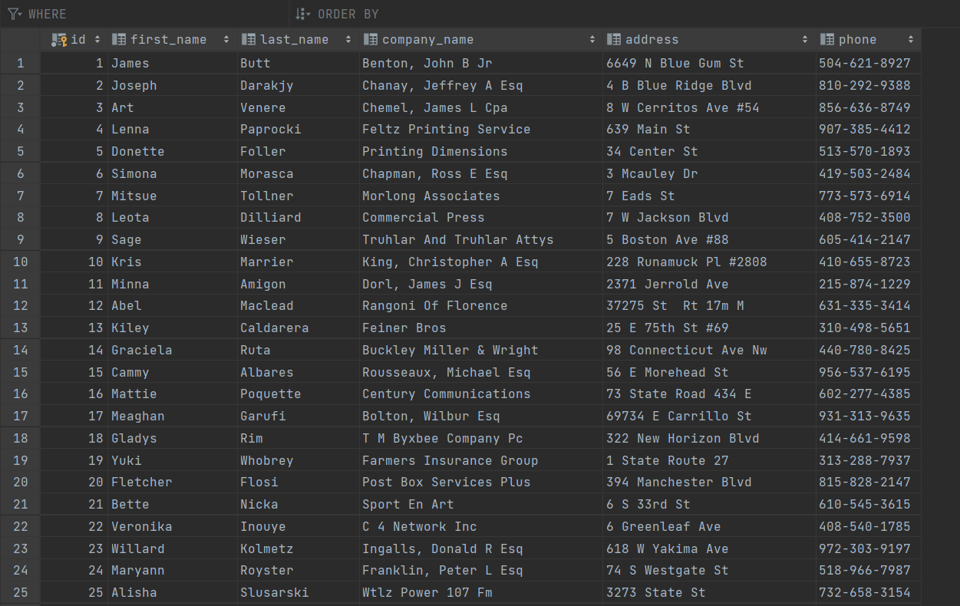

2b. My project in the browser displaying my homepage and data:

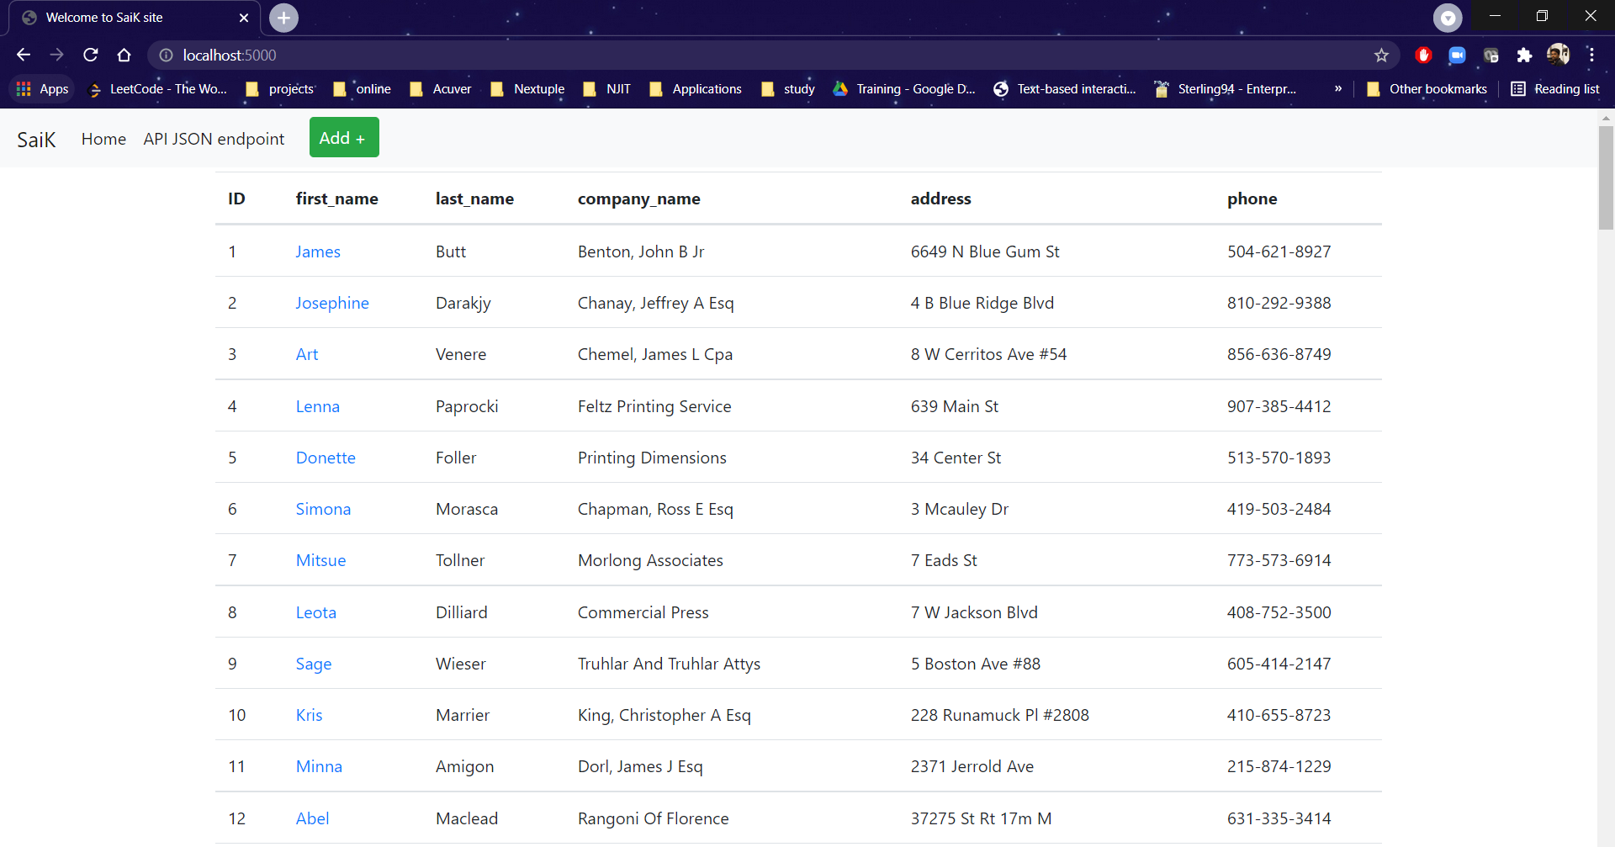

2c. My project in the browser displaying one record (I chose James for this part):

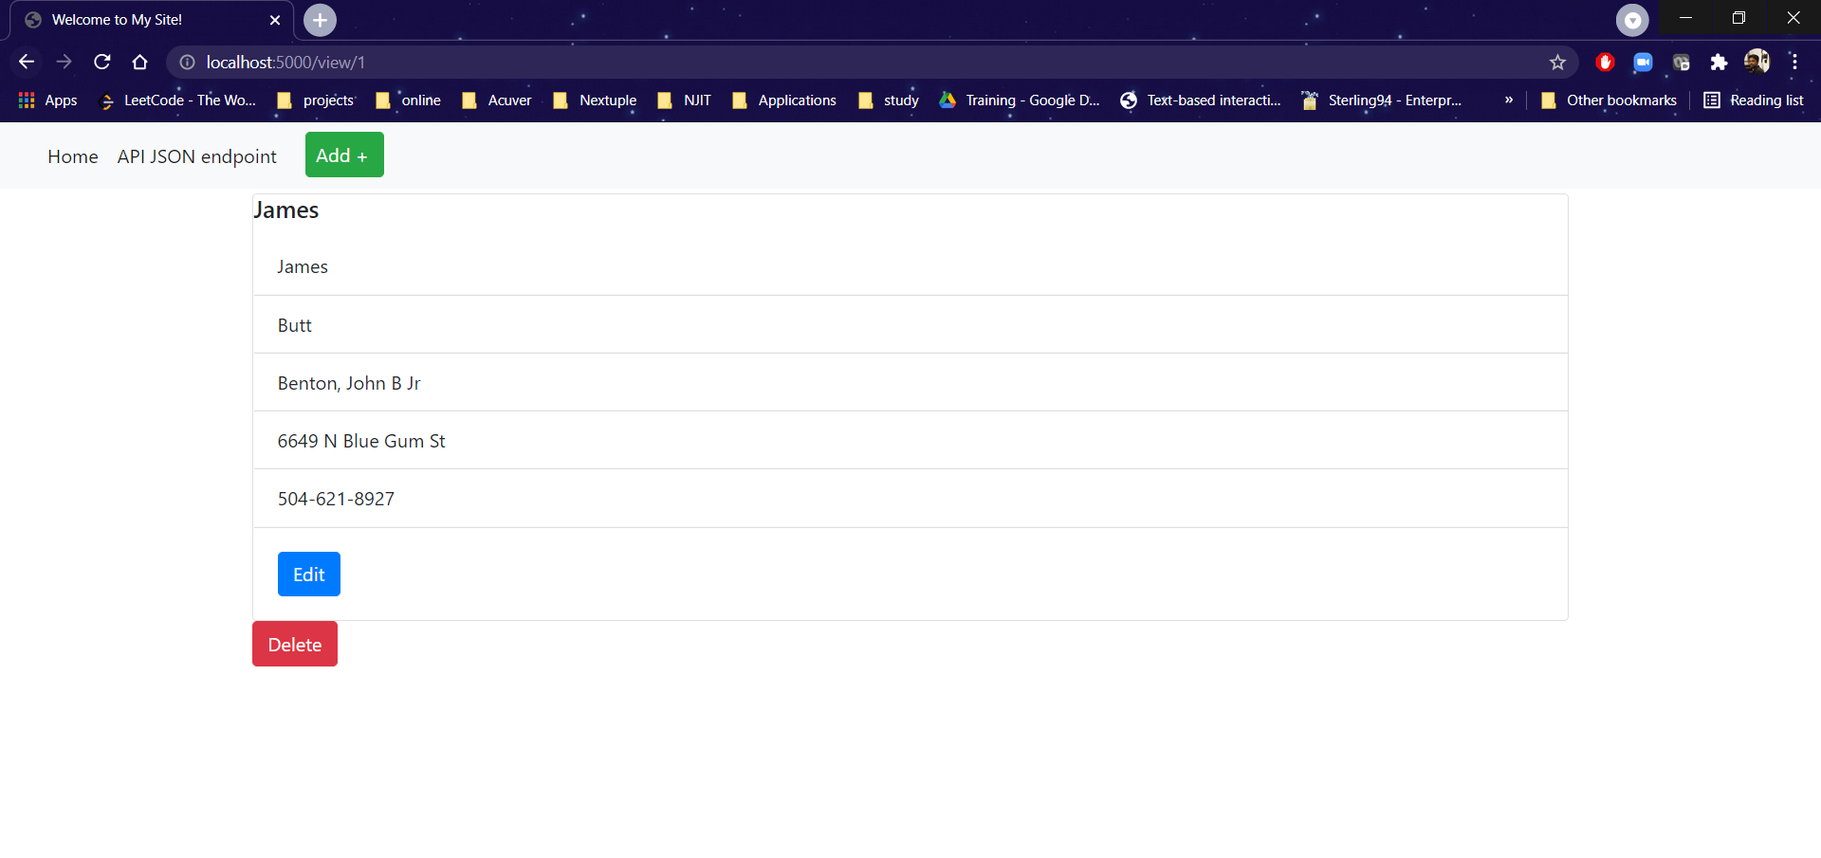

2d. My project in the browser, adding a new record. I added “Hamsa” for this part. His data was taken from <https://www.briandunning.com/sample-data/>.

Before adding the new record:

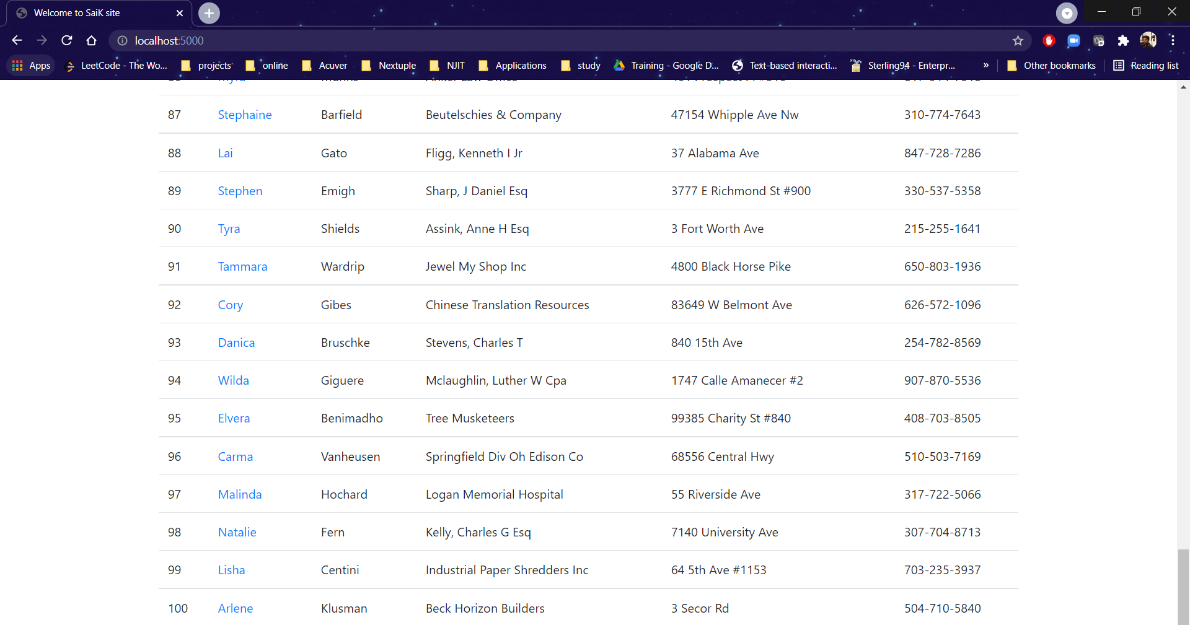

After adding the new record:

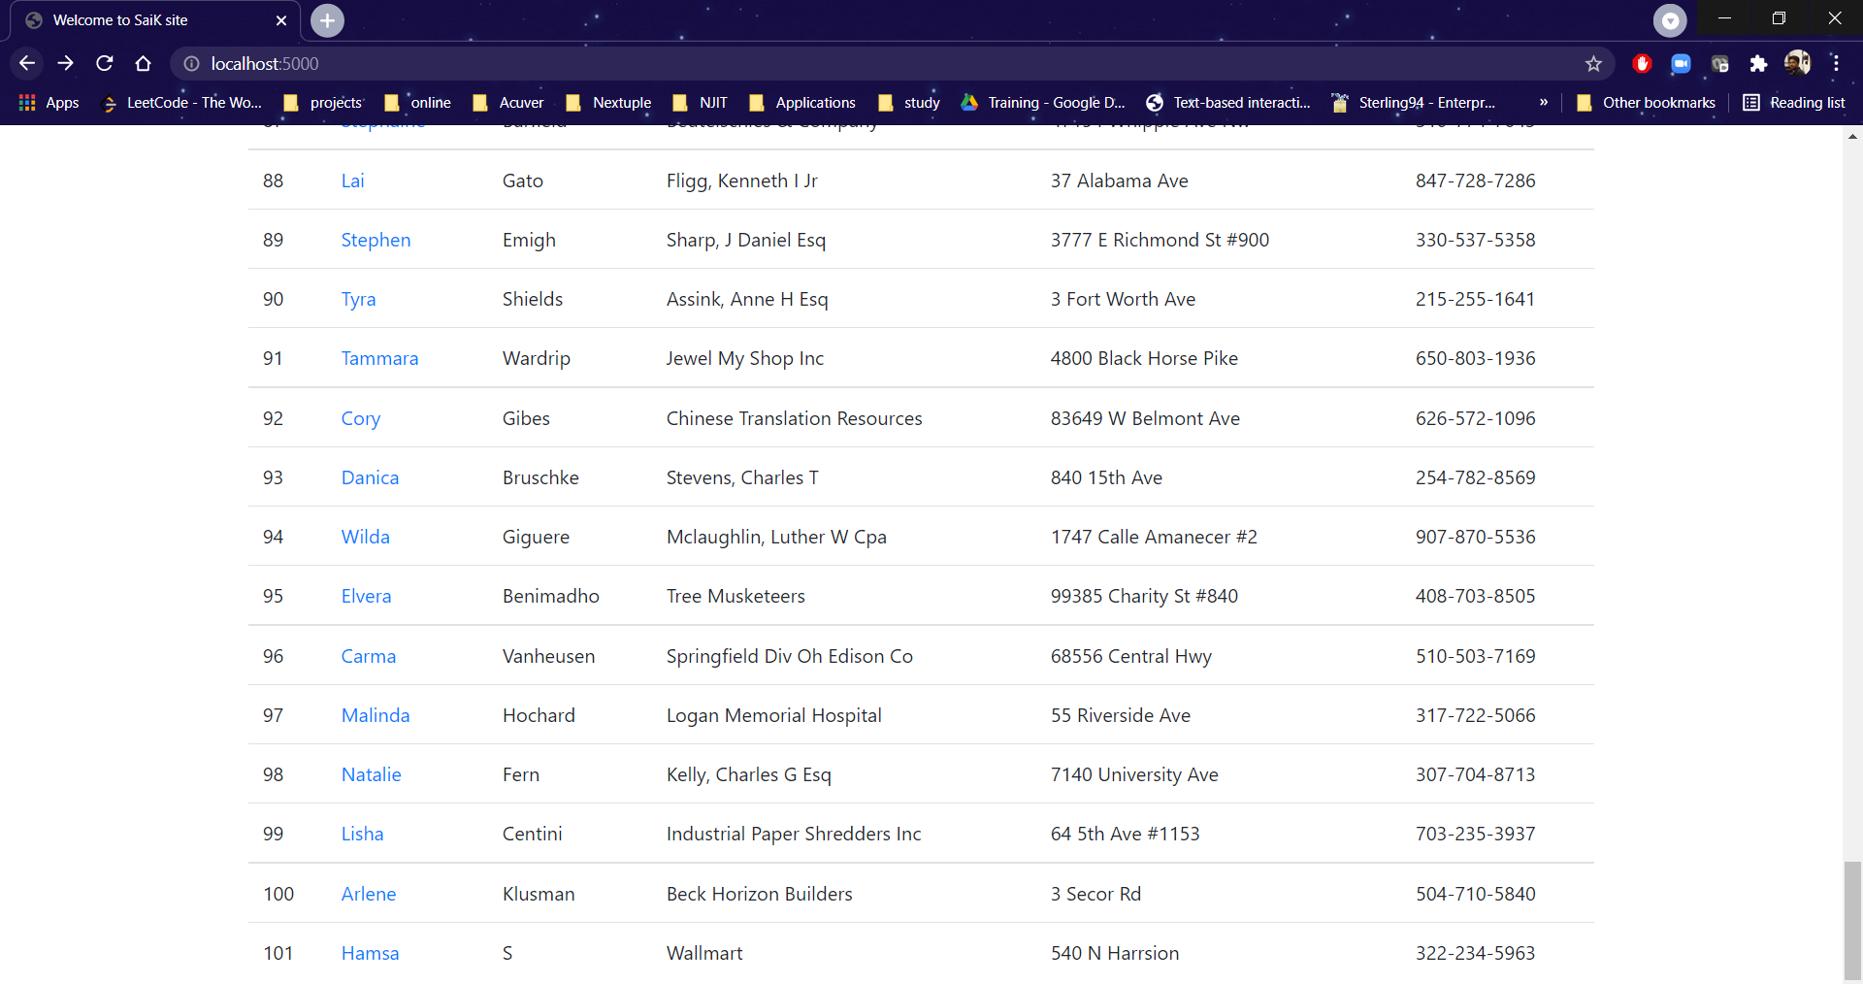

2e. My project in the browser, updating a record. I updated the record for Josephine, ID number 2. His name was updated to Joseph D.

Before updating the record:

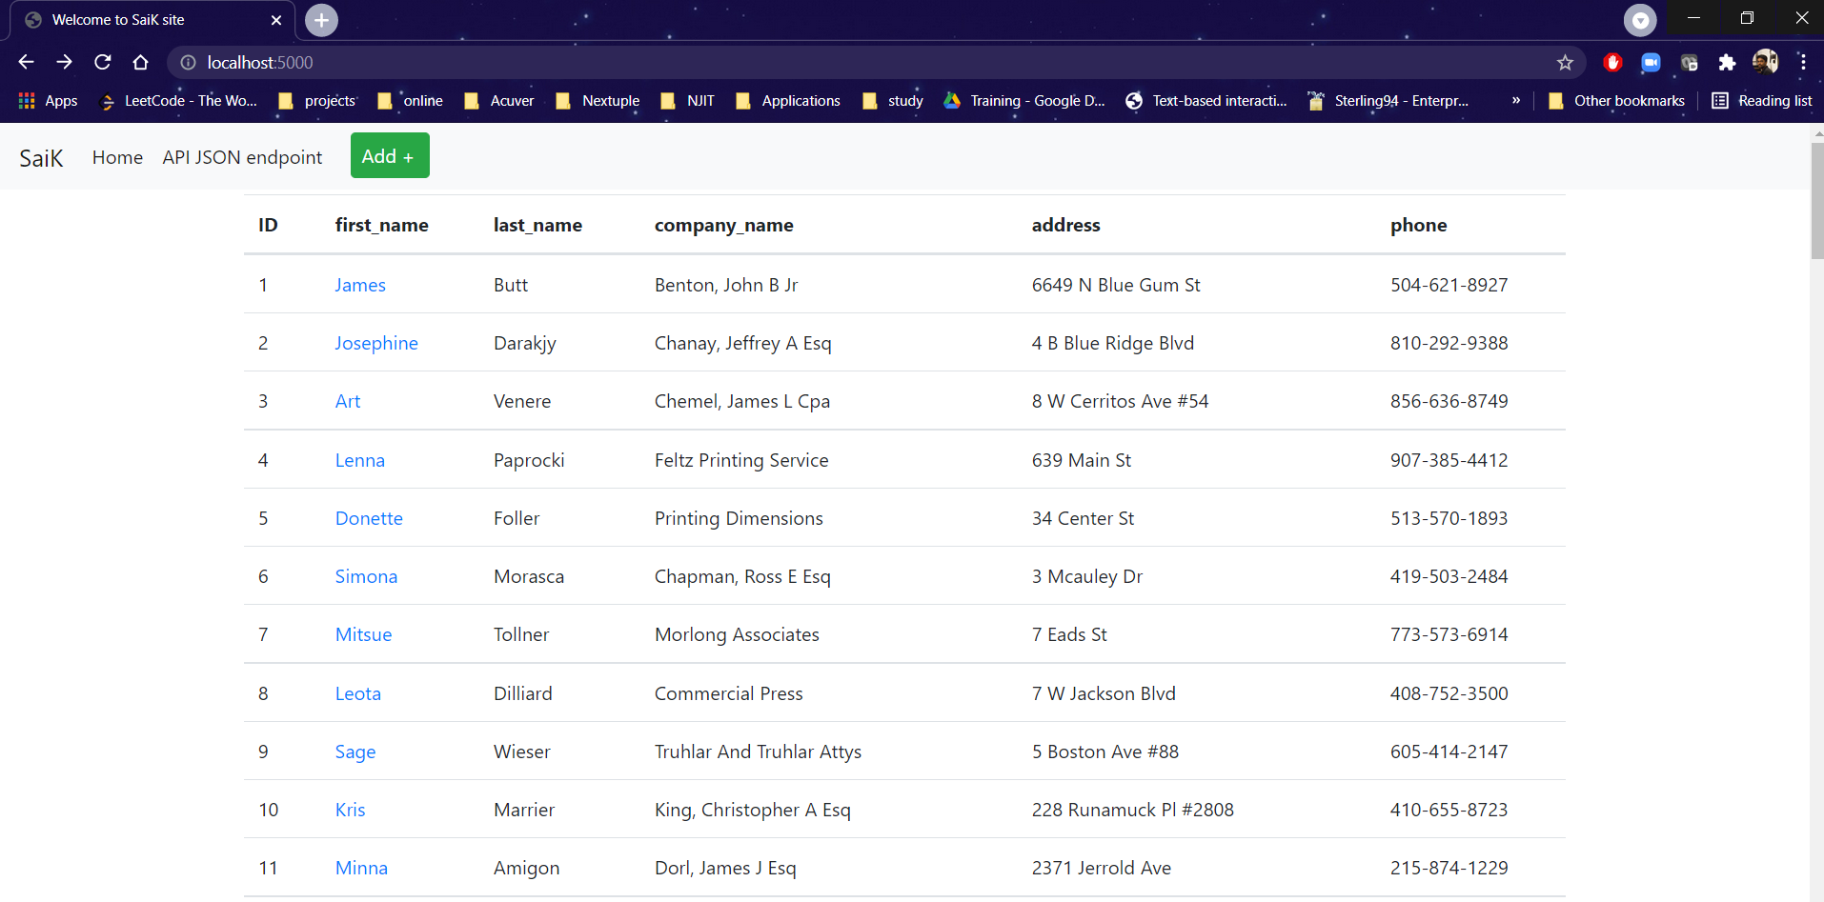

After updated the record:

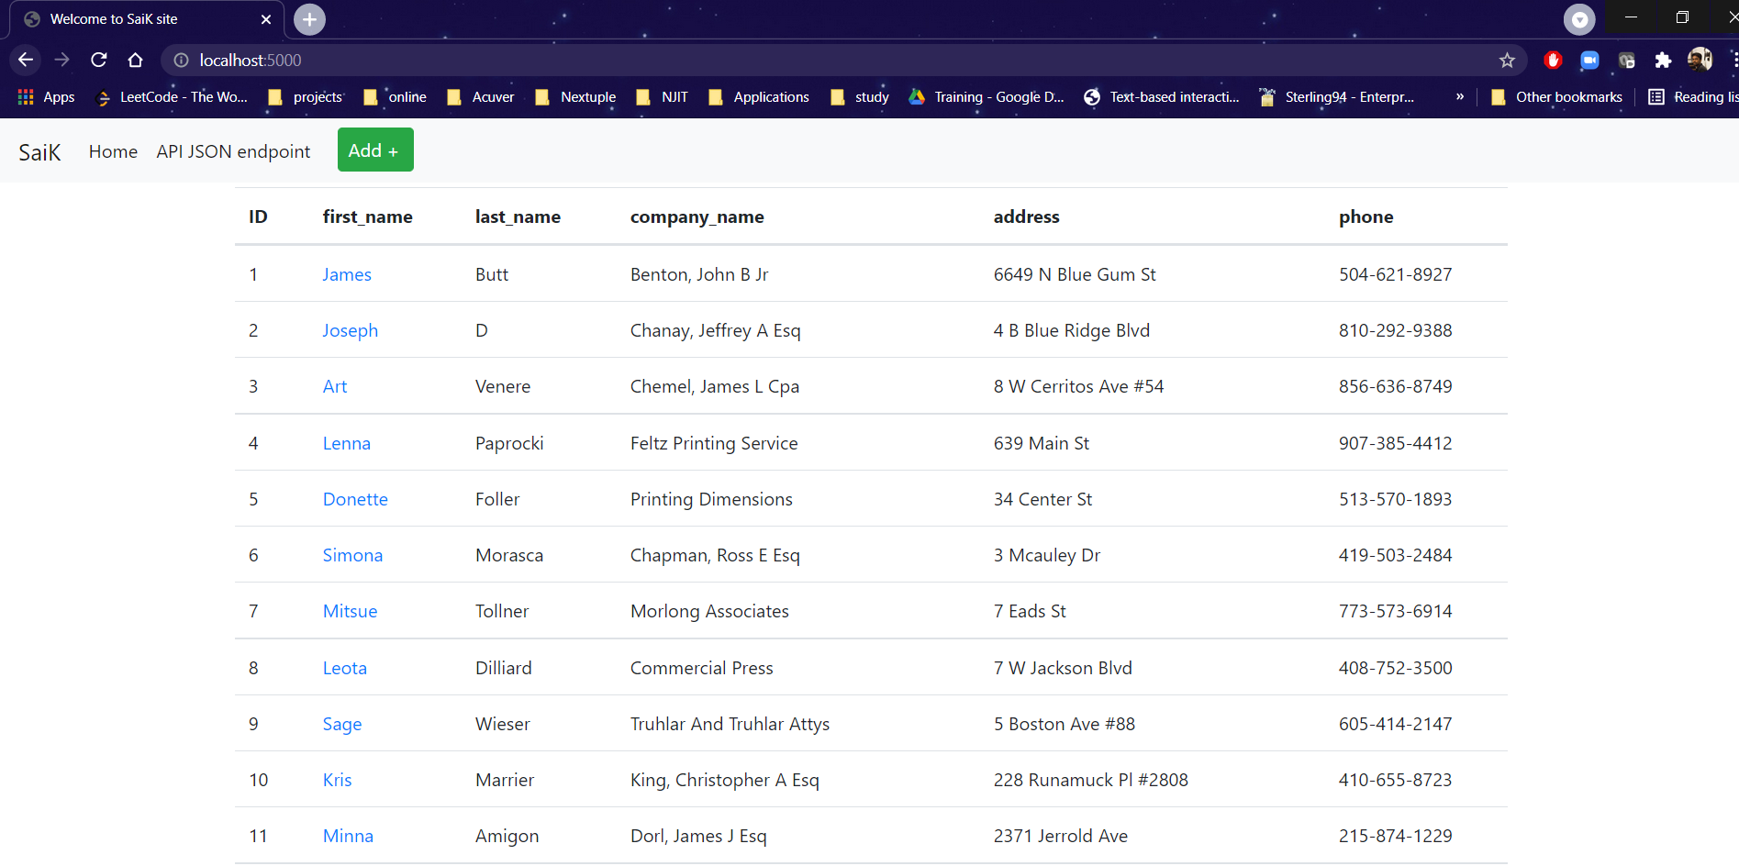

2f. My project in the browser, deleting a record. I deleted ID number 4, Lenna Paprocki.

Before deletion:

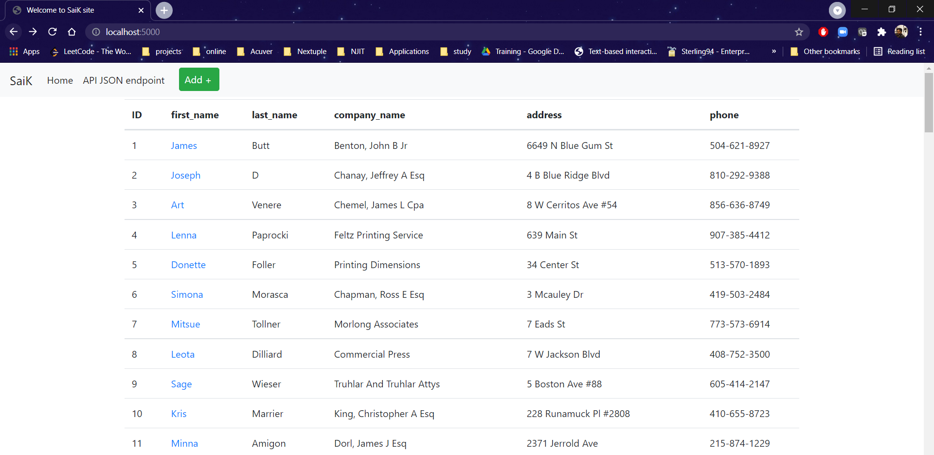

After deletion:

