**Project 3**

1. GitHub repository link: https://github.com/sainarasimhak/Project3.git

2a. My project showing all the records in Postman:

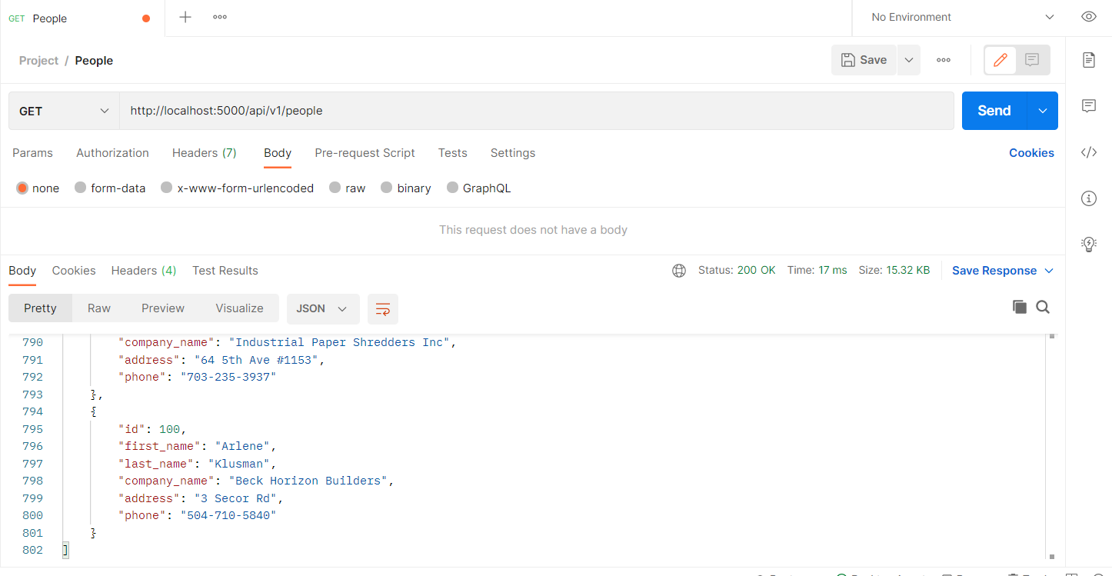

2b: My project showing one record with a GET request (I got ID #33):

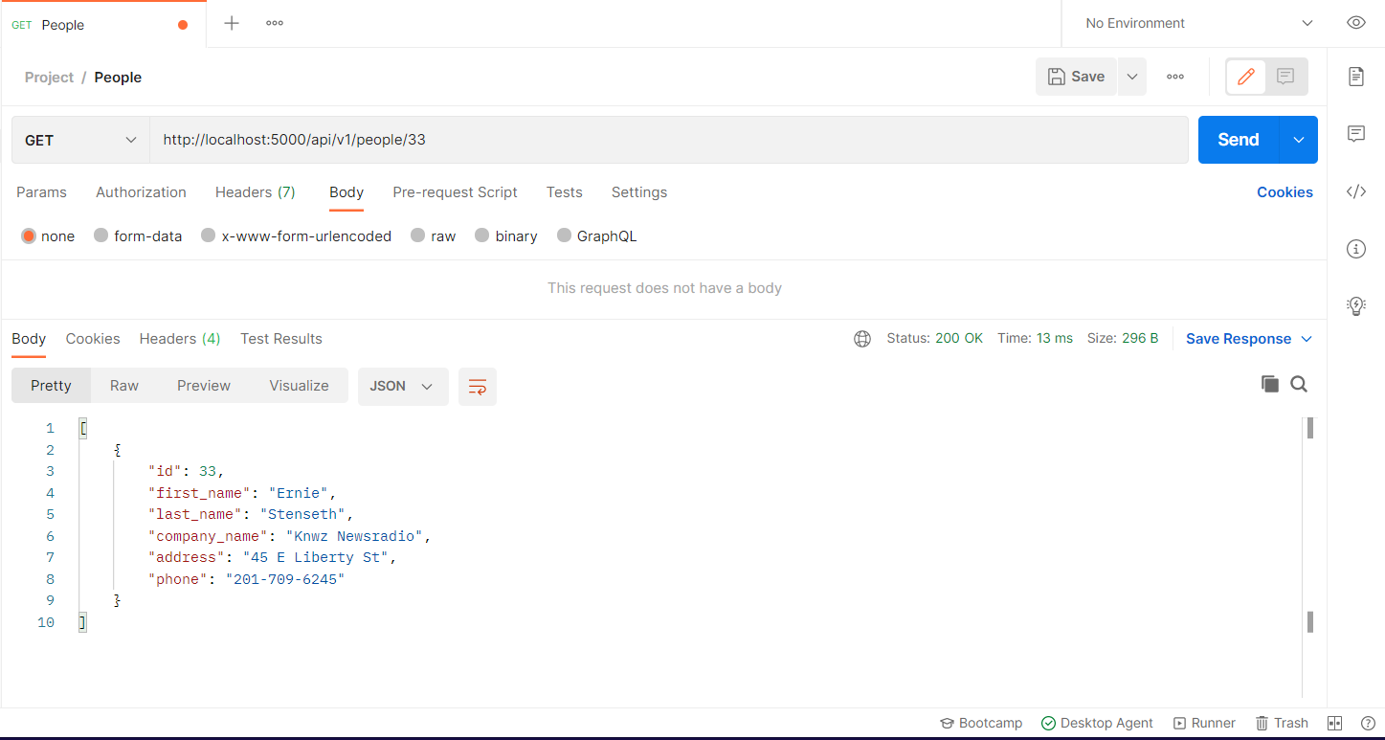

2c: Postman creating a new record (POST request). I chose to add random data (abc):

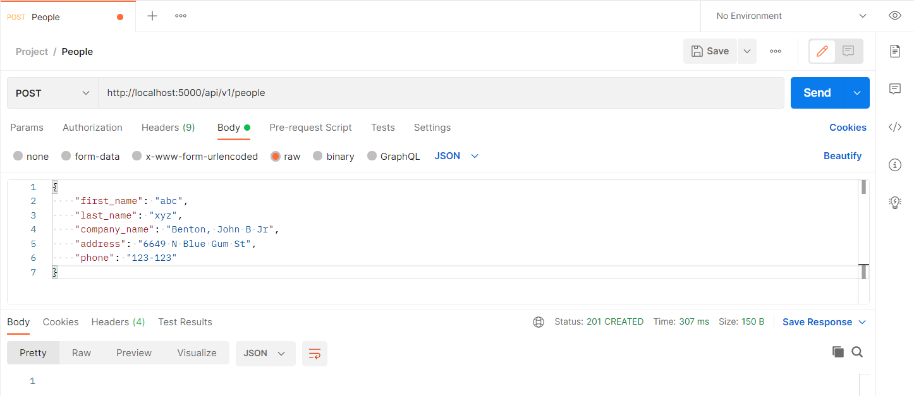

Viewing the created record in the results in Postman:

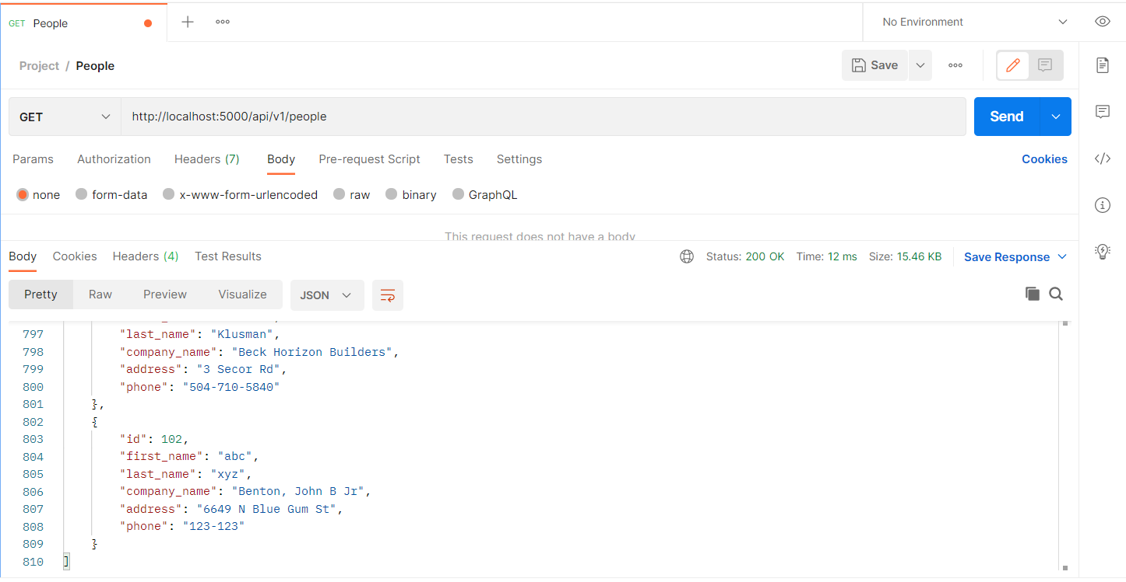

2d. Part 2d: Editing a record in Postman. I edited record ID #102. I changed his phone number from 123-123 to 999-888

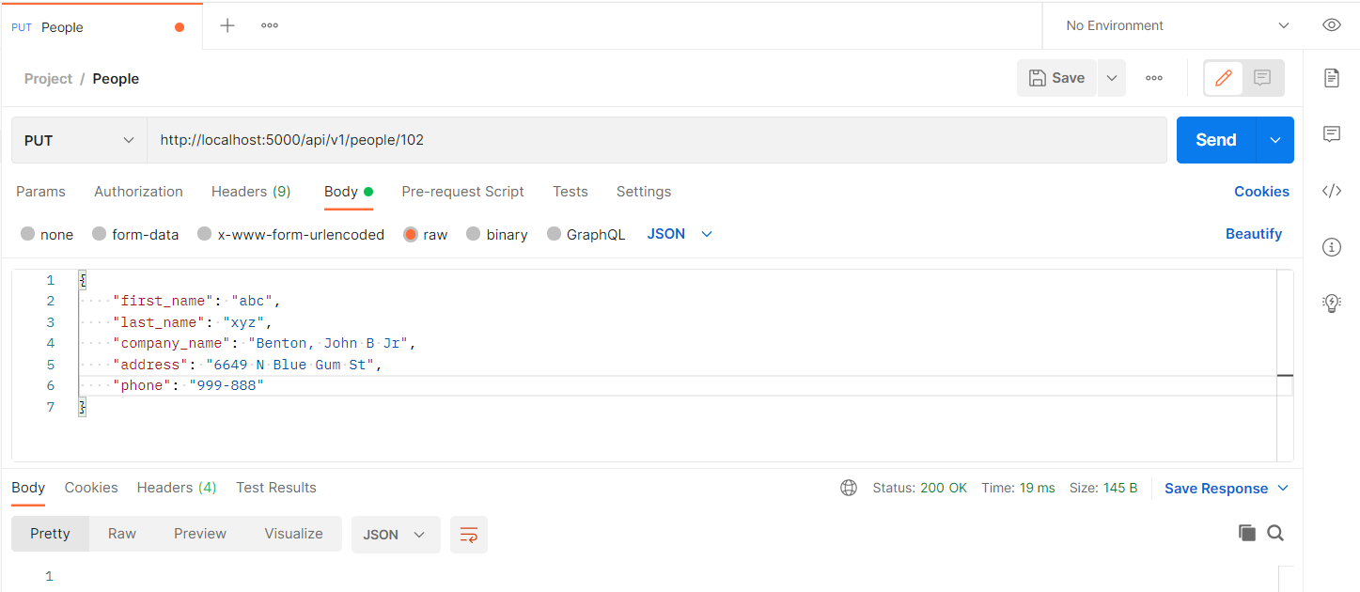

Results after the PUT request:

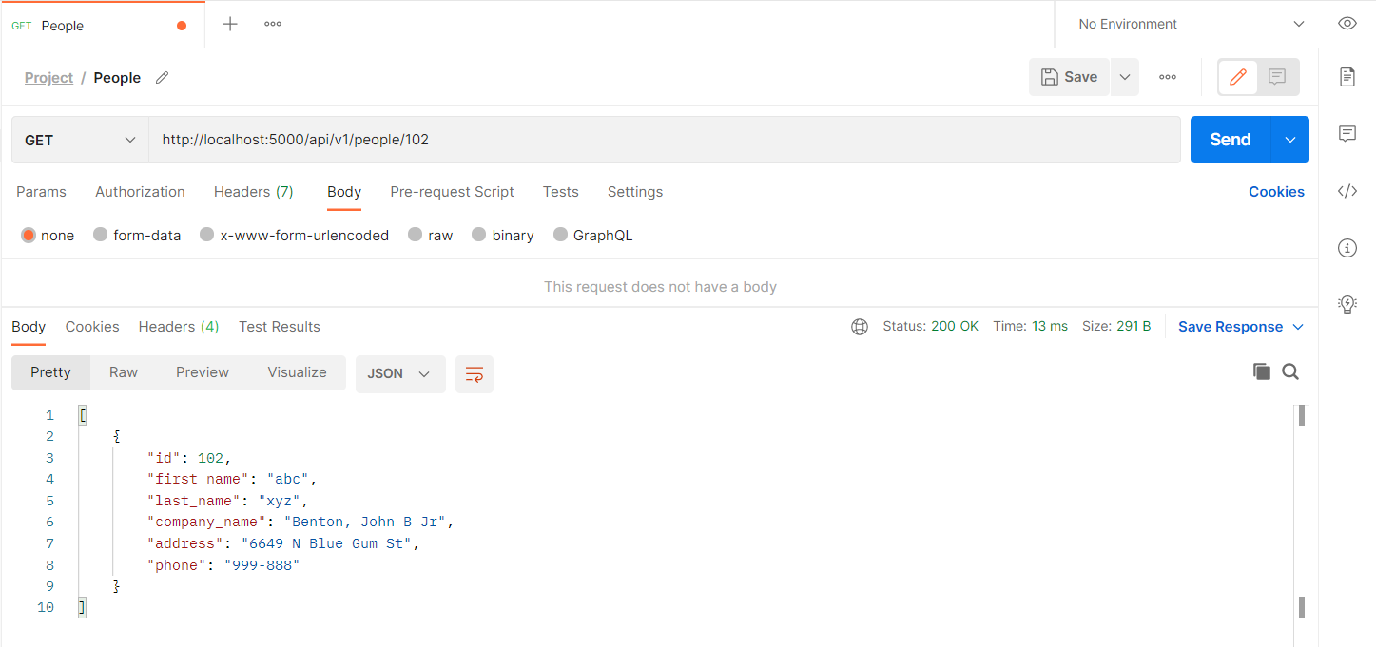

2e: Project in Postman deleting a record (DELETE request). I deleted record 102, abc.

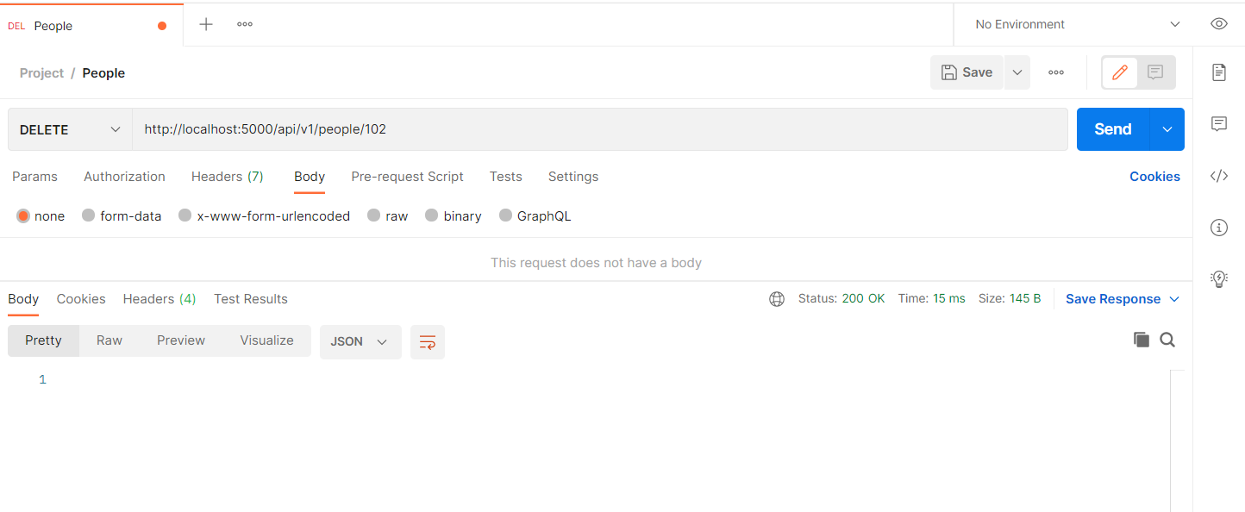

GET request of all records showing ID 101 deleted:

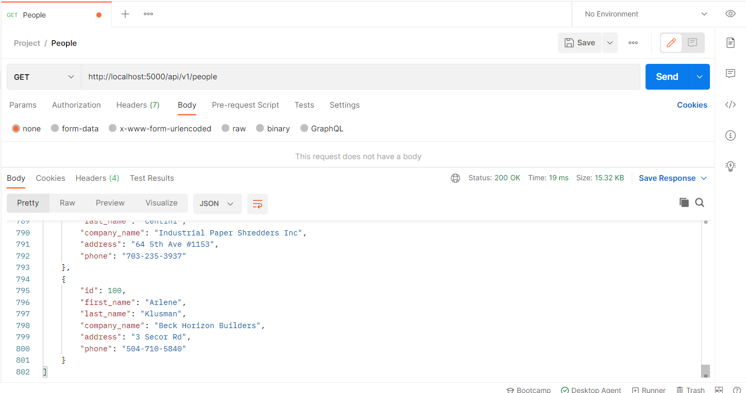

Empty record for ID 102:

