House Price Prediction — Summary of Findings
Internship Project, Week 1 | Dataset: Kaggle Housing Prices Dataset (545 properties)

Approach
The dataset contains 545 houses described by area, bedrooms, bathrooms, stories, parking, and several yes/no amenities (air conditioning, hot water heating, preferred area, etc.), plus a furnishing status. After confirming there were no missing values or duplicate rows, all yes/no fields were converted to 0/1 and furnishing status was one-hot encoded. The data was split 80/20 into training and test sets, and two regression models were trained: Linear Regression and Random Forest.

Model Performance
Model | MAE | RMSE | R² Score
Linear Regression | ₹970,043 | ₹1,324,507 | 0.653
Random Forest | ₹1,014,947 | ₹1,399,769 | 0.612
Linear Regression performed slightly better than Random Forest on this dataset — a reminder that more complex models don't automatically win, especially on a dataset of this size (545 rows).

Key Insights
Strongest price drivers: Area is by far the most influential feature, followed by number of bathrooms, air conditioning, and number of stories.
Model accuracy: The model explains about 65% of price variation (R² ≈ 0.65), with an average error of roughly ₹9.7 lakh — good for ballpark estimates, not precise valuations.
Surprise finding: Bedroom count mattered less than expected; bathrooms and air conditioning had a stronger relationship with price.
Business recommendation: Real estate businesses should price and market listings around livable area and bathroom count, and highlight amenities like air conditioning and preferred-area location as value-adding upgrades.

Chart 1: Distribution of House Prices
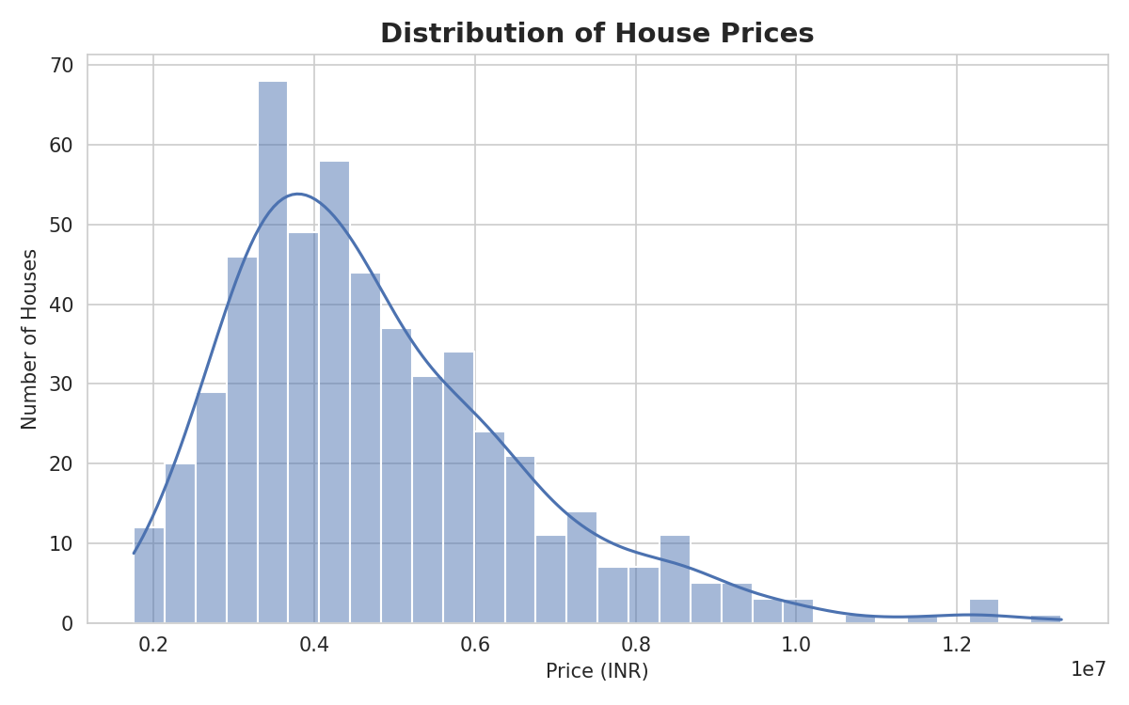

Chart 2: Correlation Heatmap
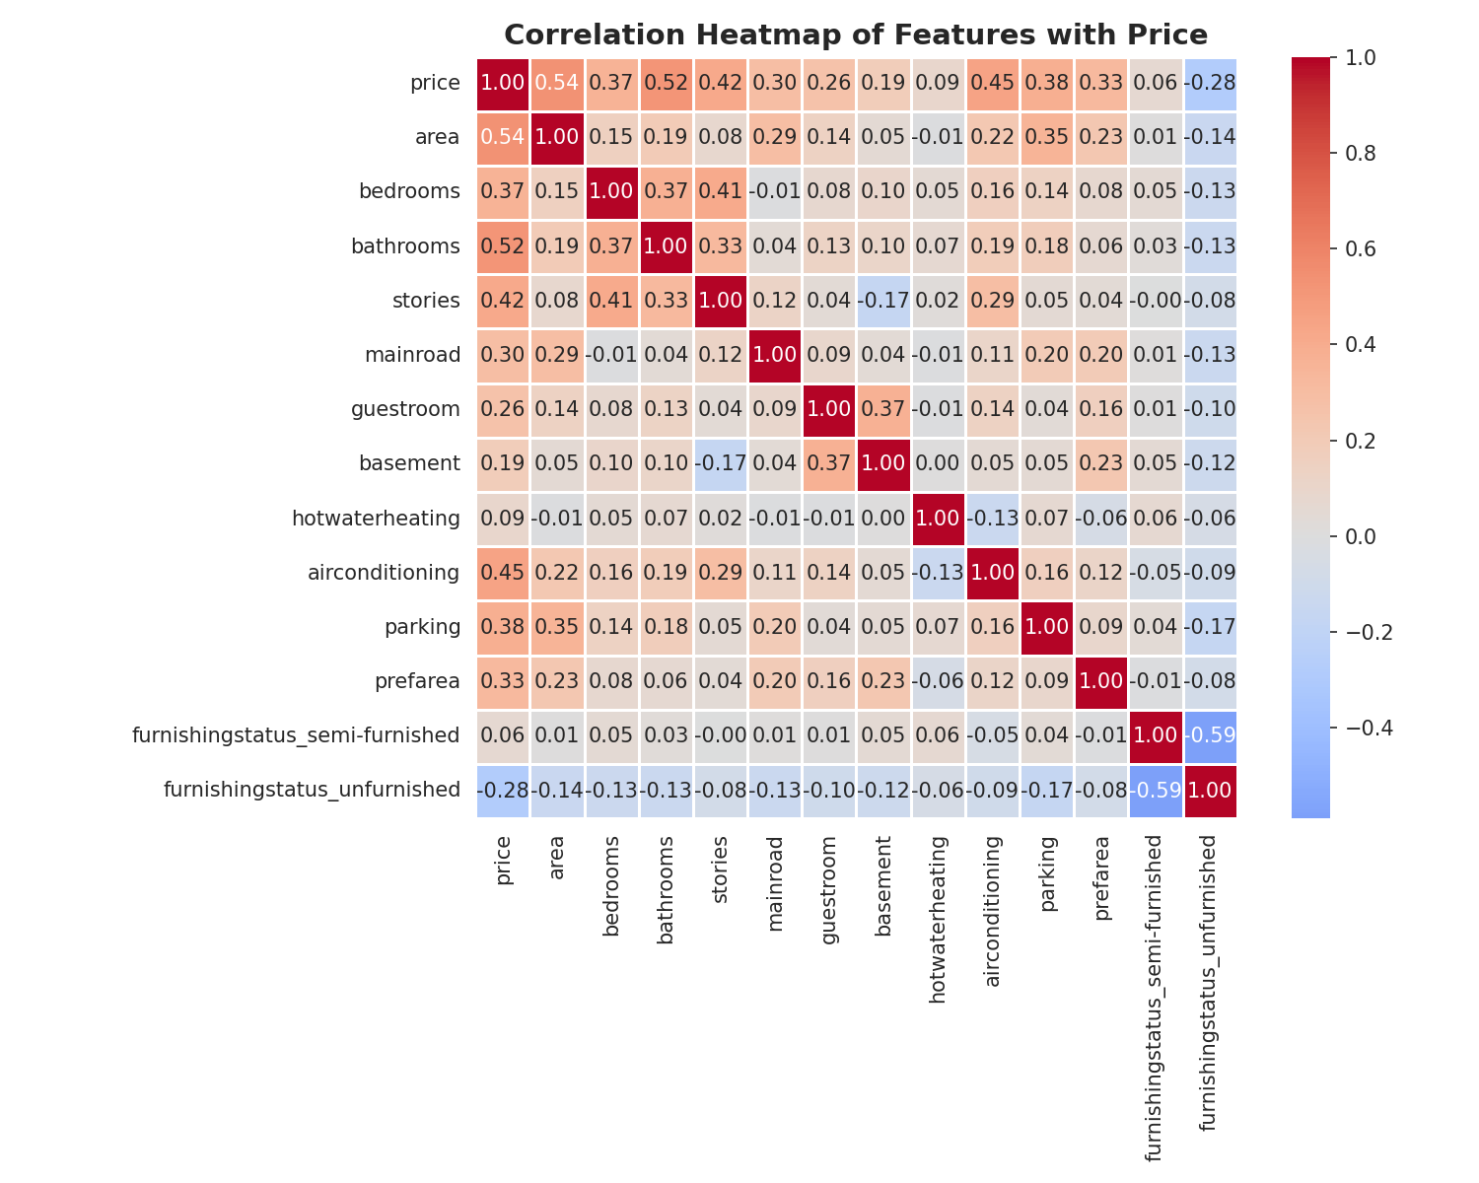

Chart 3: Actual vs Predicted Price (Random Forest)
